**1. jQuery를 이용한 Calendar 만들기**

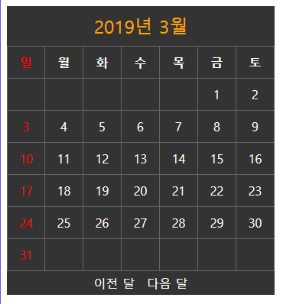

[index.html]

|  |
| --- |
| <!DOCTYPE html>  <html lang=*"en"*>  <head>  <meta charset=*"UTF-8"*>  <meta name=*"author"* content=*"tailofmoon"*>  <title>Calendar </title>  </head>  <body>  <div id=*"calendar_wrap"*>    </div>  <script src=*"app.js"*></script>  </body>  </html> |

[app.js]

|  |
| --- |
| // calendar 함수 |

[style.css]

|  |
| --- |
|  |

**2. Javascript를 이용한 Calendar 만들기**