**history 객체**

[결과]

 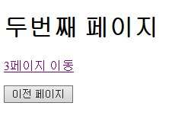 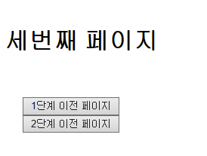

[his1.html]

|  |
| --- |
|  |

[his2.html]

|  |
| --- |
|  |

[his3.html]

|  |
| --- |
|  |