SonarQube Integration with Azure Devops

Steps 01:

* SonarQube is a open source platform developed by sonar source
* Continuously perform the code quality and automatic review the code
* Code smells, vulnerabilities , code bugs etc

Architecture Diagram of SonarQube integration with Azure devops

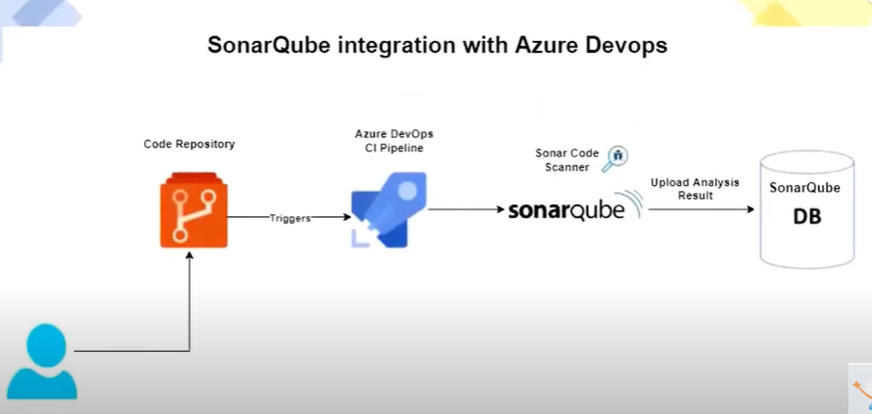

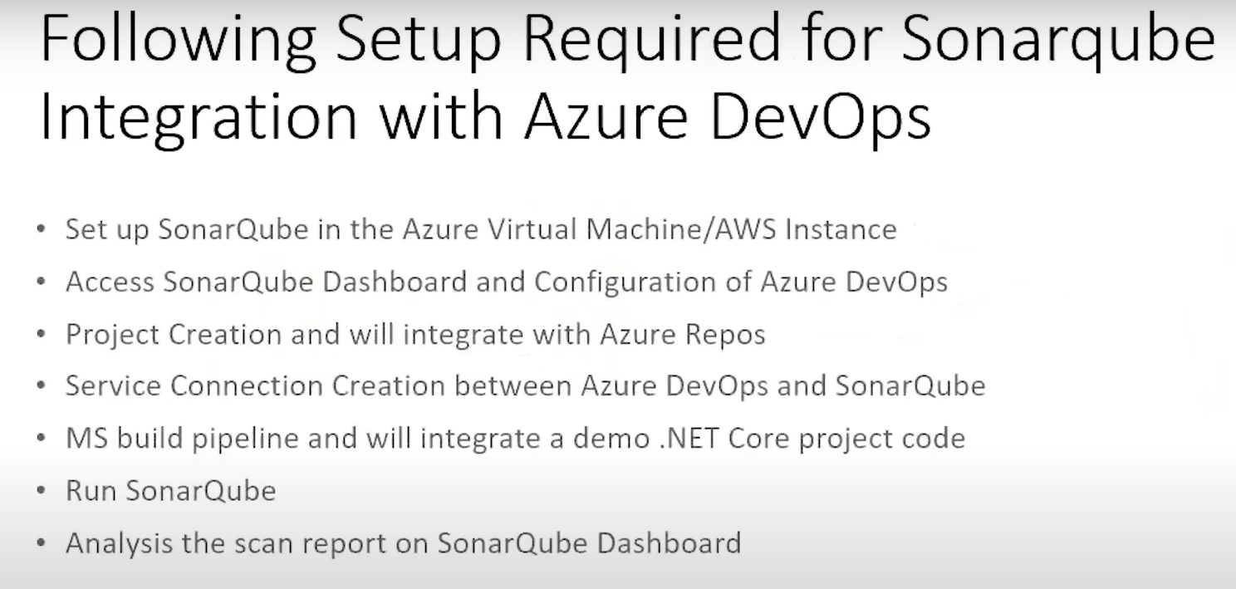

SonarQube public URL:

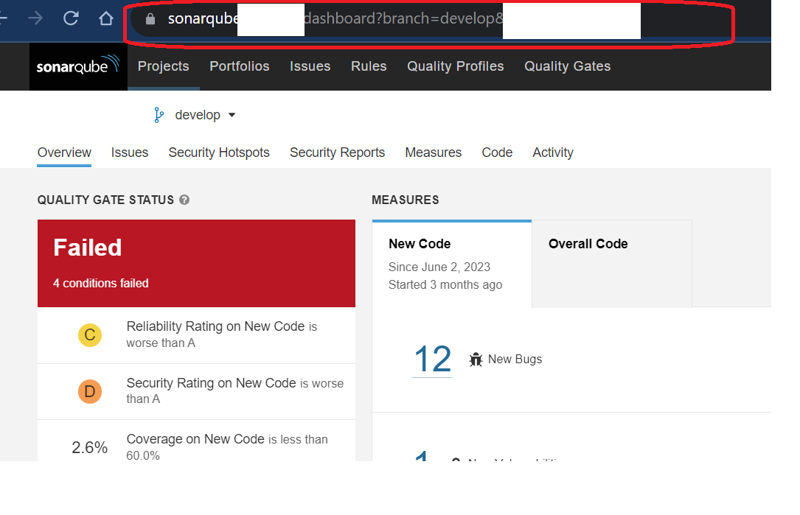

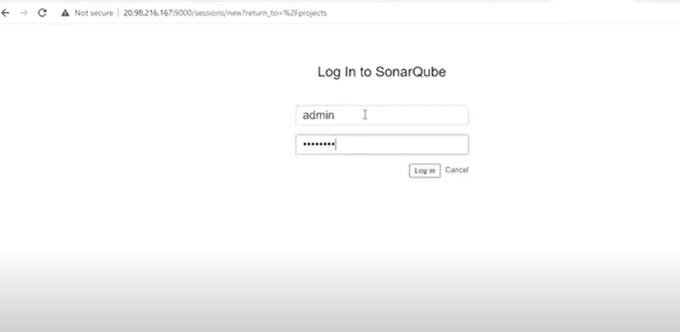

Go to administration >ALM Integration > Azure Devops > Create Configuration >

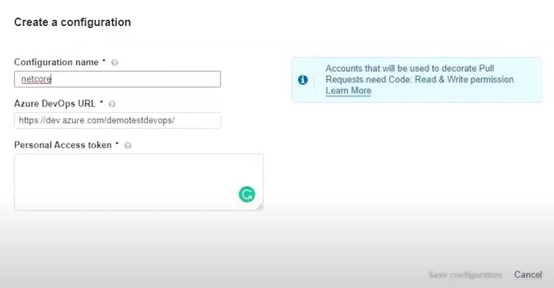

Select the URL azure devops:

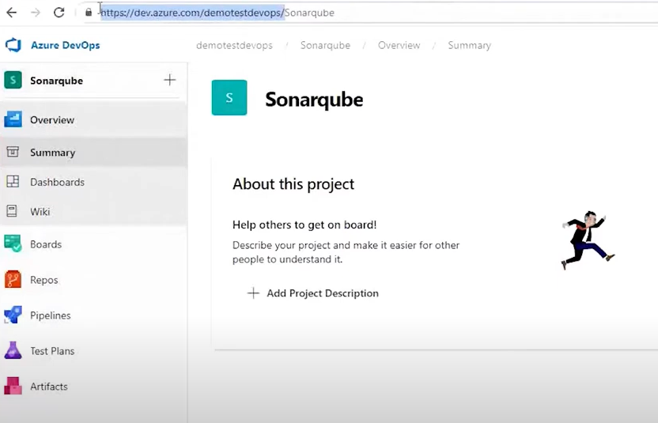

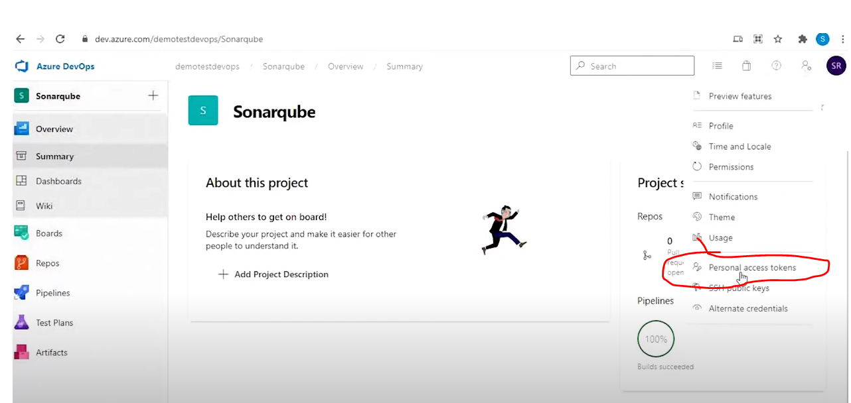

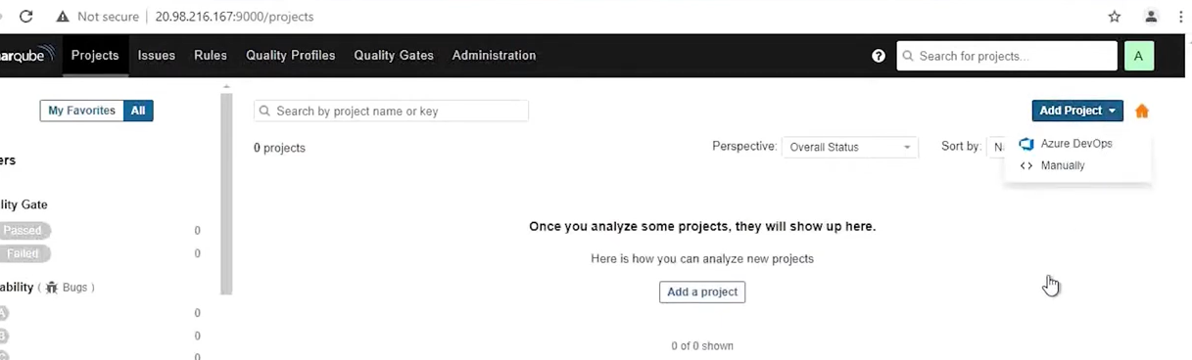

Select your repos and setup selected repository. > Azure Devops Pipeline >

Sonaqubextension> download and install

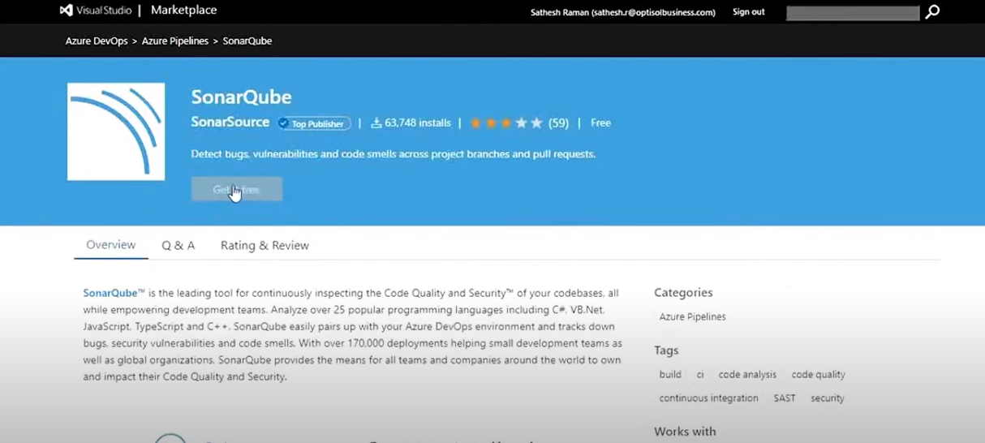

Service connection creation :

Devops portal > project setting> service connection >

Create service connection > sonarqube >

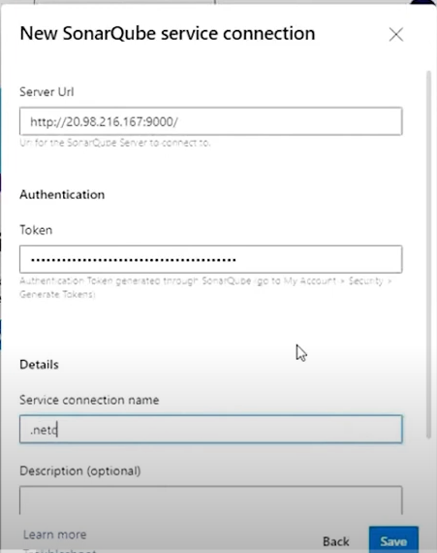

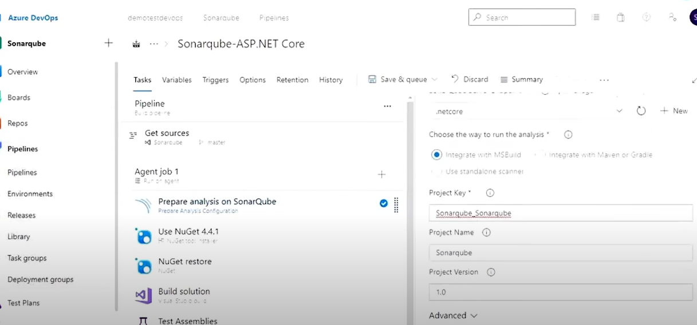

Run code analysis task :

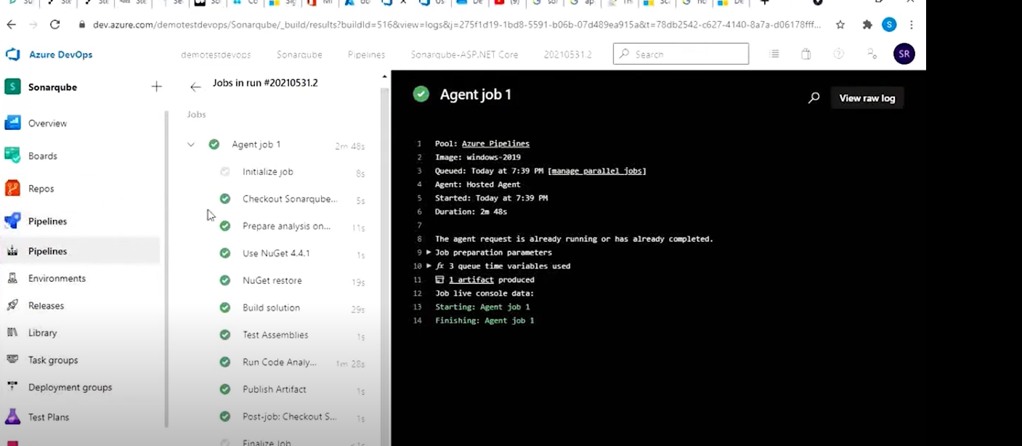

Reference link:

https://www.youtube.com/watch?v=GfgUTj4rp7c