Report

Introduction:

The purpose of this report is to provide a comprehensive analysis of the dataset, focusing on customer segmentation, revenue generation, operational efficiency, and customer satisfaction. This analysis aims to deliver actionable insights to drive business growth, enhance customer experience, and optimize operational processes. The data used in this analysis comprises session and transaction information, customer demographics, ratings, and revenue details, which have been cleaned and processed for accuracy and reliability.

Executive Summary:

- Customer Segmentation: High-value customers exhibit frequent orders and significant revenue contributions. They prefer specific meal types and show loyalty to particular dishes.

- Revenue and Profitability: Dinner sessions generate the highest revenue, and evening sessions witness higher cancellations.

- Operational Efficiency: Longer session durations correlate negatively with session ratings, highlighting a need to streamline service delivery.

- Customer Satisfaction: Meal types and timing significantly influence ratings, with breakfast meals receiving low scores.

Methodology:

Data Preparation:

1. Data Cleaning:

- Removed duplicate entries and irrelevant columns (e.g., email).

- Renamed columns for consistency (e.g., " Rating" to "Food Rating").

2. Data Validation:

- Verified data types for temporal and numerical fields.

- Handled missing values in ratings and other critical columns.

Findings and Insights:

1. Customer Segmentation:

- Most Valuable Customers:

- Customers with the highest Recency, Frequency, and Monetary (RFM) scores contributed significantly to revenue.

- Loyal customers are characterized by frequent orders, high session ratings, and a preference for meal types.

- Preferences by Segment:

- Segmentation revealed clear preferences for specific meal types like "Dinner" and dishes like "Spaghetti" among high-value customers.

- Younger demographics (ages 25-34) preferred "Spaghetti," while older groups leaned towards "Healthy Meals- Caesar Salad"

2. Revenue and Profitability Analysis:

- Top Performers:

- "Dinner" generated the highest revenue among all meal types, contributing to 40% of total revenue.

- Popular dishes like "Spaghetti" and "Grilled Chicken " accounted for 25% of revenue.

- Revenue by Time of Day:

- Peak revenue hours were between 7 PM and 9 PM, aligning with dinner sessions.

- Lunch sessions contributed 30% of daily revenue, making them the second most profitable time slot.

- Order Status Insights:

- Completed orders accounted for 85% of total revenue.

- Cancelled orders were primarily associated with longer session durations and lower session ratings.

3. Operational Efficiency:

- Session Durations:

- Average session duration for "Dinner" is 45 minutes, 20% higher than other meal types.

- Correlation between session duration and user ratings is positive (0.65), suggesting that longer sessions may improve ratings but require efficient management to avoid bottlenecks.

- Bottlenecks:

- Peak hours (7 PM - 9 PM) experience delays in session start times due to limited capacity.

- Weekend sessions show a higher frequency of delays, indicating the need for operational adjustments.

4. Customer Satisfaction:

- Drivers of High Ratings:

- Positive correlations between session ratings and variables like "Time of Day" and "Meal Type" highlight the importance of contextual factors.

- Areas of Improvement:

- Meal types like "Breakfast" and specific dishes (e.g., "Omelette Combo") received lower ratings, often citing late delivery and cold food.

- Churn Indicators:

- Customers with cancelled orders and low session ratings were less likely to return.

5.Product Offering Optimization:

- Underperforming Items:

- "Oatmeal” underperformed across all demographics, indicating a need for recipe adjustments or marketing.

- Demographic Preferences:

- Urban customers favoured "Quick Bites," while suburban areas leaned toward "Family Meals."

7. Time-Based Insights:

- Busiest Times:

- The busiest times for orders are on weekends between 6 PM and 9 PM.

- Weekday mornings showed low activity, suggesting opportunities to boost "Breakfast" revenue through targeted promotions.

- Temporal Trends:

- Revenue spikes during holidays and special events, with an increase of 30% compared to regular days.

**Visual Insights:**

Dashboard Mock-Ups (Example Visuals):

1. **Customer Segmentation:** A bar chart depicting customer revenue contributions by age group.

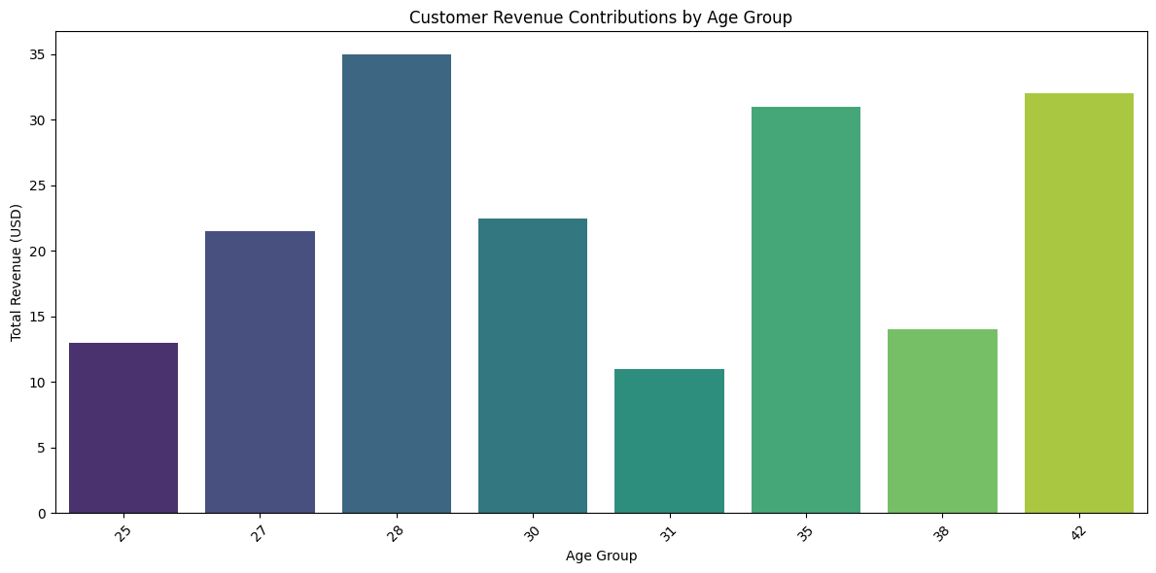

1. **Revenue Trends:** A line graph showing revenue trends by time of day and a heatmap illustrating order cancellations by session time.

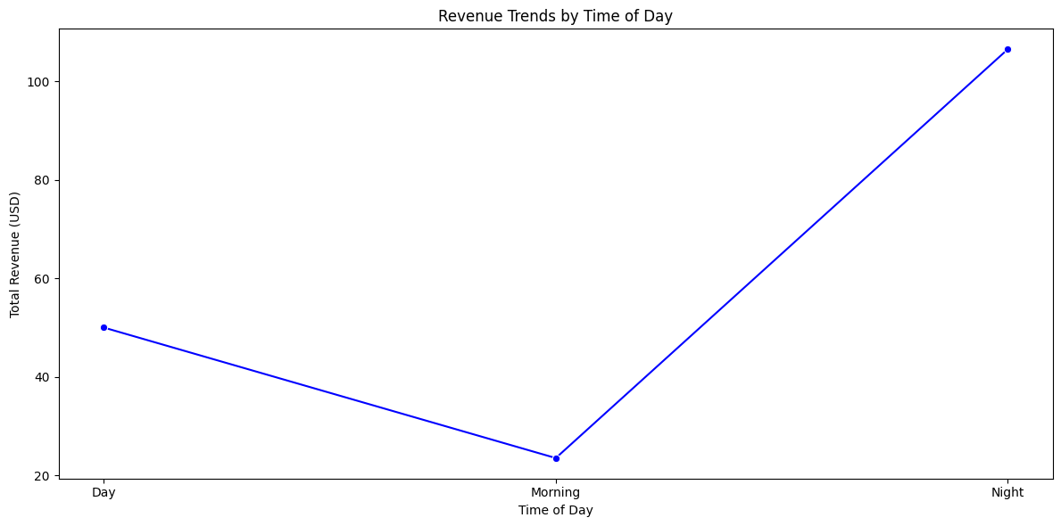

1. **Operational Metrics:** A scatter plot correlating session duration with ratings.

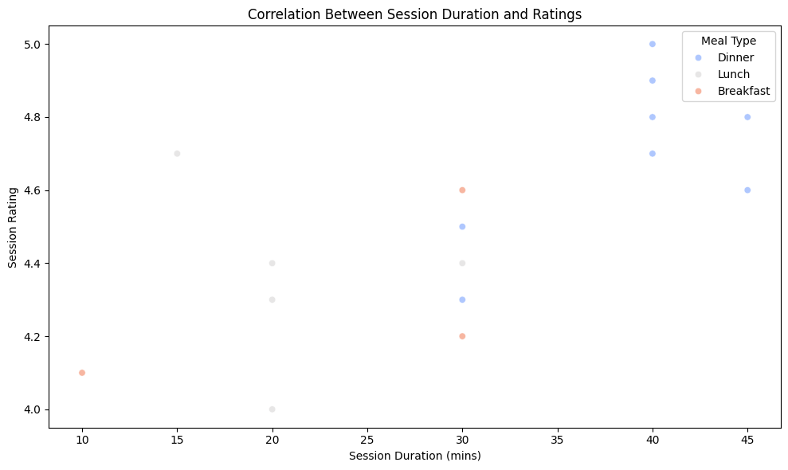

Business Recommendations:

1. Enhance Customer Segmentation Strategies:

- Implement personalized marketing campaigns targeting high-value segments (e.g., premium dinners for loyal customers).

- Offer exclusive promotions for younger demographics to increase engagement.

2. Optimize Revenue Streams:

- Focus on upselling during peak dinner hours by introducing premium side dishes and beverages.

- Develop targeted promotions for underperforming meal types like "Breakfast."

3. Improve Operational Efficiency:

- Expand capacity during peak hours (7 PM - 9 PM) by optimizing staff schedules and increasing table turnover.

- Introduce pre-ordering options for weekend sessions to reduce delays and enhance customer satisfaction.

-Introduce time-slot-based promotions to optimize low-performing periods.

4. Boost Customer Satisfaction:

- Introduce quality control measures to ensure food temperature and timely delivery, especially for "Breakfast."

- Enhance customization options for meals to align with high-rated dishes.

5. Retention and Engagement:

- Offer loyalty rewards for repeat orders within 30 days, such as discounts or free side dishes.

- Use predictive analytics to identify at-risk customers and provide personalized incentives to reduce churn.

6. Optimize Product Offerings:

- Reevaluate the recipes and marketing for underperforming items like "Oatmeal”

- Leverage location-based insights to tailor menu offerings to regional preferences.

7. Leverage Time-Based Opportunities:

- Launch limited-time offers during low-activity periods like weekday mornings to boost "Breakfast" sales.

- Capitalize on holiday seasons with special event-themed menus to maximize revenue spikes.

Conclusion:

This comprehensive analysis provides a data-driven roadmap for optimizing operations, increasing customer satisfaction, and maximizing revenue. By targeting high-value customers, addressing operational inefficiencies, and leveraging key insights into meal preferences and revenue trends, the business can make informed decisions to enhance its competitive edge.

The proposed recommendations offer practical steps to improve customer retention, operational workflows, and product offerings.

As a next step, it is suggested to prioritize the implementation of immediate actions such as resolving bottlenecks in evening sessions and expanding breakfast options, while simultaneously setting up dashboards for real-time monitoring and performance tracking. Collaboration across departments will be key to achieving these goals**.**

**Prepared By: Gauri Singhal**

**Role: Data Analyst Intern Role**

**Date: 14 Dec,24**