Lab 1:
- Write SQL code to create table Student.
- Write SQL code to create Employee table having attributes Eid, Ename, Eaddress, Ephone, Eage, Edetails and Esalary.
- Insert 19 records on Employee table.
- Display records from table using ‘WHERE’ clause.
SQL Queries:
- CREATE DATABASE DB;
- USE DB;
- To create a table student.
CREATE TABLE student(
SID INT(3) PRIMARY KEY,
f_name VARCHAR(20),
l_name VARCHAR(20),
address VARCHAR(30));
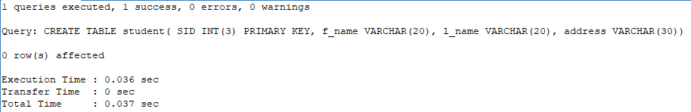

- To create a table employee.

CREATE TABLE employee(
Eid INT(3) PRIMARY KEY,
Ename VARCHAR(30),
Eaddress VARCHAR(30),
Ephone NUMERIC,
Ecity VARCHAR(20),
Eage INT(3),
Edetails VARCHAR(30),
Esalary NUMERIC
);
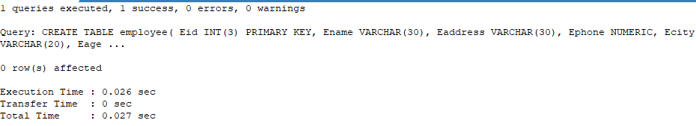

- To insert 19 records in table employee.

INSERT INTO employee VALUES
(1,'Abilekh','Banasthali','9899999999','Mustang',19,'Nice ',20000),
(2,'Alisha','Chettrapati','9799999998','Ktm',30,'Nice ',20000),
(3,'Anshu','Putalisadak','9856599999','ktm',19,'Nice',11000),
(4,'Anush','Banasthali','98989374999','ktm',19,'Nice',20400),
(5,'Ashlesha','Swoyambhu','984569999999','ktm',19,'Nice',56000),
(6,'AyushR','Asan','9899909890','Mustang',22,'Nice ',34078),
(7,'AyushT','Swoyambhu','9893649999','ktm',20,'Nice',99400),
(8,'Barsha','Banasthali','9867399999','lamjung',12,'Nice',56000),
(9,'Diya','Kalanki','9799990345','ktm',20,'Nice',98000),
(10,'Gaurav','Kapan','9799989456','Gaighat',20,'Nice good',45450),
(11,'Hrikesh','Kaldhara','9923674499','ktm',21,'Nice ',69690),
(12,'Kamana','Shorakhutte','9978459999','chitwan',20,'Nice',97600),
(13,'Krish','Dhungedhara','9994545999','uk',20,'Nice',565600),
(14,'Krishma','Jarangkhu','9990909999','ktm',19,'Nice ',203400),
(15,'Manila','Shivapuri','9999939599','syanja',21,'Nice',456000),
(16,'Shreesha','Shorakhutte','7878999999','ktm',20,'Nice',67000),
(17,'Sudip','Shorakhutte','9993434999','gorkha',20,'Nice',89000),
(18,'Sangam','Manamaiju','9999565699','bkt',20,'Nice',23000),
(19,'Upendra','Shivapuri','9967999999','patan',21,'Nice',56000);

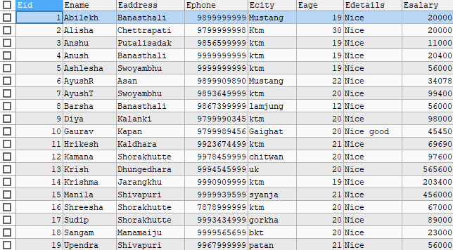

- To display records from table using ‘WHERE’ clause.

SELECT Ename,Eaddress,Esalary FROM employee WHERE Ename LIKE 'a%';
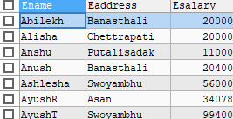

- To display records from table using ‘WHERE’ clause.
SELECT *FROM employee WHERE Ecity='ktm';
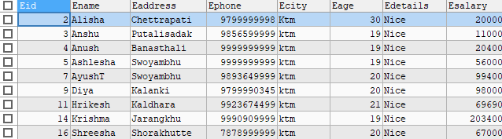

Lab 2:
- Create table employee with attributes Empid, Empname, Empaddress, Empphone, Emppost, Empsalary and insert 10 records.
- Find the employee records whose salary is greater than 30k.
- Find the employee records whose salary is less than 25k and address is ‘Dharan’.
- Find the employee records using IN/NOT IN operator.
- Find the Empid, Empname, Empsalary and Emppost from table who is ‘Manager’.

SQL queries:
- CREATE DATABASE lab2;
- USE lab2;
- CREATE TABLE employee2(
Empid INT(3) PRIMARY KEY,
Empname VARCHAR(30),
Empaddress VARCHAR(30),
Empphone NUMERIC,
Emppost VARCHAR(20),
Empsalary NUMERIC
);
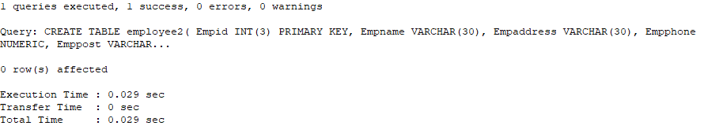

- INSERT INTO employee2 VALUES
(1,'Abilekh','Banasthali','9999999999','Accountant',20000),
(2,'Alisha','Chettrapati','9999999998','Bhanse',20000),
(3,'Anshu','Putalisadak','9856599999','Manager',11000),
(4,'Anush','Banasthali','99989374999','Manager',20400),
(5,'Ashlesha','Swoyambhu','984569999999','Administrator',56000),
(6,'AyushR','Asan','9999909890','CEO',34078),
(7,'AyushT','Swoyambhu','9893649999','Manager',99400),
(8,'Barsha','Dharan','8967399999','Peon',56000),
(9,'Diya','Kalanki','9999990345','CEO',98000),
(10,'Gaurav','Kapan','9999989456','Manager',45450);
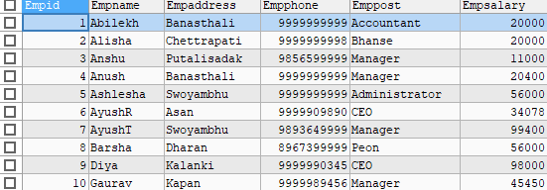

- To display employee records whose salary is greater than 30k.

SELECT *FROM employee2 WHERE Empsalary > 30000;
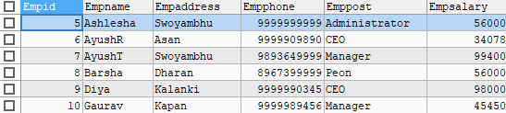

- To display employee records whose salary is less than 25k and address is ‘Dharan’.

SELECT *FROM employee2 WHERE Empsalary>25000 AND Empaddress='Dharan';

- To display employee records using IN/NOT IN operator.

SELECT *FROM employee2 WHERE Empid IN(1,4,5);
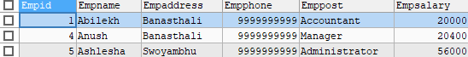

SELECT *FROM employee2 WHERE Empid NOT IN(2,3,4);
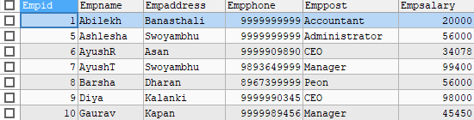

- To display Empid, Empname, Empsalary and Emppost from table who is ‘Manager’.

SELECT Empid,Empname,Empsalary,Emppost FROM employee2 WHERE Emppost='Manager';
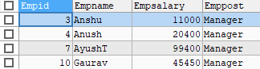

Lab 3:
- Create table student on SQL
- Add one column on existing table.
- Delete column from existing table.
- Change datatypes of existing columns.
- Display student records who read in grade 12 and have marks above 90.
Sql Queries:
- CREATE DATABASE g4r4v;

- USE g4r4v;

- CREATE TABLE student(
Sid INT(5),
Sname VARCHAR(20),
Smarks FLOAT,
Sgrade NUMERIC
);
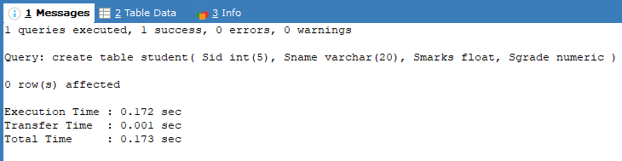
- INSERT INTO student VALUES
(1,'Abilekh',69,6),
(2,'Alisha',69,1),
(3,'Anshu',92,12),
(4,'Ashlesha',90,11),
(5,'Anush',99,1),
(6,'AyushT',82,12),
(7,'AyushR',59,9);
SELECT *FROM student;
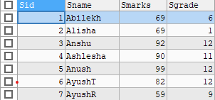

- To add a column on existing column.

ALTER TABLE student ADD Saddress VARCHAR(30);
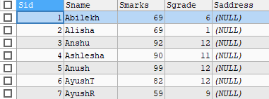

- To delete any column from existing table.

ALTER TABLE student DROP COLUMN Sid;
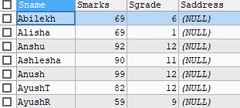

- To change datatypes of existing column.

ALTER TABLE student MODIFY COLUMN Smarks INT(3);
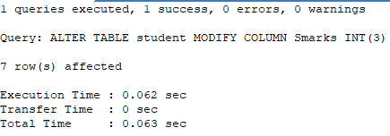
- To display student records who read in grade 12 and have marks above 90.

SELECT *FROM student WHERE Sgrade=12 AND Smarks>90;
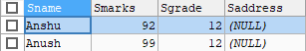

Lab 4:

- Write SQL query to update data where id is 1.
- Write SWL code to change address into “London” where name is “Dilip”.
- Writ SQL code to modify name whose id is 7.
- Write SQL code to display records from student table using aggregation functions(SUM, MIN, MAX, AVG, COUNT).
Sql Queries:
- CREATE DATABASE db4;
- USE db4;
- CREATE TABLE student(
id INT(3),
naame VARCHAR(20),
address VARCHAR(30),
marks FLOAT,
grade NUMERIC
);
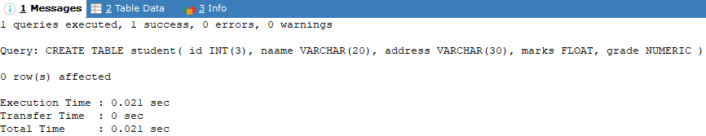

- INSERT INTO student VALUES
(1,'Abilekh','Balaju',70,6),
(2,'Alisha','Cherpati',67,1),
(3,'Anshu','Putalisadak',92,12),
(4,'Anup','chadragiri',90,11),
(5,'Anush','Balaju',99,12),
(6,'AyushT','Swoyambhu',82,12),
(7,'AyushR','Asan',59,9),
(8,'Dilip','Manamaiju',89,10);
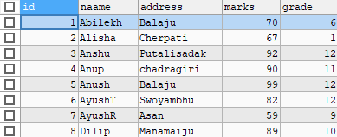

- To update data where id is 1.
UPDATE student
SET address='Baniyatar'
WHERE id=1;
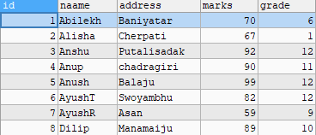

- To change address into “London” where name is “Dilip”.
UPDATE student
SET address='London'
WHERE naame='Dilip';
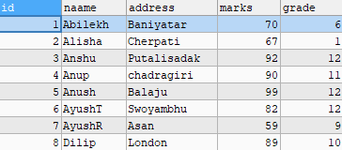

- To modify name whose id is 7.
UPDATE student
SET naame='Barsha'
WHERE id=7;
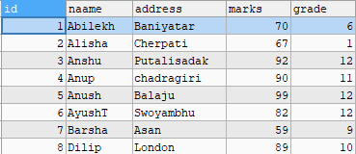

- To display records from student table using aggregation functions(SUM, MIN, MAX, AVG, COUNT).
SELECT
SUM(marks) AS TotalMarks,
MIN(grade) AS LowGrade,
MAX(grade) AS HighGrade,
ROUND(AVG(marks),2) AS AverageMarks,
(SELECT COUNT(*) FROM student WHERE naame LIKE 'a%') AS Astudent
FROM student;

