IntelliClaim
Submitted in partial fulfillment of the requirements of the degree of
Second Year Bachelor of Technology

by

Pratham Mehta, (60003240270)
Nakul Shah, (60003240147)
GauraangThakkar,(6000324025)
Dhanya Dedhia,(60003240139)

Project Guide

Name of Guide
Prof. Leena Sahu


(Information Technology)
Dwarkadas J. Sanghvi College of Engineering University of Mumbai
2025-2026

CERTIFICATE

This is to certify that the project entitled “IntelliClaim” is a bonafide work of Pratham Mehta (60003240270), Nakul Shah (60003240147), Gauraang Thakkar (6000324025), Dhanya Dedhia (60003240139) submitted to the University of Mumbai in partial fulfillment of Innovative Product Development-I course of “Second Year Bachelor of Technology” in “Information Technology”.

Name of the Guide

Dr. Vinaya Sawant Dr. Hari Vasudevan
Head of the Department Principal

Place:

Date:

DECLARATION
We declare that this written submission represents our ideas in our own words and where others ideas or words have been included, we have adequately cited and referenced the original sources. We also declare that, we have adhered to all the principles of academic honesty and integrity and have not misrepresented or fabricated or falsified any idea/data/fact/source in our submission. We understand that any violation of the above will be a cause for disciplinary action by the Institute and can also evoke penal action from the sources, which have thus not been properly cited or from whom proper permission has not been taken, when needed.

Pratham Mehta (60003240270) (Sign against the name)

Nakul Shah (60003240147) (Sign against the name)

Gauraang Thakkar (6000324025) (Sign against the name)

Dhanya Dedhia (60003240139) (Sign against the name)

Place:

Date:

APPROVAL SHEET

Project entitled, “IntelliClaim”, submitted by “Pratham Mehta” (60003240270), “Nakul Shah” (60003240147), “Gauraang Thakkar” (6000324025) and “Dhanya Dedhia” (60003240139) for the fulfillment of Innovative Product Development-I course of “Second Year Bachelor of Technology” in “Information Technology”.

Signature of Internal Examiner Signature of External Examiner

Dr. Vinaya Sawant
Name of the Guide Head of the Department

Dr. Hari Vasudevan
Principal

Place:

Date:

Abstract

IntelliClaim is a completed local prototype for insurance claim intake and assessor-led review of vehicle-damage evidence. We built a React and TypeScript web application, a FastAPI claim backend, and a separate FastAPI machine-learning service. The system manages claimant, assessor, and administrator workflows and connects claim photographs to existing pretrained models and reproducible research experiments. For historical photograph retrieval, frozen ResNet18 and released Generali OSNet-AIN encoders create image embeddings that are ranked with cosine similarity. SHA-256 supports exact-file duplicate checks, while SIFT/RANSAC and optional SuperPoint/LightGlue show local feature correspondences for assessor inspection. The broader evidence workflow includes damage detection, vehicle-make suggestions, registration-plate OCR, photograph-forensics diagnostics, invoice arithmetic, and claim-history links. On a 420-image Generali subset, OSNet-AIN reached 95.24% Recall@1 and 74.82% mAP, compared with 90.48% and 58.67% for ImageNet ResNet18. ResNet18 retrieved transformed copies of 85 held-out TQVCD photographs with 100% Recall@1 and Recall@5, but this tests edited copies rather than new photographs of the same physical damage. Local-feature reranking did not improve the selected ranking, and reliable open-set abstention and independent insurer validation remain unestablished. The project integrates existing models rather than proposing a new neural architecture; model outputs support human review and do not constitute a validated fraud probability or an automated claim decision.

List of Figures

Fig No. | Figure Name | Page No.
1 | Example detection and photograph-forensics outputs | 2
2 | IntelliClaim claim-evidence workflow | 4
3 | SIFT/RANSAC correspondences in a controlled same-image demonstration | 5

List of Tables

Table No. | Table Name | Page No.
1 | Implemented components and model roles | 4
2 | Datasets and data sources used | 6
3 | Frozen encoder comparison | 7
4 | Edited-photo reuse | 7
5 | Reranking and damage attribution | 8
6 | Abstention experiments | 8
7 | Separate structured-data baselines | 9
8 | Implementation and verification status | 9

Table of Contents
Acknowledgement 9
Abstract 5
List of Figures 6
List of Tables 7
Chapter 1 Introduction 1
1.1 Background and motivation 1
1.2 Project objectives 1
1.3 Completed project contributions 1
1.4 Scope 1
Chapter 2 Background and related methods 2
2.1 Damage and vehicle evidence 2
2.2 Image retrieval and local matching 2
2.3 Research angle 3
Chapter 3 IntelliClaim framework 4
3.1 Architecture and claim workflow 4
3.2 Claim processing sequence 4
3.3 Implemented components and model roles 4
3.4 Retrieval and correspondence display 5
Chapter 4 Datasets and experimental design 6
4.1 Datasets and data sources 6
4.2 Preprocessing and split discipline 6
4.3 Evaluation measures 6
Chapter 5 Results and interpretation 7
5.1 Frozen encoder comparison 7
5.2 Edited-photo reuse 7
5.3 Reranking and damage attribution 8
5.4 Abstention and external-source stress 8
5.5 Separate structured-data baselines 9
Chapter 6 Implementation and verification 9
Chapter 7 Limitations and future work 10
Chapter 8 Conclusion 11
References 12

Acknowledgement
We would like to acknowledge our sincere thanks and are indebted to our guide ‘Ms. Leena Sahu’ for her valuable guidance and assistance in preparing this report.
We would also like to acknowledge our sincere thanks to the Principal ‘Dr. Hari Vasudevan’ for granting us the usage of the college library facilities for the purpose of reference for this report.
We are also thankful to our Head of Department ‘Dr.Vinaya Sawant’for allowing us to use the computer laboratory and the internet facilities. We are deeply indebted to our families for their moral support and encouragement because of which this project has been completed in the true sense. Their patience and support in the course of the report writing has helped us to rejuvenate ourselves and thus give our best for the report.

Chapter 1 Introduction

1.1 Background and motivation
Motor-insurance assessment involves collecting claim details, inspecting photographs, checking supporting documents, and recording an assessor decision. A digital system can organize this evidence and retrieve potentially related photographs, but visual similarity is only an investigative clue. IntelliClaim was built to put image-analysis components inside a claim workflow while keeping the final decision with an authorized human assessor.

1.2 Project objectives
• Implement a role-aware claim workflow for claimants, assessors, and administrators.
• Connect vehicle-damage and image-evidence models to stored claim photographs.
• Retrieve visually similar historical photographs and expose matching evidence for inspection.
• Support exact and perceptual duplicate checks and incremental gallery ingestion.
• Evaluate retrieval, edited-photo reuse, reranking, damage attribution, and abstention using documented protocols.
• Present model outputs as review evidence rather than an automated fraud or claim decision.

1.3 Completed project contributions
The completed contribution is an integrated claim-evidence review system and a documented empirical evaluation. We implemented the claimant-to-assessor workflow, authenticated backend proxies, image gallery operations, historical retrieval, correspondence visualization, and experiment tooling. We integrated existing pretrained models and reported both positive and negative results. We did not invent a new neural architecture or claim a validated fraud detector.

1.4 Scope
The verified prototype runs locally. Some persistence and full-stack components were tested separately, and a staged cloud build was produced, but the hosted claim-inference workflow did not pass end-to-end verification. Independent insurer validation, reliable open-set rejection, and authorized access to all desired datasets remain outside the completed claims of this report.

Chapter 2 Background and related methods

2.1 Damage and vehicle evidence
Object-detection models predict bounding boxes and classes for visible damage regions. IntelliClaim integrates a YOLOv8-family checkpoint with six damage classes [11]; the model is used to present candidate detections to the assessor. Vehicle-make suggestions use a ViT-based classifier with a limited label set [9]. EasyOCR proposes plate text [12] and applies confidence and Indian-registration-pattern checks. Unsupported or unreadable cases remain inconclusive rather than being forced into a label.
TruFor provides image-forensics diagnostics, including a model score and localization map [7]. Its score is not calibrated as a probability that a claim photograph is authentic or manipulated. Occlusion saliency measures how the selected detector output changes when image regions are hidden; it is a sensitivity visualization, not causal proof. These components are presented as supporting evidence, not as independent findings of fraud.
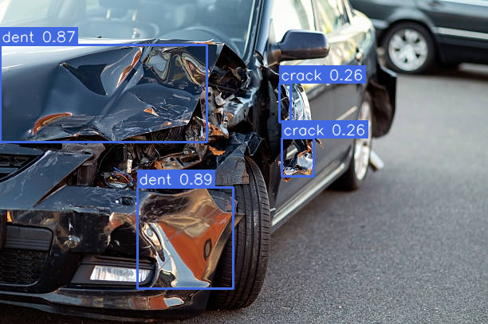
Figure 1. Example integrated damage-detection and image-forensics outputs. The visualizations are diagnostics and do not establish authenticity or claim outcome.

2.2 Image retrieval and local matching
A retrieval encoder maps a photograph to a feature vector. IntelliClaim compares normalized vectors with cosine similarity and ranks the gallery. ResNet18 serves as a general ImageNet-pretrained baseline. OSNet-AIN is a released Generali checkpoint; OSNet uses feature streams at multiple spatial scales, while the AIN variant incorporates instance normalization to improve cross-domain generalization [1], [2]. ResNet follows residual learning [8]. The project freezes both encoders for the reported comparison; it does not fine-tune them on the evaluation subset.
SHA-256 fingerprints file bytes and therefore catches exact-file duplicates. Perceptual hashes such as pHash and dHash can surface some resized or recompressed copies. They complement embeddings: hashes are useful for duplicate screening, while embeddings support ranked visual search. Neither establishes that two photographs show the same physical damage.
For selected candidates, SIFT detects local keypoints and describes their surrounding image patches [3]. RANSAC estimates a geometric relation from candidate correspondences while rejecting inconsistent outliers [4]. Optional SuperPoint and LightGlue provide learned local keypoints and matches [5], [6]. These methods produce inspectable dots and lines; they did not improve the selected ranking in our reranking experiment.

2.3 Research angle
The research question is whether frozen image representations and local-feature evidence can support historical vehicle-damage photograph review, and how far available experiments justify a match or no-match conclusion. We compare encoders, test edited copies, evaluate two local-feature rerankers, run a small damage-masking pilot, and stress-test abstention with held-out identity groups. The contribution is empirical and systems-focused: it measures the behavior and limits of existing methods rather than proposing a new model.

Chapter 3 IntelliClaim framework

3.1 Architecture and claim workflow
The browser client is implemented in React and TypeScript. A FastAPI backend handles authentication, claim records, image upload, claim status, and assessor actions. A separate FastAPI machine-learning service runs model inference and retrieval. The backend mediates access to claim images and assessor-only gallery operations. Local mode uses SQLite and local media; the repository also contains a configurable PostgreSQL, Redis/Celery, MinIO, and Neo4j full-stack setup.
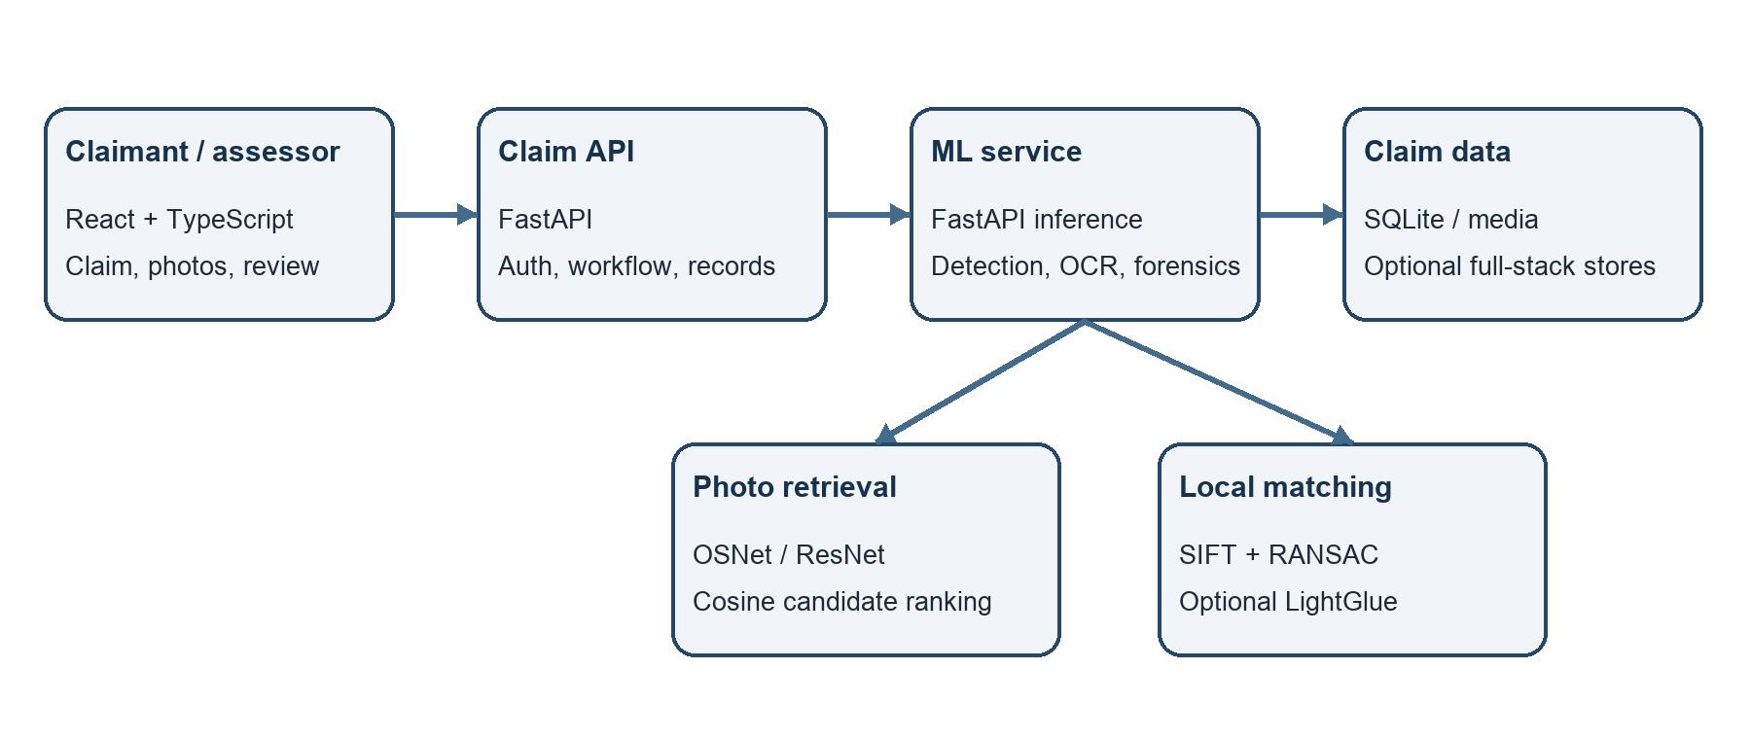
Figure 2. IntelliClaim service flow. The backend coordinates the web workflow and calls a separate inference service; the assessor remains responsible for the final decision.

3.2 Claim processing sequence
• A claimant signs in, registers vehicle details, creates a claim, and uploads photographs and supporting information.
• The backend stores claim data and photographs, then requests available image-evidence analyses.
• The ML service returns damage detections, vehicle and plate suggestions, forensics diagnostics, and retrieval candidates when the required models are available.
• The historical gallery ranks candidates using image embeddings. Duplicate hashes and image-history records provide separate evidence about exact or near-duplicate submissions.
• An assessor reviews the original image, candidate results, detection overlays, correspondence points, invoice checks, and claim history.
• The authorized assessor records an approval, rejection, or escalation with notes; IntelliClaim does not automatically make that decision.

3.3 Implemented components and model roles
Component | Method/model | Role in IntelliClaim
Damage localization | YOLOv8-family checkpoint; six classes | Displays candidate damage boxes and classes for review.
Vehicle make | ViT-based nine-class classifier | Suggests a make when the label is within the supported set.
Plate text | EasyOCR + format/confidence checks | Proposes registration text; unsupported/unreadable results stay inconclusive.
Image forensics | TruFor pretrained checkpoint | Provides a model score, reliability summary, and localization map; not authenticity probability.
Historical retrieval | Frozen OSNet-AIN; ResNet18 baseline | Embeds query/gallery photos and ranks candidates by cosine similarity.
Local correspondence | SIFT/RANSAC; optional SuperPoint/LightGlue | Shows geometric feature matches between a query and selected candidate.
Photo reuse | SHA-256, pHash, dHash | Checks exact bytes and proposes some perceptual duplicates.
Structured research | Logistic regression; feature-neighbour GraphSAGE | Exploratory, separate tabular baselines; not claim-photo identity evidence.

3.4 Retrieval and correspondence display
Gallery images are encoded at indexing time and stored with their identifiers. A query is processed with the same frozen encoder; vectors are normalized and cosine similarity is computed against the gallery. The top-k candidates are returned for assessor review. Dynamic ingestion validates image content, checks SHA-256 duplicates, encodes the new photograph, and appends its vector without recomputing the entire gallery.
The correspondence viewer overlays keypoints and matching lines on side-by-side photographs, rescaling the matching coordinates to the rendered image sizes. The displayed example intentionally compares a claim photograph with an indexed copy of the same stock image. It is a controlled interface demonstration, not evidence of repeat damage in two independent claims.
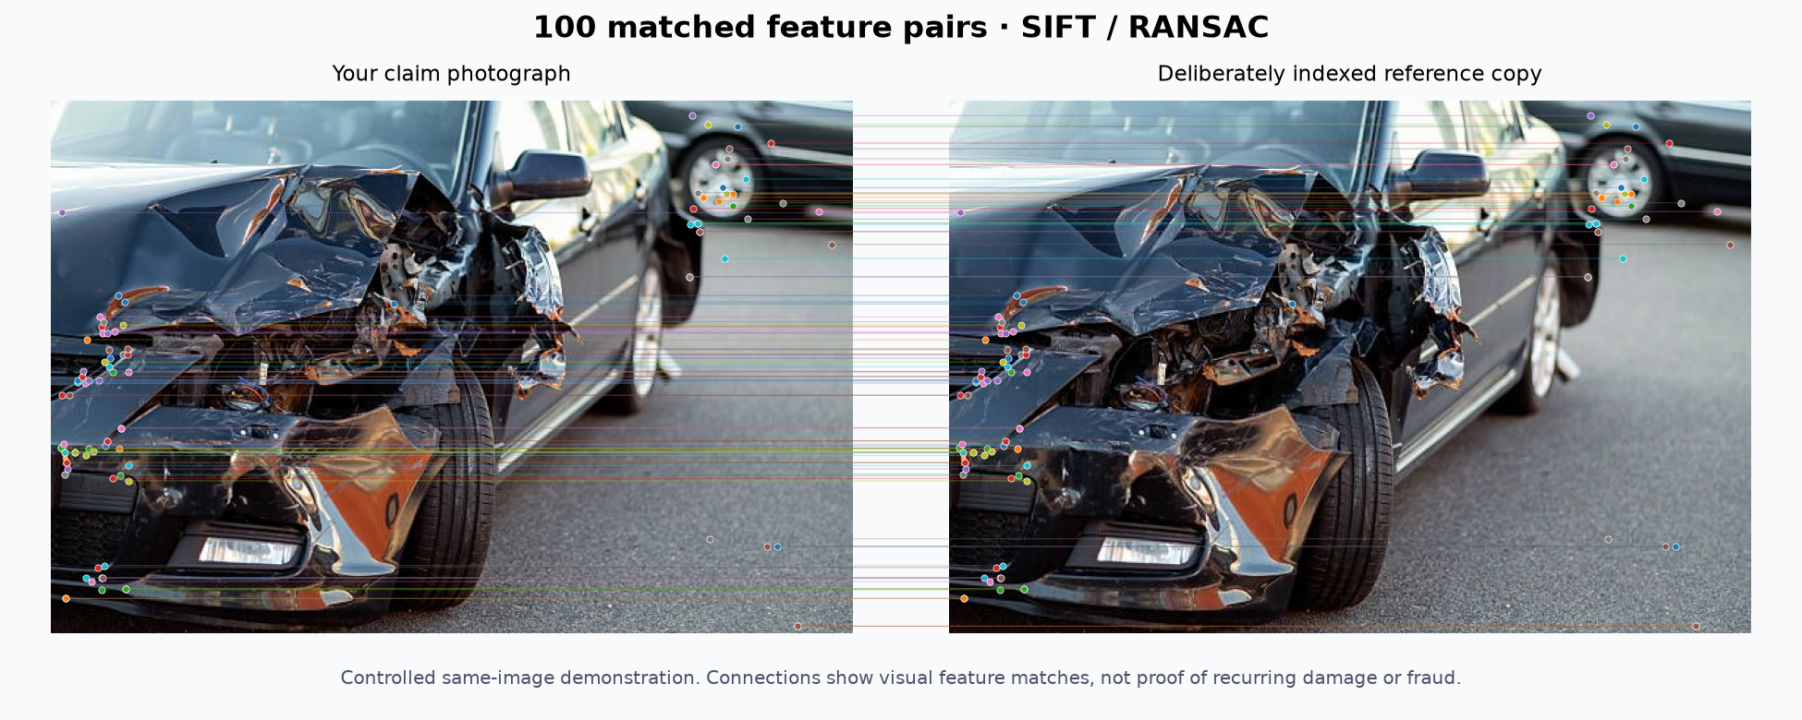
Figure 3. Controlled same-image SIFT/RANSAC demonstration. The lines show local visual correspondences; they do not prove recurring damage or fraud.

Chapter 4 Datasets and experimental design

4.1 Datasets and data sources
Source | Local data used | Purpose and limits
Generali automotive claim photographs | 420 photographs; 39 filename-prefix identity groups | Frozen encoder comparison. Group semantics and possible pretraining overlap were not independently audited.
TQVCD public examples [13] | 113 exact-content-unique images | Edited-copy reuse and external-source stress. Full 2,300-image set was not acquired; examples do not establish same-damage identity.
Insurance-claims CSV | 1,000 rows; 247 positive and 753 negative labels | Separate structured-data experiments. Provenance/license and relationship to photographs are not established.
CarDD [14] and CDDM [15] | Full datasets not acquired | Not used as complete training/evaluation sets; author access/licensing steps remain.
Stock-photo demonstration | One user-provided damaged-car photo plus a deliberately indexed copy | UI and correspondence demonstration only; excluded from benchmark metrics.

The CSV source is the public repository identified in the project documentation [16]: https://github.com/PrathamMehta101/ipd. It is not paired with the benchmark photographs. The project uses available published checkpoints for most visual components; the 420-image and TQVCD sets are used for frozen evaluation protocols, not to claim that all visual models were trained from scratch on them.

4.2 Preprocessing and split discipline
Retrieval images are decoded, resized and normalized according to each encoder’s documented input path. Exact duplicate files are excluded or grouped as specified in each experiment. The main encoder comparison leaves each query out of the gallery and removes exact duplicates. Edited-photo sources are grouped before a 28-source validation and 85-source test split. Separate identity groups are used for reranking and abstention experiments. The fixed-gallery abstention threshold is calibrated without using the unknown test groups.

4.3 Evaluation measures
Recall@1 measures whether the top-ranked candidate belongs to the expected group. Recall@5 measures whether at least one of the five highest-ranked candidates is relevant. Mean Average Precision (mAP) rewards relevant candidates appearing earlier across the full ranking. In abstention experiments, matched acceptance reports the fraction of known-match queries accepted, while unknown alerts count unknown groups incorrectly accepted as a match. These benchmark identities are filename-based groups, not verified physical-damage identities.

Chapter 5 Results and interpretation

5.1 Frozen encoder comparison
Each eligible image queries the remaining 420-image Generali subset. Encoders are frozen, and there is no target-domain fine-tuning or threshold selection. OSNet-AIN performs better than the ImageNet ResNet18 baseline under this protocol.
Frozen encoder | Recall@1 | Recall@5 | mAP
ImageNet ResNet18 | 90.48% | 93.81% | 58.67%
Released Generali OSNet-AIN | 95.24% | 98.57% | 74.82%

OSNet-AIN improves Recall@1 by 4.76 percentage points and mAP by 16.15 points. Identity-cluster bootstrap intervals from 2,000 resamples are +1.88 to +8.08 points for Recall@1 and +11.85 to +21.11 points for mAP. These intervals do not remove risks from possible training overlap or dataset shortcuts. The authors report a 385-image evaluation set, whereas the locally available subset contains 420 images; this result is not a verified reproduction of the authors’ complete protocol.

5.2 Edited-photo reuse
The experiment uses 113 unique TQVCD source images, with 28 validation sources and 85 test sources. Four edits per test source produce 340 queries: JPEG quality 35, brightness factor 0.65, a 20% crop, and horizontal reflection. Exact duplicate sources are grouped before splitting.
Method | Recall@1 | Recall@5
dHash | 68.82% | 76.47%
ResNet18 | 100% | 100%

This shows that ResNet18 retrieved edited copies of known photographs in this controlled test. It does not measure whether the system can recognize the same physical damage from a newly captured view and does not establish fraud-detection accuracy.

5.3 Reranking and damage attribution
Reranking begins with a ResNet18 candidate ranking and adds local matching evidence. Validation selected alpha = 0 for both SIFT/RANSAC inliers and LightGlue match count; therefore the final ranking stayed unchanged. Test Recall@1 was 82.76% for both methods over 58 queries. The completed LightGlue run processed 78 queries and 390 pairs in 212.36 seconds, using 256 SuperPoint keypoints, a 640-pixel maximum edge, and cached features for 256 images. This is a completed negative result: the extra score did not improve the selected ranking.
The damage-attribution pilot used eight deterministic queries and 24 candidate pairs. Both photographs had detected damage in 12 pairs; an equal-area, non-overlapping background control was available for only five pairs. Masking the query’s highest-confidence damage rectangle produced mixed results. The pilot demonstrates diagnostic feasibility, not reliable damage-specific attribution or improved retrieval.
Experiment | Protocol summary | Observed result
SIFT/RANSAC reranking | ResNet18 candidates; separate validation/test identities; top five | Selected alpha 0; test Recall@1 82.76%, unchanged.
LightGlue reranking | Same evaluation family; 78 queries, 390 pairs | Selected alpha 0; test Recall@1 82.76%, unchanged.
Damage masking pilot | 8 queries × 3 candidates = 24 pairs | Small, mixed pilot; insufficient for causal attribution.

5.4 Abstention and external-source stress
An earlier validation 95th-percentile impostor threshold failed to transfer between different galleries. It produced no-match false-alert rates of 32.78% for ResNet18 and 38.46% for OSNet-AIN. This showed that a high similarity score alone was not a safe match-acceptance rule.
A fixed-gallery continuation used 10 gallery identities, 19 unknown identity groups for calibration, and 10 additional unknown groups for testing. Two matched queries per gallery identity were held out. At a nominal 5% operating point, OSNet-AIN accepted 90% of matched queries and had 100% precision among accepted examples, but alerted on 1 of 10 unknown groups; the one-sided 95% upper bound was 39.42%. ResNet18 accepted 50%, alerted on 0 of 10 unknown groups, and had an upper bound of 25.89%. These small samples do not establish reliable 5% false-alert control.
Encoder | Matched acceptance | Precision among accepted | Unknown alerts | 95% upper bound
ResNet18 | 50% | 100% | 0/10 | 25.89%
OSNet-AIN | 90% | 100% | 1/10 | 39.42%

The 113 TQVCD examples had no exact SHA-256 overlap with the Generali subset, and both encoders produced zero apparent alerts against the fixed gallery at the frozen threshold. Without cross-source identity auditing, this is an external-source stress observation, not a validated false-positive rate. Reliable abstention remains unestablished.

5.5 Separate structured-data baselines
A separate 1,000-row CSV experiment used a 599/200/201 train/validation/test split and seven documented fields. Unverified identifiers were excluded. The logistic-regression and GraphSAGE experiments do not use authentic pairings with vehicle photographs; their scores are exploratory single-split results, not fraud probabilities for claim decisions. GraphSAGE connects feature-neighbours here, not verified collusion pairs.
Model | Held-out rows | Average precision | ROC-AUC | Brier score
L2 logistic regression | 201 | 0.6695 | 0.8785 | 0.1200
Feature-neighbour GraphSAGE | 201 | 0.7245 | 0.9008 | 0.1004

The dataset’s provenance, feature appropriateness, fairness, and multi-seed generalization require further evaluation.

Chapter 6 Implementation and verification

6.1 Claim application and gallery operations
The application includes login, role-aware dashboards, vehicle registration, claim filing, photo upload, claim status, assessor queues, evidence inspection, and human assessment. Assessors can search the historical gallery, choose candidate counts, inspect a selected match, and add an authorized claim photograph to the gallery. Gallery ingestion validates decoded image data, detects exact SHA-256 duplicates, stores the image, computes one new embedding, and updates the vector index incrementally.

6.2 Evidence handling and presentation
A selected photo can be inspected for damage detections, vehicle and plate suggestions, tampering diagnostics, image history, and related claims. The correspondence viewer renders the image pair, keypoints, and lines, with a control to show or hide the lines. Invoice parsing checks arithmetic consistency; it does not authenticate vendors or confirm market prices. Graph links help navigate shared claimants, vehicles, and photo candidates but do not establish collusion.

6.3 Verification status
Area | Completed verification | Boundary
Local application | Frontend, backend, and ML services respond locally; claim and retrieval flows exercised. | Local prototype; not a public end-to-end deployment.
Automated checks | 72 local automated tests passed; TypeScript/Vite production build passed. | Source and integration checks do not establish model accuracy.
Full-stack services | An isolated PostgreSQL/Redis/Celery/MinIO/Neo4j claim smoke passed. | Separate full-stack smoke, not hosted production proof.
Cloud persistence | Neon PostgreSQL and private Blob persistence checks passed. | Hosted model capabilities and claim inference did not pass end-to-end verification.
Human review | Assessor records the final decision; model evidence is presented with limitations. | No automatic fraud probability or automatic denial.

The repository contains deployment configuration and CI checks. A staged Vercel build reached READY, but hosted ML capabilities and a full claim-inference request failed verification. The project is therefore documented as a working local prototype with separately tested infrastructure pieces, not as an end-to-end production release.

Chapter 7 Limitations and future work

7.1 Current limitations
• The Generali evaluation subset has filename-based identity groups and does not provide an independently audited same-physical-damage benchmark.
• The TQVCD edited-photo test uses transformations of known source photographs rather than independent new photographs of the same damage.
• Full CarDD and CDDM datasets were not acquired; author access and licensing steps remain.
• Abstention experiments are small and do not establish reliable open-set rejection or a production false-alert rate.
• Local-feature reranking did not improve the selected ranking, and damage-mask sensitivity was only piloted.
• Visual model scores and forensic outputs are not calibrated insurance or fraud probabilities; model availability and inference can be image-dependent.
• The hosted claim-inference flow has not been verified end to end, and insurer validation has not been completed.

7.2 Next research and engineering steps
The next evaluation should use an author-authorized dataset with independently verified same-damage pairs, new-view positives, hard negatives, and claimant/vehicle-level separation. It should pre-register thresholds, evaluate gallery-size shifts, report uncertainty across multiple seeds, and include human assessor review. CarDD and CDDM access should be requested through official channels. Additional work should test detection and severity calibration, perform fairness and feature-ablation studies for the tabular baseline, and resolve the hosted ML inference failure before describing a public release as production-ready.

Chapter 8 Conclusion
We built IntelliClaim as a full local claim-evidence review workflow and integrated existing computer-vision methods with claimant and assessor tools. Its historical image search uses frozen embeddings; exact and perceptual hashes provide separate duplicate checks; and SIFT/RANSAC or optional LightGlue let an assessor inspect local correspondences. Experiments found that OSNet-AIN outperformed ResNet18 on the available 420-image retrieval subset and that ResNet18 retrieved transformed copies of known photographs. Local-feature reranking did not improve the selected ranking, and the available evidence does not establish reliable abstention, same-physical-damage detection from new views, or fraud accuracy. The project’s completed contribution is the integrated system, the gallery and evidence-review workflows, and a reproducible account of both the measured results and their limits.

References
[1] K. Zhou, Y. Yang, A. Cavallaro, and T. Xiang, “Omni-Scale Feature Learning for Person Re-Identification,” in Proc. IEEE/CVF International Conference on Computer Vision (ICCV), 2019.
[2] K. Zhou et al., “Learning Generalisable Omni-Scale Representations for Person Re-Identification,” arXiv:1910.06827, 2019.
[3] D. G. Lowe, “Distinctive Image Features from Scale-Invariant Keypoints,” International Journal of Computer Vision, vol. 60, pp. 91–110, 2004.
[4] M. A. Fischler and R. C. Bolles, “Random Sample Consensus: A Paradigm for Model Fitting with Applications to Image Analysis and Automated Cartography,” Communications of the ACM, vol. 24, no. 6, pp. 381–395, 1981.
[5] D. DeTone, T. Malisiewicz, and A. Rabinovich, “SuperPoint: Self-Supervised Interest Point Detection and Description,” in Proc. CVPR Workshops, 2018.
[6] P. Lindenberger, P.-E. Sarlin, and M. Pollefeys, “LightGlue: Local Feature Matching at Light Speed,” in Proc. IEEE/CVF International Conference on Computer Vision (ICCV), 2023.
[7] M. Heusel et al., “TruFor: Leveraging all-Round Clues for Trustworthy Image Forgery Detection and Localization,” in Proc. IEEE/CVF Conference on Computer Vision and Pattern Recognition (CVPR), 2023.
[8] K. He, X. Zhang, S. Ren, and J. Sun, “Deep Residual Learning for Image Recognition,” in Proc. IEEE Conference on Computer Vision and Pattern Recognition (CVPR), 2016.
[9] A. Dosovitskiy et al., “An Image is Worth 16×16 Words: Transformers for Image Recognition at Scale,” in Proc. International Conference on Learning Representations (ICLR), 2021.
[10] W. Hamilton, Z. Ying, and J. Leskovec, “Inductive Representation Learning on Large Graphs,” in Advances in Neural Information Processing Systems, 2017.
[11] Ultralytics, “Ultralytics YOLO Documentation,” https://docs.ultralytics.com/ (accessed Oct. 2026).
[12] JaidedAI, “EasyOCR,” https://github.com/JaidedAI/EasyOCR (accessed Oct. 2026).
[13] S. Lee et al., “TQVCD: Two-View Qualified Vehicle Collision Dataset,” project repository, https://github.com/dxlabskku/TQVCD (accessed Oct. 2026).
[14] USTC, “CarDD: A New Dataset for Vision-Based Car Damage Detection,” project website, https://cardd-ustc.github.io/ (accessed Oct. 2026). Full dataset access was not obtained for this project.
[15] SCUT-CCNL, “CDDM: Car Damage Detection and Matching,” project repository, https://github.com/SCUT-CCNL/CDDM (accessed Oct. 2026). Full dataset access was not obtained for this project.
[16] PrathamMehta101, “ipd: Insurance claims project repository,” GitHub, https://github.com/PrathamMehta101/ipd (accessed Oct. 2026).
[17] IntelliClaim project repository, “Research Results and Component Guide,” project documentation, GitHub, https://github.com/gauraangst5514/IPD/tree/codex/intelliclaim-documented-release (accessed Oct. 2026).

