Table of Contents

Chapter 1: Introduction 4

1.1 Background 4

1.2 Problem Statement 4

1.3 Objectives 5

1.3.1 General Objectives 5

1.3.2 Specific objectives 5

1.4 Scope and limitations 6

1.4.1 Scope 6

1.4.2 Limitations 6

Chapter 2: Background Study and Literature Review 7

2.1. Background Study: 7

2.1.1 Fundamental Theories: 7

2.1.2 General Concepts: 7

2.1.3 Terminologies: 8

2.2. Literature Review: 8

Chapter 3: System Analysis and Design 9

3.1. System Analysis: 9

3.1.1. Requirement Analysis: 9

3.1.2. Feasibility Analysis: 10

3.2 Methodology 10

3.2 GANTT CHART 12

3.4 ER-Diagram 13

3.5 DFD 14

Chapter 4: Implementation and Testing 14

4.1 Implementation 14

4.1.1 Tools Used 14

4.1.2 Implementation Details of Modules 15

4.2 Testing 17

4.2.1 Unit testing: 17

4.2.2 System testing: 17

Chapter 5: Conclusion and Future Recommendations 18

5.1. Lesson Learned / Outcome: 18

5.2. Conclusion 19

5.3. Future Recommendations 20

5.4 Continuous Improvement and User Feedback 21

Reference 21

**List of Figures**

Figure 1 - Agile Methodology 11

Figure 2 ER-Diagram (Sahaj-Subidha) 13

Figure 3 - DFD of Sahaj Subidha 22

Figure 4 - ER Diagram of Sahaj Subidha 23

# Chapter 1: Introduction

## 1.1 Background

In today's fast-paced world, individuals are increasingly preoccupied with their commitments and responsibilities, leaving them with limited time to dedicate to household chores and other unofficial tasks. As a result, many people encounter difficulties in managing various aspects of their lives. Recognizing these challenges, we are dedicated to developing an innovative web service called "Sahaj-Subidha."

Sahaj-Subidha strives to address these issues by offering a wide range of convenient home and office services to its customers. Our website aims to streamline the daily lives of individuals and businesses by providing a user-friendly platform where most of the services can be easily accessed and availed.

By utilizing the power of technology, Sahaj-Subidha aims to simplify the process of outsourcing essential tasks, allowing people to reclaim their valuable time and focus on their core priorities. Whether it's household chores, administrative duties, or specialized services, our platform serves as a one-stop solution, connecting users with reliable service providers who can efficiently meet their specific needs.

## 1.2 Problem Statement

In today's relentless and fast-paced world, individuals find themselves constantly juggling a crowd of pressing responsibilities. The relentless demands of work, personal commitments, and other responsibilities leave them with scarce time and energy to dedicate to household chores and other various tasks that are crucial to maintaining a balanced life.

The modern lifestyle has intensified the pressures faced by individuals, often pushing them to their limits. The constant race against time and the continuous need to meet deadlines can leave individuals feeling overwhelmed, stressed, and forever on the go. As a result, every day yet essential tasks, such as managing household chores, organizing personal work, or tending to maintenance issues tend to take a backseat due to compounding the challenges faced by individuals.

## 1.3 Objectives

### 1.3.1 General Objectives

* Convenience: Providing a one-stop solution for unofficial tasks, making life easier.
* Time-saving: Helping individuals save time by outsourcing tasks to trusted professionals.
* Stress reduction: Easing the burden of unofficial tasks, promoting a better work-life balance.
* Reliable service: Ensuring high-quality and trustworthy professionals for efficient task completion.
* Simplification: Streamlining processes and platforms for hassle-free task management.
* Customization: Catering to individual needs and preferences for personalized solutions.
* Support: Assisting individuals in managing daily demands, and enhancing their quality of life.

### 1.3.2 Specific objectives

* Simplify task management: Offering a wide range of services to address common unofficial tasks such as household chores, errands, administrative duties, and event organization.
* Save time: Providing reliable professionals and efficient processes to streamline task completion, freeing up individuals' valuable time.
* Reduce stress: Alleviating the burden of unofficial tasks, allowing individuals to focus on their primary responsibilities and enjoy a better work-life balance.
* Enhance well-being: Contributing to individuals' overall well-being by managing tasks, reducing stress levels, and promoting peace of mind.
* Improve efficiency: Delivering prompt and reliable service to ensure tasks are completed effectively and on time.

## 1.4 Scope and limitations

### 1.4.1 Scope

* Household Chores: Cleaning, organizing, laundry, and maintenance tasks to keep homes tidy and functional.
* Event Planning: Helping individuals organize and coordinate special events, parties, or gatherings.
* Home Maintenance: Arranging repairs, maintenance services, and managing home improvement projects.
* Administrative Support: Assisting with paperwork, bill payments, scheduling appointments, and managing personal finances.
* Other Unofficial Tasks: Addressing miscellaneous tasks based on individuals' needs and preferences.

### 1.4.2 Limitations

* Bugs and errors due to the developing phase.
* Limited service availability and coverage.
* Varied quality of service providers.
* Inability to handle highly specialized or complex tasks.
* Additional costs associated with using the service.
* Privacy and security concerns.
* Service availability restrictions.

# Chapter 2: Background Study and Literature Review

## 2.1. Background Study:

### 2.1.1 Fundamental Theories:

* **Service-Dominant Logic**: Emphasizes value co-creation through service exchanges.
* **Customer Relationship Management**: Focuses on building strong customer relationships.
* **Technology Acceptance Model**: Guides technology adoption and user acceptance.
* **Lean Six Sigma**: Enhances process efficiency and quality.

### General Concepts:

* **Convenience**: Providing a convenient service platform for individuals to manage their unofficial tasks easily.
* **Comprehensive Services**: Offering a wide range of services to address various unofficial tasks individuals encounter in their daily lives.
* **Time-saving**: Streamlining task management processes to save individuals valuable time.
* **Stress Reduction**: Alleviating the burden of unofficial tasks and promoting a better work-life balance.
* **Reliable Professionals**: Ensuring the availability of trusted and skilled professionals to deliver high-quality services.
* **Personalized Solutions**: Tailoring services to individual needs and preferences for a personalized experience.
* **Well-being Enhancement**: Contributing to individuals' overall well-being by managing tasks and reducing stress levels.

### Terminologies:

* **Service Platform**: Digital platform connecting service providers with customers.
* **Task Management**: Process of planning, organizing, and executing tasks.
* **Convenience**: Ease of use and accessibility for users.
* **Work-Life Balance**: Equilibrium between work and personal life.
* **Service Providers**: Individuals or businesses offering services.
* **Personalization**: Tailoring services to individual preferences and needs.
* **Task Outsourcing**: Assigning tasks to external professionals.
* **User Experience (UX)**: Satisfaction and usability of a product or service.
* **Service Quality**: Level of excellence and customer satisfaction.
* **Service Delivery**: Fulfilling services for customers.

## 2.2. Literature Review:

Sahaj-Subidha would explore existing research and studies on the following topics:

1. Current trends in home and office services.
2. Customer preferences and satisfaction.
3. Service provider selection and management.
4. Technology adoption and digital platforms.
5. Impact on work-life balance and well-being.
6. Service quality measurement.
7. Challenges and opportunities in the sector.

This review would provide valuable insights to inform Sahaj-Subidha's service offerings and strategies.

# Chapter 3: System Analysis and Design

## 3.1. System Analysis:

### 3.1.1. Requirement Analysis:

Requirement analysis is a critical phase in system analysis. It would involve understanding the specific needs and expectations of users. Some of the requirements are:

* Identifying service categories.
* Understanding user profiles and preferences.
* Defining service scope and coverage.
* Establishing criteria for service providers.

**Functional Requirements:**

* **User Registration and Authentication:** Users should be able to create accounts and log in securely to access the system's features.
* **Defining service scope and coverage:** Users should be able to share the various available services present in the service catalogue.
* **Search Functionality:** The system should provide search capabilities, allowing users to find specific services depending on their requirements.
* **Service Categories:** The system should include a dedicated section where users will be offered services, such as household chores, repairs, administrative support, or other specific services based on user demands.

**Non-functional Requirements:**

* **User Interface Design:** The system should have a user-friendly and intuitive interface, ensuring ease of navigation and a positive user experience.
* **Performance**: Responsive and efficient service delivery.
* **Reliability**: Stable and available with minimal downtime.
* **Security**: Healthy measures to protect user data.
* **Scalability**: Ability to handle growing user demands.
* **Usability**: Intuitive and user-friendly interface.
* **Compatibility**: Support for various devices and platforms.
* **Maintainability**: Easy maintenance and updates.

### 3.1.2. Feasibility Analysis:

* **Technical Flexibility:** The Technical Feasibility: Assessing the technological requirements and capabilities needed to develop and maintain the Sahaj-Subidha platform.
* **Economic Feasibility**: Evaluating the financial viability, projected costs, revenue streams, and potential profitability of Sahaj-Subidha.
* **Market Feasibility**: Conducting market research to understand the demand for home and office services, identify target customers, and assess competition.
* **Legal and Regulatory Feasibility**: Reviewing laws, regulations, and licensing requirements to ensure compliance for providing home and office services.
* **Operational Feasibility**: Assessing the availability of resources, workforce, service provider network, and logistical considerations for effective operations.
* **Social and Environmental Feasibility**: Considering the social and environmental impacts of Sahaj-Subidha, including job creation and sustainability.

## 3.2 Methodology

Sahaj-Subidha is simply based on service service-providing platform. Since human being's need never tends to end and as time goes on their requirement starts to grow daily. Thus by utilizing the nature of human beings we thoroughly planned our development method to be agile methodology to complete the project.

Agile methodology is a flexible approach that uses cross-functional teams to improve software solutions. It's an iterative methodology that includes: Communication and collaboration, Adaptive Planning, Continuous Improvement, Continuous planning, Testing and Integration.

Agile development allows teams to:

* Respond quickly to changing requirements
* Prioritize tasks
* Make adjustments throughout the development process
* Deliver value rapidly
* Achieve shorter time frames

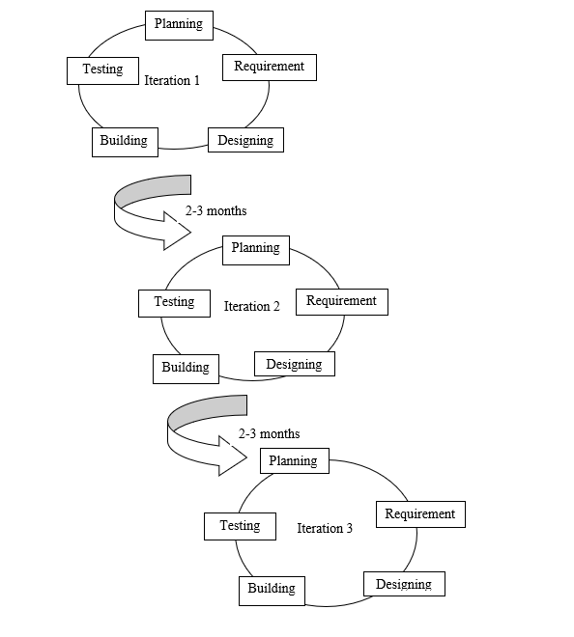

Figure 1 - Agile Methodology

## 3.2 GANTT CHART

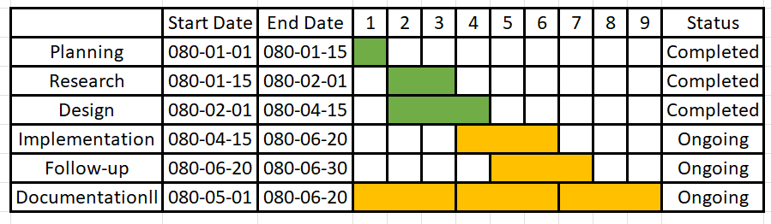The project report includes a concise Gantt chart outlining the project's timeline and tasks. It visually depicts the project's phases, milestones, and durations, enabling effective project management and tracking progress.

Table 1 - GANTT CHART

## 3.4 ER-Diagram

An ER-Diagram or Entity Relationship Diagram, is a visual model of a database schema which helps to represent the entities, relationships, and attributes within a system or project. . It helps visualize the structure of a database and its logical relationships. By using symbols such as rectangles, diamonds, and lines, an ER diagram illustrates how entities relate to each other and provides a clear understanding of the database schema.

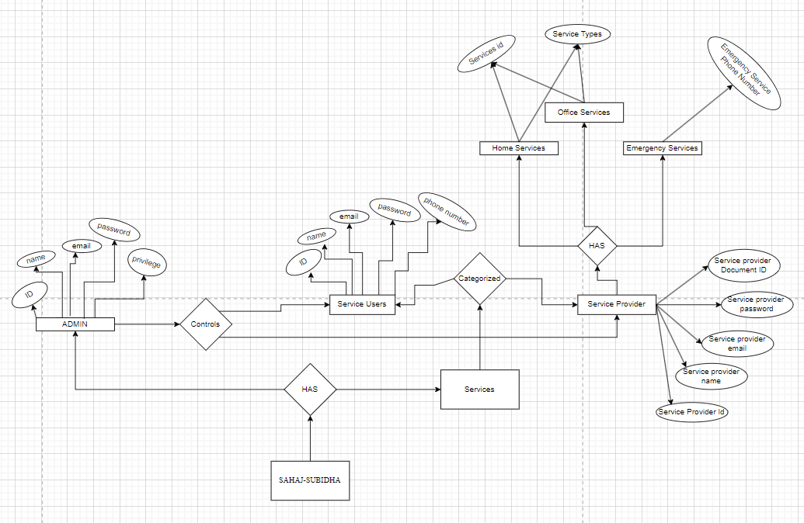

Figure 2 - ER Diagram

## 3.5 DFD

Data flow diagram is graphical representation of flow of data in an information system. It is capable of depicting incoming data flow, outgoing data flow and stored data. The DFD does not mention anything about how data flows through the system. In DFD Components DFD can represent Source, destination, storage and flow of data using the following set of components –

• **Entities** - Entities are source and destination of information data. Entities are represented by a rectangle with their respective names.

• **Process** - Activities and action taken on the data are represented by Circle or Round-edged rectangles.

• **Data Storage** - There are two variants of data storage - it can either be represented as a rectangle with absence of both smaller sides or as an open-sided rectangle with only one side missing.

• **Data Flow** - Movement of data is shown by pointed arrows. Data movement is shown from the base of arrow as its source towards head of the arrow as destination.

**Zero level DFD**

A zero-level DFD is a high-level diagram that helps stakeholders, analysts, and designers gain a clear understanding of the system's boundaries, interactions, and the flow of data into and out of the system.

# Chapter 4: Implementation and Testing

## 4.1 Implementation

### 4.1.1 Tools Used

To develop the Sahaj-Subidha system, essential tools including CASE tools, programming languages, and database platforms are utilized. These tools streamline the development process, enabling effective planning, designing, and implementation of the system's architecture and functionalities.

**CASE Tools:**

In developing the Sahaj-Subidha system, we utilize key CASE tools to improve productivity and software quality. For visualizing system components and creating user interfaces, we rely on draw.io and Figma. “draw.io” aids in system design with clear diagrams, while “Figma” enables interactive and visually appealing UI designs. We optimize coding efficiency using Visual Studio Code (VS-Code), an IDE with features like syntax highlighting and code completion. Additionally, we utilize Git for collaborative development and version control, facilitating seamless teamwork and code management. These CASE tools enhance our productivity and contribute to the success of the Sahaj-Subidha system.

**Programming Languages:**

* HTML, CSS, and JavaScript are used for creating interactive user interfaces.
* PHP is employed as a server-side scripting language for dynamic content generation and database interaction.

**Database Platforms:**

* MySQL serves as the database management system for effective data storage and retrieval.

The integration of these tools, including CASE tools, programming languages (HTML, CSS, JavaScript, PHP), and the MySQL database platform, enables the smooth implementation of the Sahaj-Subidha, providing essential functionalities for efficient system development.

### 4.1.2 Implementation Details of Modules

In the implementation phase of the Sahaj-Subidha system, various modules are developed to perform specific functions and contribute to the overall functionality. These modules consist of procedures and functions that ensure the smooth operation of the system.

The implementation details for the different modules within the Sahaj-Subidha system:

1. **User Authentication Module:**
   1. Description: The user authentication feature ensures secure system access by verifying and validating user credentials.
   2. Procedures/Functions:

* registerUser(): Creates user accounts securely.
* loginUser(): Validates user credentials for system access.
* logoutUser(): Terminates user sessions securely.

1. **Service Management Module:**
2. Description: The Sahaj-Subidha system facilitates different services provided. It provides a convenient platform for users to submit required services.
3. Procedures/Functions:

* selectService(): Enables users to select the required services through different categories.
* bookService(): Allows users to book the required services.

1. **Rating and feedback Module:**
2. Description: The Sahaj-Subidha system enables users to rate and provide feedback on services.
3. Procedures/Functions:

* rateService(): Provides users with the ability to express appreciation for the service they have obtained through our platform.

1. **Analytical and Reports Module:**
2. Description: The Sahaj-Subidha system gathers data for insights and decision-making.
3. Procedures/Functions:

* viewService(): Users can view the service provider's working efficiency.

These modules, including User Authentication, Service Management, Rating and Feedback, and Analytical and Reports, are integral components of the Sahaj-Subidha system, contributing to its overall functionality.

## 4.2 Testing

### 4.2.1 Unit testing:

Unit testing in the Sahaj-Subidha system is a crucial step in ensuring the reliability and functionality of individual modules. It involves designing and executing test cases that cover various scenarios, such as user authentication, and service management.

By conducting unit tests, we verify that each module performs as expected. For example, we test user registration to ensure that the process accurately captures user information and stores it securely.

Through comprehensive unit testing, we thoroughly examine the system's components, allowing us to identify and address any bugs or issues. This meticulous testing approach ensures that the Sahaj-Subidha web application is robust, reliable, and delivers a seamless user experience.

### 4.2.2 System testing:

System testing in Sahaj-Subidha is a crucial step in ensuring the smooth integration and functionality of all system modules and components. This testing phase involves validating the system as a whole to ensure seamless cooperation among its various parts.

Test cases for system testing encompass a wide range of functionalities. Examples include verifying user authentication to ensure successful login and registration processes. Browsing and searching for services are also tested to guarantee accurate and efficient retrieval of relevant materials. Additionally, system performance is evaluated by measuring response time and scalability under different user loads.

By simulating real-world scenarios, system testing validates the system's behaviour and functionality under diverse conditions. This comprehensive approach helps identify any potential issues or inconsistencies, allowing them to be addressed promptly. Ultimately, system testing ensures a reliable and user-friendly experience for Sahaj-Subidha users, promoting efficient service-providing tools.

# Chapter 5: Conclusion and Future Recommendations

## 5.1. Lesson Learned / Outcome:

Throughout the project's development, we have gained valuable insights and achieved significant outcomes. These key lessons and outcomes include:

1. **User-Centric Approach:** By prioritizing the needs and preferences of users, we have successfully created a platform that is intuitive and user-friendly. This approach has resulted in a positive user experience and improved user satisfaction.
2. **Service Provider Engagement**: Sahaj-Subidha can foster a network of engaged and reliable service providers, leading to better service quality and increased trust among users.
3. **Technical Expertise:** Our team's technical competence in HTML, CSS, JavaScript, PHP, and MySQL has been instrumental in building a robust and scalable system. These technologies have been effectively utilized to ensure the platform's functionality and performance.
4. **Rigorous Testing and Quality Assurance:** Through rigorous testing, including comprehensive unit testing and system testing, we have identified and resolved issues, ensuring the reliability and stability of the platform. This dedication to quality assurance guarantees a seamless user experience.
5. **Business Growth Opportunities**: With successful implementation and positive user feedback, Sahaj-Subidha can expand its service offerings, reach new markets, and achieve sustainable business growth.

By incorporating these lessons and outcomes, we have created a platform that prioritizes user needs, and service provider engagement, demonstrates technical expertise, and ensures a high level of quality as well as enhances business growth opportunities. As we continue to enhance and refine the platform, we will strive to maintain these principles and provide an exceptional environment for our users.

## 5.2. Conclusion

In conclusion, Sahaj-Subidha is a user-friendly service platform that provides convenient access to a wide range of home and office services. With efficient scheduling, reliable service providers, and a focus on customer satisfaction, Sahaj-Subidha enhances convenience and efficiency for users. By prioritizing compliance, continuous improvement, and adaptation to market trends, Sahaj-Subidha is poised for business growth and expansion.  
The platform's user-friendly interface and streamlined service request process have significantly improved convenience for users. With just a few clicks, users can easily browse through various service categories, select their desired services, and submit their requests. This eliminates the need for time-consuming research and manual coordination, allowing users to focus on their other priorities. While Sahaj-Subidha is still in development, it has the potential to revolutionize online learning and offer a seamless user experience.  
 However, it is important to acknowledge the platform's limitations, such as the possibility of encountering bugs. Moving forward, continuous improvement and refinement, including the development of a mobile application and integration with other platforms, will enhance functionality and accessibility. Incorporating gamification elements and gathering user feedback will further contribute to the platform's growth and effectiveness in serving everyone's needs.

## 5.3. Future Recommendations

Looking ahead, there are several recommendations for future enhancements and developments of the Sahaj-Subidha platform:

1. **Expansion of Service Offerings**: Sahaj-Subidha can consider expanding its service offerings to cater to a broader range of user needs. Conduct market research and analyze user preferences to identify potential services that align with the platform's mission and target audience.
2. **Partnerships and Collaborations:** Forge strategic partnerships with reputable service providers, local businesses, or industry organizations to expand service coverage and enhance credibility. Collaborations can also lead to cross-promotion and joint marketing efforts, attracting a larger user base.
3. **Enhanced Customer Support:** Invest in a robust customer support system to promptly address user queries, concerns, or complaints. Offer multiple channels of communication such as live chat, phone support, and email, ensuring users feel supported throughout their journey with Sahaj-Subidha.
4. **Continuous Improvement and User Feedback:** Regularly gathering user feedback, conducting surveys, and actively incorporating user suggestions into future updates will ensure that the platform evolves to meet the evolving needs of students and provides an optimal learning experience.
5. **Mobile Application Development**: Develop a dedicated mobile application for Sahaj-Subidha to offer users the convenience of accessing services and managing requests on their smartphones. A mobile app can improve accessibility and user engagement, leading to increased adoption and usage.
6. **Social and Environmental Responsibility**: Embrace sustainability practices by promoting eco-friendly service providers and encouraging green initiatives. Incorporate socially responsible practices into the platform's operations, such as supporting local communities.

By implementing these future recommendations, Sahaj-Subidha can further solidify its position as a leading service platform, attract a larger user base, and adapt to the evolving needs of users in an increasingly digital and connected world.

## Continuous Improvement and User Feedback

## Reference

DFD

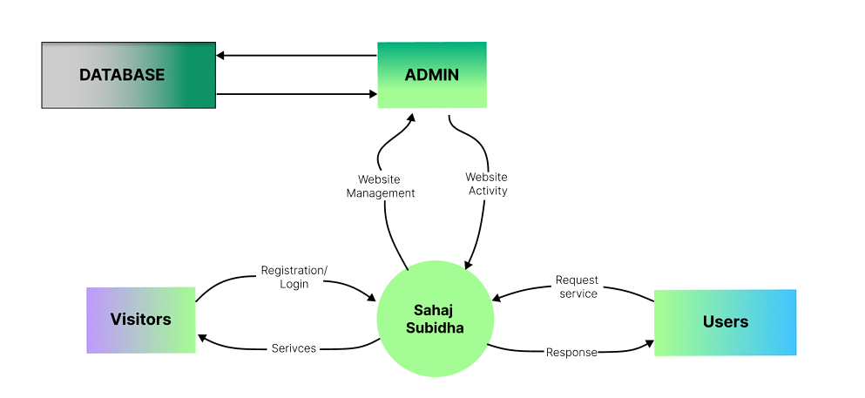

Figure 3 - DFD of Sahaj Subidha

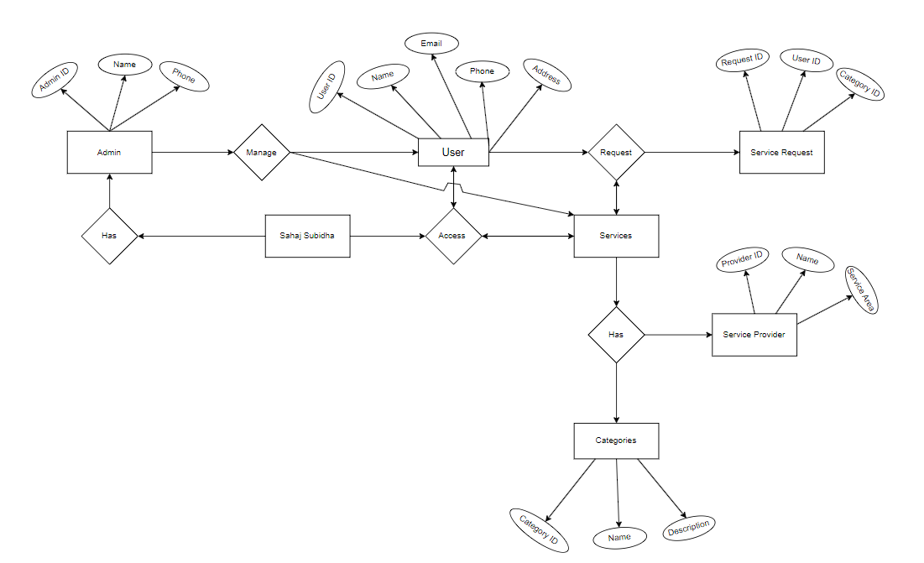 ER-diagram:

Figure 4 - ER Diagram of Sahaj Subidha

Table 1. GANTT Chart

|  |  |  |  |  |  |  |  |  |  |  |  |  |  |  |
| --- | --- | --- | --- | --- | --- | --- | --- | --- | --- | --- | --- | --- | --- | --- |
| **Task** | | **20 March 2023** | **20 April 2023** | | | **20 May 2023** | | | **20 June 2023** | | | **20 July 2023** | | **Estimation**  **Days** |
| **Planning** |  | | |  | |  | | |  | | |  | | 25 |
| **Research** |  | |  | | | | |  |  | | |  | | 25 |
| **Design** |  | |  | |  | | | | |  | |  | | 20 |
| **Implementation** |  | |  | | |  |  | | | | | |  | 35 |
| **Follow up** |  | |  | | |  | | |  | |  | | | 25 |
| **Documentation** |  | | | | | | | | | | | | | **120** |