Description Regarding the Result:
- All the nodes are created based on circumference coordinate of the circle with initial radius passed in argument
- After continuous sharing of neighbor list by each node, the nodes started connected to nodes with shortest distance
- Distance details of each node can be seen in ./NeighborListFiles/1_N1000_k5.txt
Example:
Details of Sum-Distance of each Node (Cycle: 15)
============================
Node ID: 0 Sum-Distance: 21.866457096896422

Node ID: 1 Sum-Distance: 27.135970064721608

Node ID: 2 Sum-Distance: 28.430846105959496

Node ID: 3 Sum-Distance: 19.824150798573896

Node ID: 4 Sum-Distance: 27.066996136120192

Node ID: 5 Sum-Distance: 24.139274876084823

Node ID: 6 Sum-Distance: 20.4740665186268

Node ID: 7 Sum-Distance: 10.362495233224486

Node ID: 8 Sum-Distance: 23.991236952696926

- Plots examples

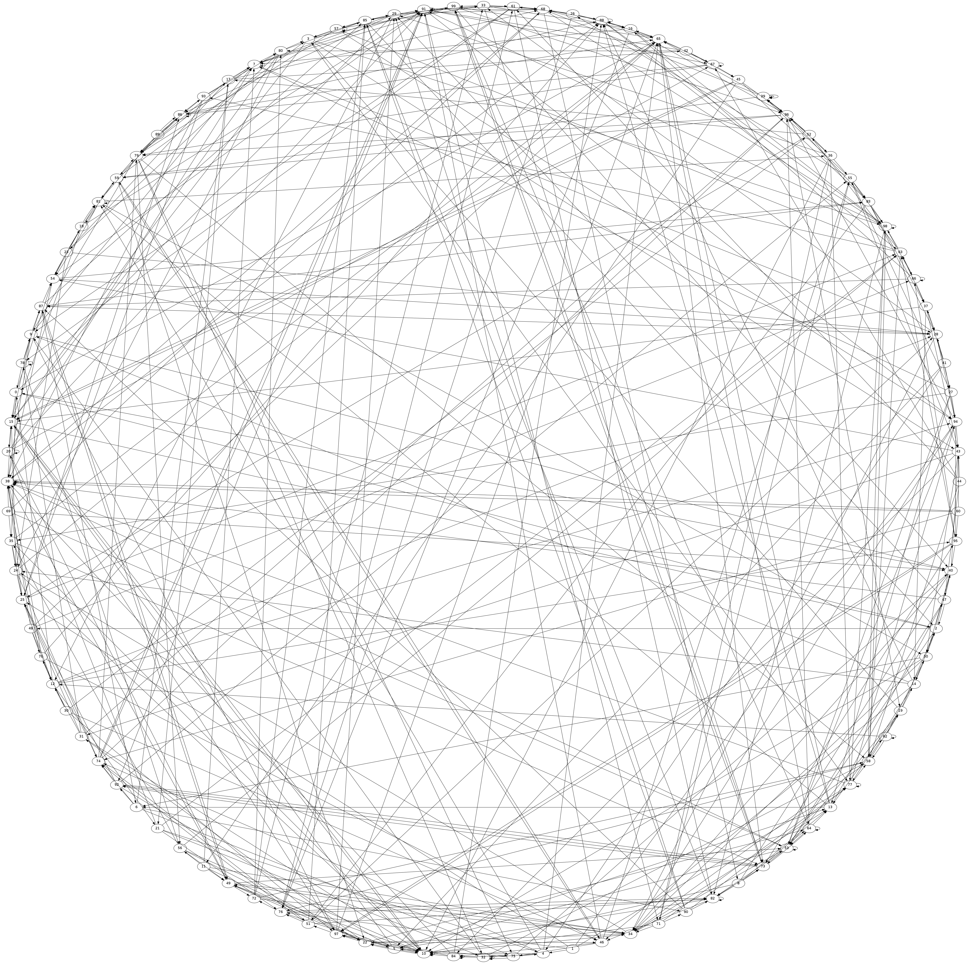

Figure: 1_N100_k5_0.png

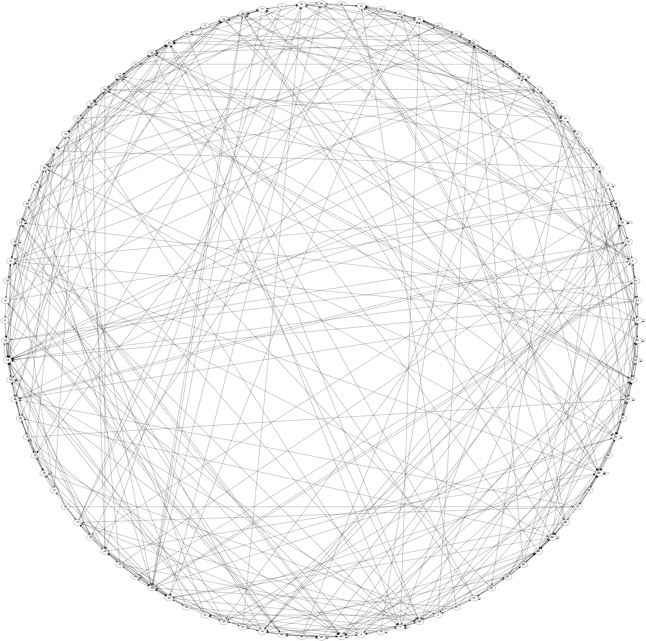
Figure: 1_N100_k5_5.png

