Answer-1: Screen-shots of various WebUI of hadoop cluster

Figure-1: JobTracker portal

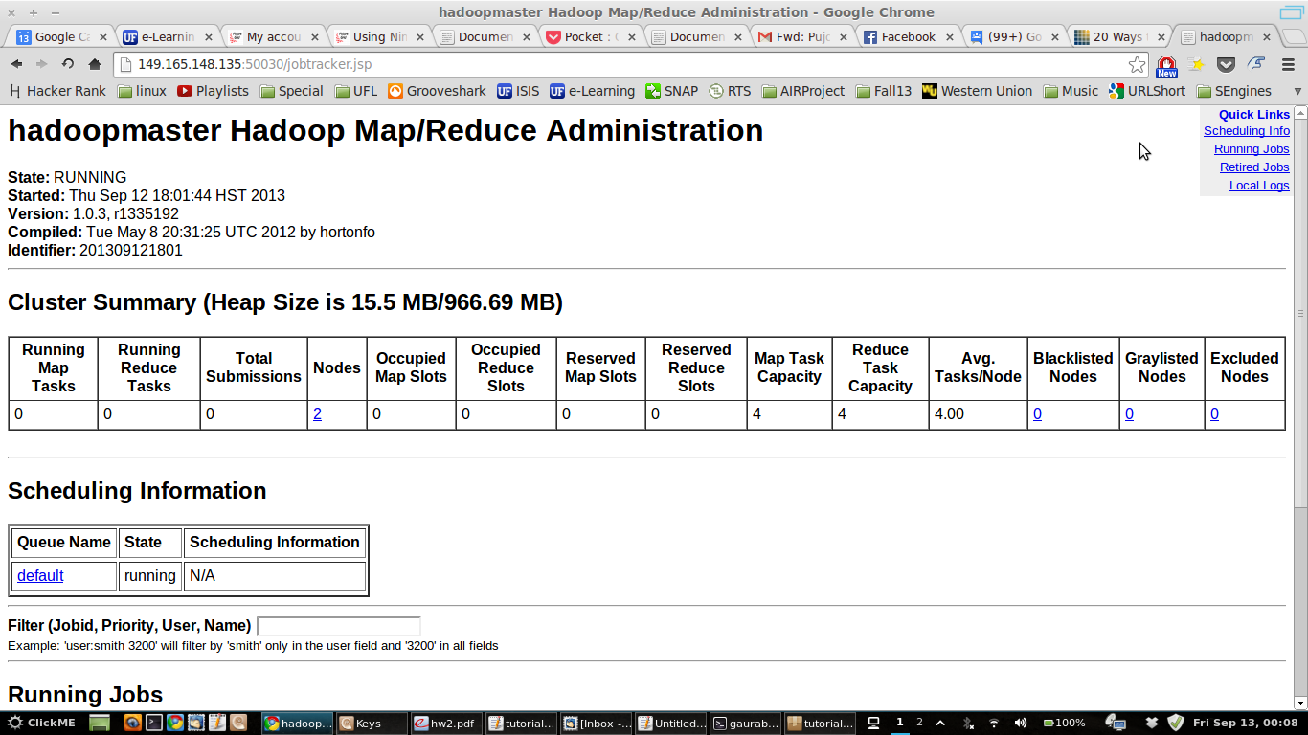

Figure-2: Map-Reduce Portal
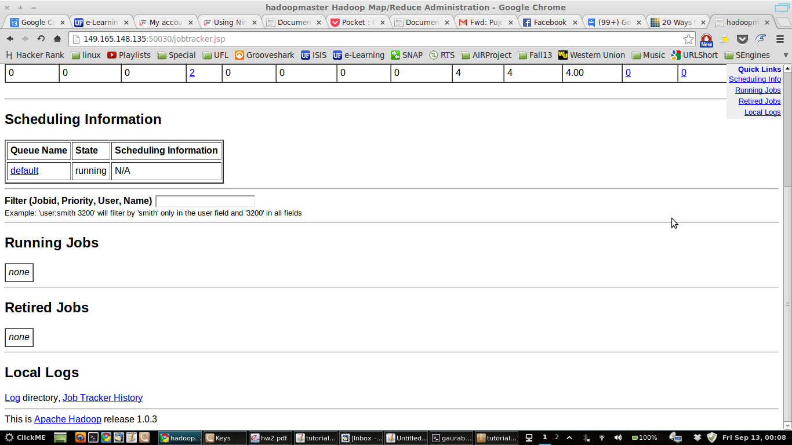
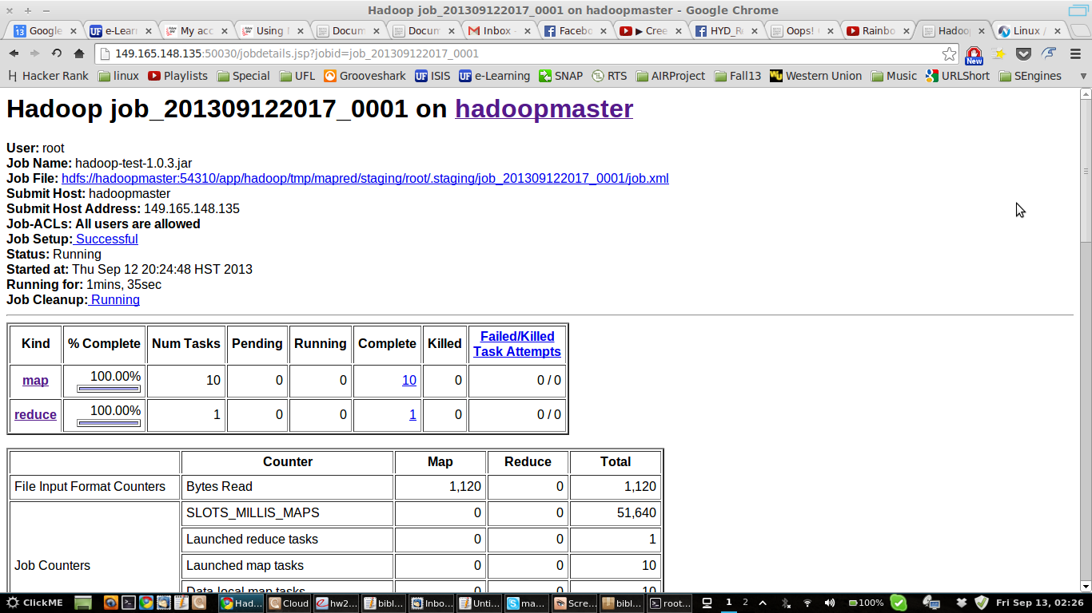

Figure-3: Map-Reduce Completion Graphs

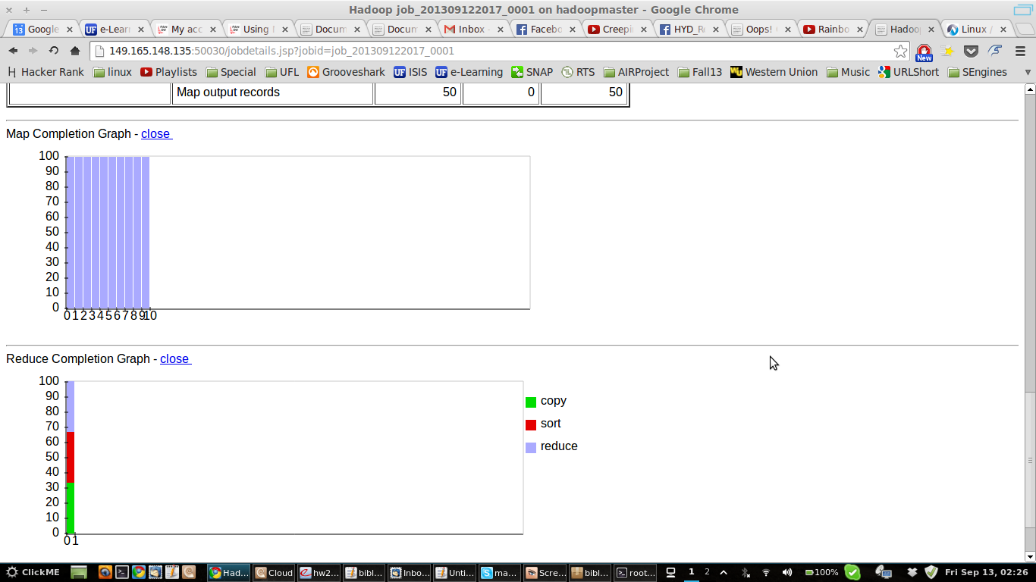
Figure-4: Map Task list

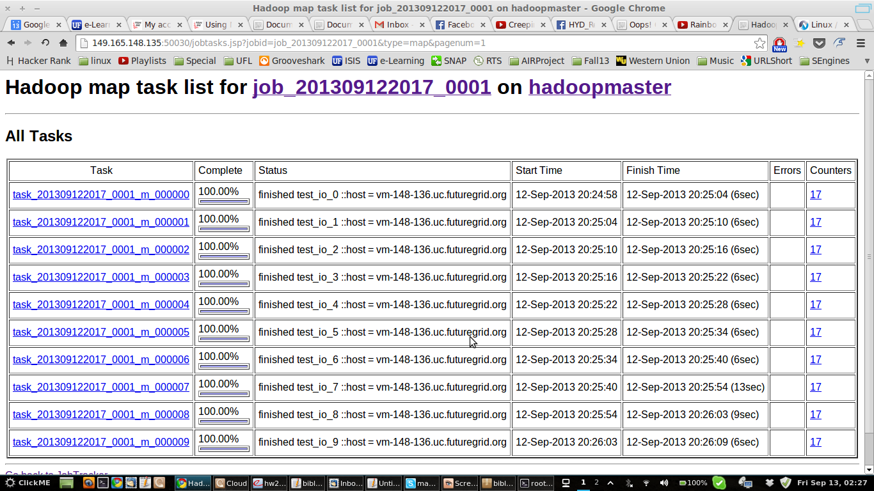

Figure-5: Reduce Task List
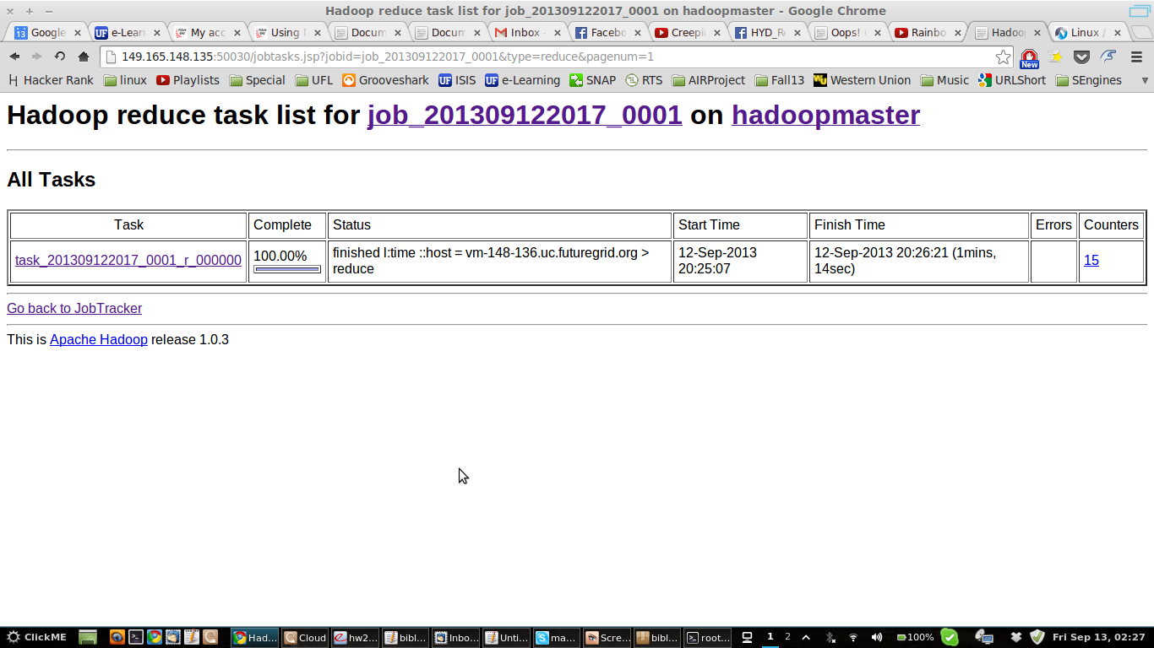

Figure-6: Screen-shot of TestDFSIO on hadoop cluster

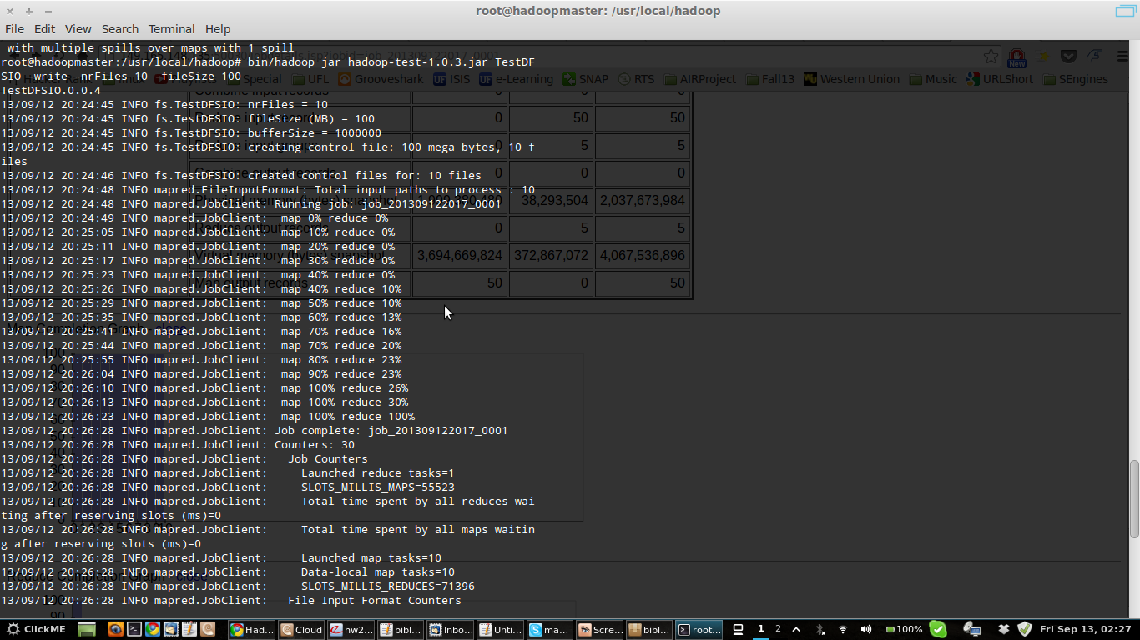

Answer-2:

