Linear differential equation for the feedback control system on hadoop cluster based on manipulation of maxMaps values in cluster:

y(k+1) = a*y(k) + b*u(k)

u(k): function of input efficiency of the MapReduce job
y(k): execution rate

Code Design:
Prerequisite: please provide 300MB of txt data for the WordCountPair job in order to run it for longer period and allow the TrackMapReduceJob to kick in and manipulate the maxMaps values to limit efficiency within the required limit (feedback control of efficiency).

- WordCountPair.java
Usage: WordCountPair <inputHDFSLocation> <outputLocation>
On hadoop cluster:
./local/hadoop/bin/hadoop jar WordCountPair.jar usr.code.WordCountPair <inputHDFSLocation> <outputLocation>
Example:
./local/hadoop/bin/hadoop jar WordCountPair.jar usr.code.WordCountPair /usr/HDFS /usr/ouput23

- TrackMapReduceJob.java
Usage: TrackMapReduceJob <jobId> <referencePercentage> <noOfSlaveNodes>
On hadoop cluster:
../local/hadoop/bin/hadoop jar TrackMapReduceJob.jar usr.code.TrackMapReduceJob <jobId> <refrenceLimitEfficieny> <noOfSlaveNodesInCluster>
Example:
../local/hadoop/bin/hadoop jar TrackMapReduceJob.jar usr.code.TrackMapReduceJob job_201310190031_0006 40 4

- TrackMapReduceJob.java is designed to manipulate maxMaps value in fair-scheduler.xml to limit the efficiency of the MapReduce job within the required value. From above example if the efficiency is limited to (refrenceLimitEfficieny) 40% (required) and the no. of slave nodes in cluster is 4
- Max no. of mappers allowed is, MaxMap=8
- So TrackMapReduceJob will monitor the efficiency of initialize the maxMaps to 4 intially to get better control results and wait for the changes to kick in and if the efficiency is still less then the refrenceLimitEfficieny it will keep on increasing the maxMaps for the cluster.
- With each increase in maxMaps TrackMapReduceJob will wait for 10-15 sec for the changes to kick in.
- This increase will continue till maxMaps value reach 8 OR efficiency reaches threshold value
- maxMaps value will be decreased if the efficiency increases beyond (refrenceLimitEfficieny+2)
- So TrackMapReduceJob will try to limit the efficiency between (38-50%)

Based on the increasing beyond threshold the error is calculated

Data Related to feedback controlled changes of maxMaps and its impact on perfomance are in ControlBehaviourOnMaxMapsValues_V3.txt

Data Calculation:
Reference Efficiency: 40
e(k) : error
k: time
N: no. of max. mappers
yWave(k): actual efficiency (considered as Job Execution Rate from the values )
efficiency= ((prog)/(timeLapsed)*10000000);
uWave(k): considered as percentage of job completed by Mapper divided by 10

Delta u(k) = 0.39
Delta y(k) = 35.86

k | N | uWave(k) | yWave(k) | u(k) | y(k) | e(k)
02:17:16 | 4 | .015 | 13.7 | −0.375 | -22.16 | -26.3
02:17:25 | 4 | .030 | 16.02 | -0.36 | -19.84 | -23.98
02:17:35 | 5 | .046 | 15.2 | -0.344 | -20.66 | -24.8
02:17:46 | 6 | .061 | 14.9 | -0.329 | -20.96 | -25.1
02:17:56 | 7 | .076 | 17.0 | -0.314 | -18.86 | -23
02:18:10 | 8 | .153 | 23.4 | -0.237 | -12.46 | -16.6
02:18:25 | 8 | .248 | 30.92 | -0.142 | -4.94 | -9.08
02:18:44 | 8 | .415 | 41.7 | 0.025 | 5.84 | 1.7
02:18:54 | 7 | .490 | 44.85 | 0.1 | 8.99 | 4.85
02:19:03 | 6 | .573 | 47.60 | 0.183 | 11.74 | 7.6
02:19:16 | 5 | .676 | 51.48 | 0.286 | 15.62 | 11.48
02:19:21 | 4 | .769 | 56.35 | 0.379 | 20.14 | 16.35
02:19:32 | 3 | .953 | 64.66 | 0.563 | 28.8 | 24.66
02:19:42 | 2 | 1.0 | 64.29 | 0.61 | 28.43 | 24.29

Values of Si Estimates for the Data
S = {4018.0005, 70.2514, 1.2492, 4000.4122, 69.2300}

Parameter a and b calculation:
a = (S(3)*S(4)-S(2)*S(5))/(S(1)*S(3)-(S(2))^2);
b = (S(1)*S(5)-S(2)*S(4))/(S(1)*S(3)-(S(2))^2);

a = 1.5925
b = -34.136
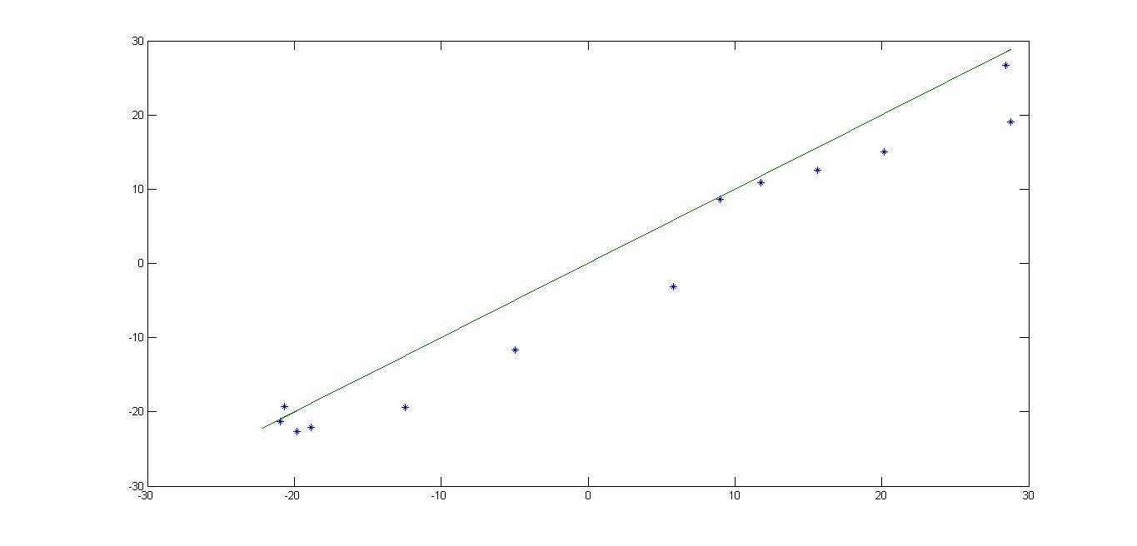
Final Graph:
Feedback Control for MapReduce Job (WordCountPair)
Predicted
Actual

Step Graphs

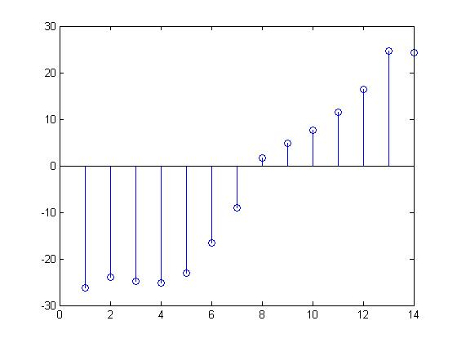
e(k)
k

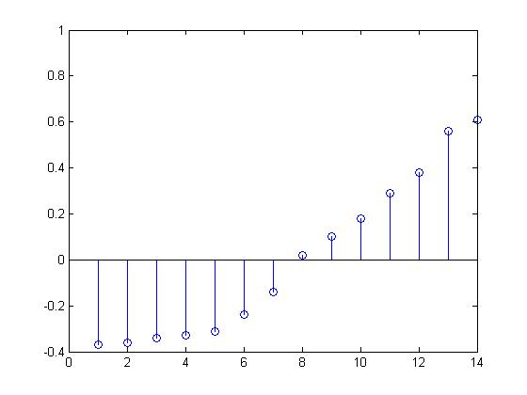
u(k)
k

u(k)

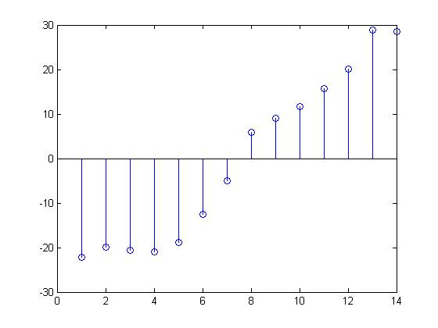
y(k)
k

Final Linear Equation:

y(k+1) = a*y(k) + b*u(k)

y(k+1) = 1.5925*y(k) - 34.136*u(k)

therefor z-transformation:
with initial condition of y(0)=0
and u(k) as Ramp function u(k) =k : after stabilization

U(z) = z/(z-1)²

Y(z) = { b/(z-a) }*U(z)

Y(z) = {(-34.136 * z ) / (z – 1.5925) * (z-1)² }

