Howard University
College of Engineering and Architecture
Department of Electrical Engineering & Computer Science

Large Scale Programming
Fall 2024

Midterm Exam – Part I
October 17, 2024

Part I: 50 pts. (essay questions)

Instructions:
- Submit completed exam to your github repository under package org.howard.edu.lsp.midterm

Verify that the commit(s) completed successfully

- OPEN BOOK, OPEN NOTES. THERE IS NO COLLABORATION ON THIS EXAM
- Site any and ALL references for anything obtained off the internet.

Name: Gaurav Adhikari
ID: @03086202

Question 1. (10 pts.)

You are reviewing the following class in a Fitness Tracking System. The class is intended to manage various aspects of a user’s fitness activities.

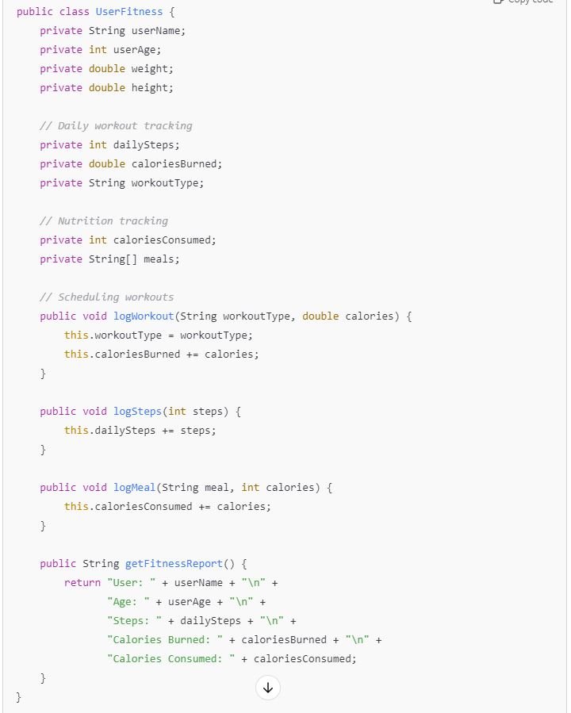

Tasks:
- Analyze the UserFitness class. Explain why this class has low cohesion. (5 pts.)
Ans: The UserFitness class demonstrates low cohesion because it manages multiple, unrelated responsibilities. This violates the Single Responsibility Principle in Java, which states that a class should only have one reason to change. For example, this class is responsible for tasks such as tracking daily workouts, scheduling workouts, logging meals, retrieving step counts, and generating fitness reports. These tasks are handled by different methods within the same class, which are loosely related. Moreover, not all the class members are relevant to each method, indicating that the class members and functionality are not closely bound or focused on a singular purpose. This fragmentation of responsibility is what leads to low cohesion.

- Describe, in general, how you would split the UserFitness class into more cohesive classes. Your answer should not be a complete design. (5 pts.)
Ans: To split the UserFitness class into more cohesive classes, we can break it down by grouping related methods and class members. For example, attributes like userName, weight, and height can be moved to a separate UserDetails class, which handles personal information. Methods like logSteps and logWorkout can go into a UserWorkout class to focus solely on workout-related tasks. Similarly, logMeal and caloriesConsumed can be placed in a UserNutrition class for meal tracking. This separation helps isolate responsibilities, making the design more cohesive and manageable. During this process, potential relationships between these classes, such as inheritance or composition, may also become clear, further enhancing the design.

Question 2. (5 pts.)
Given the following, answer the below questions.

A university manages its students using a program that has a class Student with subclasses FirstYear, SecondYear, and ThirdYear for year-specific state and behaviors. The program has a List that contains all Students.

Ans: Should Student be a class, an abstract class or an interface? Explain your answer
In this case, the Student class should be designed as an abstract class. There is an "is-a" relationship between the Student class and its subclasses (FirstYear, SecondYear, and ThirdYear), as each of them is a Student. We should not make the Student class a regular class because we don’t want it to be instantiated; it should remain a concept, with the specific implementations handled by its subclasses. We also shouldn't use an interface because interfaces are meant for classes that share some methods, but in this case, the subclasses share both attributes and methods. Therefore, making Student an abstract class is appropriate since students may share common attributes but have year-specific behaviors or methods they implement.

- At the end of each year, the third-year students graduate and must be removed. This is done by passing the list to the following method:

void removeThirdYears(List<Students> students) {
for (Student student : students) {
try {
ThirdYear = (ThirdYear) student;
students.remove(thirdyear);
}
}
}

Why is the above method flawed? Hint: Another Arthur Riel heuristic (5 pts.)
The method is flawed based on Arthur Riel’s heuristic, which says that all base classes should be abstract. Since we have designed the Student class to be abstract, we should not use it directly in concrete operations, such as passing it to methods. Instead, specific subclasses like ThirdYear should be passed to the method.

Question 3. (5 pts.)
Given the following, answer the below questions.

public class BankAccount {
public String accountHolderName;
public String accountNumber;
public double balance;
public double interestRate;

public BankAccount(
String accountHolderName,
String accountNumber,
double initialDeposit,
double interestRate) {
this.accountHolderName = accountHolderName;
this.accountNumber = accountNumber;
this.balance = initialDeposit;
this.interestRate = interestRate;
}

// Exposed implementation for adding interest
public void addInterest() {
double interest = balance * (interestRate / 100);
balance += interest;
}

// Exposed implementation for deposits
public void deposit(double amount) {
balance += amount;
}

// Exposed implementation for withdrawals
public void withdraw(double amount) {
balance -= amount;
}
}

- Is BankAccount well-encapsulated? Why nor why not? If so, describe what changes you would make to the class. Otherwise, state nothing. (5 pts.)
No BankAccount class is not well-encapsulated. It is not well encapsulated because the implementation details for the main methods like addingInterest, depositing amount, and withdrawing are publicly accessible. To make the class more encapsulated, we should make these methods private. Also, the fields like accountName, number, initialDeposit ae public, we can also make them private to make it more encapsulated.

Question 4. (10 pts.)
Given the following, answer the below questions.

Given:
A car manufacturer uses Java software to track current vehicles being built. The UML diagram below shows an excerpt of the current software structure. You should assume the presence of other appropriate fields and methods

Car
getTrimLevel()
Engine
accelerate()
getFuelLevel()
Base
Sports
Luxury
Electric
Petrol

Each car can be built to one of three trim levels: Base, Luxury or Sport. They can also be configured with an electric or petrol engine. At various points in the manufacturing process the customer can choose to change the trim level.

Task:
- Explain in detail why the current structure does not support this. (5 pts.)
Current structure does not support this because it uses inheritance to do this. Currently each car is specifically tied to its subclasses, so when the user wants to change the trim level of a car later in the manufacturing process it cannot be done dynamically after the car has been instantiated. To do so, a new car object has to be created.

- Describe how to refactor the structure to allow trim-level change for a car to dynamically change. Hint: How would you modify Car to use composition to solve the problem? (5 pts.)
We can use composition to allow trim-level change for a car to dynamically change. We could create a new interface TrimLevel having the common methods between different TrimLevel and create concrete classes for base, sports, luxury that implements the TrimLevel interface and the car class would only hold the reference to the trimLevel object, as different instance of different trim level can be assigned if needed.

Question 5. (5 pts.)
Suppose you are about to code a particular class and find that you have written another class with nearly the functionality that you now are developing. This means that the two classes in large parts contain the same code, but in smaller parts have different code. Explain in detail why this may be a problem and how to solve it. Give your answer in terms of Arthur Riel’s design heuristics.
Ans: We should always the principle of DRY in programming which says don’t repeat yourself. And to answer the problem in terms of Arthur Riel’s design heuristics if we have two classes having same code, or same members and behaviors, it is better to reorganize the class and use inheritance. We should make a common base class which captures the data and methods of both the classes.

Question 6. (5 pts.)
Suppose we need to store instances of the classes Car and BankAccount in a database. To obtain low coupling it may seem as if the functionality to save an instance should be in precisely those classes, since they have the information that shall be saved. Why is it unwise to place the database calls there?
It is unwise to place the database calls in Car and BankAccount because doing so violates the Single Responsibility Principle, as these classes should focus on their domain logic, not persistence. It also increases coupling, making the code dependent on the database and harder to modify. Instead, use a separate persistence layer (e.g., DAO or Repository) to maintain high cohesion and ensure better separation of concerns, making the system more flexible and easier to maintain.

Question 7. (5 pts.)
Given a set of requirements, what conditions must be met to make it appropriate to create a new class hierarchy using inheritance? Neither superclass nor subclass exist before, the question is about designing a new class hierarchy.

For inheritance, we need classes sharing common methods, behaviors and having isA relationship with the super class.

Question 8. (2.5 pts.)
Describe the difference between inheritance and composition why would you choose one over the other.
For inheritance we need isA relationship between the classes, but for composition we need hasA relationship between the classes.
Choose inheritance when classes share common behavior and methods.
Choose compostion when you want flexibility and don’t want hierarchy

Question 9. (2.5 pts.)
Explain the meaning of cohesion and describe whether low or high cohesion is better.

Cohesion refers to how closely related and focused the responsibilities of a class or module are.
High cohesion means that a class or module has a single, well-defined purpose with related functionality grouped together.High cohesion is preferred because it aligns with the Single Responsibility Principle, ensuring that a class is only responsible for one aspect of the system.

