Production Mode

Home Page

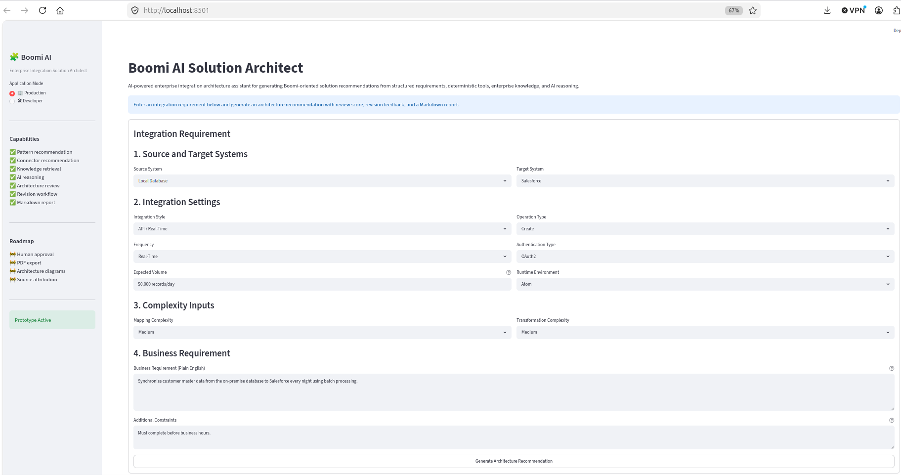
Description: Application landing page showing structured integration form.

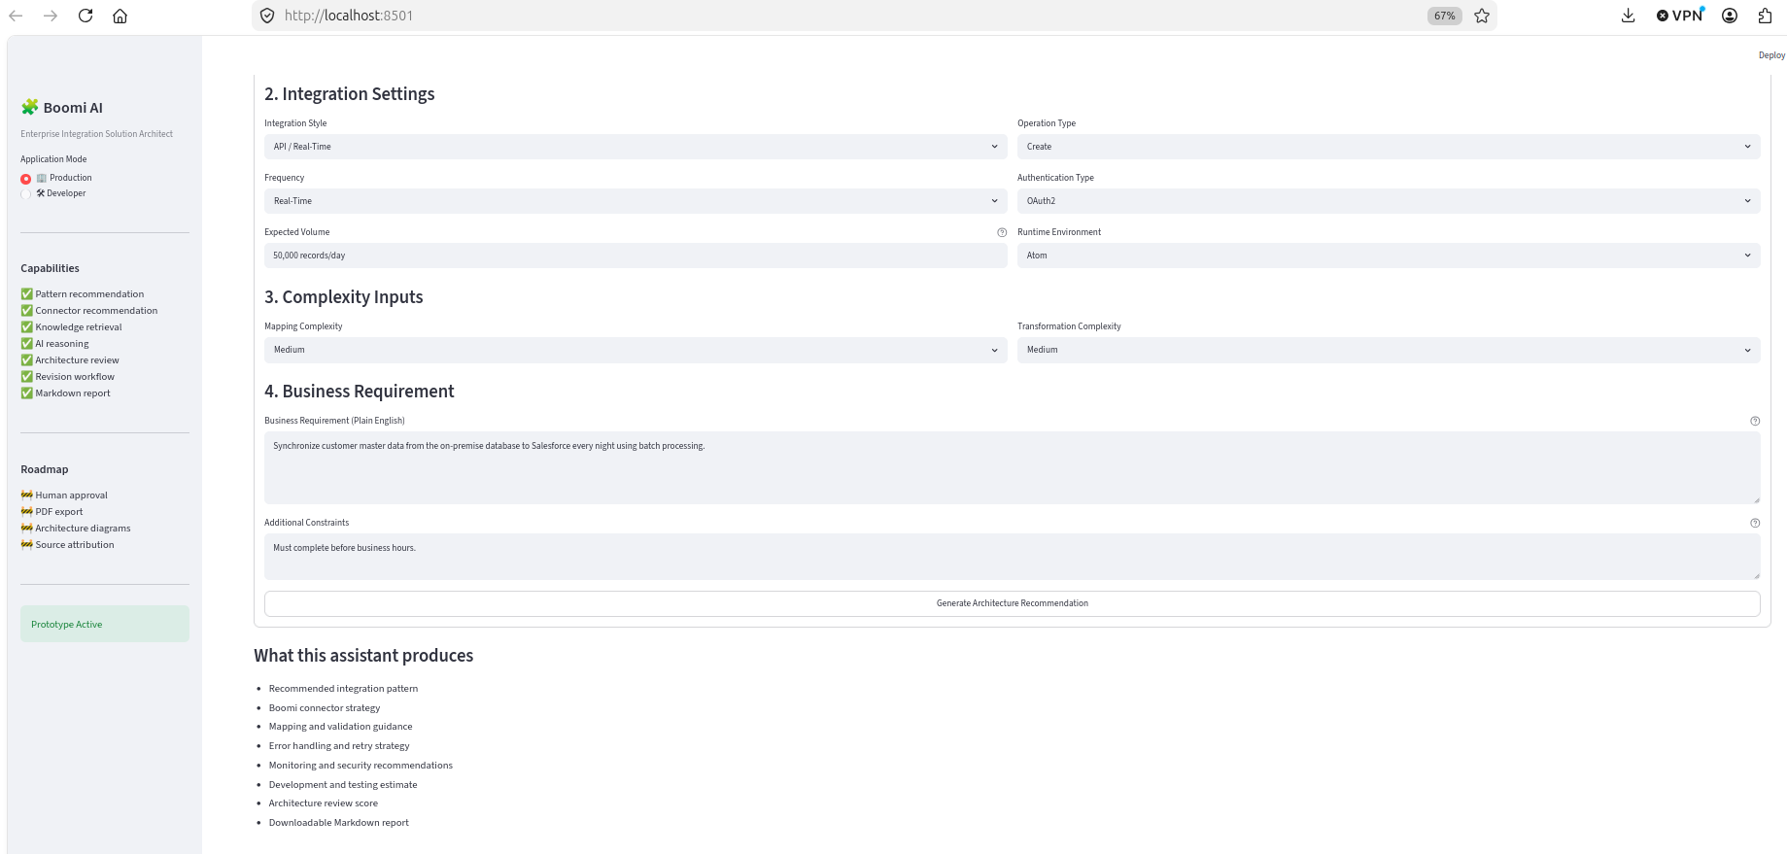
Description: Application landing page showing what this assistant produces.

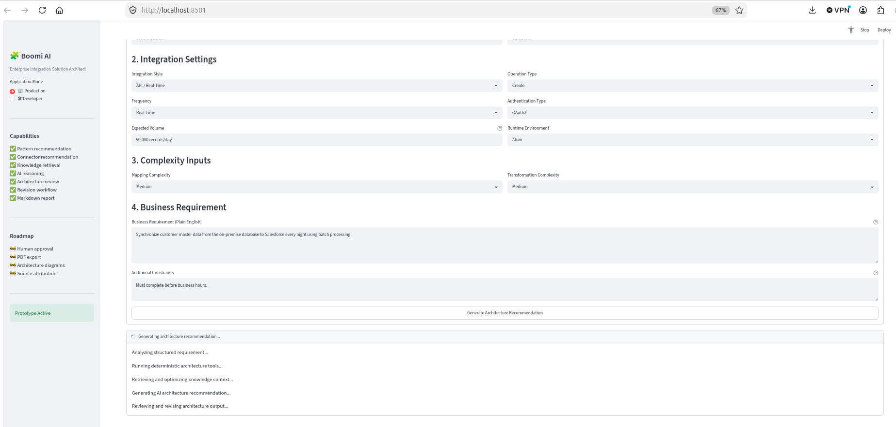
Description: Application showing assistant progress in production mode.

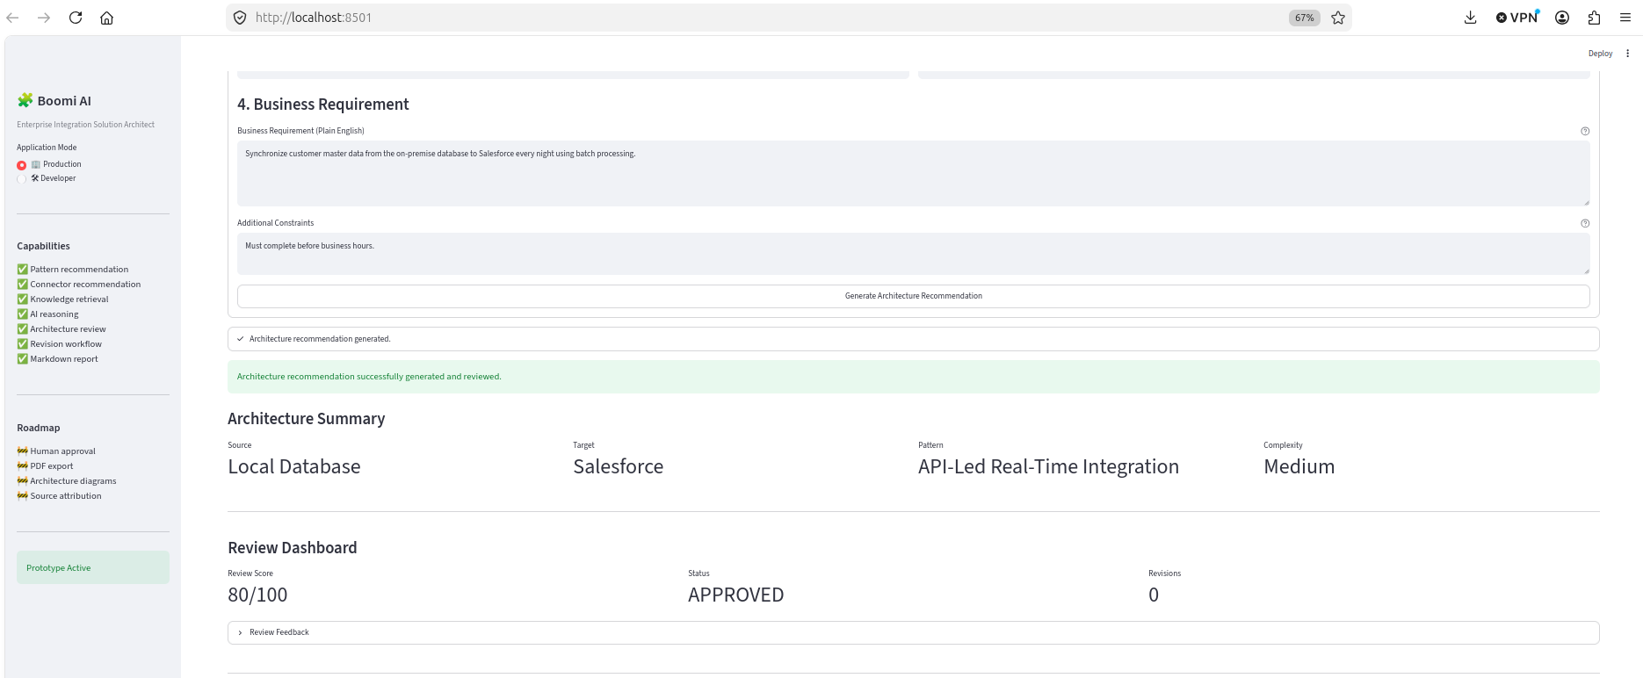
Description: Application showing production mode architecture summary.

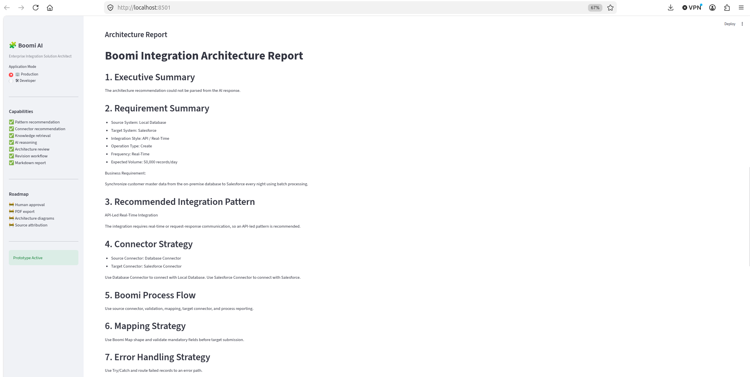
Description: Application showing production mode architecture report part 1.

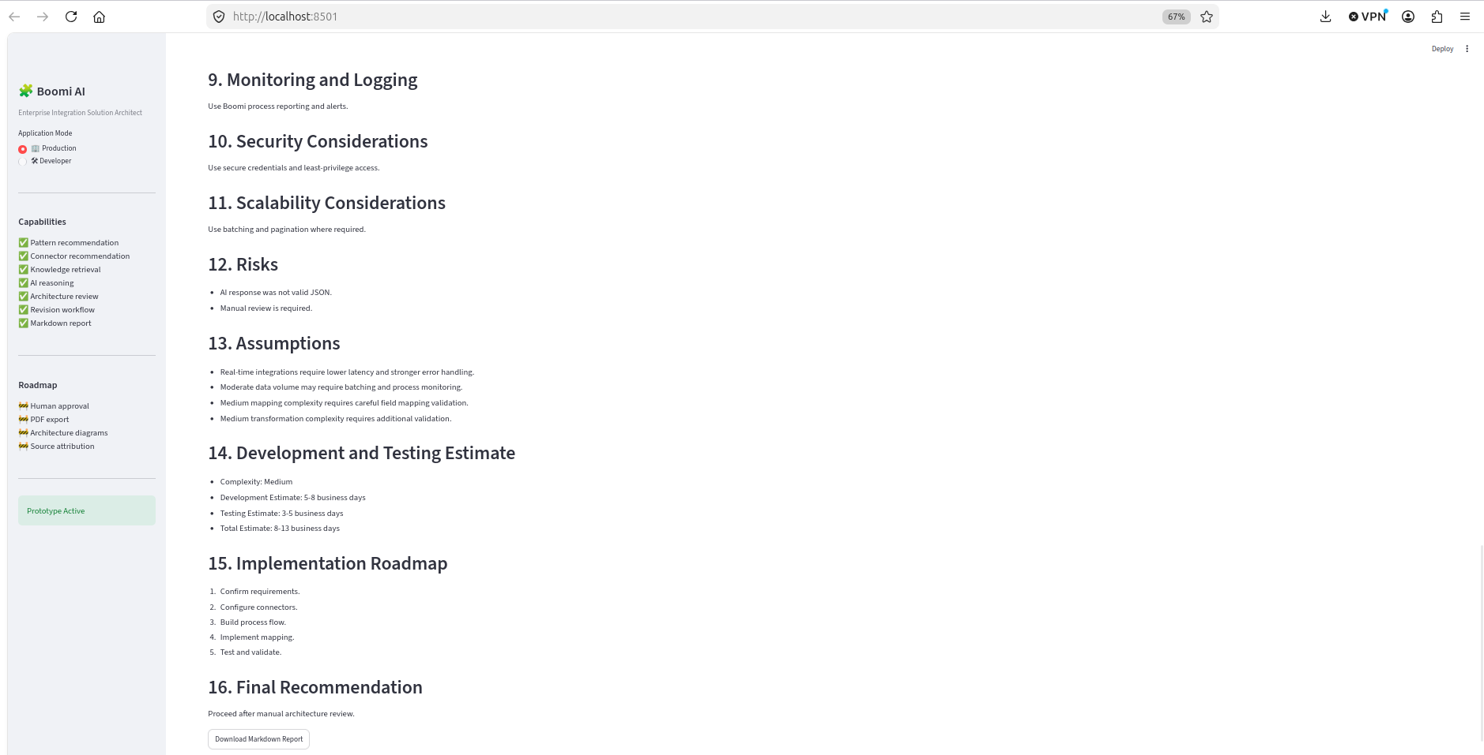

Description: Application showing production mode architecture report part2 with report download .

Developer Mode

Home Page
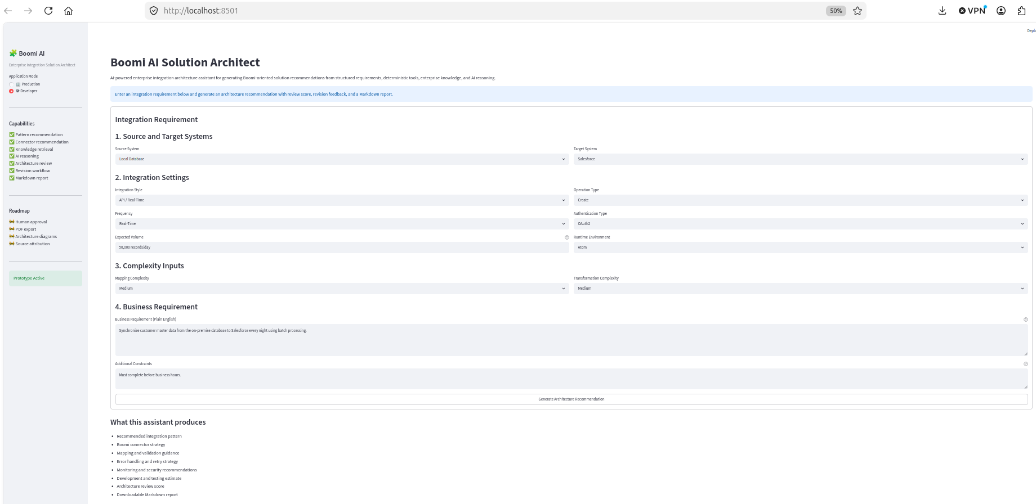

Description: Application landing page showing structured integration form.

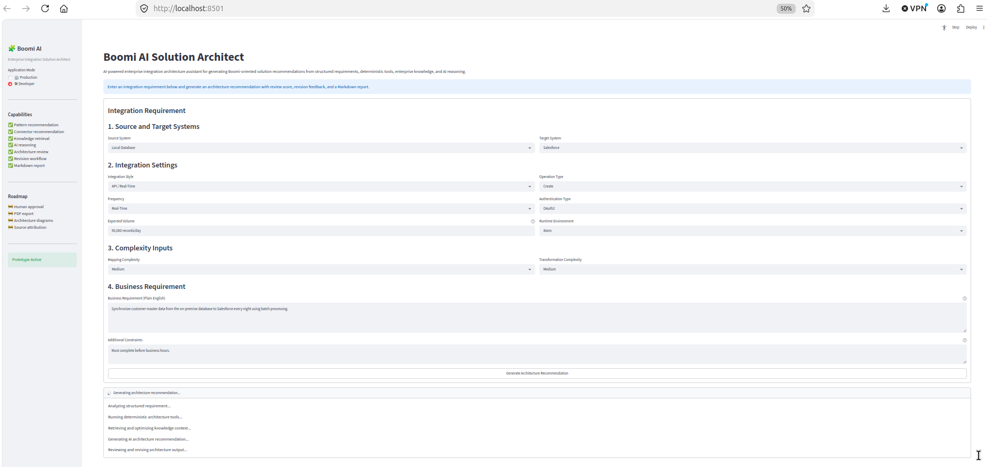

Description: Application landing page showing what this assistant produces.

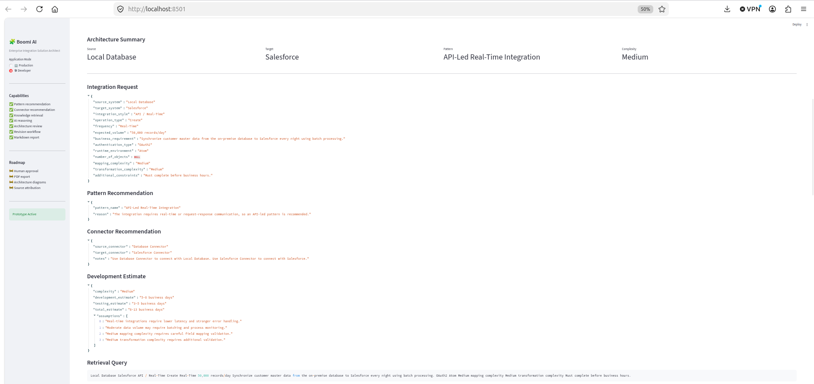
Description: Application showing developer mode architecture summary part 1.

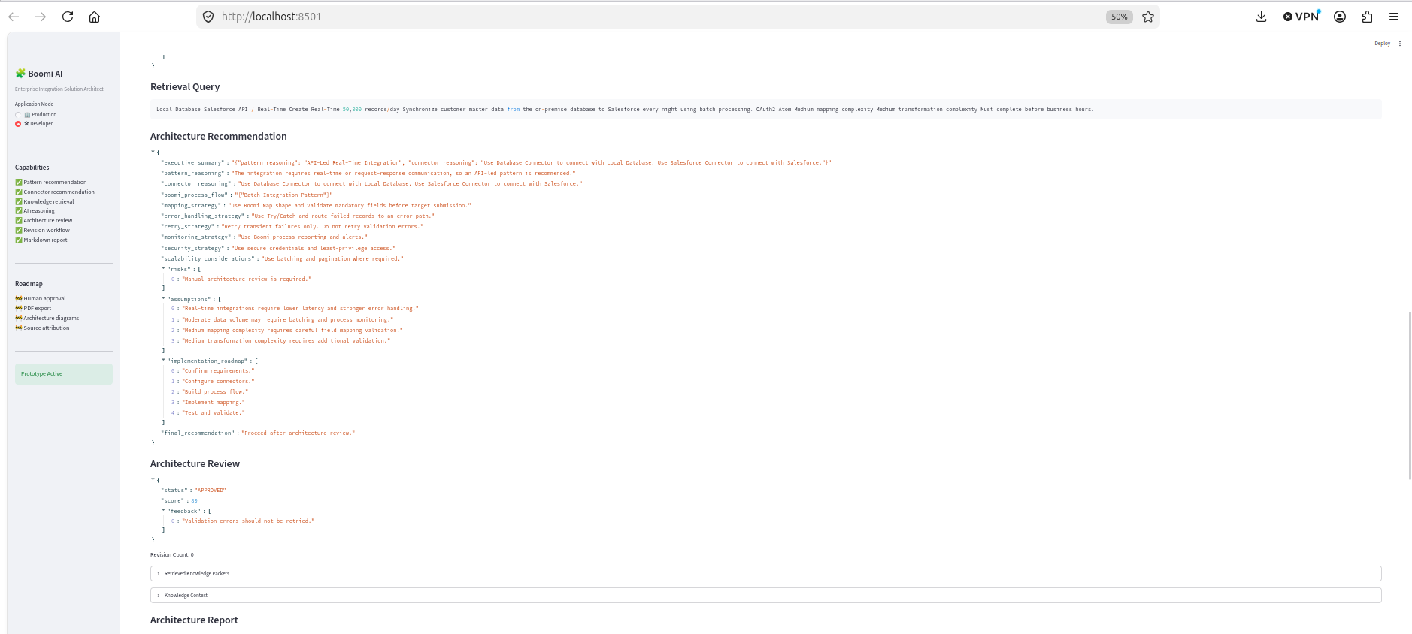
Description: Application showing developer mode architecture summary part 2.

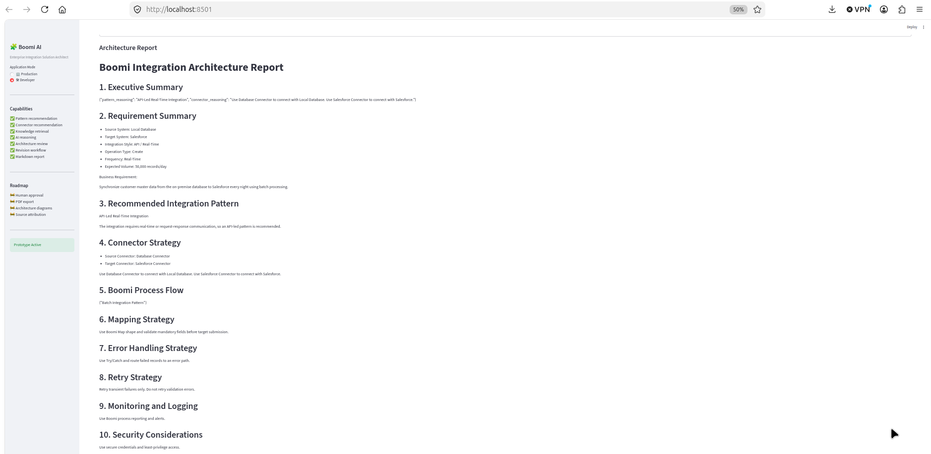

Description: Application showing developer mode architecture report part 1.

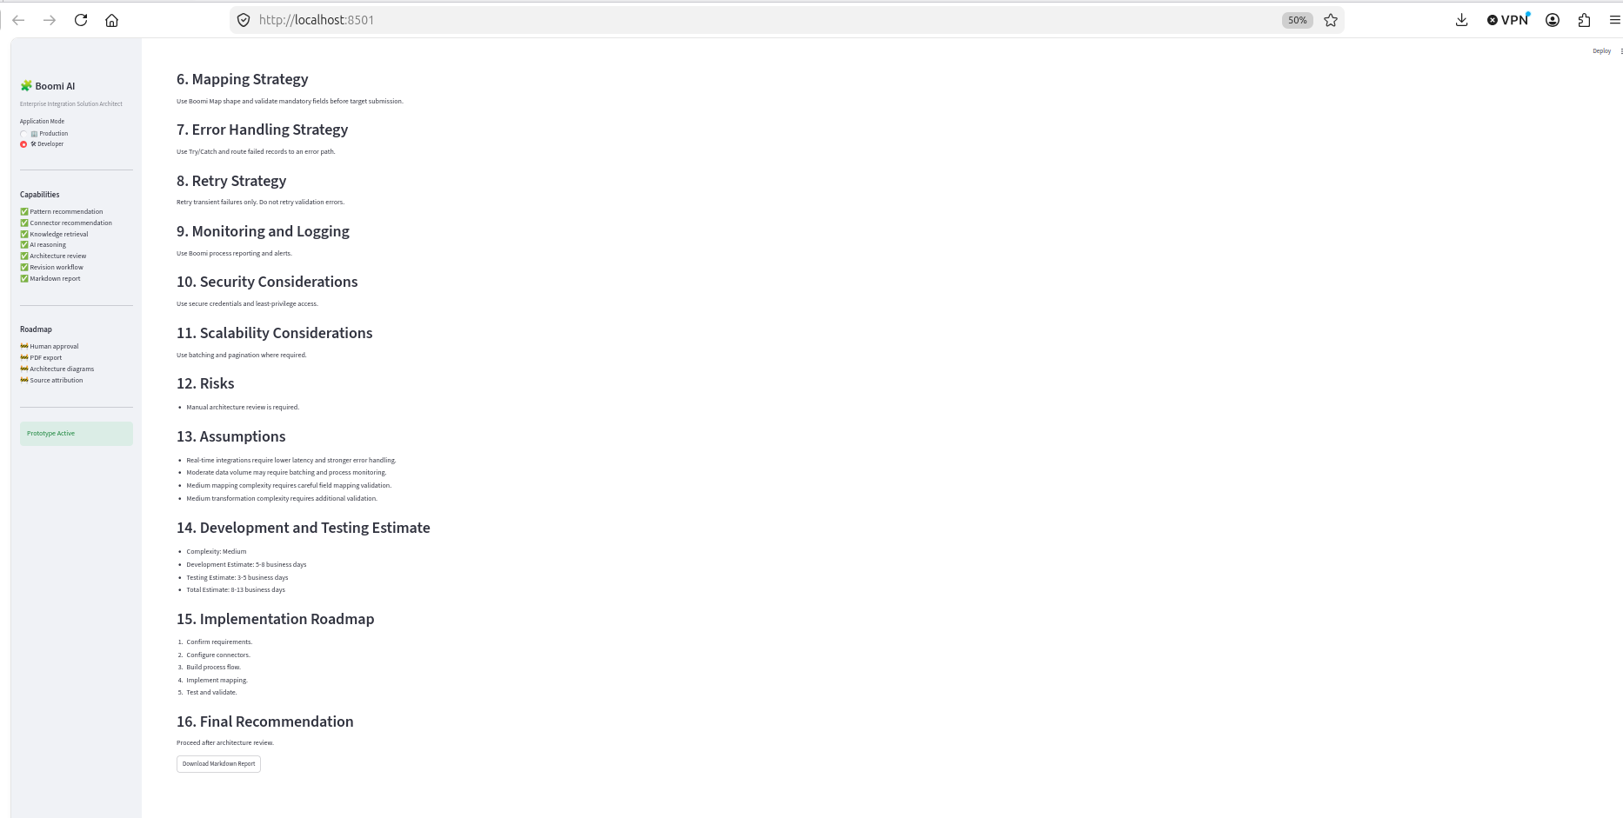
Description: Application showing developer mode architecture report part2 with report download .

