**Babu Banarasi Das University**

**NAME: Gaurang Rastogi**

**ROLL NO: 1240258180(37)**

**SEC:**  **BCADS23**

**SUB: NO SQL (Mongodb)**

**Submitted to : Mr. Ankit Soni**

**-:NO SQL MONGODB PROJECT:-**

Q1. List the names and departments of students who have more than 85% attendance and are

skilled in both "MongoDB" and "Python".  
**ANS :**

 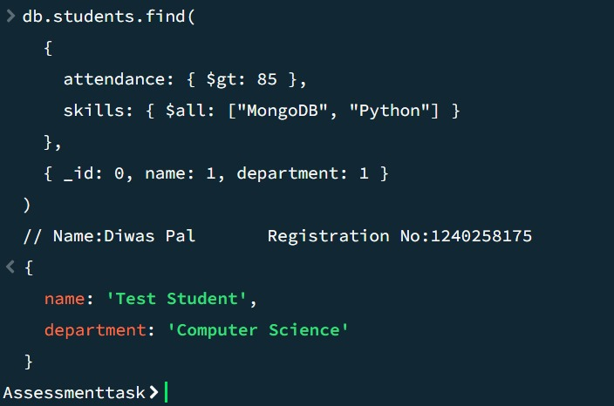

Q2. Show all faculty who are teaching more than 2 courses. Display their names and the total

number of courses they teach

ANS:

 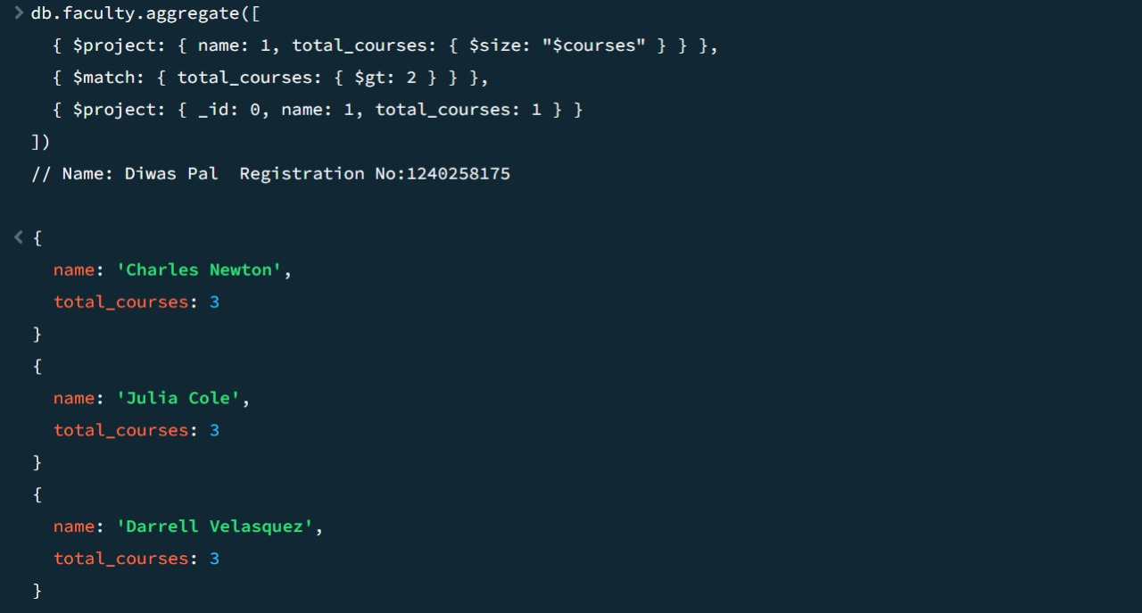

Q3. Write a query to show each student’s name along with the course titles they are enrolled in

(use $lookup between enrollments, students, and courses).

ANS:

 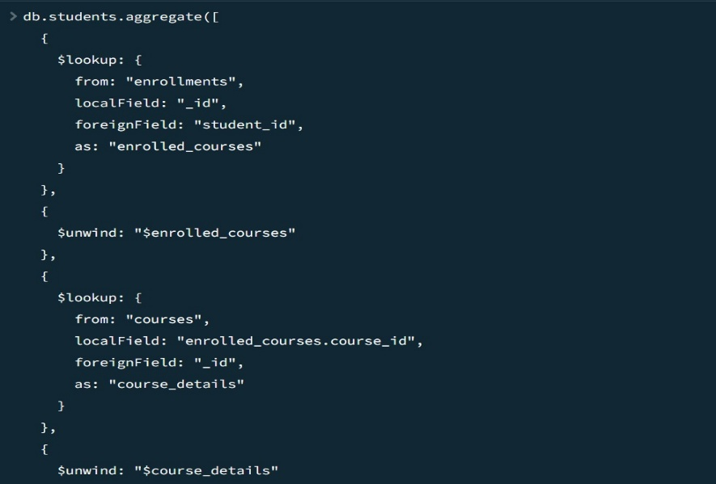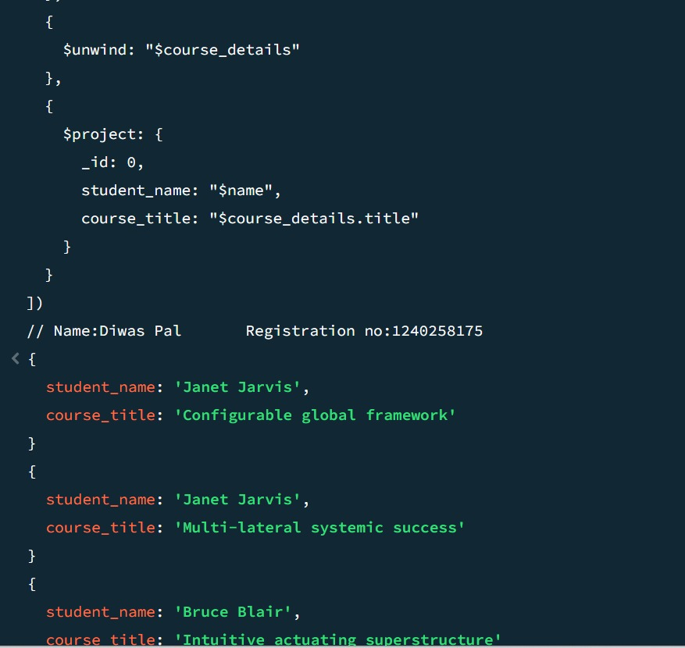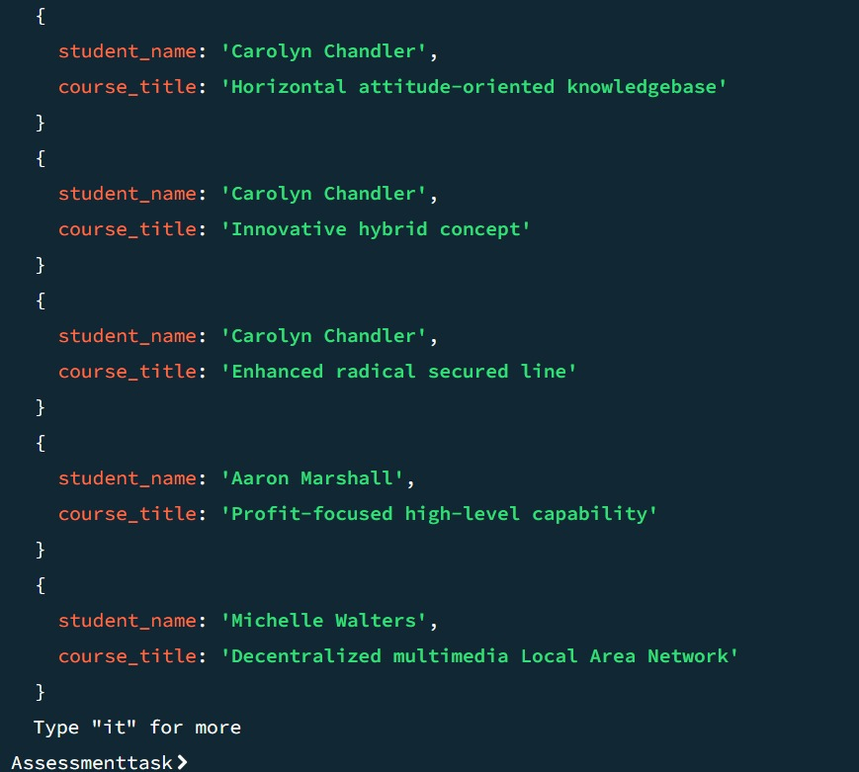

Q4. For each course, display the course title, number of students enrolled, and average marks

(use $group).

ANS:

 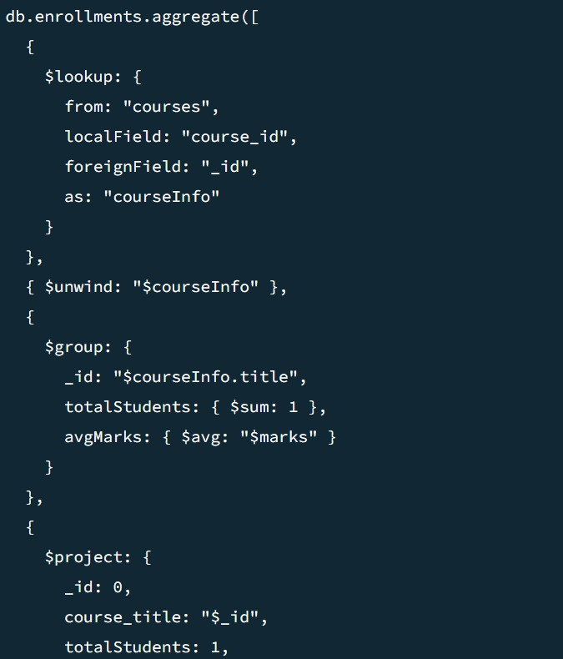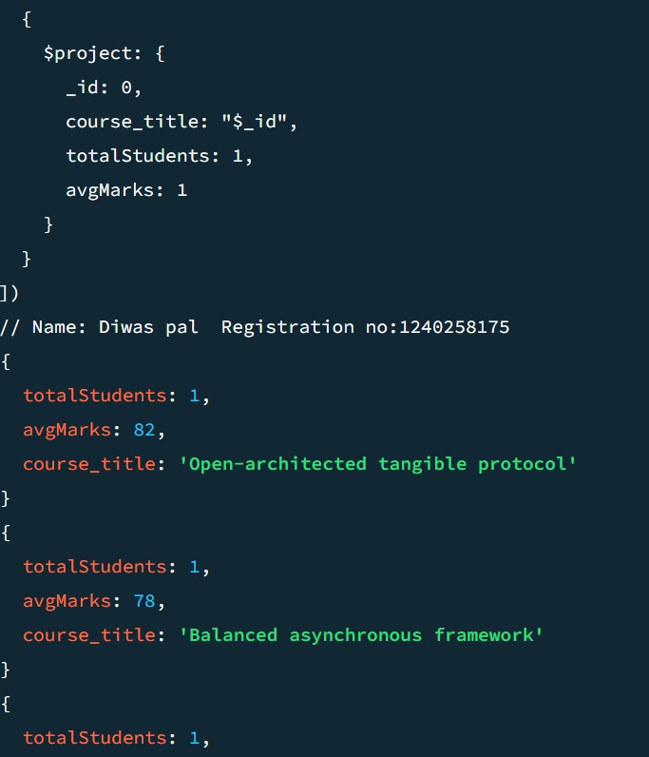

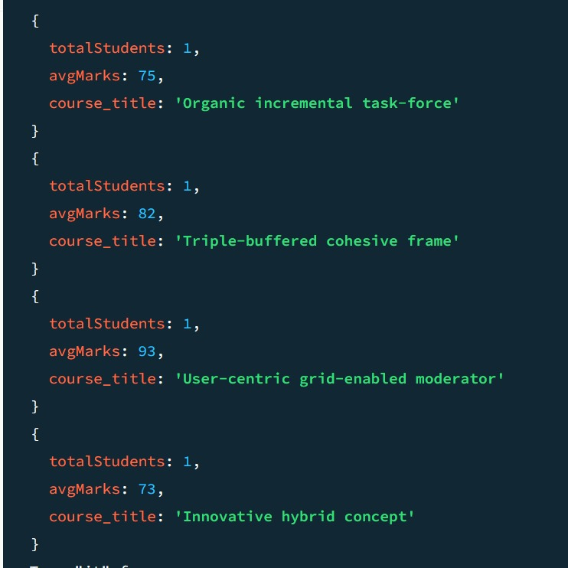

Q5. Find the top 3 students with the highest average marks across all enrolled courses.

ANS:

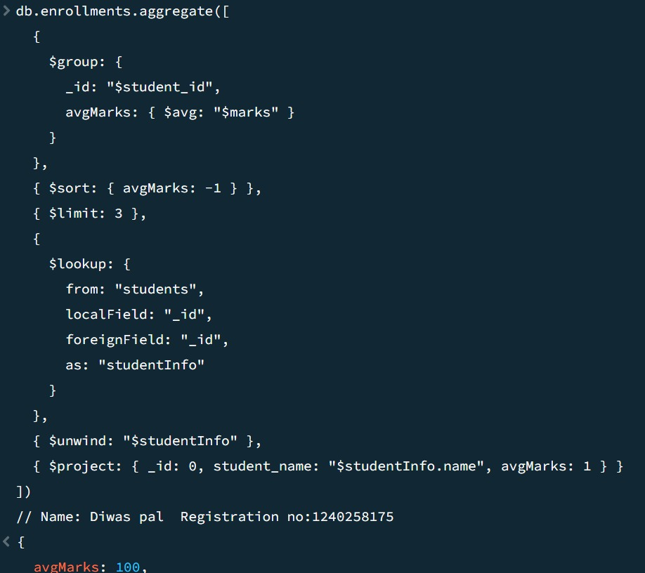

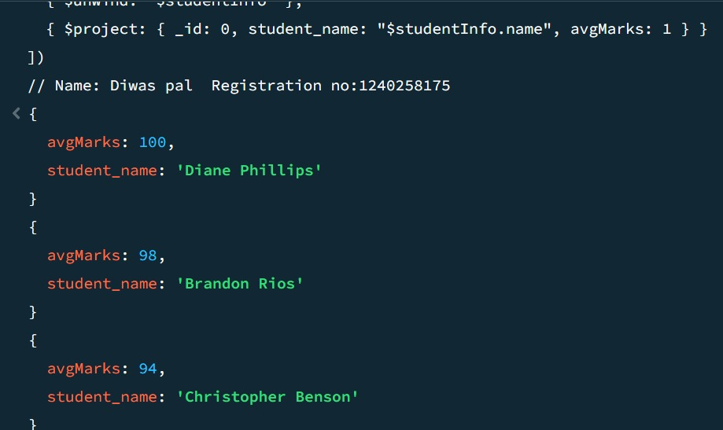

Q6. Count how many students are in each department. Display the department with the highest

number of students

ANS:

 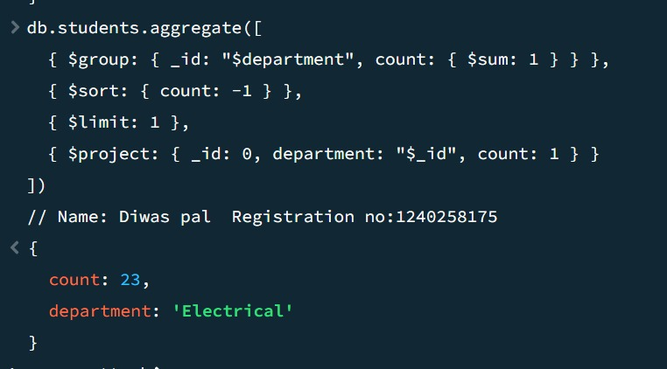

Q7. Update attendance to 100% for all students who won any "Hackathon".

ANS:

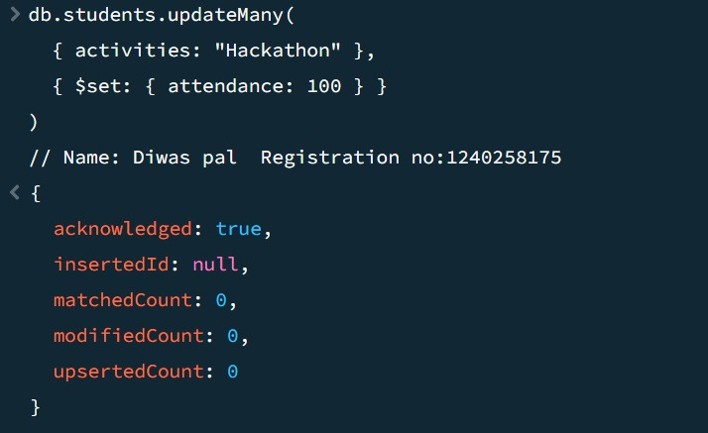

Q8. Delete all student activity records where the activity year is before 2022.

ANS:

 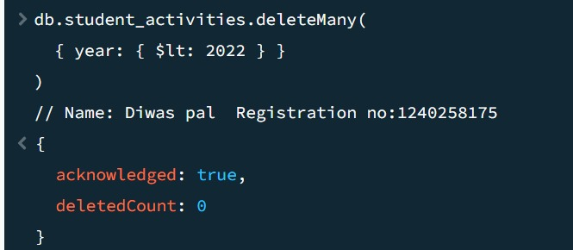

Q9. Upsert a course record for "Data Structures" with ID "C150" and credits 4—if it

doesn’t exist, insert it; otherwise update its title to "Advanced Data Structures".

ANS:

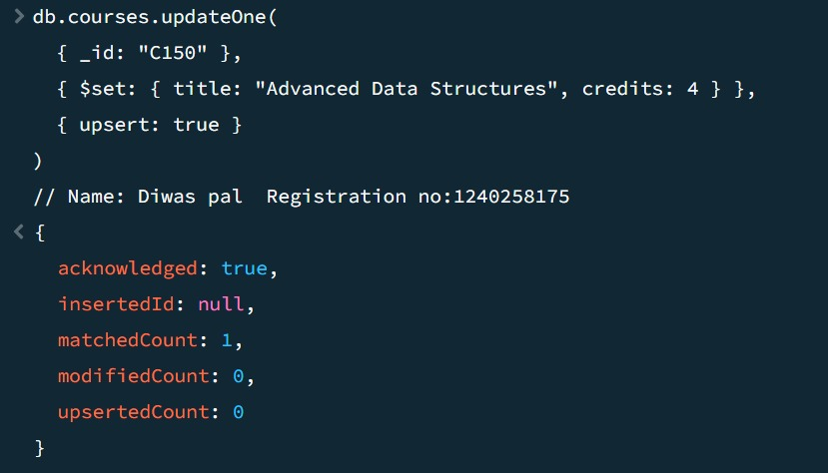

Q10. Find all students who have "Python" as a skill but not "C++".

ANS:

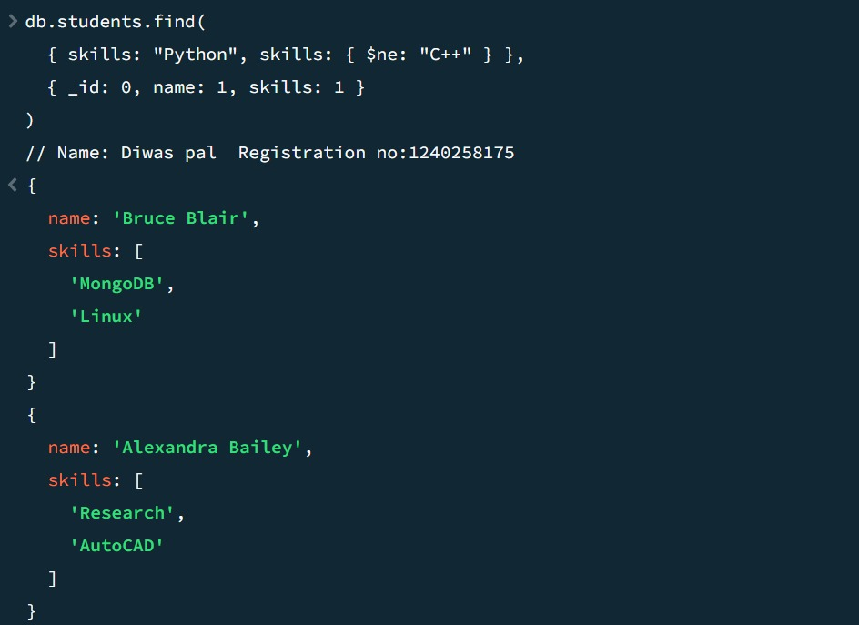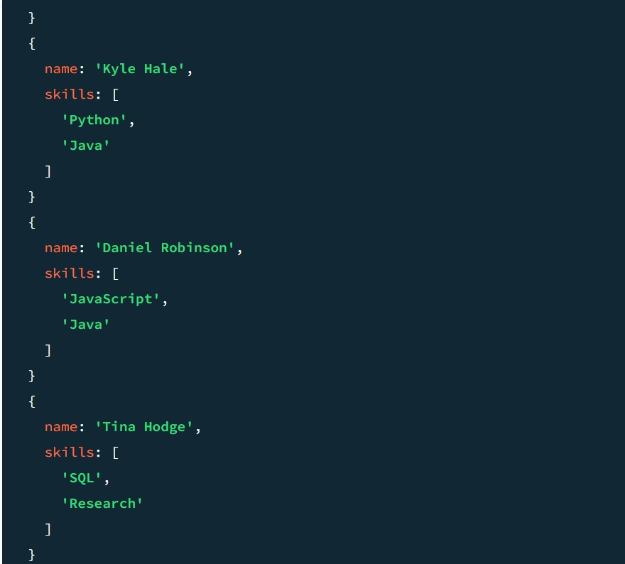

Q11. Return names of students who participated in "Seminar" and "Hackathon" both.

ANS:

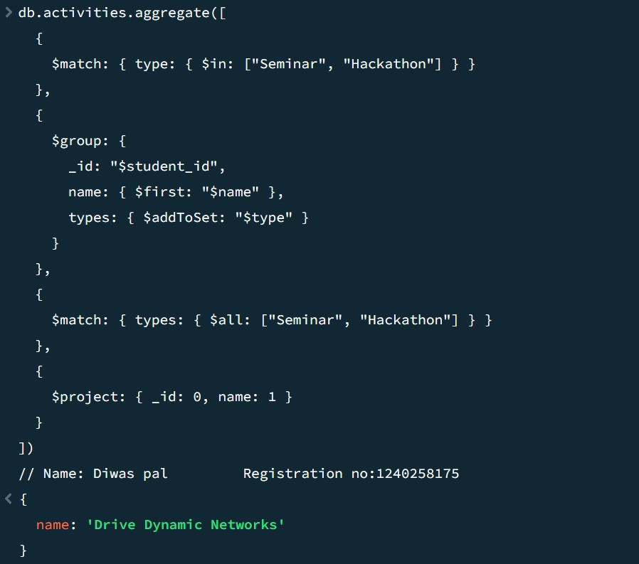

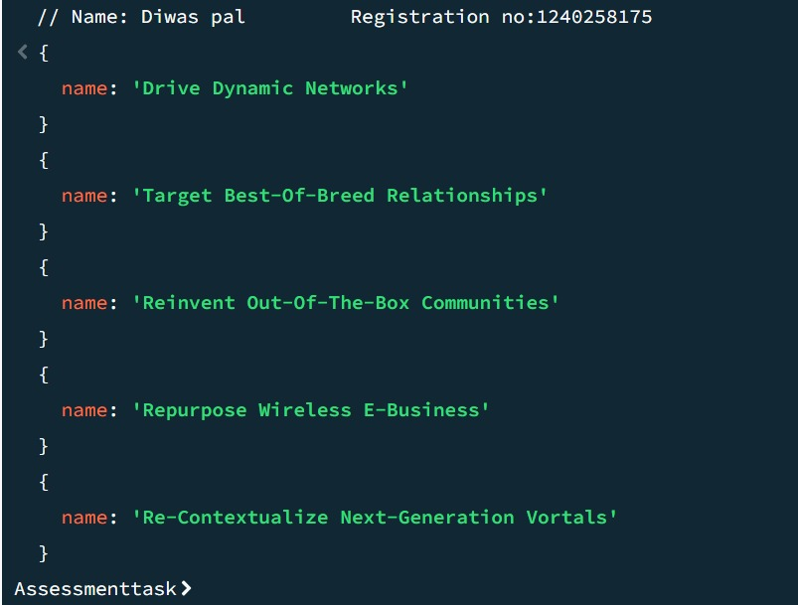

Q12. Find students who scored more than 80 in "Web Development" only if they belong to

the "Computer Science" department.

ANS:

 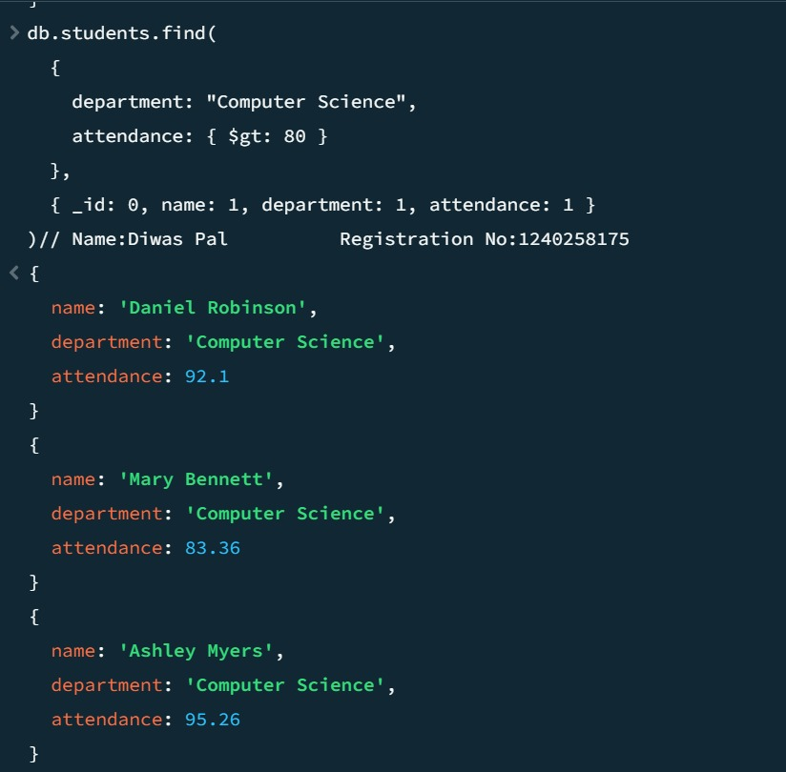

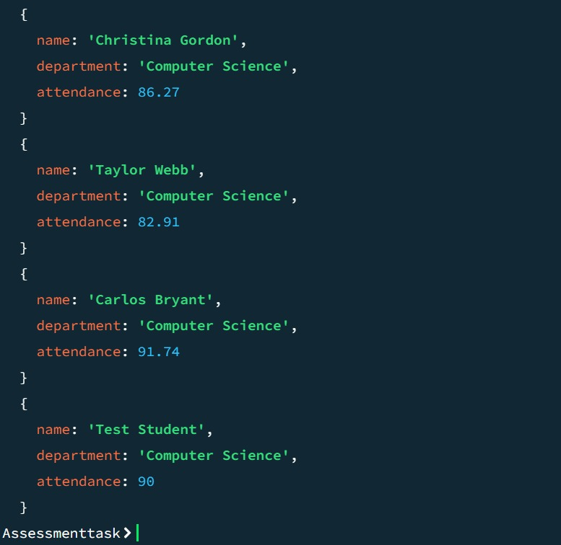

Q13. For each faculty member, list the names of all students enrolled in their courses along with

average marks per student per faculty.

ANS:

 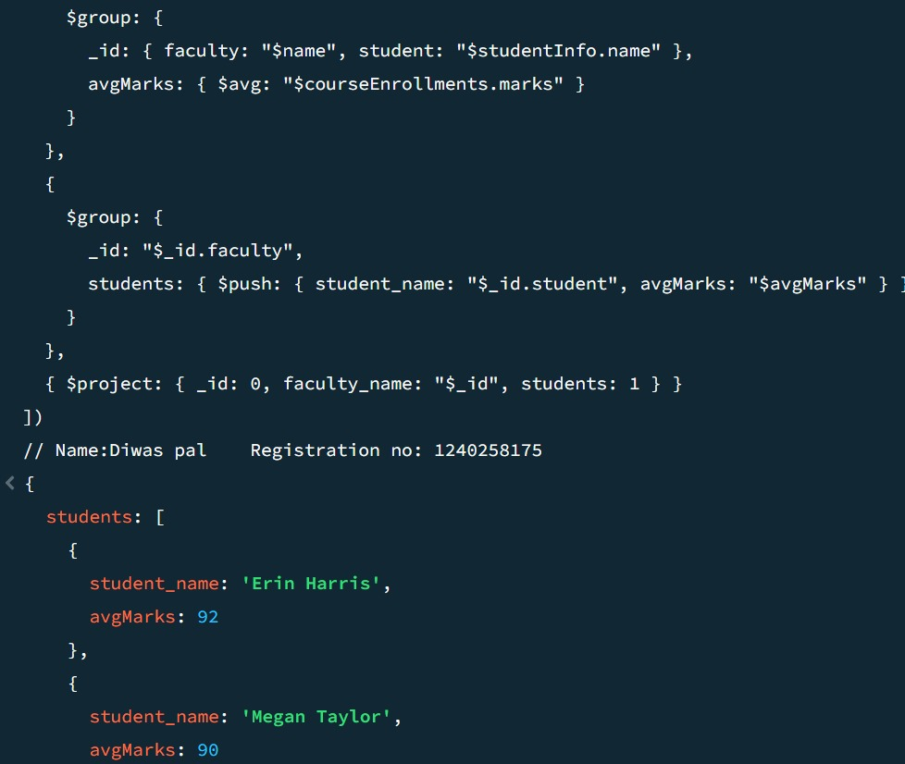

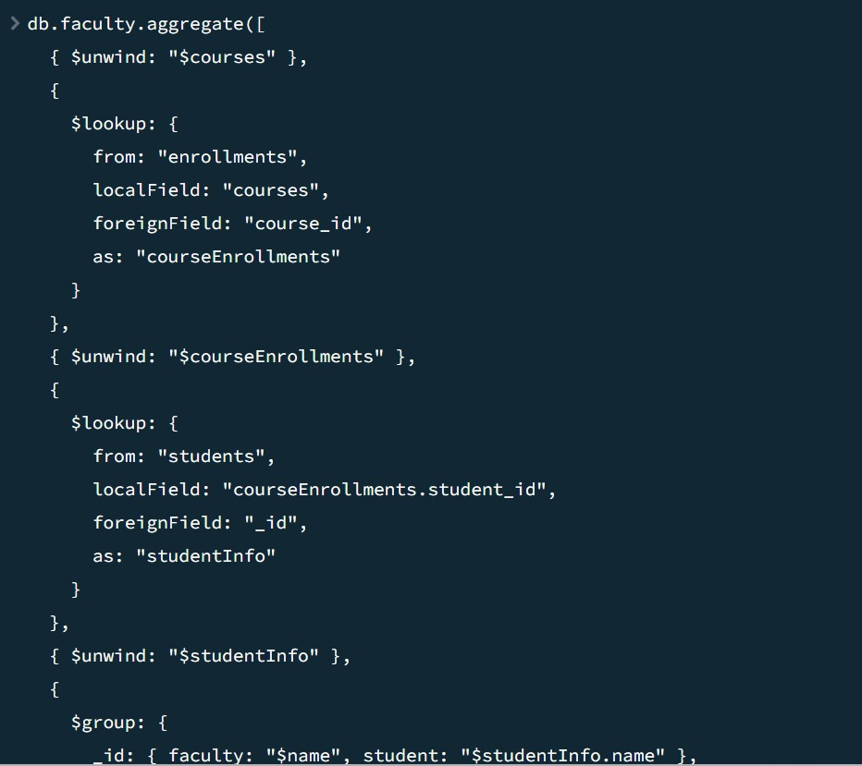

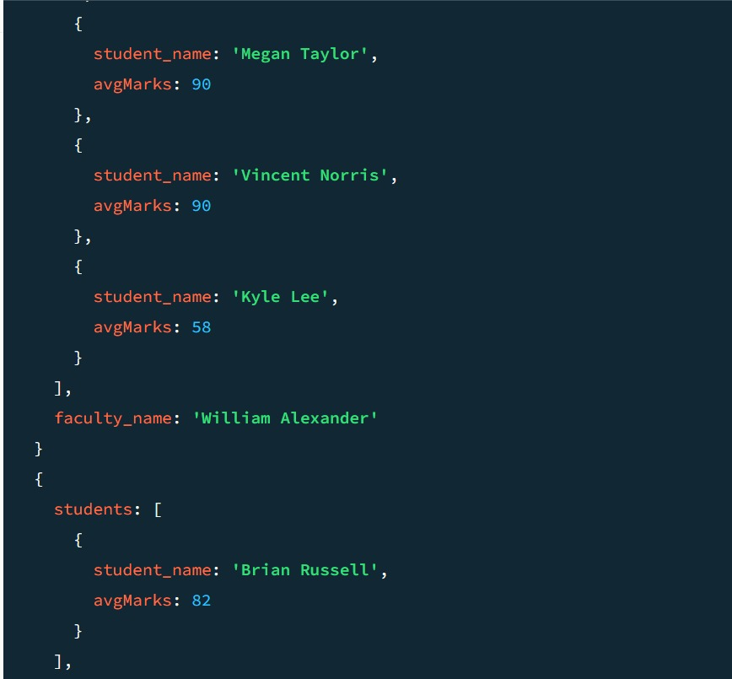

Q14. Show the most popular activity type (e.g., Hackathon, Seminar, etc.) by number of student

participants.

ANS:

 