CMS (Content Management System)

- Development Tool (IDE)
  - Eclipse

- Technical Specification
  - Spring 3.0
  - Hibernate 3.0
  - Maven
  - JDK/JRE (Java 6) – updated to JAVA 7
  - JSP, Bootstrap, Java Script, JQuery, CSS

- Server
  - Tomcat 6

- Database
  - MSSQL 2008 - (currently : Gujarat MSSQL2016 / Maharashtra MSSQL2012 )

- Utility’s
  - node.js utility - Getting require file information like file size, file name etc...
  - SWF to MP4 Converter - Convert SWF file to MP4
  - MP4 Joiner - Joining converted SWF bunch of MP4 files to one.

- Other
  - Socket Communication
  - Install4j (for setup)
  - Database Replication
  - SMS Integration
  - Mail Integration
  - Ck-editor
  - TinyMCE
  - AWS – MySQL for uploading update data as content update
  - S3 – Updated content files for TOPClass and TCLite
  - Sentinel EMS – Third Party licensing Software

- Installation and setup process of CRM Project
  - Open an eclipse and import project.
  - Make sure java 6 and Tomcat - 6 version are installed.
  - Copy .m2 repository folder like 'C:\Users\user1\.m2' path of working CMS and paste in your system on same path.
  - Right click on server and add new server as Tomcat 6.
  - Right click on project and run as server.

- Start up Process of CRM
  - Run SWF_TO_MP4 Converter Utility
  - Run MP4 Joiner Utility
  - Start the server and run cms project

- mysql_database.properties file
All constants are describe in this file like jdbc database credential, all cron job URL and timing, upload file path, swf file upload path, utility swf to mp4 converter(.exe) path, utility mp4 joiner(.exe) path, sms configuration and encrypt key of all project, different server API path etc ..

- About CMS

- CMS stand for 'Content Management System', there are manage syllabus year to concept mapping through object(content) like all types of content. and that object can be map with multiple concept or chapter, topic/sub topic of particular syllabus year,
- It manage hierarchy level that are listed as below.
  - Hierarchy of Syllabus year to sub topic
  - Parent Level Hierarchy
  - Syllabus Year
  - Board
  - Medium
  - STD
  - Semester (if required)
  - Subject

  - Child Level Hierarchy
  - Chapter
  - Topic
  - Sub Topic
  - Sub Topic...N

- Child level hierarchy are import from previous year if needed, like sub1 and sub2 are available in std-1 of year 2020-21 and same as import in std-1 or std-2 of year 2021-22
- If authority make any kind of changes in any level then it pass to subject expert for approval, once subject expert approved the changes then it going to update.

Concept Creation
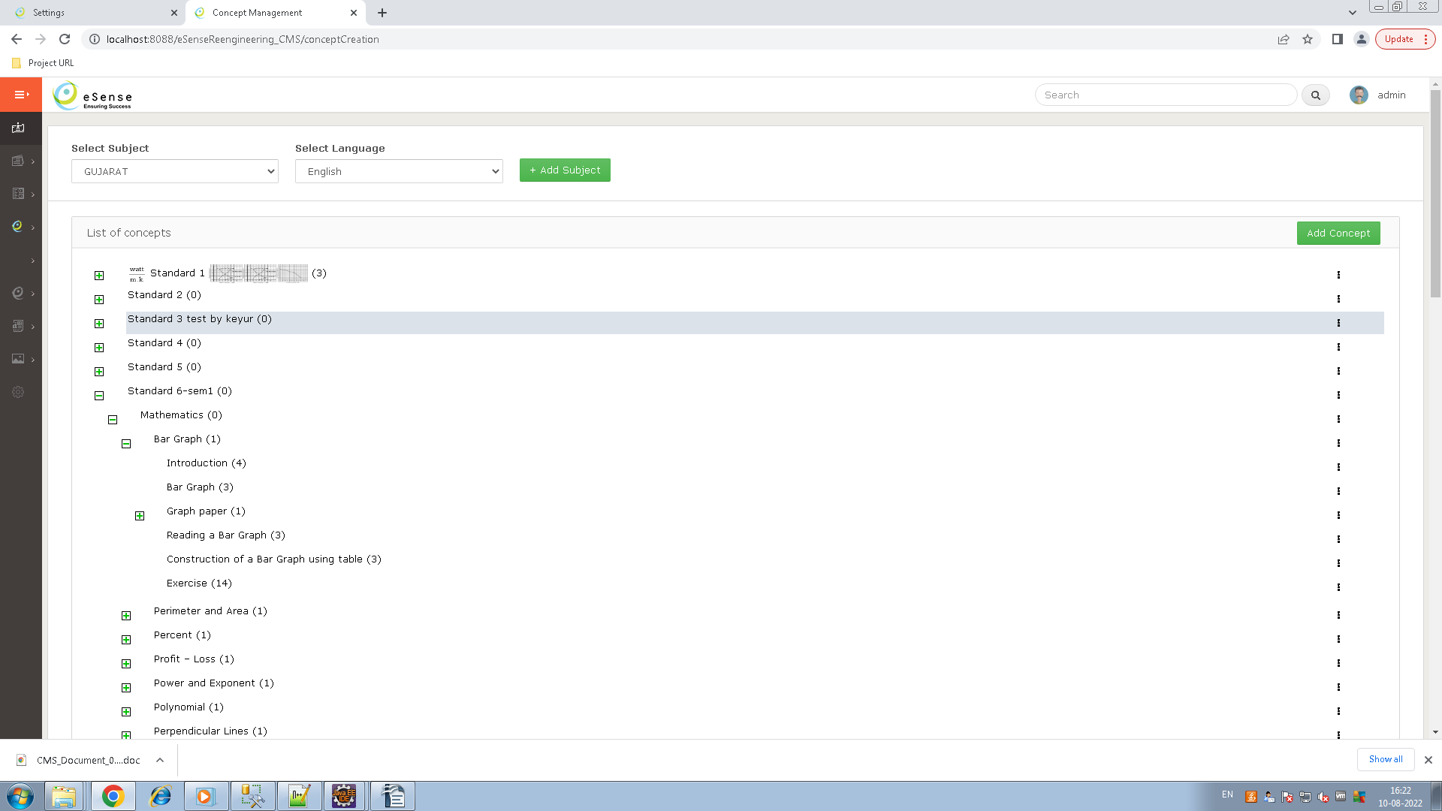
- This is used for creating a subject and language wise hierarchy like concept to N – level of concept as tree, with edit, delete, add sub concept and add object functionality.
- Purpose of this transaction to map this concept with chapter or topic.
- Add/Edit Concept
  - If not single concept in selected subject and language mapping then display Import from excel button here we can download excel format and import it by click on 'Import By Excel ' button. Currently we use only English language, in other language edit.
  - Add parent concept by click on the add button, add concept name and different language translator details to add a new concept.
- Remove concept – here we can remove concept by click on the remove button of drop-down toggle of concept hierarchy.
- Add sub concept
  - we can add N - level concept by click on add sub concept in drop- down toggle of concept hierarchy.
- Add object(file)
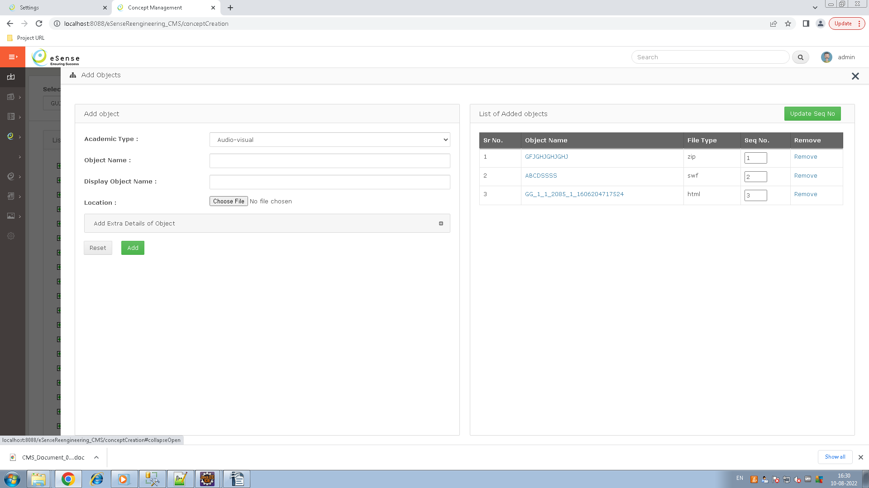
  - select academic type, and add object name, display name and select file which you have mapped with concept, While adding object we can add swf, pdf,html,mp4 etc file in object
  - Save extra information like time, file size, resolution etc..
  - Process while adding a object
    - Getting path in mysql.propertifile file for save location of file
    - While upload a swf file then call node.js utility and get all the properties detail of this file.
    - while adding a new object and object file as swf then calling swfToMP4 converting utility for converting this swf file to MP4 formate and set it's response in object_swf_mp4_tracker table, while converting swf to mp4 getting any issue then its response are updated in this table, so while restart CMS it's convert first pending file for convert and set response in this table.
    - Save concept with object relation mapping in object_relation_mapping table.
  - We can show all object by click on a concept in tree, display all object which are mapped with this concept. view or delete this object by click on the view and remove button, click on the file name of this object to show file information as all mapped concept with this file, all mapped syllabus year with this file, used in which product, and update this object if needed.
  - Update sequence no of object by click on the 'Update Sequence' button.
  - Here we can map this concept to other concept by click on the 'Map With Concept' button to select concept which you will map with this object.
  - If edit any object then update all the table which linked with this object.
  - NodeJS utility
    - This utility is use for getting file information like file type, total play time of file, size, etc.
    - It getting properties details of only swf file, if you upload any other file then it can't call the utility for getting properties details.
    - In short we can say that it is only used for SWF files to getting properties details.
  - SWF_To_MP4 converter utility
    - While adding a new object as SWF format then call this utility and convert swf file to mp4 format
- Data table
    - Concept_master (for subject Id mapping)
    - concept_translation_detail (for language id mapping)
    - concept_object_relation
    - object_master
    - category_detail
    - object_swf_mp4_tracker
Syllabus Creation
- Manage Master (Setting Menu)
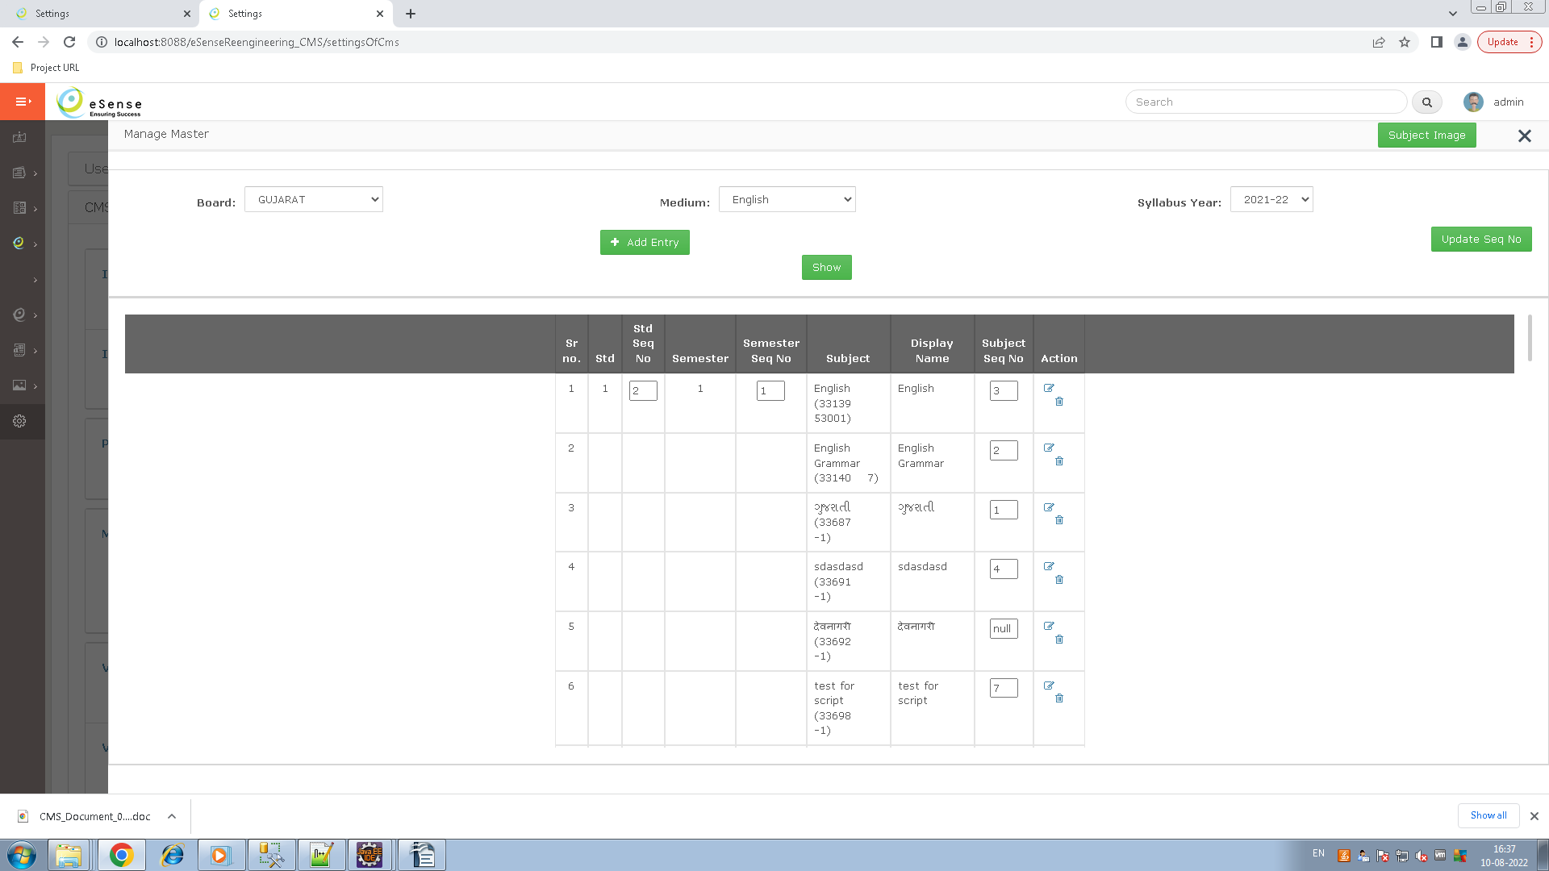
  - Here manage add, edit and delete functionality of level hierarchy. Select Board, Medium and Syllabus year and click on the show button to display all standard to subject level data in the grid, here we can delete or update any record by click on the edit/delete icon on the grid record.

  - When adding new standard and subject then we call ems for getting product id and feature id for the managing licensing for product.

  - New standard → call ems with (first three character of board name /first three character of medium name /std/standard name) for example board name is Gujarat, medium name is English and standard name is 3 then made a string as → GUJ/ENG/STD1.

  - New subject → call ems with subject name, Imagine subject name is Science then we passed science for getting feature id from EMS.

  - Delete only those entry which child data is not available other wise getting message like 'can not edit/delete, Subject are associated with syllabus'

  - Currently board, medium and syllabus year new add functionality is hidden.

  - Hear we can set sequence no of standard, semester and subject .

  - Subject Image button – Upload subject wise image.

  - Data Table
    - category_detail
    - syllabus_master
    - cms_activity_log

- Syllabus Creation
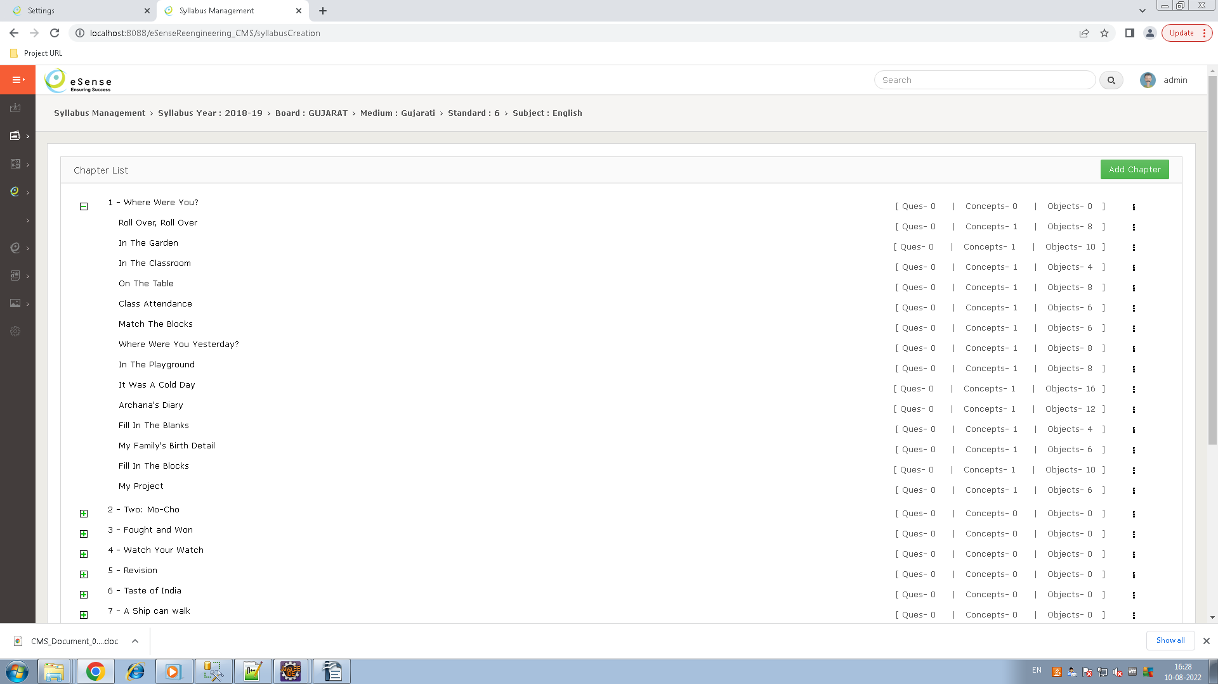
- This transaction is use for create the chapter to N-level topic in a subject, here we can map concept with any chapter or n-level topic.
- Select syllabus year to standard/semester level hierarchy to display all subject of this standard/semester.
- Click on a subject to open a slider and shown all chapters of selected subject if available, if not available a single chapter in this subject, then there are three way to create a chapter to n-level topic hierarchy like 'Import from excel', 'Import from previous year subject', 'add chapter and create new n-level topic manually'.
- If a single chapter is available in selected subject then not import from previous year or excel.

- Import from excel
  - Select the subject and click on the 'Import From Excel' button to open a pop-up, here showing import functionality with download link of excel format, we can download excel format here and after filling the data of downloaded excel you can import this excel by selecting this file and click on the import button to import this excel.

  - Using excel we can import chapter with it's weightage to n- level topic hierarchy.

- Import from previous year subject

  - Select the subject and click on the 'Import From Previous Year' button to open a new slider for selecting previous syllabus year to subject level hierarchy, here display two different flag when select a subject of previous year like 'import Questions' and 'Import Session Plan', select this flag if needed and click on the 'Import' button to import all chapter to n-level topic hierarchy with mapping of questions, concept, etc..

  - Import Questions flag – if checked this flag while importing a subject, then import all question mapped with subject topic are import in selected subject.

  - Import Session Plan flag - For importing a session plan to previous year subject if checked this flag then import previous year subject session plan.

- add chapter and create new n-level topic manually
  - Add chapter manually while new chapter is needed after previous year chapter import, then we can add new chapter with 'Add Chapter' button.

  - Chapter text and weightage are needed for adding a new chapter.

  - Add Topic - After added a chapter we can add n -level of this chapter by click on 'Add Topic' of drop-down toggle on right of the chapter/parent topic.

  - Edit/Delete Chapter – Here we can edit or delete chapter or topic by click on edit or delete chapter/topic of right drop-down toggle. If you delete chapter and topic then first delete it's child then and then only you can delete this chapter or topic.

  - Concept Mapping – Here we can map multiple concept with chapter and it's topic, by click on the map with concept in drop-down toggle right on chapter or concept. Click on map with concept to open a slider for selecting a concept, filter subject and language wise concept and checked concept which you have map with this topic, and click on the update button to map this concept with selected topic.

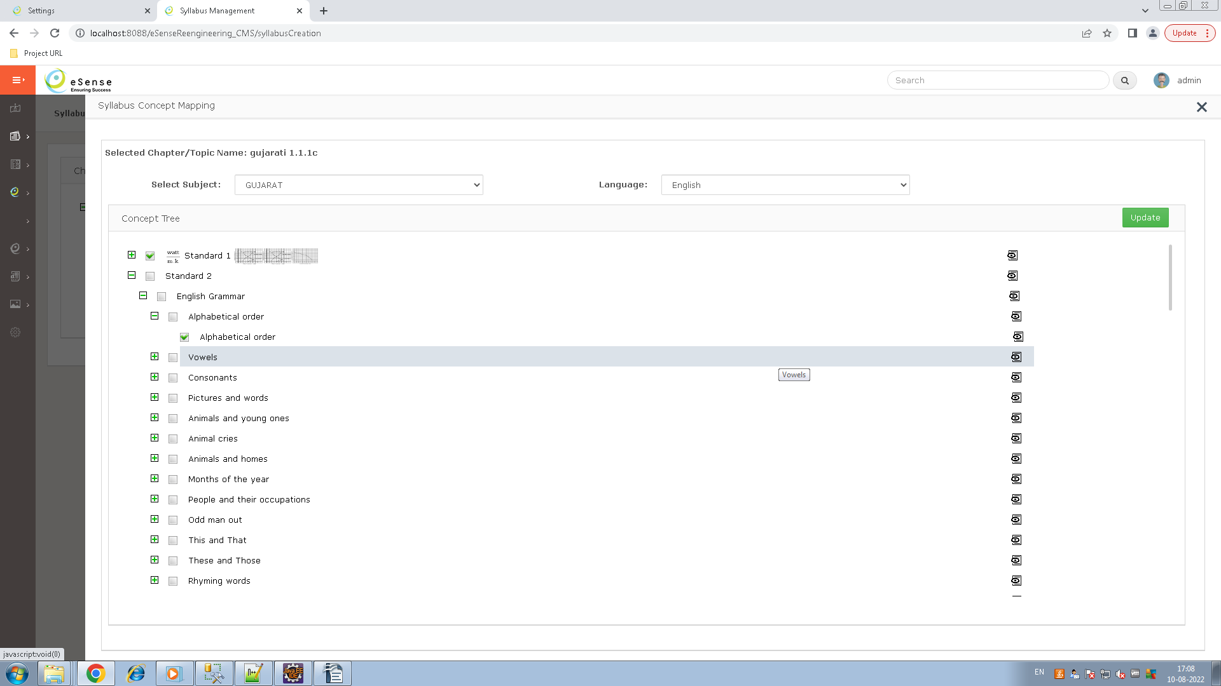
- Import Master From Previous Year
  - It is a functionality for importing all master data from Board to subject level hierarchy from previous year.
  - Here we can fill the syllabus year with from date, to date which we need to import master data from previous year, then click on save button to show all the previous syllabus years list with redio button, you can select one which you need for copy all the master data to current year.
  - Here we stop triggers of inserting records in update tracker table while import from previous year functionality.

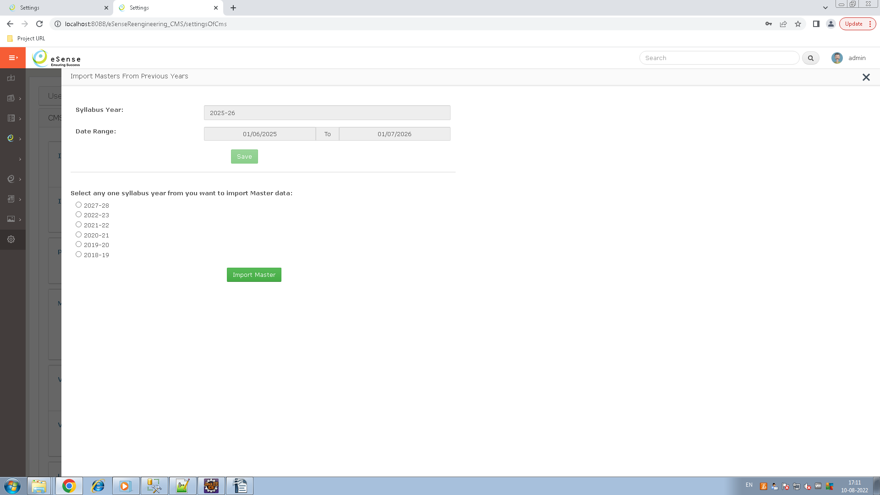
  - Data Table
    - category_detail
    - syllabus_config_master
    - update_tracker_exclude_subject_tbl
    - user_subject_mapping
    - syllabus_chapter_master
    - syllabus_chapter_detail
    - syllabus_concept_detail
    - category_lable_master
    - chapter_details_lable_mapping
    - category_lable_mapping
    - cms_activity_log

- Activity Creation
  - This transaction is used for creating a html based activity at chapter level, heare we can create an number of activity in same chapter.
  - Here if any concept bind with this chapter then activity also mapped with this concept while saving an activity.
  - And if not any concept bind with selected chapter then here functionality to binding this activity to selected concept and also mapped this concept with selected chapter by click on 'Activity Mapping' button.
  - Here displaying all the activities of selected chapters by click on 'search' button, we can change the display name by click on display name text off listening activities.
  - Here different functionality as 'Edit Activity', 'Download', 'Web Preview' and 'Mobile Preview' in the toggle drop-down of listed activity.

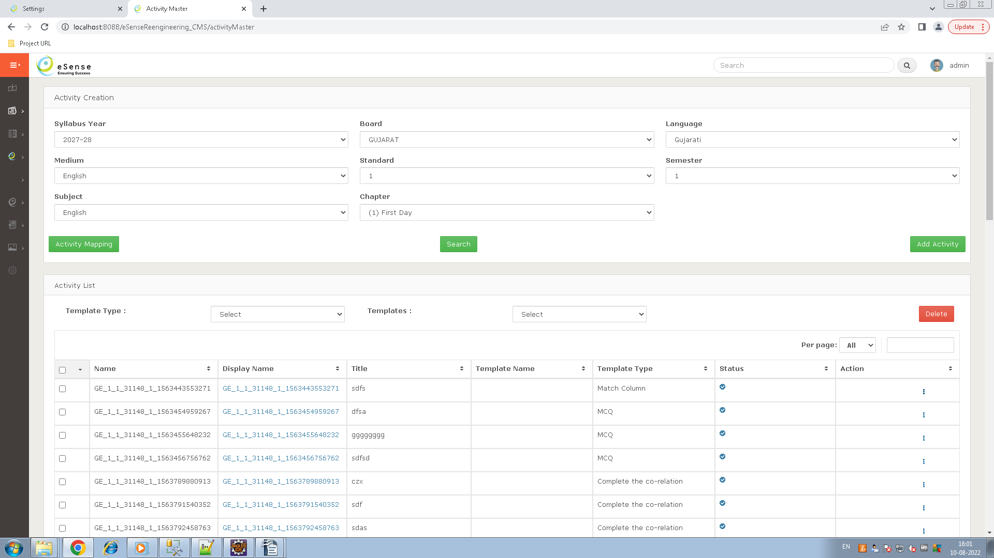

- activity-web-builder
  - It's a separate project to create an activity as 'activity-web-builder'. In this project we are managed different type of template to build an activity, we can select an template to build and activity to selected template type.
  - In this project we can customize the themes as change header, footer color, space between questions, shape of the button etc.
  - And also we can save this themes for the building different activity of same theme.
  - Its different rule set of activity to build, so we can select rule set for building activity, and its mandatory.
  - Note : We are use same database for 'activity-web-builder' project
  - Data Table
    - activity_template_type
    - activity_template_master
    - activity_mapping
    - activity_master
    - activity_rules
    - activity_rules_master
    - activity_pattern_theme_mapping
    - activity_question_master
    - activity_question_option_master
    - activity_user_log
    - activity_user_master
    - activity_pattern_master
    - activity_pattern_element_master

Question Entry Module
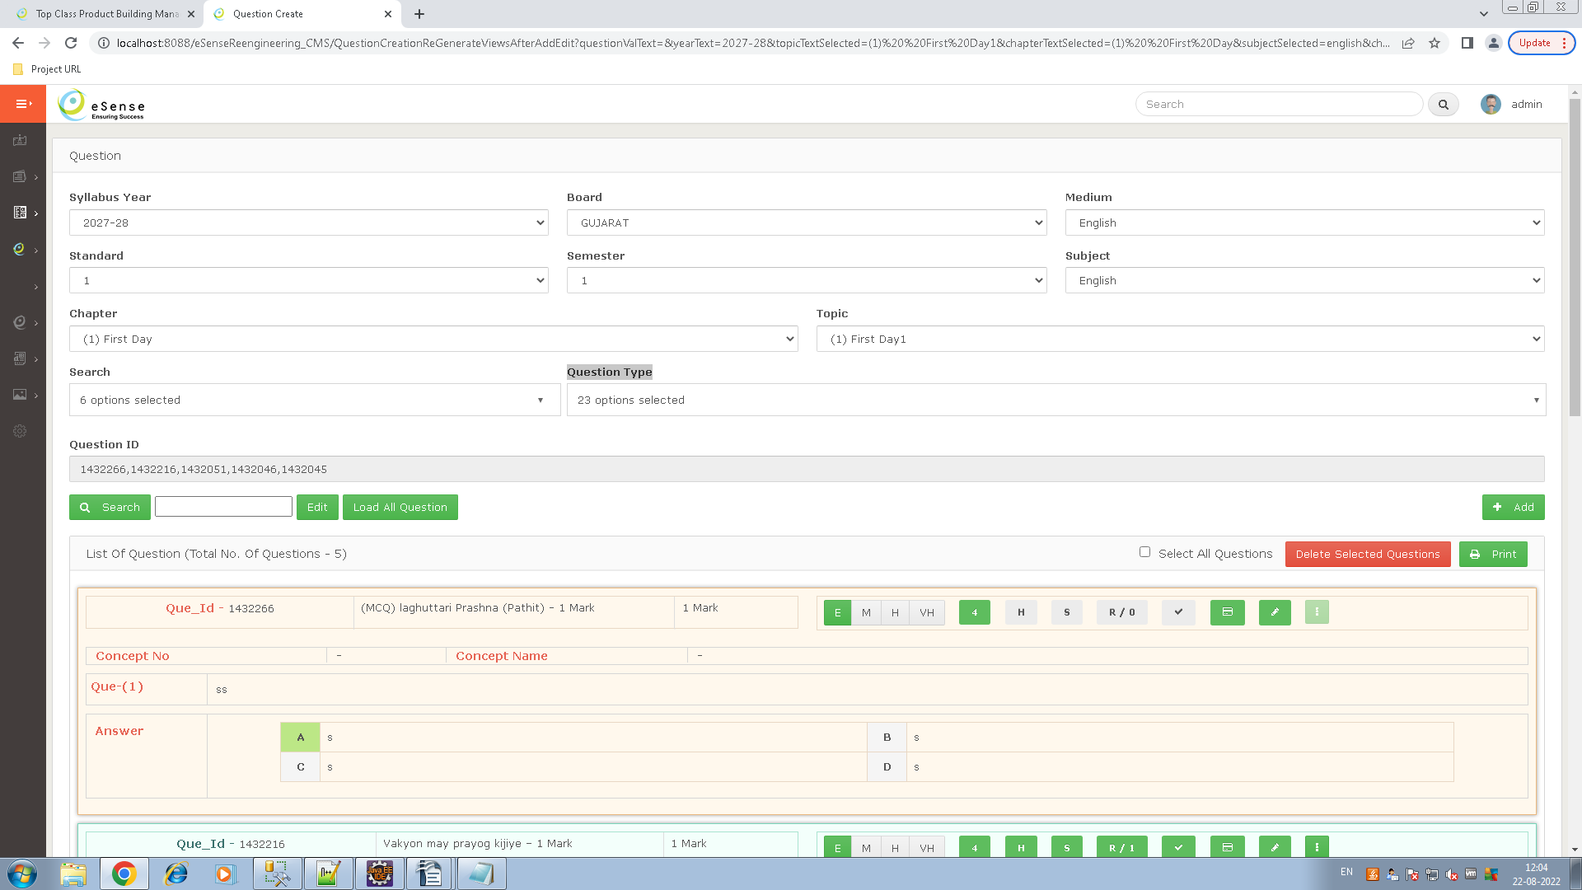
- This module is use for create the questions, move questions and copy questions using question id. And mapped any question on parent topic of chapter, here we can not mapped or create question in child topic of parent topic.
  - Create/edit/delete Question (Question Create Page In Menu)
    - Select syllabus year to chapter topic level hierarchy in drop down and click on the search button to display first three question and click on the Show All button to display all mapped questions with selected topic of chapter.
    - Display two check box in this page like 'Font Type Times New Roman' and 'Show In Active Question', if we check times new roman check box then use times new roman font while creating a question, and if we check show in active check box the display all deleted(In Active) question while click on the search or show all button.
    - Once the all question is showing on selected topic then display 'Print Question' button, if we need print of selected topic question then click on that button to print those questions.
    - Here we can active deleted question at edit time by selecting the active in drop down and click on edit button to active his question in this chapter.
    - Active flag is maintain at mapping level so if we delete this question in this topic, then it deleted only this chapter. If this question is mapped with other chapter topic then not affected on this chapter.
    - Edit and delete question by click on edit and delete icon of listed question of selected chapter. And also after selection of topic, we can enter question id and click on the 'Edit Question' button to open slider for edit this question.
    - Did any kind of change in question like edit, delete or create new then add that upset that entry in tc_question_mapping table.
    - When create a new question than first created question in tc_question_master table and mapped this question with selected topic in tc_question_mapping table.
    - Concept No and Concept Name
      - here concept no and name is used while question creation for chapter wise question grouping, like when we add a question and set concept no =1.1 and concept name ='Hollywood' then all question which we set same concept no and name then all questions are inside Hollywood concept.
    - Inside Question
      - Question text
      - Options if needed
      - hint
      - solution
      - approach
      - Remedy
        - Here we can add multiple remedy in single question by selecting the error type and click on save button to displaying remedy as box.
        - Inside remedy
          - there are two radio like Lesson Plan and Remarks
            - Lesson Plan
              - Session Id and Step Id in drop down
              - Enter session remarks
              - Refer model answer as hint or solution as check box
            - Remarks
              - Enter Remarks
              - Refer model answer as hint or solution as check box
    - While create a new question.
      - First select question type like short question, MCQ, etc.. and select further selection as per requirement.
      - If we select question type as MCQ then display options of this question, here enter question text, different options, hint, solution, approach, remedy, and select require options in drop down and click on the save button to save this question.
    - While edit a question
      - If edited question id is mapped with multiple chapter then in back end first create that replica in tc_question_mapping table and change that mapping on tc_question_mapping table.
  - Copy Questions.(Question Copy And Move Page In Menu)
    - Here select syllabus year to topic level hierarchy in drop down, and enter multiple question id as coma separated and click on the 'Copy Question' button to copy those questions on topic of selected chapter.
    - If Question id's which we have entered for copy is in current syllabus year chapter, then first crate new replica of this question in tc_question_master table, after mapped this questions in Tc_question_mapping table.
    - If Question id's which we have entered for copy is not in current syllabus year chapter, then it not create replica in tc_question_mapping table, only create new mapping of this questions in tc_question_mapping table.
    - So while editing any question first we check mapping in tc_question_mapping table, if we found more then one entry(mapping) then create new replica of this question and made changes in mapping of this question in tc_question_mapping table.
  - Move Question (Question Copy And Move Page In Menu)
    - In same page select syllabus year to chapter level hierarchy in the drop down, and click on the 'Move Question' button for moving selected topic question to other topic.
    - Here we can move questions only current and before syllabus year of selected chapter syllabus year.
    - Once we click on the 'Move Questions' button to open a slider and showing all questions of selected chapter with check box, here checked question which you have moving for another topic of chapter and click on the 'Next' button to open a slider for selecting another syllabus year to chapter level hierarchy, select chapter and click on save button to moved selected questions to this topic.
    - In question moving functionality we have update only mapping in tc_question_mapping table like chapter_detail_id, chapter_master_id, for_update=1, on_air=11111, author_checked=0 and author approved =0.
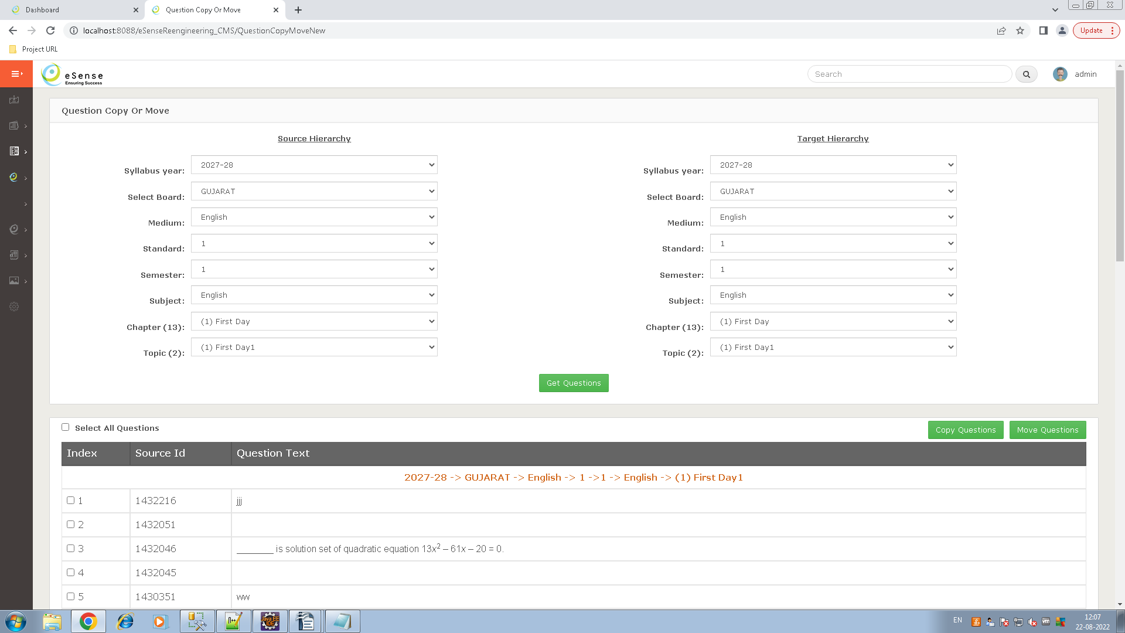
- Did any kind of changes in question like edit, delete, copy, and move then always update for_update=1, on_air=11111, author_checked=0 and author_approved =0 in tc_question_mapping table.
    - Important of this flag in tc_question_mapping table
      - for_update – this is used for update is generated of Top Class Product, if for_update getting 1 then update is pending and 0 then this question update is generated.
      - on_air – This is used in TopScorer product for synchronize updated questions , here value of on_air is 11111 then first 1 is for live server, second 1 is for staging, third 1 is for server 3, fourth 1 is for server 4, and last 1 is for server 5, if updated question is synchronized with live server then change value 11111 to 01111, so we have determine this question is synchronized success with live server.
      - author_approved – This is used for question is approved or not. If we found 1 then approved that question from subject expert else pending for approval. Note : questions are synchronized after approval of subject experts.
      - author_checked – This is used for approval Id.
- Data Table
  - tc_question_master (while insert new question)
  - tc_question_options (while insert new question)
  - tc_question_remedy (while insert new question)
  - tc_question_message_type (for selection remedy type/create new error type)
  - tc_question_mapping (while insert new question)
  - question_type_master (for selecting the question type)
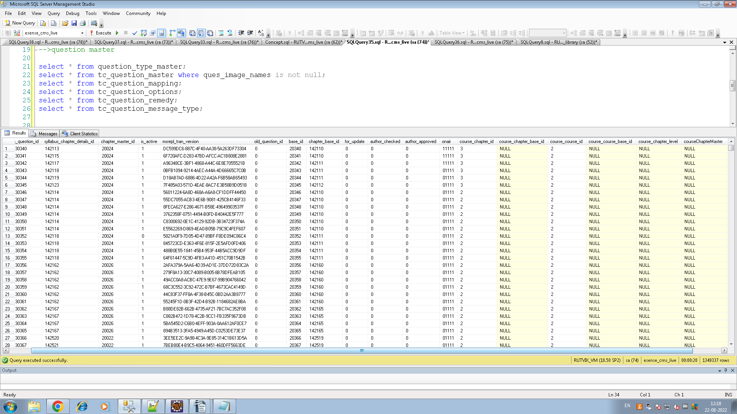

Product Building & Burning

- Different types of product building & burning

- TOP Class
  - TOP Class Building
  - TOP Class Burning
- TOP Scorer
  - Lesson Plan Product Building
  - Lesson Plan Instruction Guide
  - TOP Scorer Burning
- UTOP
  - UTOP Building
  - UTOP Burning
  - UTOP Image Burning
- You Tube
  - You tube Building
  - You tube Burning

- Analysis of Product Building and Burning

- TOP Class & TOP Scorer

- TOP Class/TOP Scorer Building(School Product)

  - Purpose of this transaction - manage final object(files) of chapter, topic to N topics which will use in burning process.
  - Select medium level hierarchy to displaying standard, semester and subject information in grid with action link like 'Add Content' or 'Manage Content'.
  - If you add content in the first time then display a link like 'Add Content', once you added content then displaying link name like 'Manage Content'
  - Click on the 'Add Content' link, then showing all chapter to the topic level hierarchy of selected subject.
  - Checked chapter/topic in hierarchy then open a pop-up and showing mapped object of selected subject/topic and added object for final product burning.
  - Here different types of content types in drop-down like 'Main Content' and 'Additional Content', select content type and move object for final product burning.
  - Chapter level, there are different types of content as listed below.
    - Additional Content, Glossary, Chapter Summary, Exercise, Practice Test, CCE, Notes, and Activity
  - Topic level, there are two different types of content as listed below
    - Main Content
      - Only SWF file are use in TOP Class, So you have not selecting the MP4 and any other files file.
    - Additional Content
      - Both SWF and any other types of file are moving.
  - Checked .swf files and click on move button to add a file in
  - Here we have set the sequence no of an added object and click on 'Update Sequence No' button to update the sequence no of those files.
  - We have removed the added file using click on remove link.
  - After add object, the select product is ready or not and enter no of the percentage of question bank and click on the save button to insert an entry in the product_master table.

  - Data Table
    - product_master – save the product ready and question bank percentage.
    - syllabus_content_master – Move content from mapped concept to final product

- TOP Class Burning (School Product – use Included/excluded subject- select only included subject)

  - Purpose of this transaction – build a setup with encrypted script file and object bundle(objects and images)
  - Syllabus Year - Here display only those syllabus year in drop-down which completed building process.
    - When select syllabus year - showing medium wise different board in grid which completed building process
  - Product Type – Full Product and Demo Product
    - Full Product
      - Selection of subject
      - Excluded subject show as red color, so we have not permit to select this subject.
      - Checked a product , and click on filter icon to open a pop-up – select the subject and click on save subject button.
    - Demo Product
      - Selection of chapters
      - Checked a product , and click on filter icon to open a pop-up – select the chapter and click on save chapter button.
  - With Data – if checked then burning a product with data.
  - Select the product which you have burning.
  - Click on 'Burn product' button to start the burning process.
  - Click on 'View Burn Product' to showing completed burn product.

  - Data Table
    - Product_master – get details for product is ready or not.
    - syllabus_content_master – get details for creating object bundle and script file bundle.
    - Product_detail – save burning data

- TOP Scorer
- Lesson Plan Product Building
  - Select Subject - selecting the subject level hierarchy
  - Select chapter and click on the 'Show Session' button to showing all session inside that chapter.
  - Click on the 'Add Session' button to add new session, or import session from subject of any syllabus year
  - Create step in current session by clicking on the plus button , we can add multiple content type in single step by clicking on the plus button.
  - We can add content like pdf, images by clicking on the 'Add Content' button of content type in specific created step of session.
  - Modification of pdf file like hide some portion, add button and set different content in that button click.

  - Data Table
    - session_content_type_master
    - session_master
    - session_step_master
    - session_step_content_master
    - step_content_topic_master
    - step_content_pdf_plant_matser

- Lesson Plan Instruction Guide
  - Purpose of this transaction – Managing subject wise multiple instruction
  - Select syllabus year, board, medium, standard, semester and subject.
  - Click on the 'Show Instruction' button to showing all instruction inside selected chapter.
  - Click on the 'Add Instruction' button to add new instruction for this subject, we can add multiple instruction in a subject with managing sequence no of instructions.
  - Here we can add file as different instruction types.
  - Enter sequence no and click on the 'Update Sequence' button to update the sequence no of instructions .

  - Data Table
    - top_scorer_instruction_master
    - top_scorer_instruction_detail

- TOP Scorer Burning-(Pen-drive Product – not used Included/Excluded subject – select all subject)
  - Purpose of this transaction – build a setup with encrypted script file and object bundle(objects and images)
  - Select the syllabus year to board level hierarchy.
  - Display board level hierarchy after building process completed – check product ready flag in product_master table.
  - Select different burning process like Data Base with File or Database Only.
  - Data Base with File - if checked then burning a product with data.
  - Database Only - if checked then burning a product without data.
  - If included lesson plan then check lesson plan check-box.
  - Product Type – Product App, Demo App, Eco App
    - Product App
      - Selection of subject
      - Select the subject and click on the 'Burn Product' button.
    - Demo App
      - Selection of chapters
      - Select without projector of demo, if not selected – demo are runnable in projector.
      - Select the chapter level hierarchy and click on the 'Burn Product' button.
    - Eco App
      - Selection of chapters
      - Percentage – How many percentage of chapter wise questions are use in product.
      - Select the chapter level hierarchy and click on the 'Burn Product' button.
  - Click on 'Burn product' button to start the burning process.

  - Data Table
    - Product_master – get details for product is ready or not.
    - syllabus_content_master – get details for creating object bundle and script file bundle.

- UTOP
- UTOP Building (Tablet Product )
  - Purpose of this transaction - manage final object(files) of chapter and topic to N topics.
  - Select medium level hierarchy to displaying standard, semester and subject information in grid with action link like 'Add Content' or 'Manage Content'.
  - If you add content in the first time then display a link like 'Add Content', once you added content then displaying link as 'Manage Content'
  - Click on the 'Add Content' link, then showing all chapter to the topic level hierarchy of selected subject.
  - Checked chapter/topic in hierarchy then open a pop-up and showing mapped object of selected subject/topic and added object for final product burning.
  - Here different types of content types in drop-down like 'Main Content', 'Additional Content', Glossary etc. select content type and move object for final product burning.
  - Chapter level, there are different types of content as listed below.
    - Additional Content, Glossary, Chapter Summary, Exercise, Practice Test, CCE, Notes, and Activity
  - Topic level, there are two different types of content as listed below
    - Main Content and Additional Content
      - Only MP4 file are use in UTOP, So you have not selecting the any other files .
  - Checked .MP4 files and click on move button to add a file.
  - Here we have set the sequence no of an added object by click on the 'Update Sequence No' button.
  - We have removed the added file using click on remove link.
  - After added object, select product is ready or not and enter no of the percentage of question bank then click on the save button to insert an entry in the product_master table.
  - Mp4 and swf both mapping are available in object_content_mapping table,
  - in object master table is_mp4 field for determine the is mp4 file or not, and linked_object_id stored the object id of mp4/swf file.

  - Data Table
    - product_master - save the product ready and question bank percentage details.
    - utop_syllabus_content_object_master – Object details
    - utop_syllabus_content_master - Move content from mapped concept to final product
- UTOP Burning (Tablet Product, sqllite database, not use included\excluded subject(all subject))
  - Purpose of this transaction – create encrypted script file and object bundle(files and images)
  - Select the syllabus year to board level hierarchy.
  - Display board level hierarchy after building process completed – check product ready flag in product_master table.
  - Select different burning process like Data Base with File or Database Only.
  - Data Base with File - if checked then burning a product with data like object(images and files).
  - Database Only - if checked then burning a product without data.
  - Only subject level selection for burning.
  - Click on 'Burn product' button to start the burning process.

  - Data Table
    - Product_master – get all details
    - utop_syllabus_content_object_master – get details for creating the bundle and scrip file.
    - utop_syllabus_content_master – get details for creating the bundle of object.
- UTOP Image Burning (Deprecated)
  - Utop image burning is a process of the converting subject, chapter, topic text and questions data to base64 String(image).
  - UTOP is a product of mobile tablet, currently deprecated for burning process of images cause now tablet support all languages.
  - Select hierarchy to medium level then display all board to subject level hierarchy with checked box, check subject which you have burn process for images and click on the 'Burn Product' button to start a burning process and display a success pop-up while done.
  - In burning process text of subject, chapter and topic base64 image stored in 'index_image_master' table with ID and questions text images of base64 are stored in same table column like base_image.

  - Data Table
    - index_image_master

- You Tube – (upload the sample video on you tube with tag name)
- You Tube Building
  - Purpose of this transaction - manage final object(files) of chapter and topic to N topics.
  - Select medium level hierarchy to displaying standard, semester and subject information in grid with action link like 'Add Content' or 'Manage Content'.
  - If you add content in the first time then display a link like 'Add Content', once you added content then displaying link as 'Manage Content'
  - Click on the 'Add Content' link, then showing all chapter to the topic level hierarchy of selected subject.
  - Checked chapter/topic in hierarchy then open a pop-up and showing mapped object of selected subject/topic and added object for final product burning.
  - Here different types of content types in drop-down like 'Main Content', 'Additional Content', Glossary etc. select content type and move object for final product burning.
  - Chapter level, there are different types of content as listed below.
    - Additional Content, Glossary, Chapter Summary, Exercise, Practice Test, CCE, Notes, and Activity
  - Topic level, there are two types of content as listed below
    - Main Content and Additional Content
      - Only MP4 file are use in You Tube, So you have not selecting the other files .
  - Checked .MP4 files and click on move button to add a file.
  - Set tag name while move a object for filtering video as tag on youtube.
  - Here we have set the sequence no of an added object by click on the 'Update Sequence No' button.
  - We have removed the added file using click on remove link.
  - After added object, select product is ready or not and enter no of the percentage of question bank then click on the save button to insert an entry in the product_master table.

  - Data Table
    - product_master - save the product ready and question bank percentage details.
    - youtube_syllabus_content_object_master – Object details
    - youtube_syllabus_content_master - Move content from mapped concept to final product
- You Tube Burning
  - Purpose of this transaction – process of creating file bundle(not encrypted) and excel file with details of chapter object details.
  - Select the syllabus year to board level hierarchy.
  - Here only creating object bundle(without encryption) and excel file.
  - Subject to chapter level selection for burning.
  - Click on the 'Burn product' button to start the burning process.

  - Data Table
    - Product_master – get all details
    - youtube_syllabus_content_object_master – get details for creating the bundle and scrip file.
    - youtube_syllabus_content_master – get details for creating the bundle of object.

Update Module
- There are five different transactions of update module as listed below
- Subject Exclude/Include
- Release To Market
- Generate Update
- Excluded Subject Burning (Need Modification)
- App Update Creation
- Analysis of Update Module
- Subject Exclude/Include
  - Showing all syllabus year in drop-down
  - select syllabus year and click on 'Select Subject To Exclude' button to open a slider and showing board wise subject hierarchy, checked subject which you have exclude for update and click on 'Save' button to exclude that subject for update.
  - Once we have exclude a subject of specific board then after any operation perform like update, delete, new chapter insert in that subject, all entry insert as excluded in update tracker table.
  - Data Table
    - update_tracker_table
    - update_tracker_excluded_subject_tbl
  - Effects on table while exclude/include subject and modified that subject
    - While adding a new subject then inserted new entry through trigger in 'update_tracker_excluded_subject_tbl' and set isExcluded as '0' and isSetup as '1' and inserted another entry in update_tracker table with hierarchy id and other different column like isAdd, isDelete, isEdit, cahnge_info, ExcludeSubEntry, RelatedSubId, author_chacked, author_approved, RelatedChpId etc..
    - Exclude any subject then set isExcluded ='1' in 'update_tracker_excluded_subject_tbl' table and update all entry in 'update_tracker' table and set ExcludeSubEntry='1'.
    - Any kind of changes is make after excluded the subject, then insert all entry in 'update_tracker_tbl' as set ExcludeSubEntry = '1'
    - Inserted chapters of excluded subject then set isExcluded ='0' in 'update_tracker_excluded_subject_tbl' table and update all entry in 'update_tracker' table and set ExcludeSubEntry='0', version_no ='subject_id' add new entry in update_tracker table with all data like added chapter, object, question etc...
    - Excluded subject not showing on 'Release To Market' and ' Generate Update' transactions, hence it can't go for approval from subject expert and not further process of update.
- Release To Market
  - Select the hierarchy like syllabus year, board, medium, standard, and subject and click on the 'Show' button to showing chapter wise all new update of current year.
  - Purpose of this transaction is final approval from subject expert after update on any subject/topic/object etc..
  - Uses only after final setup is generated and some new update is arriving till current year.
  - Author can approve change log chapter by click on 'Approve' button
  - While click on 'Approve' button then modified 'update_tracker' table and set author_chacked = 'approved_by_id', author_approved='1', Approved_on = 'Date'
  - once approval is done from subject expert then it go for update.

  - Data Table
    - update_tracker_tbl
- Generate update
  - Purpose of this transaction is generating update after final approval of a subject expert.
  - Uses only after final setup is generated and some new update is arriving till a current year.
  - Here showing all update in current year in different two parts like board (parent) level hierarchy, and subject(child) level hierarchy.
  - Board level hierarchy showing the board with id, base_Id, minor version and major version, If you generate the update of parent level hierarchy then check the box in grid and click on the 'Update' button that displays as the top left side of parent grid then it starting a update generation process of board level.
  - In chapter level hierarchy, select syllabus year, board, medium and click on the 'show' button to showing all update in chapter level as a tree hierarchy of standard to subject, check subject which you have generate the update and click on the 'Update' button to generating final update.
  - Current update is generate after failed update success.
  - Process of update generation
    - check pending update
    - if pending update found then send it to s3 server with script and content bundle
    - Creating file path folder
    - encrypt the string and create query and put in query.sql file
    - encrypt object files and put in specific folder

  - State of Update Summary Table
    - Stat 1 : Start update generation Process
    - Stat 1 :update generation validated
    - Stat 1 :update generation already running
    - Stat 2 : update generation validated
    - Stat 3 : update path created
    - Stat 4 : update records found
    - Stat 4 : update records not found
    - Stat 5 : update script generated successfully. but, error in file writing.
    - Stat 5 error in update script generating
    - Stat 5 : update script/content writen in file successfully
    - Stat 6 : Error in update zip creation
    - Stat 6 :update zip successfully created
    - Stat 6 : Error in update version changes (entity, update tracker table)
    - Stat 7 : cms success
    - Stat 8 : Error in sent aws zip to aws
    - Stat 9 :Error in collecting update entity in cms to aws
    - Stat 9 :Error in sent update entity to aws
    - Stat 9: Error in update version is sent to aws
    - Stat 10 : all success

  - Data Table
    - Update_summary – get pending update details, manage all flag.
    - update_tracker_tbl – generate final update.

- Excluded Subject Burning
  - This transaction is same as product burning but here burn only those subject which are excluded.
  - Here display syllabus year to excluded subject level hierarchy with radio button in the grid, we can select the radio and click on the 'TC Pro Excluded Subject Burning' button for the burning process.
  - Get excluded subject hierarchy in the 'update_tracker_excluded_subject_tbl' table.
  - Pre Burning part – set isActive = 0 and version = 0.5 of relSubjectId in update_tracker_tbl where getting version null.
  - Generate query and object bundle with encryption.
  - Post-butning part – update by subject id and include this subject in update_tracker_exclude_subject_tbl.
  - Data Table
    - update_tracker_tbl
    - update_tracker_exclude_subject_tbl
    - Related all table for create query and object bundle.
- App Update Creation (Not Use now)
  - This functionality is used for generate Application update.
  - Here we can select product type, application file of the product and select database of this product to generate an application.

Setting module
- There are three part of setting module as listed below
- User Preferences
  - Preferences
  - Change Password
  - Default Mail Id For Claiming Password
  - Static Data Management
    - Manage About Us
    - Manage Contact Us
    - Manage Disclaimer
    - Manage Term & Condition
    - Manage Privacy Policy
- CMS Management
  - Product Burning Path
  - Manage Master
  - View Log
  - User Management
  - Publication
  - Session Content Type
  - Author Subject Mapping Management
  - Set Syllabus Display Name Management
  - Arihant Question Type
  - User Notification Management
  - Template Type
  - Template Master
- Cloud to CMS
  - Cloud To CMS Data Import
  - TS To CMS Data Import
  - CMS – TS Data Mapping
  - CMS To TS Synchronize
  - TS To CMS Final Test Question Import
    - CK/TS Quiz And Question Data Report
  - CMS To TS Question Type Master Synchronize
  - CMS To TS Question Import
- Description of setting module
- Preferences
  - Preferences
  - Here different types of screen are showing in drop-down like 'Dashboard', 'Concept', 'Syllabus', 'Product' , and 'Setting'
  - Purpose of this functionality for land user when log-in process completed.
  - Only admin can use this functionality for showing landing page, he can not set landing page of other user.
  - Select landing page and click on save button to set lending page.

- Data Table
  - cms_admin_master

  - Change Password
    - Here user can change the password by enter current password, new password and re-enter new password.
    - Currently this functionality is use only admin.
    - Data Table
      - cms_admin_master
  - Default mail ID for Claiming Password
    - User Field, Save email of Login user in cms_admin_master table.
  - Static Data Management
- Manage About Us, Manage Contact Us, Manage Disclaimer, Manage Term & Condition, Manage Privacy Policy
  - Save all information as dynamic in cms_detail table.
  - Data Table
    - cms_detail
- User Management
  - Product Burning Path
    - Here set all the path of different product burning, this use at the time of product burning for putting a setup bundle.
    - Data Table
      - cms_detail
  - Manage Master
    - Here manage add, edit and delete functionality of level hierarchy. Select Board, Medium and Syllabus year and click on the show button to display all standard to subject level data in the grid, here we can delete or update any record by click on the edit/delete icon on the grid record.
    - When adding new standard and subject then call ems for getting product id and feature id for licensing process of school.
    - New standard → call ems with (first three character of board name +/+standard name) like board name as Gujarat and standard name as 3 then make a string like → guj\3 and return product id.
    - New subject → call ems with subject name like 'Science' and return feature id.
    - Delete only those entry which child data is not available other wise getting message like 'can not edit/delete, Subject are associated with syllabus'
    - But currently board, medium and syllabus year add functionality is hidden for some reason.
    - We can assign standard , semester and subject bye click on the 'add entry' button after selecting board, medium and syllabus year, also add new standard, semester, and other subject by click on the plus icon. Here subject are already added so we can not add new subject, if need to adding new subject then select radio as other subject.
    - Hear we can set sequence no of standard, semester and subject .
    - Subject Image button – Upload subject wise image.
    - Data Table
      - category_detail
      - syllabus_chapter_master
      - syllabus_chapter_detail
      - syllabus_master
      - cms_activity_log
      - syllabus_config_master

  - View Log
    - For displaying from and to date wise activity log data.
    - Data Table
      - cms_activvity_log

  - User Management
    - Here display all user in the grid with edit and delete functionality.
    - Only admin can access this transaction for editing and deleting and adding new user record.
    - Data Table
      - cms_admin_master

  - Manage Publication (currently not used in Live)(made for top class, top scorer pen drive)
    - For add, edit, and delete the publication
    - Data Table
      - publication_master

  - Session Content Type(currently not used in product)(for Top Scorer pen-drive)
    - Its a static table so we can not add new entry, only edit and delete this record through this transactions.
    - Id of this table are used in logic so we can not change the Id of them.
    - Data Table
      - session_content_type_master

  - Author Subject Mapping Master
    - For assign and unassigned subject to author for approve any changes on this subject after setup burning.
    - Here select author(user) name, syllabus year, board name and medium name then display standard wise subject in accordion toggle.
    - Checked the subject which you have assigning for selected author, and click on the save button.
    - Data Table
      - cms_adin_master – for getting author name
      - syllabus_master – for getting syllabus year
      - category_datail – for getting board and medium
      - syllabus_subject_master – for getting subject
      - user_subject_mapping – for save subject and user mapping

  - Set Syllabus Display Name Management
    - Use for update display name of board, medium, standard, semester and subject.
    - Here select any one level like board, medium, standard, semester and subject and click on the 'Get Data' button to display all name and display name of this level, we can update display name by click on update button.
    - Data Table
      - category_detail
      - syllabus_chapter_detail
      - syllabus_chapter_master
      - syllabus_master

  - Arihant Question Type Management
    - here display all question types like 'Arihant and '' Esense',
    - only arihant question type is editeble. As well add new new question type by click on the 'Add' button
    - If any questions are maped with edited question type then we can not change the question type like 'Is MCQ' or 'Subjective'
    - Data table
      - question_type_master

  - User Notification Management
    - Set the notification or pop-up for user, there are two types of notification like display alert in notification icon and show in pop-up.
    - Authority can set the date and time and text for notification to user of CMS.
    - Here displaying all previous notification with edit icon in the grid, so we can edit this notification.
    - Data Table
      - notification_master

  - Template Type
    - Here display list of template types, we can add, edit or active/inactive any template type as per requirement, it use for creating an activities.
  - Template Master
    - Here we can add multiple different template master in different template type. In-sort we can say that its a default template masters of different template type..

- Cloud to CMS
- This used for synchronized data with TopScorer and Study-Buddy product both database is same , our product like TopScorer, this is work like TopScrorer pen-drive offline developed in JAVA, and TopScorer.com online Developed in PHP and Study-Buddy for generate question paper developed in PHP.
- We are use Cloud To CMS all transaction for TopScorer.com and Study-Buddy product for synchronize question from CMS to TS, and synchronized final quiz which created by TopScorer.com from TS to CMS for TopScorer offline pen-drive product.
- Here five different server like live server, staging server, server 3, server 4, and server 5.
  - Cloud to CMS Data Import
    - Currently we are not use this transaction because currently we are not working on cloud for data import/export.
  - TS(TopScrorer) to CMS Data Import
    - This is use for getting parent level hierarchy from TS, here we have get hierarchy as different two call, first call for getting board to standard level hierarchy and second call for getting semester to topic level hierarchy.
    - In first call getting board to standard level hierarchy when click on the 'Import Board-Medium-Standard' button and display in table with check box, select check box and click on 'Import-Semester-Subject-Chapter-Topic' button to getting semester to topic level hierarchy of selected board.
    - Save all data in data base with TS_ID.
  - CMS to TS Data Mapping
    - This is use for mapping CMS to TS with cms_id and ts_id, here show both hierarchy of CMS and TC, select syllabus year to topic level hierarchy of CMS and select board to chapter level hierarchy in TS, then click on the 'Save And Next' button to set CMS_ID with TS_ID.
    - CMS-TS Mapping Report – This report is use for showing mapped data with TS to CMS
  - CMS to TS Synchronized
    - This is use for sending TS-CMS mapped id to TopScorer.com, select board to subject level hierarchy and click on the 'Send CMS Id' button to rest call to TopScorer.com and send CMS_ID with TS_ID .
  - TS to CMS Final Question Import
    - This is use for importing final test data from TopScorer.com live server to CMS.
    - Select board to subject level hierarchy and click on the 'Import Final Test Question' button to rest call from CMS to Topscorer.com server and importing those data in CMS, click on 'Import Failed Question' to rest call form CMS to TopScorer.com and importing failed question in CMS.
    - Data Table
      - CK_QUE_IN_QUIZ
      - CK_QUIZ_LIST
    - CK/TS Quiz and Question Data Report
      - Showing subject wise imported final quiz and question, here we can delete TS subject, ck quiz and generate CK quiz Base64 images of selected subject.
  - CMS to TS Question Type Master Synchronize
    - here showing all server with radio button select any one radio and click on send button to rest call from CMS to TopScorer.com server for sending all question type master data.
    - Update button for synchronize with TS server and update all data of question type master.
  - CMS to TS Question Export
    - This use for exporting data from CMS to TS server, click on this link for selecting syllabus year to subject level hierarchy and select server and click on the 'Send Subject Question Data' to rest call from CMS to TS server and export all question to TS.
    - We are use CRON for sending subject question data from CMS to TS server, we have add subject id in mysql.properties file, sending only those subject question data which we are set subject id in mysql.properties file.
Image Portal
http://192.168.*.*:5555/eSenseReengineering_CMS_New/gotoSearch
- Folder wise .swf and .fla file upload.
- Image extract from .swf and .fla drawing file as base64 format.
- Image saved from base64 to jpg format. ( with another 3 copy in differenct resolution )
- Tag added on image for searching functionality.
Search Object
Search for any object like swf, pdf, images etc... http://192.168.*.*:5555/eSenseReengineering_CMS_New/searchObject
Report Module
- List Of Reports in CMS
  - Syllabus
    - Main Content
      - This report is showing subject -standard -semester-chapter wise 3rd level total object size and and total played time of this object.
      - Here we can change played time by click on the time of the object, call node.js file utility and count valid played time and update it.
    - Syllabus
      - This report is showing chapter wise total total object time and topics wise total questions and total time - 3rd level.
      - Note : Getting all questions like active and inactive in all reports.
    - Syllabus With PDF and MP4
      - This report is showing subject wise chapter and its total questions, total object duration, pdf file of this topic and converted mp4 file of this object.
    - Not Mapped With Concept
      - This report showing is showing subject wise topic to n-level topic which is not mapped with any concept.
    - Concept-Object Mapping
      - This report is showing subject wise total topic to n-level topic and concept name of mapped topic, click on topic and concept name to open a pop-up and showing all object of this concept or topic.
    - Not Mapped For Product
      - Content display which are not mapped with any product.
    - Syllabus Comparison
      - This report is use for compare two different syllabus year.
      - Select both side hierarchy and click on the report button to showing all chapter to n-level topic in both side.
    - Old Syllabus Assign New
      - When a syllabus copying in new year at that time to check both years data
    - Subject Image
      - This report is showing subject wise image exist status with image id.
  - Question
    - Question Level
      - This report is showing subject wise easy, medium, hard and vary hard total questions of subject.
    - New-Old Question Id
      - This report is showing topic wise new question id and old question id.
      - If we move or copy and question then some cases create new replica of this question, then copied question id is a old question id and replicated question id is a new question Id.
    - Subject Wise Question
      - This report is showing subject wise question type wise total active + inactive question of this subject.
    - Question Overview
      - This report is showing subject wise chapter wise all details of question like question type, hint, solution, publisher, remedy error type, no of remedy of this question, etc...
    - Subject Question Type
      - This report is showing subject wise topic wise total question and no of question of different publisher, question types and marks..
    - Copy Question Remedy
      - This report is showing topic wise question and it's remedy, here we can copy remedy to other questions.
    - Question Image Exist
      - This report is showing subject wise topic wise questions, which is not exist there images.
  - Update
    - Update
      - This report is used for old module(Deprecated)
    - Update Generation
      - This report is used for old module(Deprecated)
    - Update Version
      - This report is used for old module(Deprecated)
    - Update Release To Market
      - This report is showing date wise user wise update list.
    - Pending Approval
      - This report is showing standard wise subject wise no of update which are pending for approval or update generation.
      - Here showing subject experts name with approval status and update generation status.
  - Product
    - Session Plan Time
      - This report is showing chapter wise session plan and timing of object which are mapped with thet session.
    - CMS – CK chapter Mapping
      - This report is used for old module(Deprecated)
    - CMS – TS Mapping
      - This report is showing CMS to TS mapped record with TS_ID and CMS_ID.(Chapter Mapping and Topic Mapping)
    - CK/TS Quiz and Question Data
      - This report is showing subject wise no of quiz and questions which are synchronized with CMS-TS/TS-CMS
    - UTOP Product Building
      - This report is showing chapter wise pdf and mp4 file status for UTOP product.
    - Index Image
      - This report is showing subject wise chapter wise topic and it's converted base64 images for UTOP and TV with update button, click on this button to convert image again to base64 format. And click on the topic of the chapter to open a slider and showing all question of this chapter.
      - Here display three check box like 'Question Id', 'Question, Options' and 'Hint Solution' for converting images to base 64.
      - if we select 'question id' and 'hint, solution' check box and enter questions Id in text area and click on the report button to converting hint and solution images to base64 format of entered questions.
    - Object Convert
      - Object Conversion Report
        - This report is showing conversion status of swf to mp4, like showing status of object(in queue, sent, failed), wait time and sent time of object.
      - Object Joiner Report
        - This report is showing joiner status of swf files to mp4 file, like showing status of object(in queue, sent, failed), wait time, sent time of object, converted mp4 file, total files, object path, UTOP object ids and you tube object ids with change flag button in grid.
        - Here click on the change flag button to change the flag in object_swf_mp4_tracker file, so this object is not going again for joining process.
  - Arihant
    - Remedy Change
      - This report is showing topic wise questions with remedy, hint, solution and error type.
    - AV Download
      - This report is used for old module(Deprecated)
  - Other
    - View Subject Wise Log
      - This report is showing subject wise date wise log records or only date wise log records.

Course Module
- In course module we can create individual course at any level of category and add chapters, content, questions, also we can create a bundle of collection of courses.
- We can also product wise burning those course and bundle for market perspective.
- Also we can generate the update at parent and child level after approval of mapped course to author.

Category
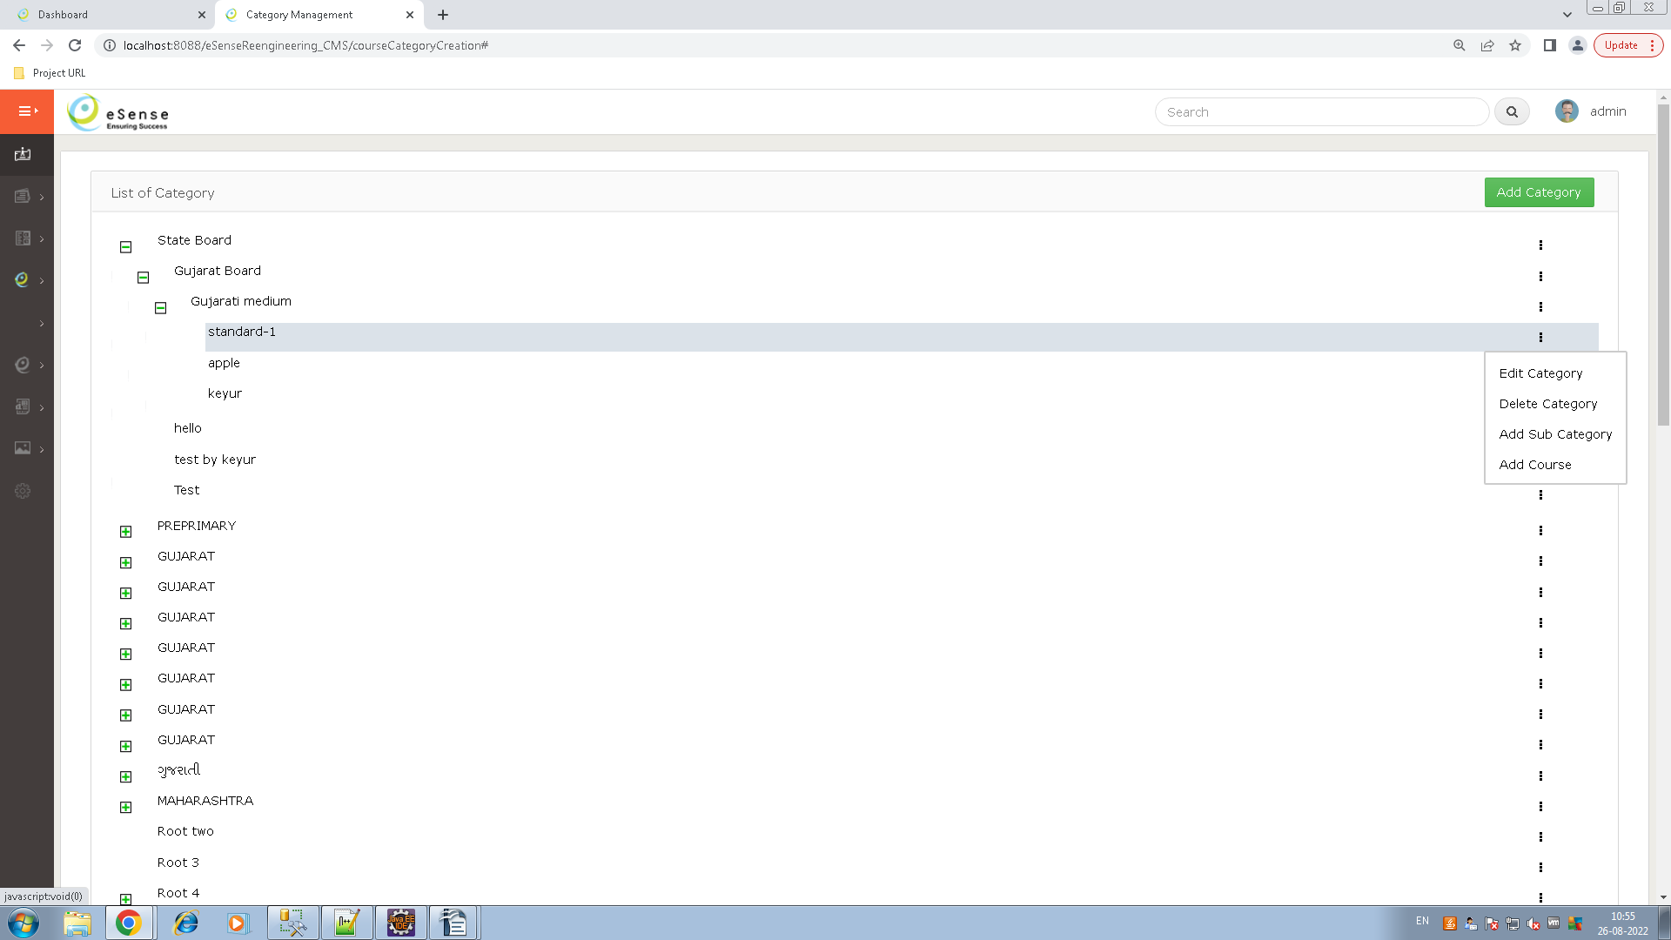
- Here we can create N-Level of category with thumbnail, and add course of any level of category by click on add course on toggle selection of category hierarchy.
- We managed minor and major version of parent(top) level category for generating update thorough versioning.
- Data Table :
  - course_category_master

Course Management
- Here we can create a course by selecting the category which we need to showing a course.
- Here showing listing of all active and inactive course, you can activate or De-activate course by clicking on the activate/De-activate toggle of course listing vice-versa
- If semester is required or not in the course then you can manage it by switch button while creating a course.
- If you set semester is required the while creating a chapter you need to selection of semaster is mandatory else not shown samaster while crating a chapter.
- If same course is in multiple product, you can select multiple product while creating a course.
- Course listing :
- Here in superadmin login showing 'Sync With TS' button, you can synch full course with TOPScorer by click on this button.
- Also you can copy a same course to different category by click on Copy Course of course listing toggle.
- Here you can select different copy selection for course like only Course details copy, Copy Course with chapters and topic, Copy course with chapter-topic and question bank, with/without data.
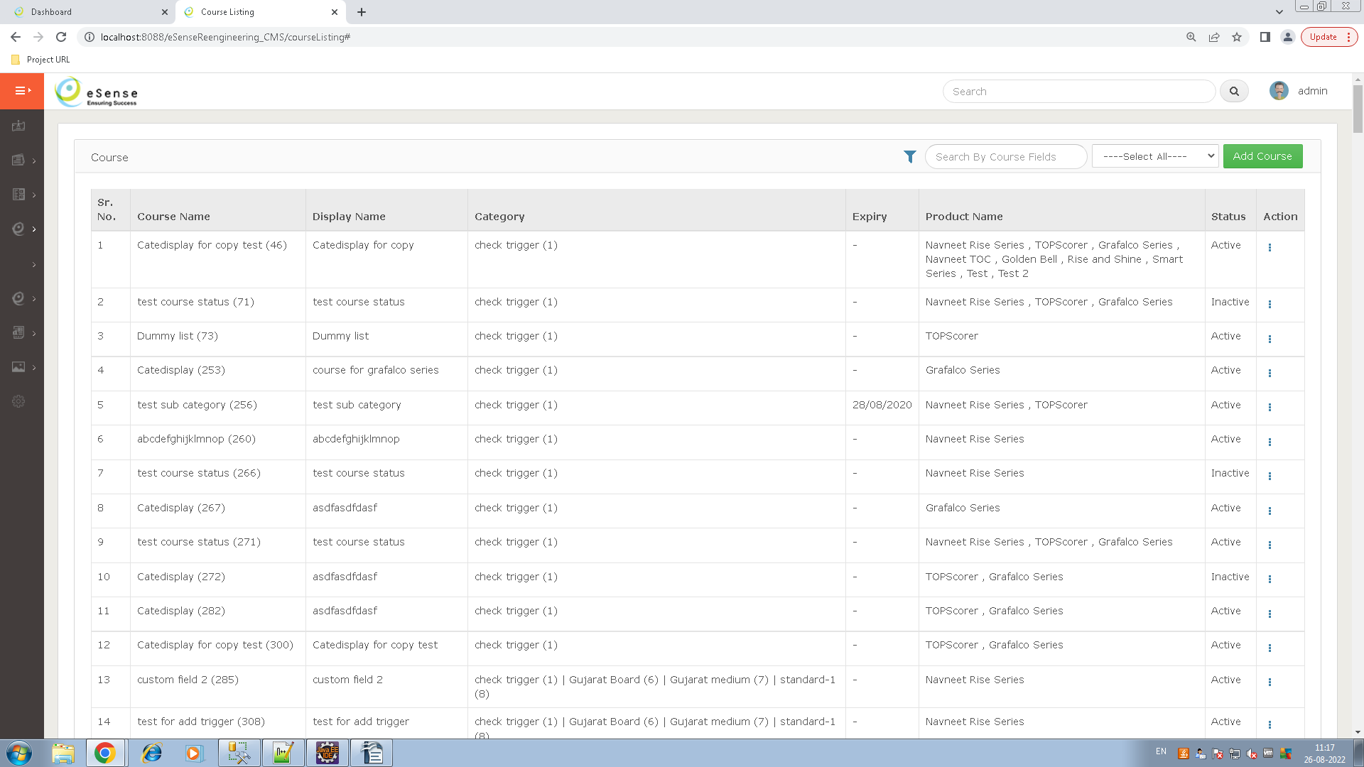
- Course creation :
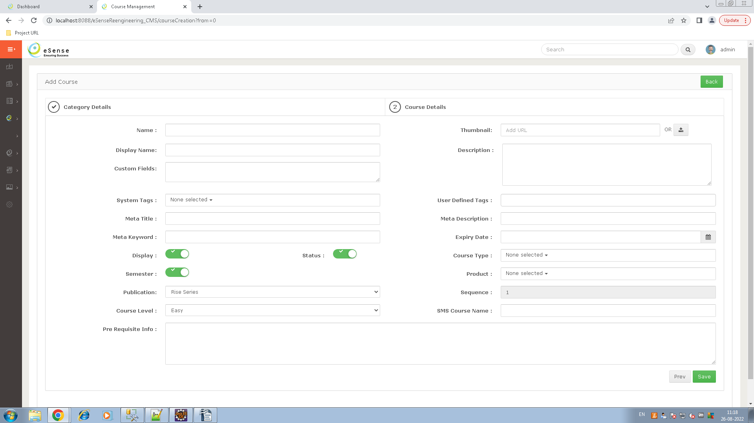
- If you creating an course for TOPScorer product then showing 'Add In Sub Category' button, here you can select multiple category.
- This functionality is use for top scorer it need to display same course in multiple category so we can add it by click on this button.
- Here calling EMS for product and feature id while save the course for licensing, and maped it in the course_ems_licence table.
- Data Tables :
  - course_course_master
  - course_tag_master
  - course_course_tag_transaction
  - course_content_type_master
  - course_course_content_type_mapping
  - course_category_mapping
  - course_ems_licence
  - course_sync_server_master
  - course_sync_status_tracker
- Question Creation
  - You can add/edit questions using course listing screen, click on 'Add Question' button of toggle of course listing to add/edit the questions.
  - It is almost same as QEM of syllabus.
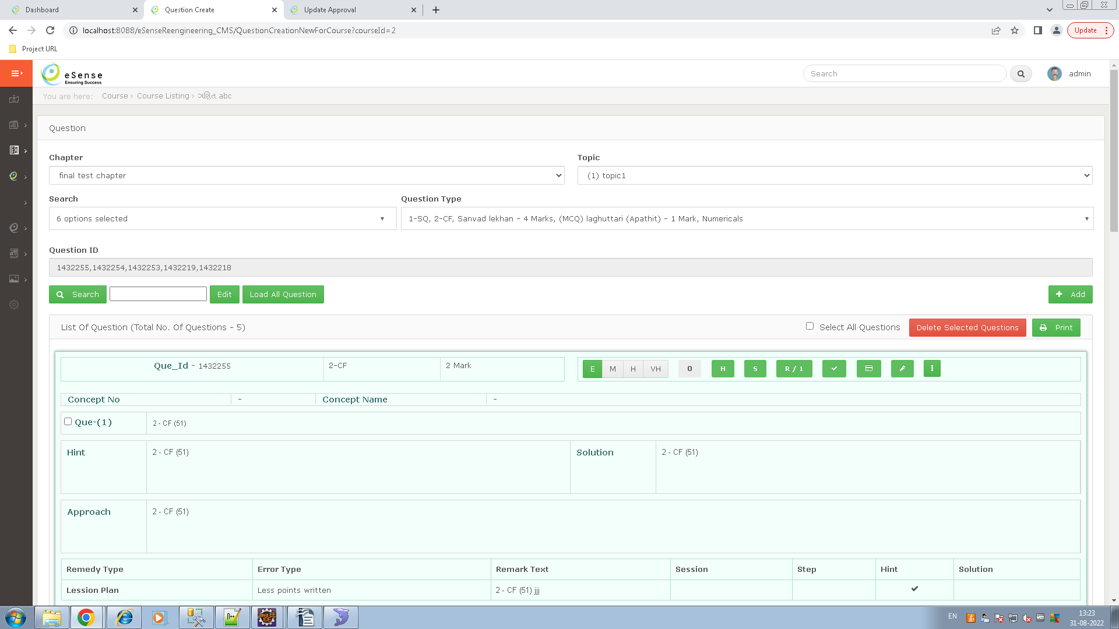
This question entry module is same as syllabus QEM so refere syllabus question entry module for more understanding.
  - Here only different in tc_question_mapping table we are added column like course_course_id,course_course_base_id, course_chapter_id and course_chapter_base_id.
- Data Table
  - tc_question_master (while insert new question)
  - tc_question_options (while insert new question)
  - tc_question_remedy (while insert new question)
  - tc_question_message_type (for selection remedy type/create new error type)
  - tc_question_mapping (while insert new question)
  - question_type_master (for selecting the question type)
- Chapter Creation
- You can create the chapter by click on the 'Add Chapter' of course listing toggle.
- Here displaying all the chapter hierarchy of this course you can add/edit and delete any level of chapter hierarchy.
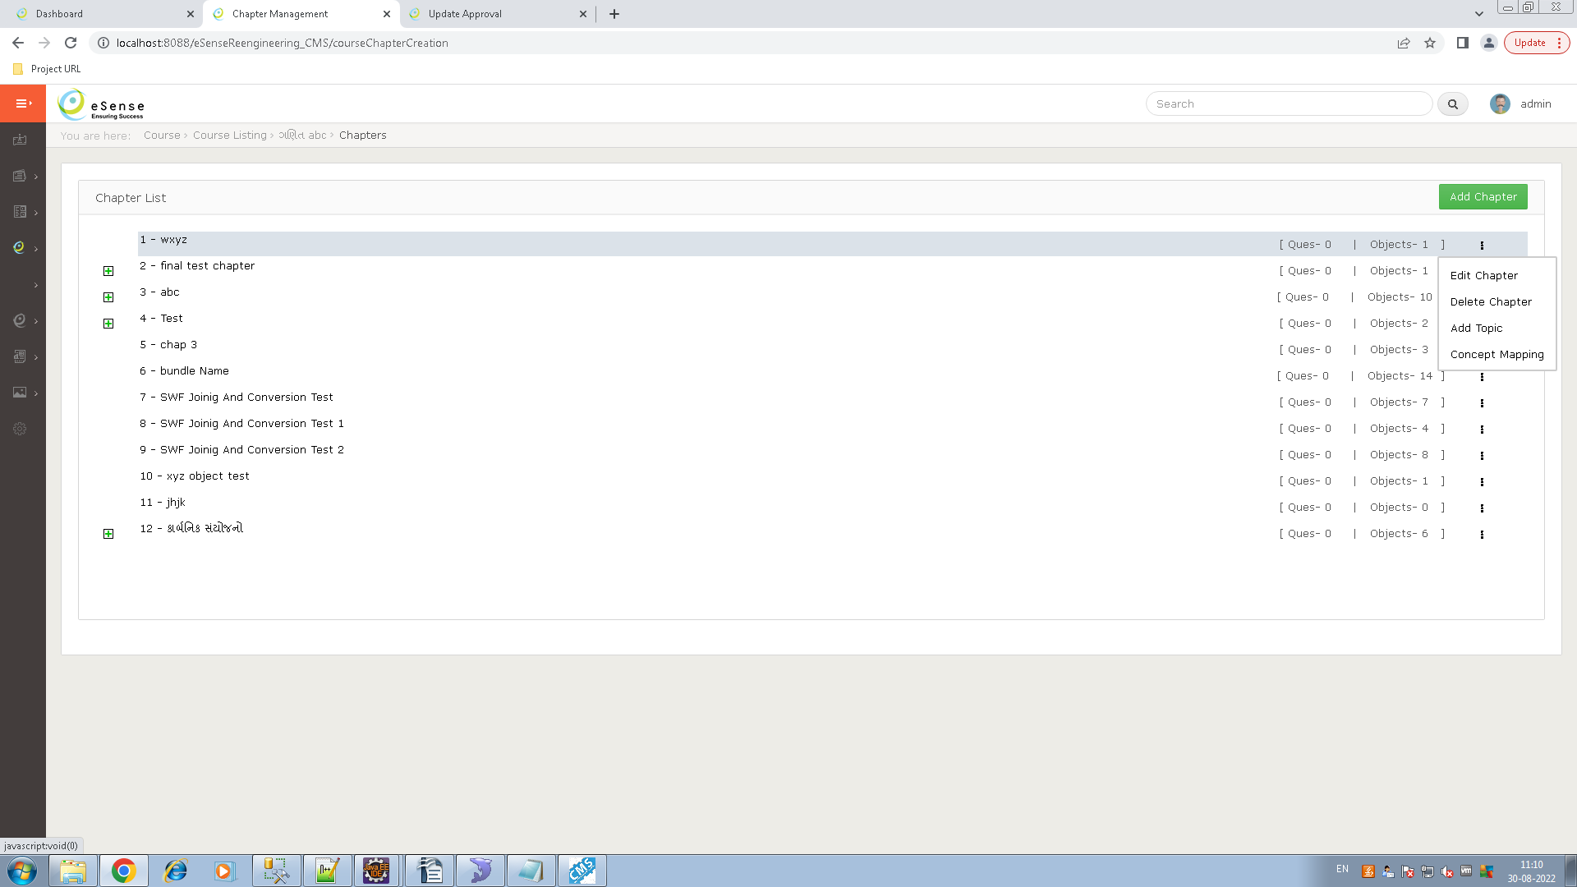
- Here you can map a object to chapter topic by click on 'Concept Mapping' of chapter/topic listing toggle.
- You can map object of different concept by selecting concept of left side window, after click on concept showing all object of selected concept showing in middle window, here select the object which needed in content tab and click on mode button.
- Add the different tab which have needed in right side window for content of selected chapter/topic and add objects in this tab using move button.
- Also add intro text and is display on ts flag for TOPScorer product by click on 'Add Intro Text' button.
- After added all the content you can save by click on save button.
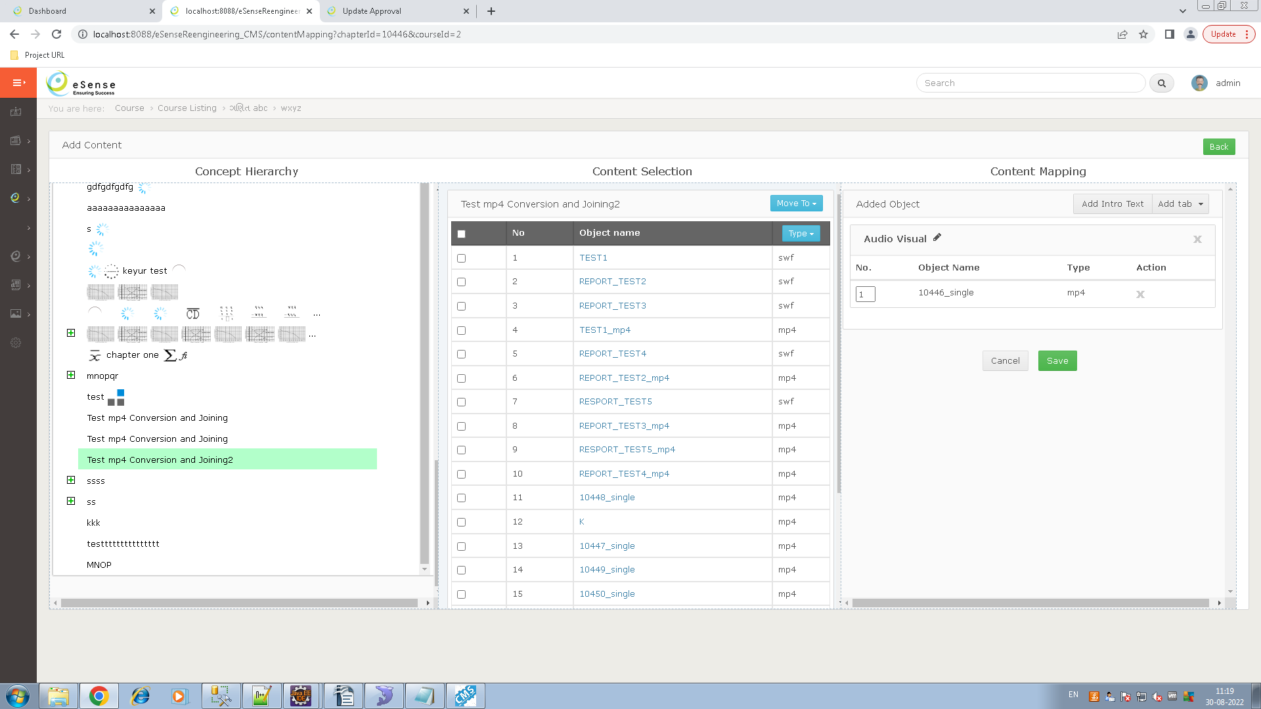
- Data Table
  - course_chapter_master
  - course_content_feature_master
  - course_chapter_content_feature_mapping
  - concept_master
  - concept_translation_details
  - object_master

- Course Bundle
  - Course bundle is collection of different product wise courses in a single package/bundle, here displaying list of all bundle and also you can displaying bundle with different filter applying on this screen.
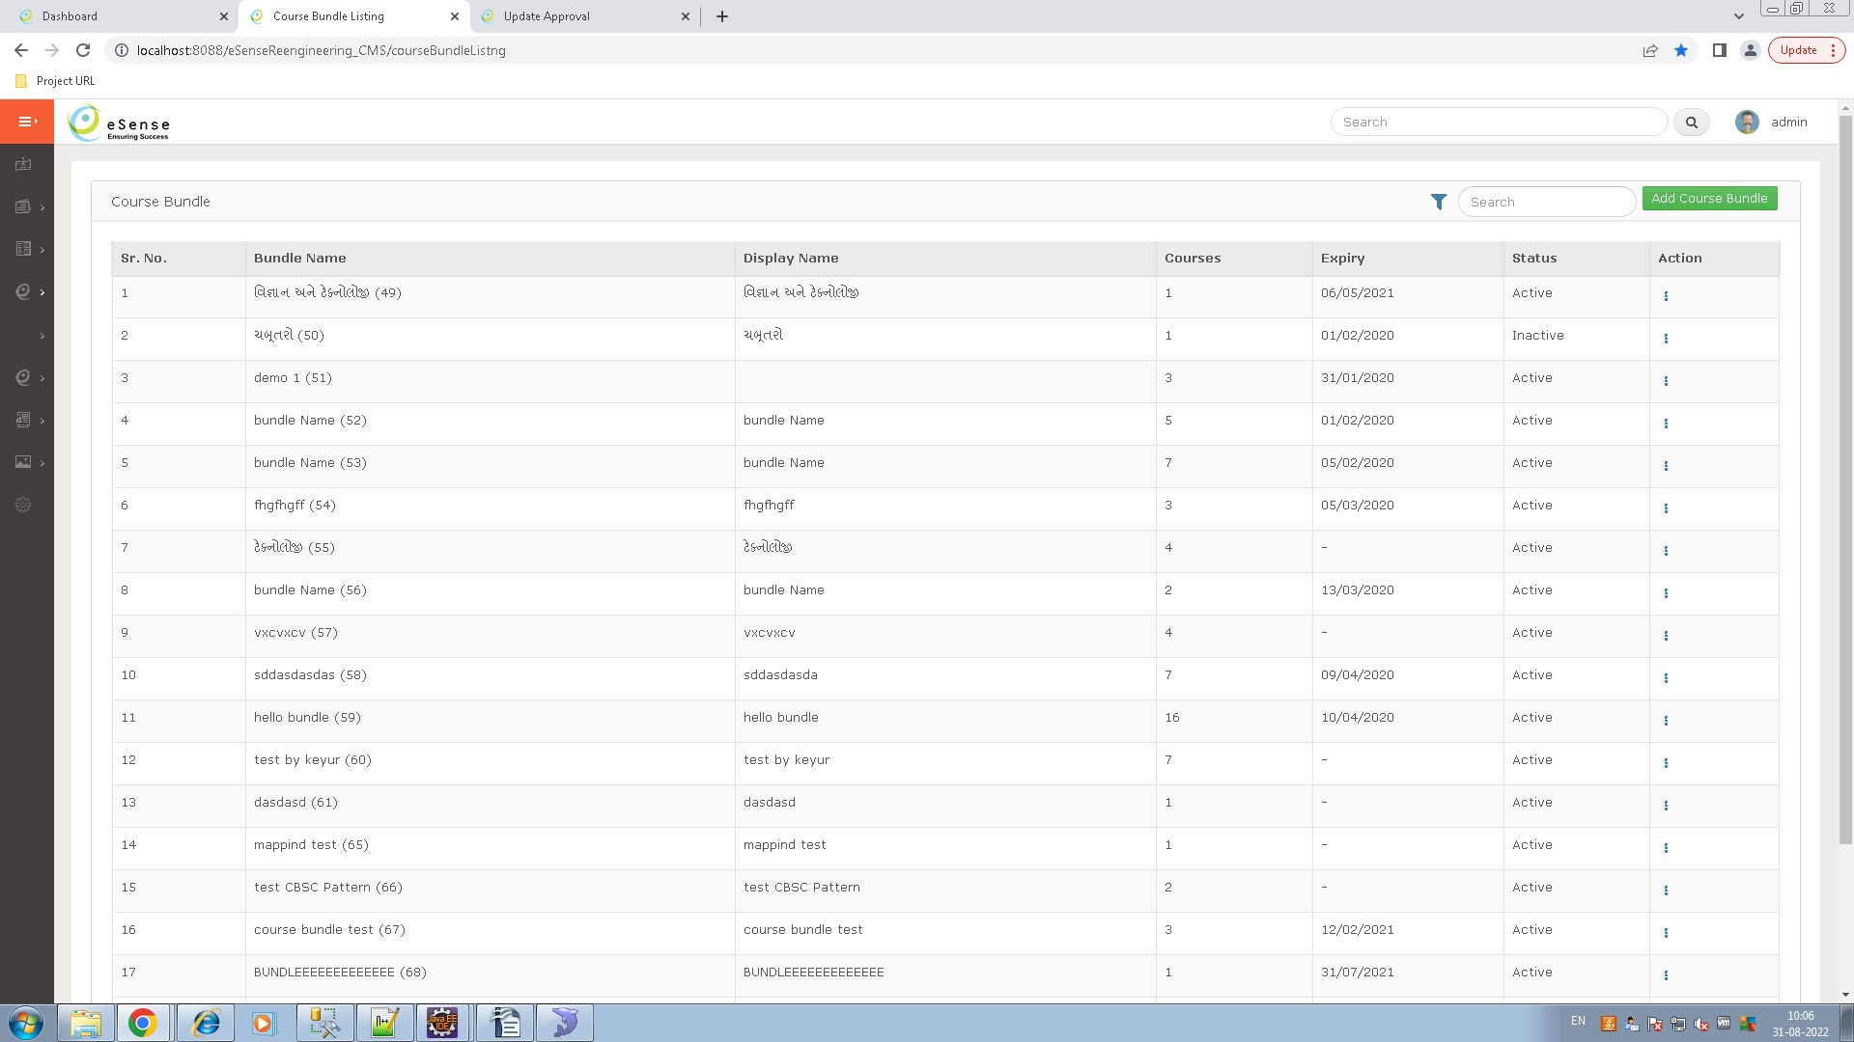
  - Using toggle of buindle listing you can active/de-active bundle and also edit the particular bundle.
  - Add Course Bundle
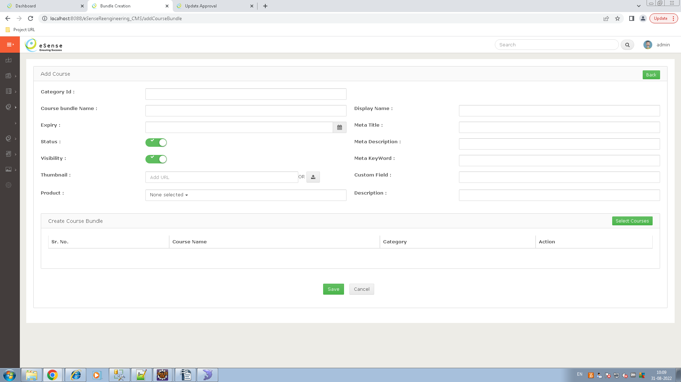

  - Fill all the mandatory field which have been need for bundle and click on save button to save the bundle.
  - Here category id is an id of category use for displaying bundle in particular category in TOPScorer, it's only use for TOPScorer product courses.
  - Selecting the product which have use to add courses of selected product in a bundle, click on 'Select Course' button to select the courses for bundle, here only displaing course of selected product.
- Data Table
  - course_bundle_master
  - course_bundle_course_mapping
  - course_category_mapping
- Course Burning
  - Course burning is an process of generating script and collecting data with encryption of selected courses and bundles as per product database/folder structure.
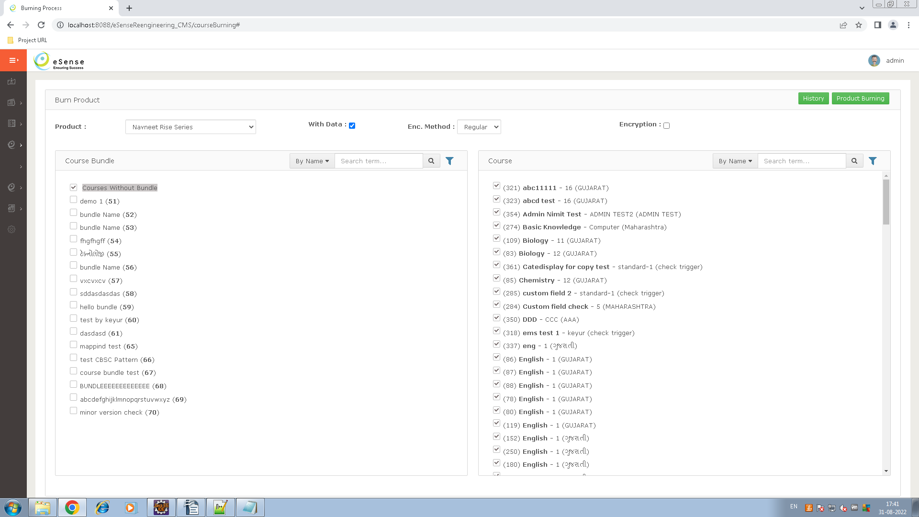
  - Here you can select courses and bundles by applying different filter, also you can select the checkbox as with data or not, we are burned a product in different two encryption method as 'Regular' or 'UTOP', you can select any one for burning to encrypt the data and question script using selected encryption method.
  - Also check the checkbox for encryption or not, this checkbox is used only question bank script is encrypt or not while burning.
  - After selection courses and bundle click on 'Product Burning' to open a popup, select the product for, and enter the comment and setup name and click on 'Burn product' to start an burning process.
  - In burning process we are pass final path to install4j and execute the command to start install4j process and it prepared the final setup for product.
- Release To Market
  - Select the hierarchy like syllabus year, board, medium, standard, and subject and click on the 'Show' button to showing chapter wise all new update of current year.
  - Purpose of this transaction is final approval from subject expert after update on any subject/topic/object etc..
  - Uses only after final setup is generated and some new update is arriving till current year.
  - Author can approve change log chapter by click on 'Approve' button
  - While click on 'Approve' button then modified 'update_tracker' table and set author_checked = 'approved_by_id', author_approved='1', Approved_on = 'Date'
  - once approval is done from subject expert then it go for update.

  - Data Table
    - update_tracker_tbl
- Generate Course update
  - Purpose of this transaction is generating update after final approval of a course author.
  - Here displaying product wise all updates of courses, we generate an update like (parent) level hierarchy, and Course(child) level hierarchy.
  - In update process first check the failed update in course_update_summary table, if found then first generated this update then current update is generated.
  - Process of update generation
    - check pending update
    - if pending update found then send it to s3 server with script and content bundle
    - Creating file path folder
    - encrypt the string and create query and put in sql file
    - encrypt object files and put in folder structure.

  - State of Update Summary Table
    - Stat 1 : Start update generation Process
    - Stat 1 :update generation validated
    - Stat 1 :update generation already running
    - Stat 2 : update generation validated
    - Stat 3 : update path created
    - Stat 4 : update records found
    - Stat 4 : update records not found
    - Stat 5 : update script generated successfully. but, error in file writing.
    - Stat : 5 error in update script generating
    - Stat 5 : update script/content written in file successfully
    - Stat 6 : Error in update zip creation
    - Stat 6 :update zip successfully created
    - Stat 6 : Error in update version changes (entity, update tracker table)
    - Stat 7 : cms success
    - Stat 8 : Error in sent aws zip to aws
    - Stat 9 :Error in collecting update entity in cms to aws
    - Stat 9 :Error in sent update entity to aws
    - Stat 9: Error in update version is sent to aws
    - Stat 10 : all success

  - Data Table
    - course_Update_summary – get pending update details, manage all flag.
    - course_update_tracker_table – generate final update.

