A

PROJECT REPORT

ON

**“Ghost - AI Desktop Assistant”**

Towards partial fulfilment of the requirement in

**4th Semester BSCIT (2022)**

**Submitted by:**

M. Faizan Faruk Bhagat (210510124002)

Dhruv Amrutbhai Desai (210510124006)

Gaurang Rajanikant Patel (210510124018)

**Submitted To:-**



**Parul Institute of Computer Application,**

**Parul University.**

Under the guidance of

Assistant Professor

JAY PANCHAL

**Acknowledgement**

*The success and final outcome of this project required a lot of guidance and assistance from many people and we are extremely privileged to have got this all along the completion of our project. All that we have done is only due to such supervision and assistance and we would not forget to thank them.*

*We respect and thank* ***Dr Priya Swaminarayan, Dean,*** *FITCS for providing us an opportunity to do the project work in BCA and giving us all support and guidance, which made us complete the project duly. We are extremely thankful to Mam for providing her support and guidance, although she had busy schedule managing the academic affairs.*

*We would not forget to remember* ***Prof. Hina Chokshi, HOD,*** *BCA department for her encouragement and more over for her timely support and guidance till the completion of our project work.*

*We owe our deep gratitude to our project guide* ***Assistant Professor Jay Panchal,*** *who took keen interest on our project work and guided us all along, till the completion of our project work by providing all the necessary information for developing a good system.*

*We are thankful to and fortunate enough to get constant encouragement, support and guidance from our Parents, all Teaching staffs of BCA Department which helped us in successfully completing our project work. Also, we would like to extend our sincere esteems to all staff in laboratory for their timely support.*

***[M. Faizan Faruk Bhagat] [210510124002]***

***[Dhruv Amrutbhai Desai] [210510124006]***

***[Gaurang Rajanikant Patel] [210510124018]***



PARUL INSTITUTE OF COMPUTER APPLICATION

**CERTIFICATE**

This is to certify that ***M. Faizan Faruk Bhagat, Dhruv Amrutbhai Desai, Gaurang Rajanikant Bhai*** the student(s) of Parul Institute of Computer Application, have satisfactorily completed the project entitled “***Ghost - AI Desktop Assistant****”* as a part of course curriculum in BSCIT semester-IV for the academic year 2021-2022 under guidance of ***Assistant Professor JAY PANCHAL.***

Enrollment Number: 210510124002

Enrollment Number: 210510124006

Enrollment Number: 210510124018

|  |  |  |
| --- | --- | --- |
| **Quality of work** | **Grade** | **Sign of Internal guide** |
| **Poor / Average / Good /**  **Excellent** | **B /B+ / A / A+** |  |

Date of submission:

HOD, Principal,

**Prof. Hina Chokshi** **Dr Priya Swaminarayan**

**INDEX**

|  |  |
| --- | --- |
| **Content** | **Page No.** |
| 1. Research | 01 |
| 1. Feasibility Studies | 02 |
| * 1. Technical Feasibility | 03 |
| * 1. Economic Feasibility | 03 |
| * 1. Operational Feasibility | 03 |
| 1. System Requirement Specification | 04 |
| * 1. Introduction to SRS | 04 |
| * 1. Abstract | 04 |
| * 1. System Users | 04 |
| * 1. Modules | 05 |
| * 1. Modules Description | 05 |
| * 1. Hardware / Software Requirement | 05 |
| * 1. Flow Chart | 06 |
| * 1. TimeLine Chart | 07 |
| 1. Technology Description | 08 |
| * 1. Features and Limitations of New System | 08 |
| 1. Data Flow Diagram | 09 |
| * 1. Context Level DFD’s | 09 |
| * 1. Level 1 DFD’s | 09,10 |
| * 1. Level 2 DFD’s | 11,12 |
| * 1. Level 3 DFD’s | - |
| 1. Use Case Diagram | 13,14 |
| 1. Class Diagram | 15 |
| 1. Activity Diagram | 16 |
| * 1. Description of Activity Diagram | 16 |
| 1. E-R Diagram | - |
| * 1. E-R Diagram Description | - |
| 1. Data Dictionary | 17 |
| * 1. Description of Data Dictionary | 17 |
| 1. Form Design (Screenshots Phase 1, 2, 3, 4 and Validation’s Screenshots) | 18,19 |
| 1. What is Testing? | 20 |
| * 1. Importance and Types of Testing | 20 |
| 1. Future Enhancement | 21 |
| 1. References and Bibliography | 22 |

1. **Research**
   1. **What is research?**

Research is an organized investigation into a specific topic or problem in order to discover new information, draw conclusions and provide solutions. It is an in-depth study of a subject or topic that involves gathering information from a variety of sources, such as books, articles, interviews, surveys, and experiments. Research is often used to expand knowledge and solve problems.

* 1. **Types of Research Methodology**

Research methodology is the process used to collect information and data for the purpose of making business decisions. It involves several steps, such as defining a research question, gathering data, evaluating sources, analyzing data, and reporting the findings.

There are four types of Research Methodology: -

* Qualitative vs. quantitative.
* Quantitative research.
* Qualitative research.
* Mixed methods research.

1. **Feasibility Studies**

**What is Feasibility?**

A feasibility study is a detailed analysis that considers all of the critical aspects of a proposed project in order to determine the likelihood of it succeeding.

* 1. **Technical Feasibility**

Technical Feasibility can be described as the formal process of assessing whether it is technically possible to manufacture a product or service. Before launching a new offering or taking up a client project, it is essential to plan and prepare for every step of the operation. Technical feasibility helps determine the efficacy of the proposed plan by analysing the process, including tools, technology, material, labour and logistics.

* 1. **Economic Feasibility**

The purpose of an economic feasibility study is to demonstrate the net benefit of a proposed project for accepting or disbursing electronic funds/benefits, taking into consideration the benefits and costs to the agency, other state agencies, and the general public as a whole.

* 1. **Operational Feasibility**

Operational feasibility is the measure of how well a proposed systemsolves the problems, and takes advantage of the opportunities identified during scope definition and how it satisfies the requirements identified in the requirements analysis phase of system development.

* 1. **Importance of Feasibility Studies**

Feasibility studies can identify the logistical, financial, and market challenges of a proposed project by evaluating: What the estimate would be to fund the project. When the potential business will offer a return on investment. The market for the proposed product or service.

* 1. **Feasibility Study of our Proposed System**

**2.5.1 Technical Feasibility**: This involved investigating the function, performance, and limits that may have an impact on the ability to build an acceptable Software. We investigated the whole functionality to be given in the software, as defined in the system requirement specification, and determined whether everything was feasible utilising several types of frontend and backend platforms.

**2.5.2 Economical Feasibility:** This is a critical factor to consider while creating a project. We chose the technology with the lowest feasible cost in mind. The organisation must bear all hardware and software costs. Overall, we estimate that the advantages the organisation would obtain from the proposed system will more than offset the system's initial and ongoing expenditures.

**2.5.3 Operational Feasibility:** Without a doubt, the suggested system is entirely GUI-based, making it incredibly user-friendly, and all inputs are self-explanatory even to a layperson. Furthermore, sufficient training has been provided to users in order for them to understand the essence of the system and feel at ease with the new system.

1. **System Requirement Specification**
   1. **Introduction To SRS**

A software requirements specification is a comprehensive description of the intended purpose and environment for software under development. The SRS fully describes what the software will do and how it will be expected to perform.

* + 1. **What is SRS?**

A software requirements specification is a description of a software system to be developed. It is modelled after business requirements specification. The software requirements specification lays out functional and non-functional requirements, and it may include a set of use cases that describe user interactions that the software must provide to the user for perfect interaction**.**

* + 1. **Need of SRS**

Requirement Specification is a descriptive note about the software that is under development. It is documented by the developer of the software for the clients and users and describes the purpose of the software. It gives a detailed overview of the software product, its parameters and goals.

* 1. **Abstract**

Artificial Intelligence is the future of the IT industry. It is an emerging field in right direction and help us achieve our goal in an easier and systematic manner. As a technologist, one who develops it, must program the AI in a manner so that its capacity is used as a boom and not as a curse.

* 1. **System Users**

1. Admin
2. User
   * 1. **Description of User Role**
3. Admin

Manage the database of Username & Passwords as well it also manages the database of User Queries.

1. User

He/she give commands to automate task.

* 1. **Modules**
* Registration
* Login
* Commands
  1. **Modules Description**
* Registration

Users have to create a new account by entering their email id’s, username and password for registration in Ghost.

* Login

It enables user to use Ghost by entering accurate credentials in login module.

* Commands

User gives different commands to automate their task such as to know the time, to know the temperature, to set the alarm, to open websites, to search Wikipedia, to do arithmetic calculation, to do file operation (create, move, delete) from respective directories etcetera.

* 1. **Hardware Requirements**

|  |  |
| --- | --- |
| **Name of Components** | **Specification** |
| Processor | Intel and AMD Ryzen |
| RAM | 2 GB or more |
| Hard Disk | 40 GB to 80 GB |

* 1. **Software Requirements**

|  |  |
| --- | --- |
| **Name of Components** | **Specification** |
| Operating System | Windows, Linux |
| Software development Kit | Python |
| Tools & languages | TKinter, Python |

* 1. **System Flow Diagram**

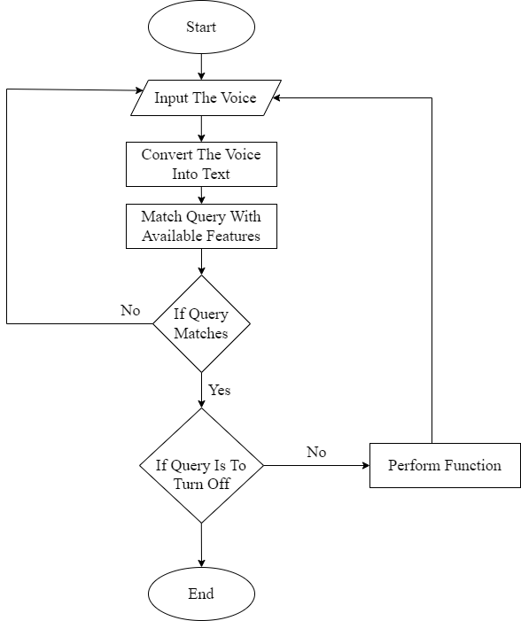

* 1. **Time Line Chart**

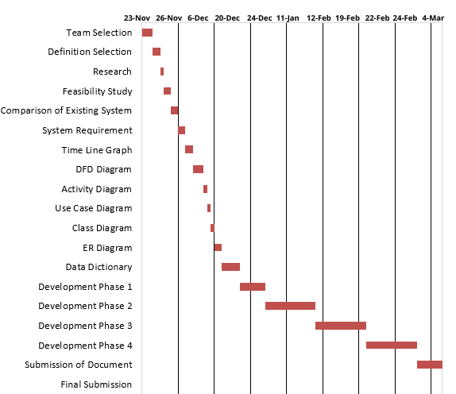

Figure 3.7.1. Time Line Chart

1. **Technology Description**
   1. **Features and Limitations of New System**

|  |  |
| --- | --- |
| **Existing System** | **New System** |
| Able to see current time | Integrated Machine Learning |
| Able to set alarm | More Optimum Listening |
| Able to see temperature | Command will be given in Hindi Language |
| Able to do arithmetic calculation | More Secure |
| Able to open any websites | Fast Processing & Less Reaction Time |
| Able to do file Operation such as create, move and delete file | Will be able to do More accurate file operation |
| Able to search from any Wikipedia | Will add more automation Feature |

1. **Data Flow Diagram**
   1. **Context Level DFD’s**

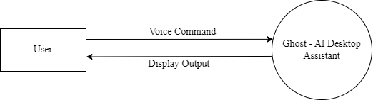

* 1. **Level 1 DFD’s: (Admin)**

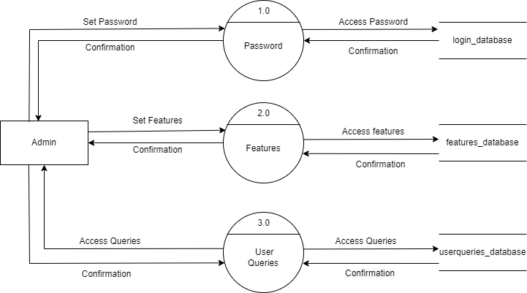

* 1. **Level 1 DFD’s: (User)**

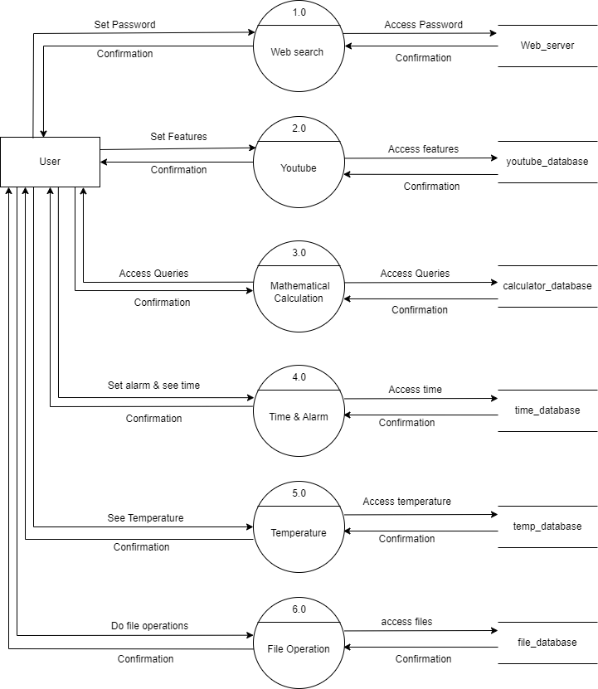

* 1. **Level 2 DFD’s: (Admin)**

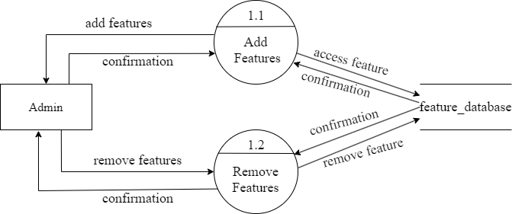

* 1. **Level 2 DFD’s: (User)**

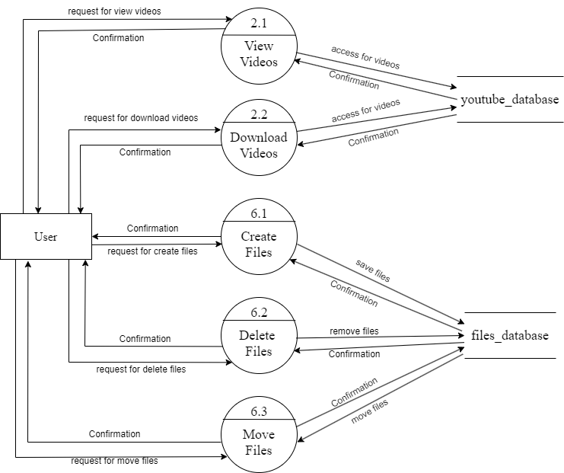

1. **Use Case Diagram**

**Admin**

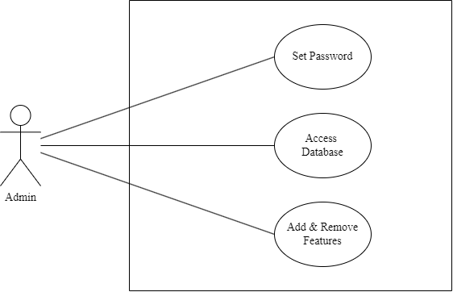

**User**

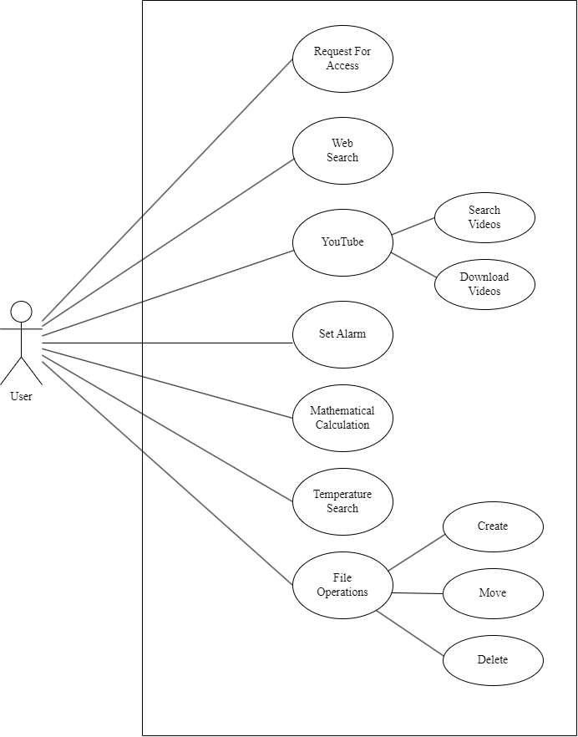

1. **Class Diagram**

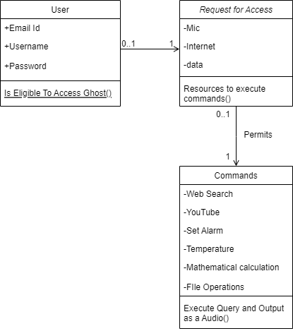

1. **Activity Diagram**

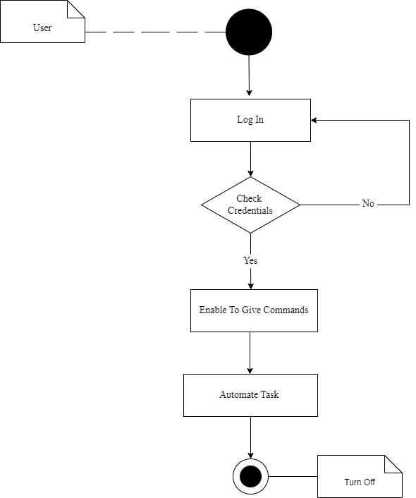

* 1. **Description of Activity Diagram**

User log in the system by enter accurate his/her credentials. By Successfully login it enables user to give commands to Ghost. And Ghost will automate task according to user’s queries. After given all commands user have to turn of the Ghost.

1. **Data Dictionary**
2. **Table Name:** User

**Table Description: It includes user’s information.**

|  |  |  |  |  |  |  |
| --- | --- | --- | --- | --- | --- | --- |
| **Sr. No** | **Field Name** | **Datatype** | **Size** | **Description** | **Constraint** | **Example** |
| 1 | Id | Int | - | User_id of user & it’s auto increment | PRIMARY KEY | 303 |
| 2 | Email | Varchar | 50 | Email id of user | NOT NULL | [abc@gmail.com](mailto:abc@gmail.com) |
| 3 | Username | Varchar | 50 | Username of user | NOT NULL | Bscit |
| 4 | Password | Varchar | 20 | Password of user | NOT NULL | 20122001 |

* 1. **Description of Data Dictionary**

Ghost includes only user’s database for now. In User’s database in includes four fields such as ID, EMAIL, USERNAME, PASSWORD. ID field has Int database, EMAIL field includes Varchar datatype with 50 size, USERNAME field includes Varchar datatype with 50 size and PASSWORD includes Varchar datatype with 20 size. Among all fields only User_id field are having PRIMARY KEY constraint and other fields are having NOT NULL constraint.

1. **Form Design (Screenshots Phase 1 ,2,3,4 & validation’s screenshots)**
   1. **Development Phase -1**

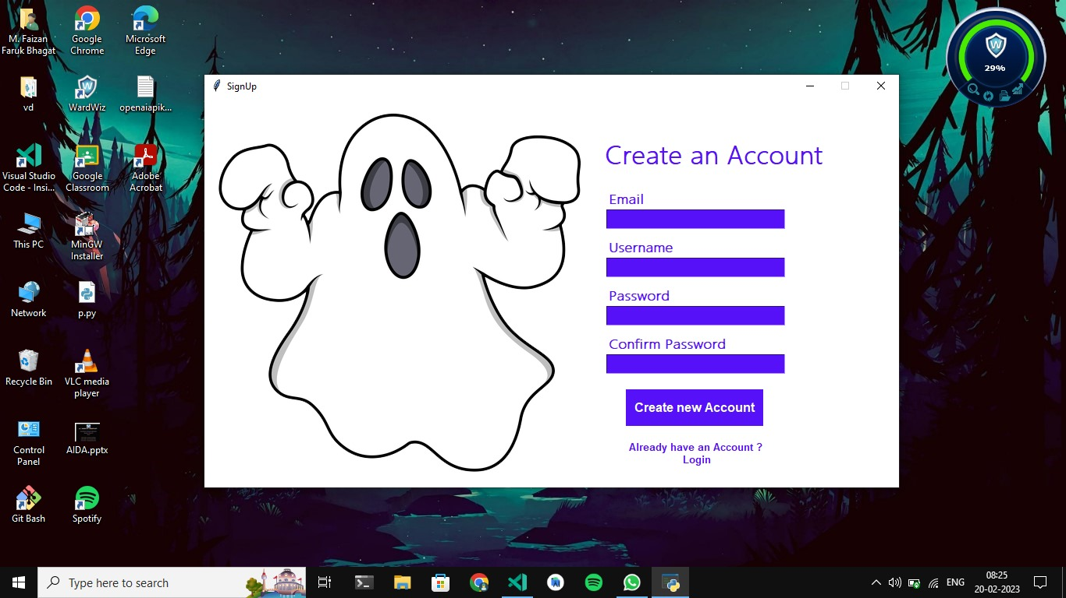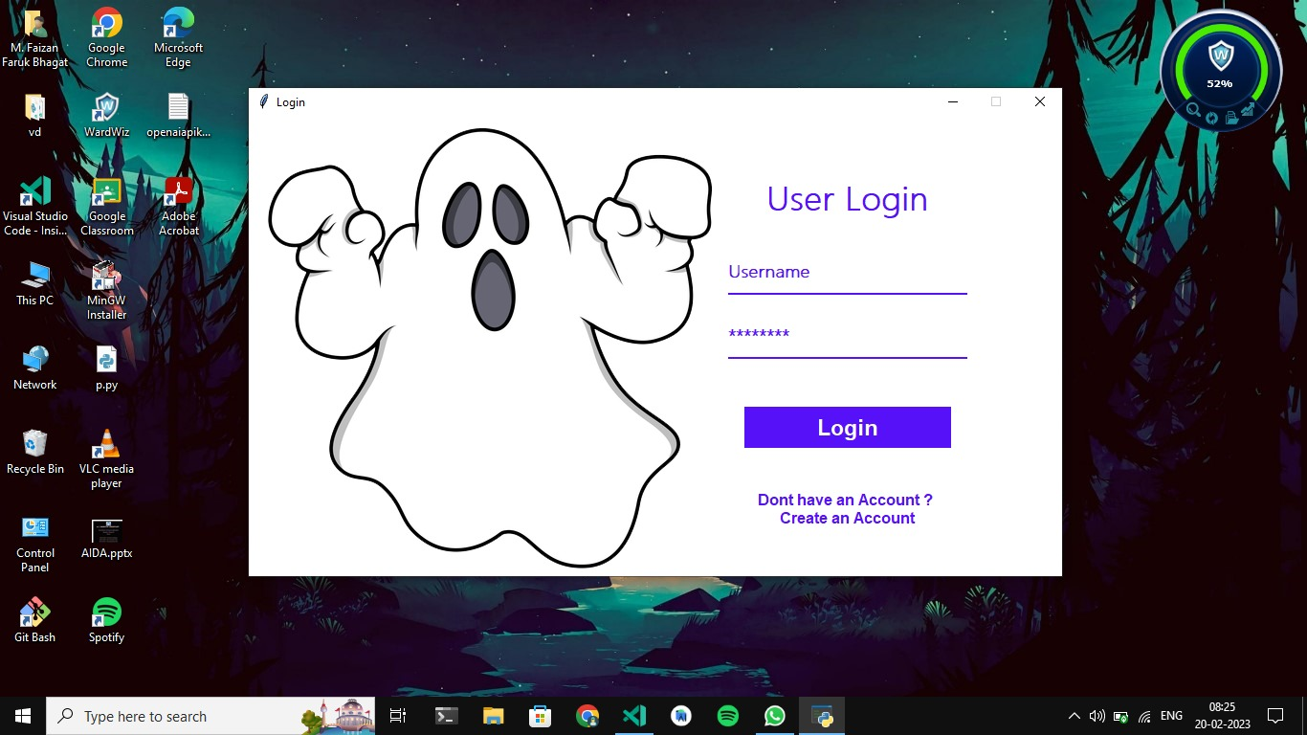

* 1. **Development Phase -2**

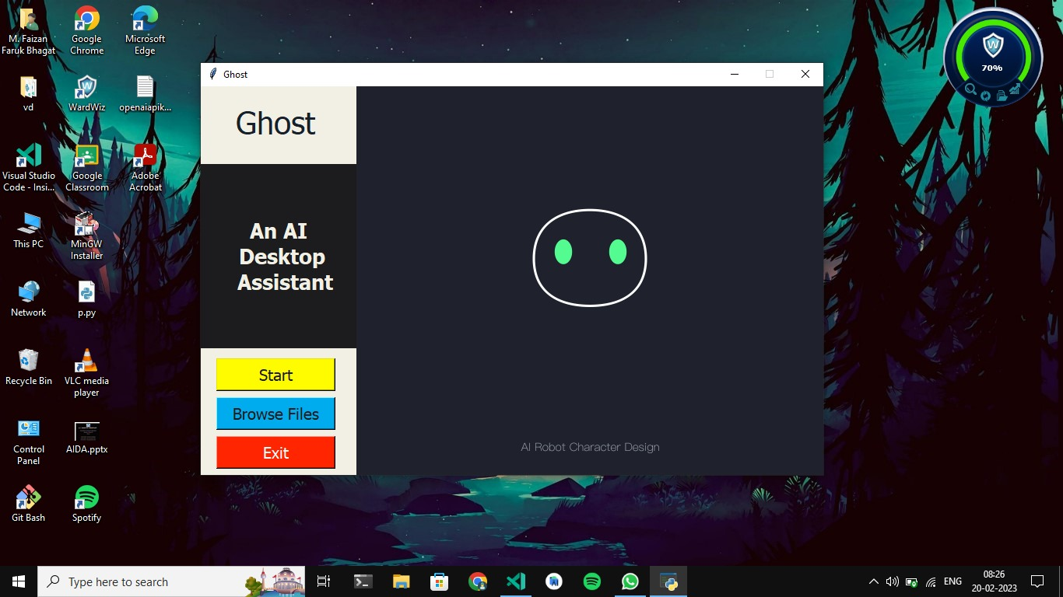

* 1. **Development Phase -3**

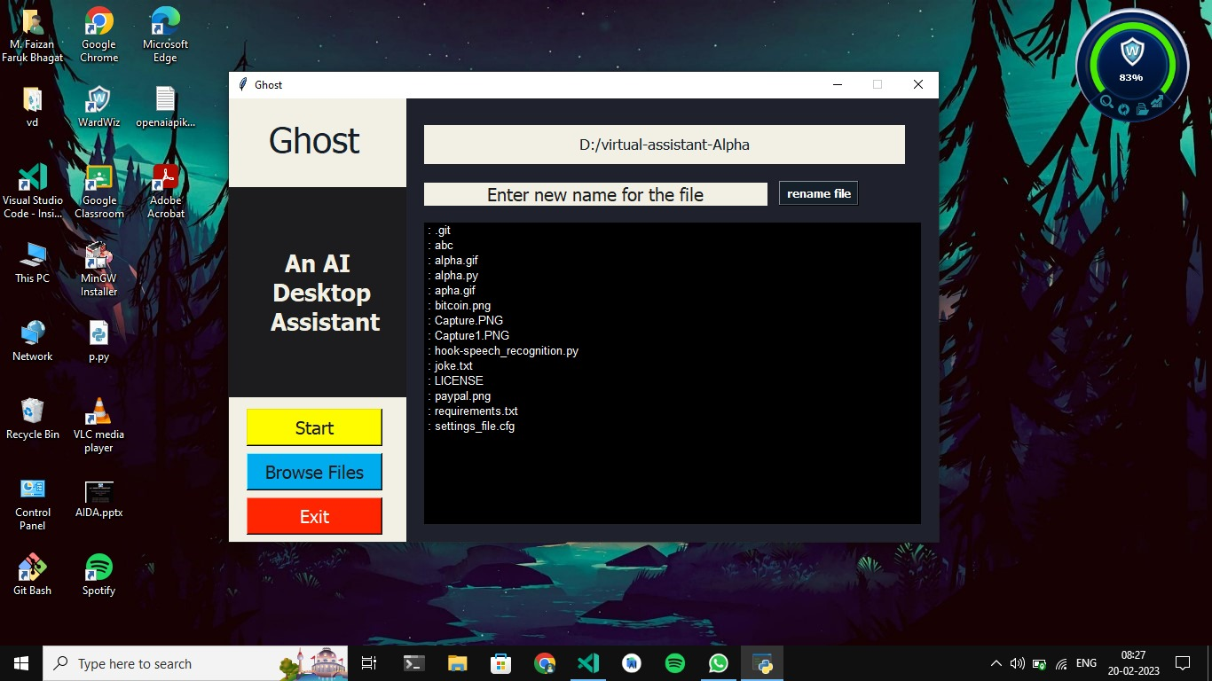

* 1. **Development Phase -4**

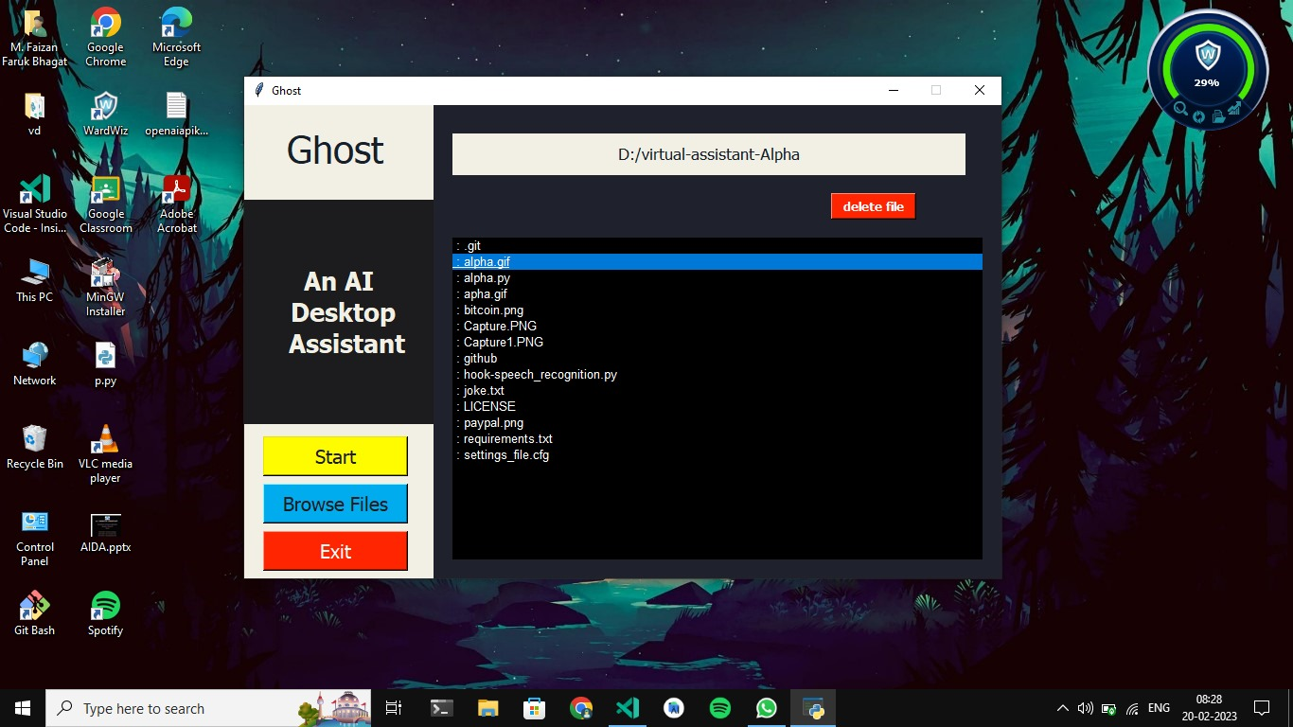

**11. What is testing?**

**11.1. Importance and types of testing**

Software testing is the process of evaluating and verifying that a software product or application does what it is supposed to do. The benefits of testing include preventing bugs, reducing development costs and improving performance.

Types of testing ­: -

* Black Box Testing: -

Black Box Testing is a software testing method in which the internal structure/design/implementation of the item being tested is not known to the tester. Only external design and structure are tested.

* White Box Testing: -

White Box Testing is a software testing method in which the internal structure/design/implementation of the item being tested is known to the tester. Implementation and impact of the code are tested.

1. **Future Enhancement**

* In Future Enhancement we would like to Integrate Machine Learning.
* Also improve module of listening.
* We would also like to add Different language as a listening module such as Hindi.
* Ghost will be more secure in nearest time.
* It will also have fast processing time and less Reaction time.
* Ghost will be able to do more accurate file operation such as rename file.
* We also well add more automate feature as commands in Ghost in upcoming future.

1. **References & Bibliography**

* [chat.openai.com](https://chat.openai.com/chat))
* [Iron Man Jarvis AI Desktop Voice Assistant - YouTube](https://www.youtube.com/watch?v=Lp9Ftuq2sVI)
* [Wolfram Alpha](http://en.wikipedia.org/wiki/WolframAlpha)
* Artificial Intelligence for Dummies Book
* Automate Boring Stuff Using Python