**A**

**Project Report**

**On**

**Networking Web Application for Developers**

**Submitted by**

***M. Faizan Faruk Bhagat [210510124002]***

***Priya JayeshBhai Dalvi [210510124005]***

***Dhruv Amrutbhai Desai [210510124006]***

***Gaurang Rajanikant Patel [210510124018]***

***Shiv Jigneshkumar Patel [210510119002]***

**as**

**Partial fulfilment of Semester V**

**of Bachelor of Science in Information Technology**

**for A.Y. 2023-2024**

**Under the Guidance of**

**Assistant Professor**

**Megha Trivedi**

**Submitted To**

**Parul Institute of Computer Application,**

**Faculty of IT & Computer Science**

**Parul University**





**Acknowledgement**

*The success and final outcome of this project required a lot of guidance and assistance from many people and we are extremely privileged to have got this all along the completion of our project. All that we have done is only due to such supervision and assistance and we would not forget to thank them.*

*We respect and thank* ***Dr. Priya Swaminarayan, Dean,*** *FITCS for providing us an opportunity to do the project work in BCA and giving us all support and guidance, which made us complete the project duly. We are extremely thankful to Mam for providing her support and guidance, although she had busy schedule managing the academic affairs.*

*We would not forget to remember* ***Dr. Hina Chokshi, HOD,*** *BCA department for her encouragement and more over for her timely support and guidance till the completion of our project work.*

*We owe our deep gratitude to our project guide* ***Assistant Professor Megha Trivedi,*** *who took keen interest on our project work and guided us all along, till the completion of our project work by providing all the necessary information for developing a good system.*

*We are thankful to and fortunate enough to get constant encouragement, support and guidance from our Parents, all Teaching staffs of BCA Department which helped us in successfully completing our project work. Also, we would like to extend our sincere esteems to all staff in laboratory for their timely support.*

***[M. Faizan Faruk Bhagat] [210510124002]***

***[Priya Jayeshbhai Dalvi] [210510124005]***

***[Dhruv Amrutbhai Desai] [210510124006]***

***[Gaurang Rajanikant Patel] [210510124018]***

***[Shiv Jigneshkumar Patel] [210510119002]***



**PARUL INSTITUTE OF COMPUTER APPLICATION**

**CERTIFICATE**

This is to certify that ***M. Faizan Faruk Bhagat, Priya Jayeshbhai Dalvi, Dhruv Amrutbhai Desai, Gaurang Rajanikant Patel, Shiv Jigneshkumar Patel*** the students of Parul Institute of Computer Application, have satisfactorily completed the project entitled “***Networking Web Application for Developers”*** as a part of course curriculum in BSCIT semester-V for the academic year 2023-2024 under guidance of ***Assistant Professor MEGHA TRIVEDI.***

Enrolment Number: 210510124002

Enrolment Number: 210510124005

Enrolment Number: 210510124006

Enrolment Number: 210510124018

Enrolment Number: 210510119002

|  |  |  |
| --- | --- | --- |
| **Quality of work** | **Grade** | **Sign of Internal guide** |
| **Poor / Average / Good /Excellent** | **B /B+ / A / A+** |  |

Date of submission:

HOD, Principal,

Prof. Hina Chokshi Dr. Priya Swaminarayan

**Abstract**

* The networking web application for developers is a casual platform that facilitates developer to connect and interact with each other. This provides a space where a developers can get to know about other developers working on similar or various technologies. Here, Developers get aware of skills, achievement and experiences of other developers, providing opportunities to them to collaborate. Here, users can manage their profile, add skills and their description, also can showcase their certifications. User can also post feed, like, comment or save a post. User can create resume as well as can attend technical test modules. User can also make connections.

**INDEX**

|  |  |
| --- | --- |
| **Content** | **Page No.** |
| 1. Research | 1 |
| 1. Feasibility Studies | 2 |
| * 1. Technical Feasibility | 2 |
| * 1. Economic Feasibility | 2 |
| * 1. Operational Feasibility | 3 |
| 1. System Requirement Specification | 4 |
| * 1. Introduction to SRS | 4 |
| * 1. System Users | 5 |
| * 1. Modules | 5 |
| * 1. Modules Description | 5 |
| * 1. Hardware / Software Requirement | 6 |
| * 1. Flow Chart | 7 |
| * 1. TimeLine Chart | 8 |
| 1. Technology Description | 9 |
| * 1. Features and Limitations of New System | 9 |
| 1. Data Flow Diagram | 10 |
| * 1. Context Level DFD’s | 10 |
| * 1. Level 1 DFD’s | 11 |
| * 1. Level 2 DFD’s | 12 |
| 1. Use Case Diagram | 13 |
| 1. Class Diagram | 14 |
| 1. Activity Diagram | 15 |
| * 1. Description of Activity Diagram | 16 |
| 1. Sequence Diagram | 17 |
| 1. E-R Diagram | 18 |
| * 1. Description of E-R Diagram | 18 |
| 1. Data Dictionary | 19 |
| * 1. Description of Data Dictionary | 23 |
| 1. Form Design (Screenshots Phase 1, 2, 3, 4 and Validation’s Screenshots) | 24 |
| 1. What is Testing? | 28 |
| * 1. Importance and Types of Testing | 28 |
| 1. Future Enhancement | 29 |
| 1. References and Bibliography | 30 |

1. **Research**
   1. **What is research?**

Research refers to the systematic investigation, study, and analysis of a particular topic or issue in order to gain new knowledge, insights, or understanding. It involves the exploration and examination of existing information, data, theories, or phenomena, as well as the formulation of hypotheses, collection of data, analysis of results, and drawing of conclusions.

* 1. **Types of Research Methodology**

There are several types of research methodologies that can be employed in various fields of study. Here are some commonly used research methodologies:

**Experimental Research**: This involves manipulating variables and measuring their effects in controlled settings to establish cause-and-effect relationships.

**Correlational Research**: This approach examines the statistical relationship between two or more variables to determine if they are associated with each other, without implying causation.

**Qualitative Research**: This methodology focuses on understanding and interpreting people's experiences, beliefs, and motivations. It involves collecting data through interviews, observations, or textual analysis and often uses thematic analysis or grounded theory to derive meaning from the data.

**Quantitative Research**: This methodology involves collecting numerical data and analyzing it statistically to identify patterns, trends, and relationships. It typically relies on structured surveys, experiments, or large-scale data analysis.

1. **Feasibility Studies**

**What is Feasibility?**

* Feasibility refers to the practicality and viability of a project, idea, or plan. It assesses whether something is achievable, realistic, and economically and technically feasible. Feasibility studies are conducted to evaluate the potential success of a project or initiative before investing significant resources into its implementation.
  1. **Technical Feasibility**
* This assesses whether the necessary technology, equipment, infrastructure, and resources are available or can be developed to support the project.
  1. **Economic Feasibility**
* This evaluates the financial viability of the project by estimating costs, potential revenues, and return on investment. It considers factors such as market demand, pricing, competition, and long-term sustainability.
  1. **Operational Feasibility**
* This examines whether the project can be effectively implemented and integrated into existing systems or processes. It considers organizational capacity, human resources, skills, and potential impact on day-to-day operations.
  1. **Importance of Feasibility Studies**
* Feasibility is of utmost importance in ecommerce as it enables businesses to assess the viability, practicality, and potential success of a project. It helps allocate resources effectively, mitigate risks, evaluate financial viability, analyse the market, optimize operations, and make informed decisions. By conducting a thorough feasibility study, businesses can increase their chances of launching and sustaining a successful ecommerce venture.
  1. **Feasibility Study of our Proposed System**
* **Technical Feasibility**: Technical Feasibility can be described as the formal process of assessing whether it is technically possible to manufacture a product or service. Before launching a new offering or taking up a client project, it is essential to plan and prepare for every step of the operation. Technical feasibility helps determine the efficacy of the proposed plan by analysing the process, including tools, technology, material, labour and logistics.
* **Economic Feasibility**: The purpose of an economic feasibility study is to demonstrate the net benefit of a proposed project for accepting or disbursing electronic funds/benefits, taking into consideration the benefits and costs to the agency, other state agencies, and the general public as a whole.
* **Operational Feasibility:** Operational feasibility is the measure of how well a proposed system solves the problems, and takes advantage of the opportunities identified during scope definition and how it satisfies the requirements identified in the requirements analysis phase of system development.

1. **System Requirement Specification**
   1. **Introduction To SRS**

The Software Requirements Specification (SRS) serves as a comprehensive document that outlines the detailed requirements for a software project. It acts as a blueprint or roadmap that guides the development team in building the desired software system. The SRS document is typically created during the early stages of the software development life cycle and serves as a reference for stakeholders, including clients, project managers, developers, and testers**.**

**3.1 What is SRS?**

SRS stands for Software Requirements Specification. It is a document that serves as a formal and detailed representation of the requirements for a software system. The SRS document outlines the functionalities, features, and constraints of the software, providing a clear and comprehensive understanding of what the system should accomplish.

* + 1. **Need of SRS**

The need for a Software Requirements Specification (SRS) in ecommerce or any software development project is essential for several reasons:

**Clear Communication:** An SRS serves as a comprehensive document that clearly communicates the requirements and expectations of the ecommerce project to all stakeholders involved, including business owners, developers, designers, and testers. It helps ensure a common understanding of the project's scope, functionalities, and constraints, reducing misunderstandings and ambiguities.

**Requirement Analysis**: The SRS acts as a foundation for the requirement analysis process. It helps identify and document the specific features, functionalities, and performance criteria that the ecommerce system should possess. This analysis helps in identifying any gaps or inconsistencies in the requirements early on, allowing for timely adjustments and improvements.

**Basis for Development**: The SRS serves as a blueprint for the development team. It provides detailed information about the system's functional and non-functional requirements, user interfaces, data structures, and integration points with other systems. This document guides the development process, ensuring that the system is implemented according to the specified requirements

* 1. **System Users**
* User (Developer)
  + 1. **Description of User Role**
* User: User (Developer) can register to the web application to connect with other developers. Here, users can manage their profile, add skills and their description, also can showcase their certifications. User can also post feed, like, comment or save a post. User can create resume as well as can attend technical test modules. User can also make connections.
  1. **Modules**
* Login/Register
* Manage profile
* Showcase certifications
* Manage Post feed
* Create Resume
* Attend technical tests
* Make connections
  1. **Modules Description**

**Login/Register**: In this Login Module user can login in his own account and if there is no account of user so first go to the register Module to register for account.

**Manage Profile**: In this module, users can manage their profiles, that is a user can add description, skills and avatar image to the profile.

**Manage Post Feed**: In this module, users can post image or content, like comment or save other posts.

**Create Resume**: Users can generate their resume form here by providing information regarding themselves.

**Attend Technical Tests**: By this, users can check their technical proficiency, users can attend tests and can check their performances.

**Make Connections:** Here, users can connect with other users that are developers by following them and watching their feed.

* 1. **Hardware Requirements**

|  |  |
| --- | --- |
| **Name of Components** | **Specification** |
| Processor | 11th Gen Intel(R) Core (TM) i5-1135G7 @ 2.40GHz 2.42 GHz |
| RAM | 3 GB or more |
| Hard Disk | 1TB |

* 1. **Software Requirements**

|  |  |
| --- | --- |
| **Name of Components** | **Specification** |
| Operating System | Windows, Linux, Android, IOS |
| Software development Kit | React JS, Supabase and Authentication and database services by Supabase |
| Tools & languages | Javascript, Supabase, Material UI, React Packages (React Router DOM, React Toastify) |

* 1. **Flow Chart**

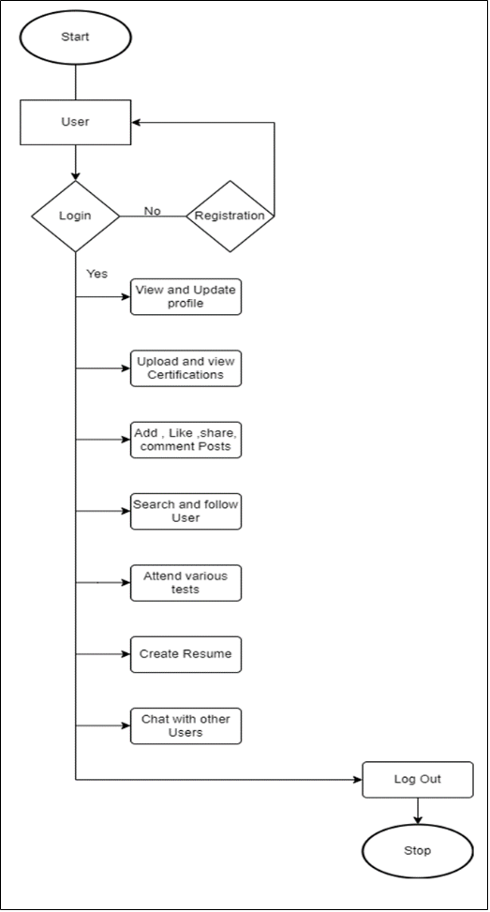

**Fig 3.7.1 Flow** chart of Networking Web Application for Developers

* 1. **Time Line Chart**

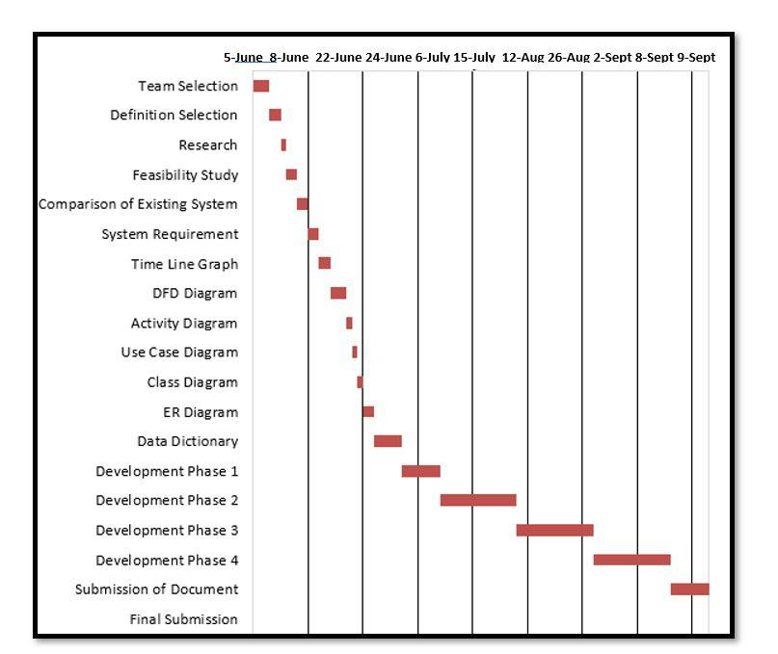

**Figure 3.8.1.** Time Line Chart

1. **Technology Description**
   1. **Features and Limitations of New System**

|  |  |
| --- | --- |
| **Features** | **Limitations** |
| Third party Developer (User) can get to know about other developers.  Users can showcase their skills, experiences and certifications in the developer community.  Users can connect and interact with other users working on similar technologies.  Provides a space that facilitates the opportunities of collaboration of various users on a project by connecting them. | For now it does not provide a platform where users can share and work together on a project by coding it on the platform itself.  No integrated compiler or interpreter  No code files sharing |

1. **Data Flow Diagram**
   1. **Context Level DFD:**

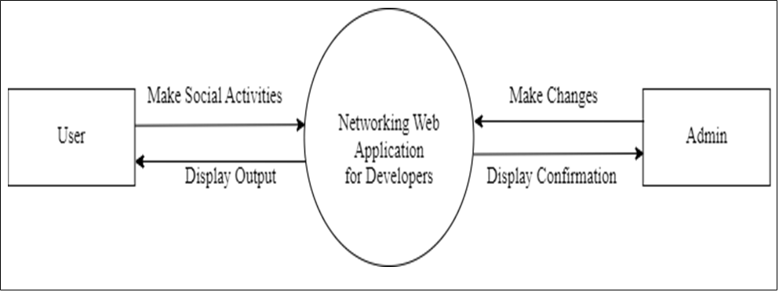

**Figure 5.1.1**. Context Level DFD: 0 Level

* 1. **Level 1 DFD:**

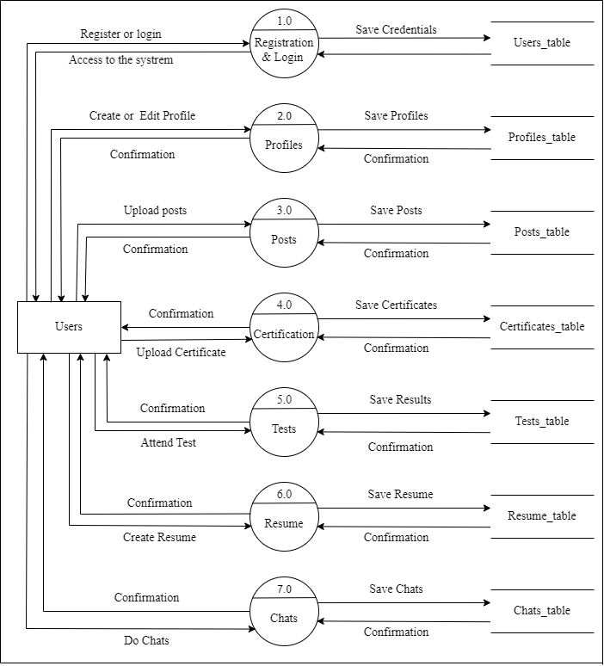

**Fig5.2.1** First level DFD

* 1. **Level 2 DFD:**

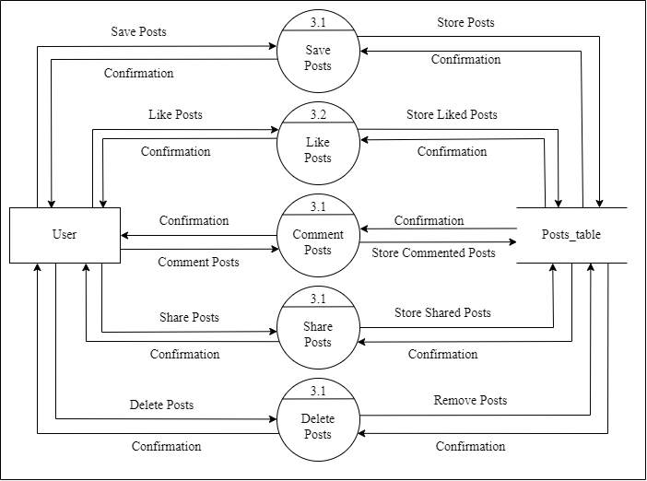

**Fig5.3.1** Second level DFD

1. **Use Case Diagram**

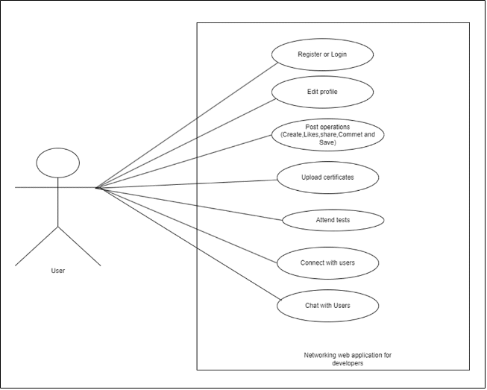

**Figure 6.1** Use case diagram

1. **Class Diagram**

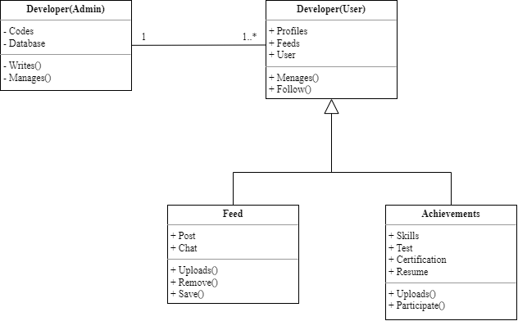

**Fig 7.1.1** Class Diagram

1. **Activity Diagram**

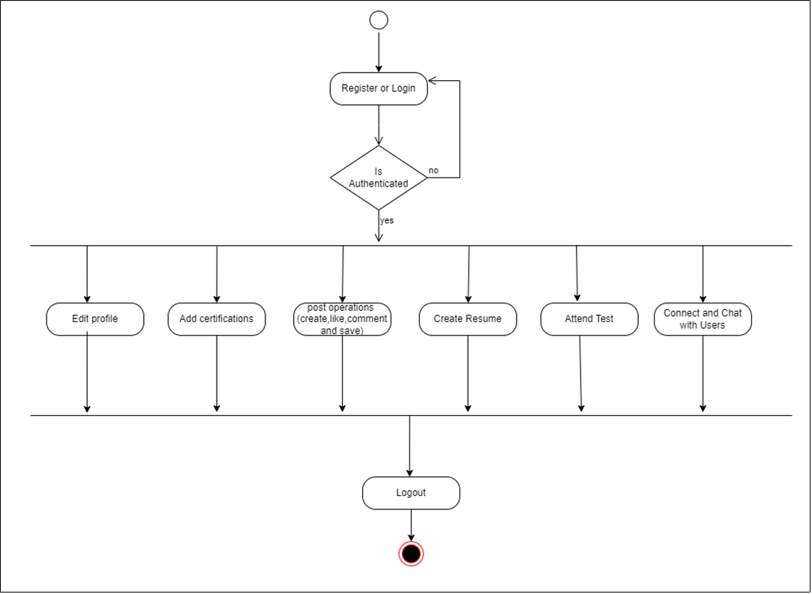

**Fig 8.1.1** Activity Diagram

* 1. **Description of Activity Diagram**

An activity diagram is a type of behavioural diagram in UML (Unified Modelling Language) that depicts the flow of activities and actions within a system or a process. It provides a visual representation of the sequential and parallel flow of activities, along with the conditions, decisions, and loops involved.

The main purpose of an activity diagram is to illustrate the business and operational workflows, showing how different activities are performed and how they interact with each other. It focuses on the actions and transitions between them rather than the objects or classes involved.

1. **Sequence Diagram**

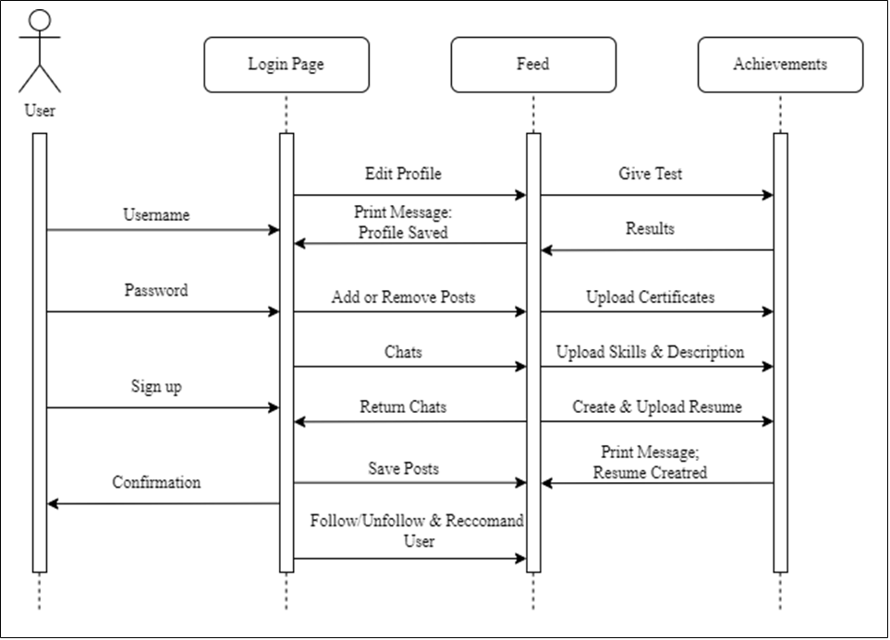

**Fig 9.1.1** Sequence Diagram

1. **E-R Diagram**

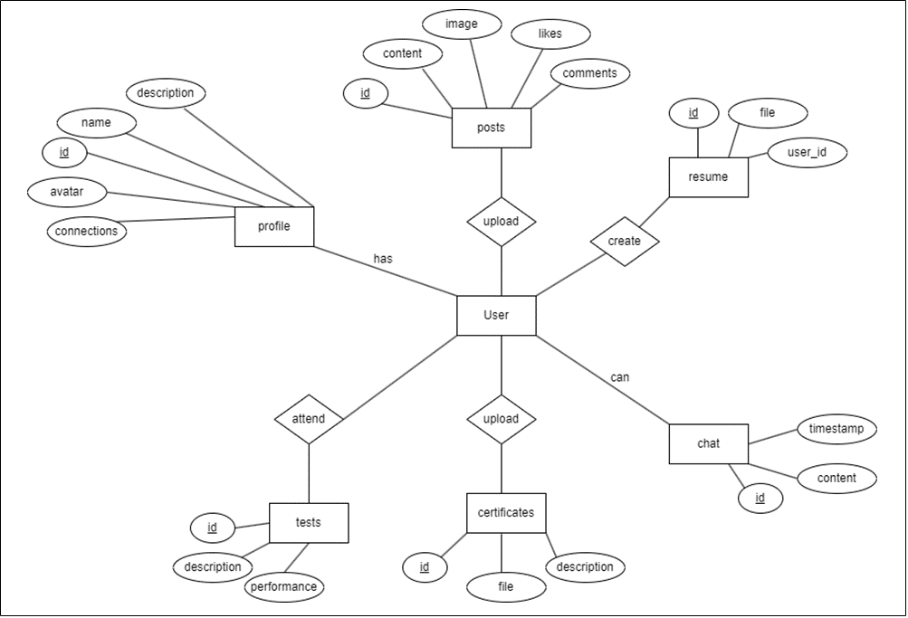

**Fig 10.1.1** E-R Diagram

* 1. **Description of E-R Diagram:**

An Entity-Relationship (ER) diagram is a visual representation of the entities (objects or concepts) within a system or domain, their attributes, and the relationships between them. It is commonly used in database design to depict the logical structure of a database. Relationships can also have cardinality, which specifies how many instances of an entity can be associated with instances of another entity.

1. **Data Dictionary**

**11.1 Table Name: profiles**

|  |  |  |  |  |  |  |
| --- | --- | --- | --- | --- | --- | --- |
| **Sr. No** | **Field Name** | **Datatype** | **Size** | **Description** | **Constraint** | **Example** |
| 1 | Id | uuid | 20 | Unique user Id for the user | Primary key | Ecbv5-121b-321bfd-bn76 |
| 2 | Email | Varchar | 20 | Email of the user | Not null | admin@gmail.com |
| 3 | username | Varchar | 20 | name of the user | Not null | Faizan |
| 4 | avatar | varchar | 160 | Image url of the user avatar | - | https:supabase/storage/  vclound/imageprofile.jpg |
| 5 | description | varcher | 20 | Description about user | - | Data analyst |
| 6 | skills | Text array | 180 | Skillset of user | - | Leadership ,Programming |
| 7 | followers | Uuid array | 180 | Uid of followers of the user | - | fc18-121b-313`21bfd-bn76910 |
| 8 | following | Uuid array | 180 | Uuid of other users folloed by the user | - | fc18-121b-313`21bfd-bn76910 |
| 9 | Saved posts | Uuid array | 180 | Uuid of the posts saved | - | fc18-121b-313`21bfd-bn76910 |

**Table 1** profiles table Data Dictionary

**11.2 Table Name: Posts**

This table with contain details about posts

|  |  |  |  |  |  |  |
| --- | --- | --- | --- | --- | --- | --- |
| **Sr. No** | **Field Name** | **Datatype** | **Size** | **Description** | **Constraint** | **Example** |
| 1 | id | uuid | 20 | Id of the post | Primary key | Upser-217-udsf-32486 |
| 2 | author | uuid | 20 | Uuid of the author of the post | Foreign Key | fc18-121b-313`21bfd-bn76910 |
| 3 | content | Varchar | 100 | Text content of the post | Not null | This is a post |
| 4 | Image url | Varchar | 180 | url for the image of the post | Not null | https:supabase/storage/  vclound/imagepost.jpg |
| 5 | Likes | Uuid array | 180 | Uuid of users who liked the post | - | fc18-121b-313`21bfd-bn76910 |
| 6 | Comments | Object array | 340 | Array of comments and the users | - | User:”fc18-121b-313`21bfd-bn76910”,  Comment:’fantastic” |

**Table 2** post table Data dictionay

**11.3 Table name: Achievements table**

This Table with contain details of user achievements

|  |  |  |  |  |  |  |
| --- | --- | --- | --- | --- | --- | --- |
| **Sr. No** | **Field Name** | **Datatype** | **Size** | **Description** | **Constraint** | **Example** |
| 1 | Id | uuid | 30 | Unique id of certificate | Primary key | fc18-121b-313`21bfd-bn76910 |
| 2 | author | uuid | 20 | Uuid of the author of the certificate | Foreign key | fc18-121b-313`21bfd-y1w7 |
| 3 | description | Varchar | 100 | Description of certificate | Not null | Cracking GSOC |
| 4 | File url | varchar | 300 | url of the certificate file | Not null | https:supabase/storage/  vclound/certifticate-GSOC.pdf |

**Table 3** Achievements Data dictionary

**11.4 Table name: Resume Table**

This Table with contain details regarding resumes

|  |  |  |  |  |  |  |
| --- | --- | --- | --- | --- | --- | --- |
| **Sr. No** | **Field Name** | **Datatype** | **Size** | **Description** | **Constraint** | **Example** |
| 1 | id | uuid | 20 | Unique id of resume | Primary key | Iuq2wi-21quudso-whqkx |
| 2 | Author id | uuid | 20 | Id of the author of resume | Foreign key | Iuq2wi-21quudso-whqkx |
| 3 | Resume file url | varchar | 300 | url for the resume file | Not null | https:supabase/storage/  vclound/Faizan’s-rresume.pdf |

**Table 4** Resume Data dictionary

**11.5 Table name: Tests Table**

This Table with contain details regarding Technical test

|  |  |  |  |  |  |  |
| --- | --- | --- | --- | --- | --- | --- |
| **Sr. No** | **Field Name** | **Datatype** | **Size** | **Description** | **Constraint** | **Example** |
| 1 | id | uuid | 20 | Unique id of a test | Primary key | Iuq2wi-21quudso-whqkx |
| 2 | Author id | Uuid  array | 200 | Id of the author and their performances in test | Not null | User:Iuq2wi-21quudso-whqkx,  Marks: 8 |
| 3 | Test Question object array | Object array | 600 | Array of object containing questions and their answers | Not null | Q:’Who is the Top G?”  A:”Faizan” |

**Table 5** Tests Data dictionary

**11.6 Table name: Chats Table**

This Table with contain details regarding user chats

|  |  |  |  |  |  |  |
| --- | --- | --- | --- | --- | --- | --- |
| **Sr. No** | **Field Name** | **Datatype** | **Size** | **Description** | **Constraint** | **Example** |
| 1 | id | uuid | 20 | Chat Id | Primary key | Iuq2wi-21quudso-whqkx |
| 2 | Author id | Uuid | 200 | Id of the author | Not null | User:Iuq2wi-21quudso-whqkx, |
| 3 | Content | varchar | 600 | User text content in chat | Not null | “Data science is interesting” |

**Table 6** Chats Data dictionary

**11.5 Description of Data Dictionary**

A data dictionary is a centralized document or repository that provides a detailed description of the data elements (also known as data attributes or fields) within a database or information system. It serves as a reference guide for understanding the structure, content, and meaning of the data stored in the system. The purpose of a data dictionary is to provide a standardized and comprehensive explanation of the data elements, their definitions, data types, allowable values, relationships, and other relevant metadata. It is commonly used by data analysts, database administrators, developers, and other stakeholders involved in data management and system development processes.

1. **Form Design (Screenshots Phase 1 ,2,3,4 & validation’s screenshots)**
   1. **Login and Registration modules:**

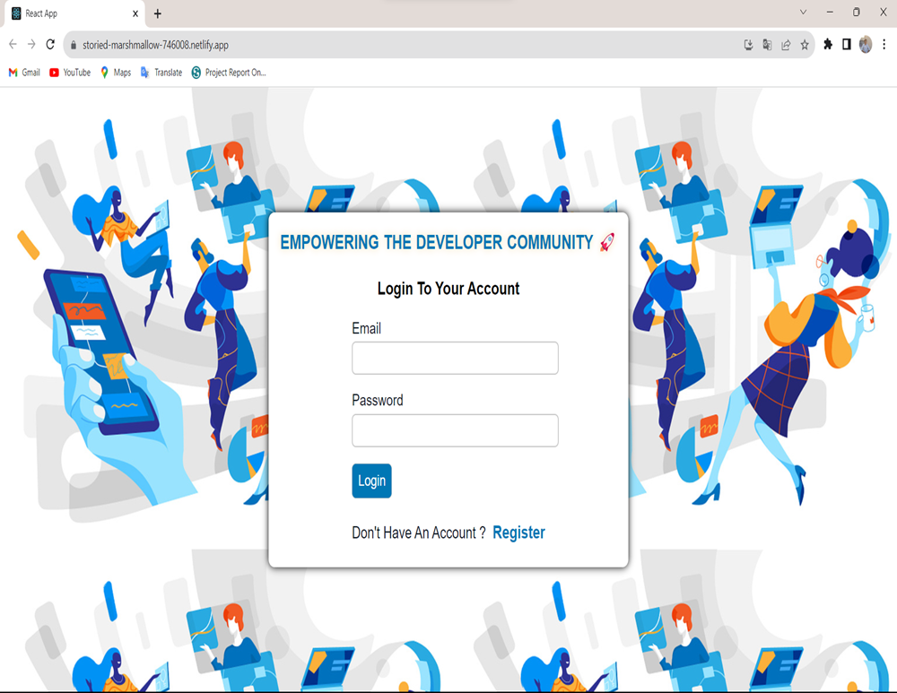

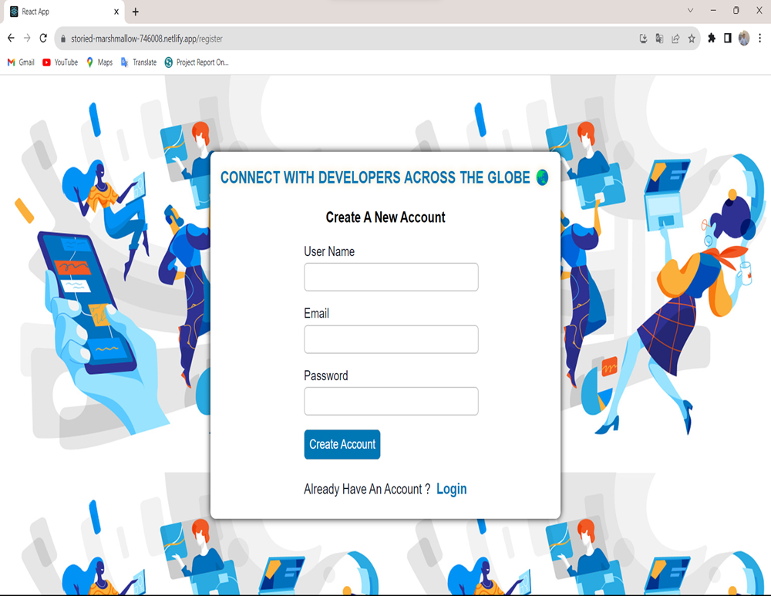

Users can create an account and login with their credentials

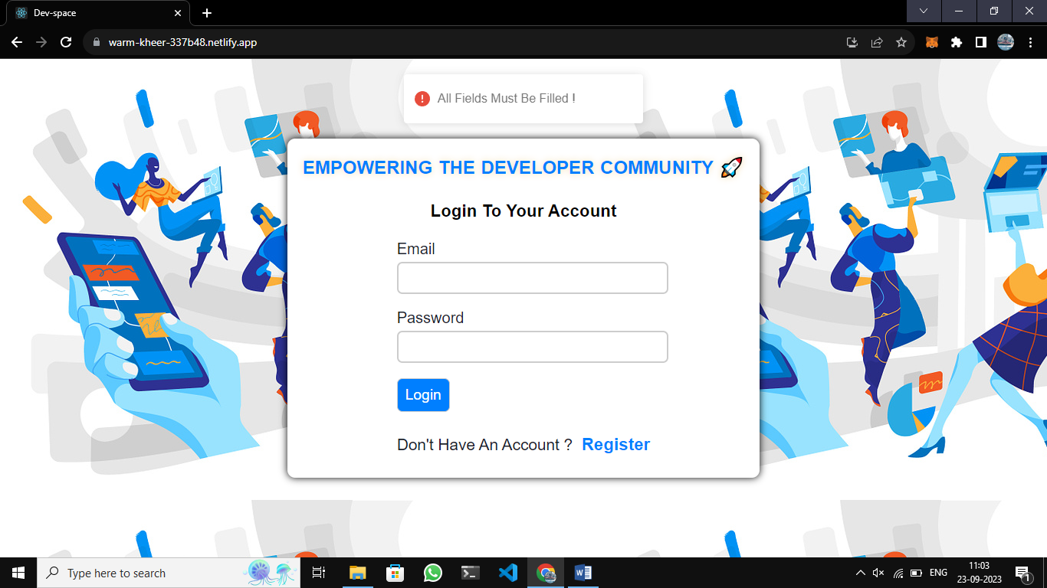

User cannot login if the credentials are invalid.

* 1. **User Profile module:**

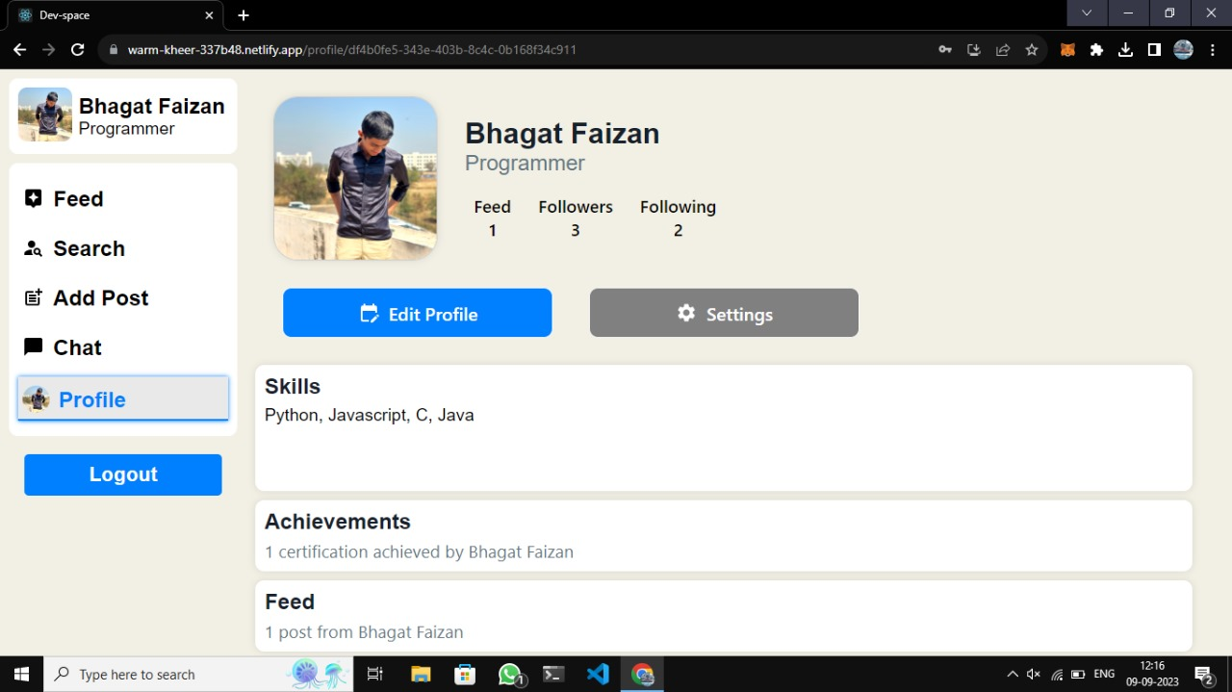

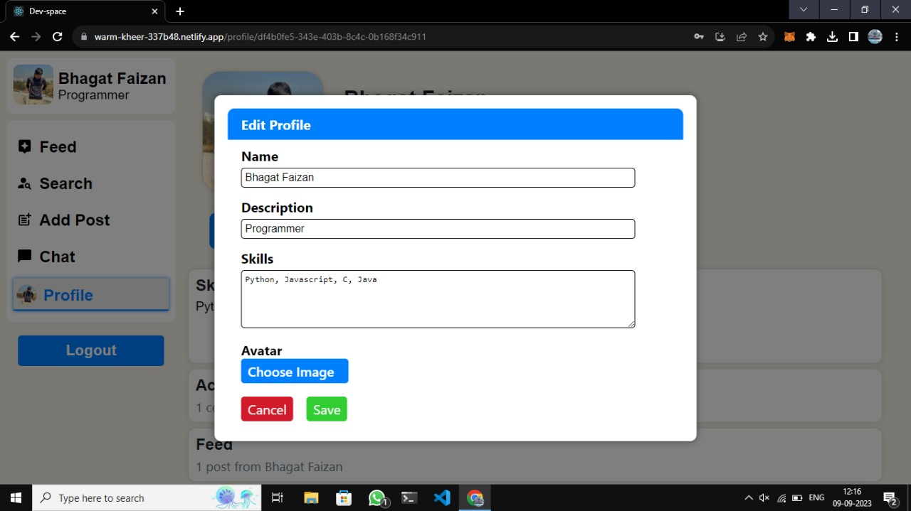­­­­

User can edit the profile, change name, and add a description and skills. User can also add or change avatar.

* 1. **Feed and chat module:**

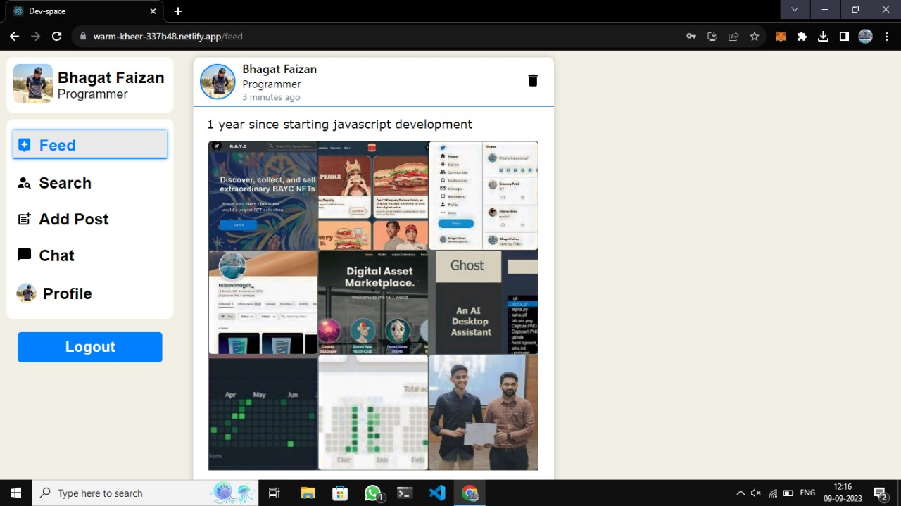

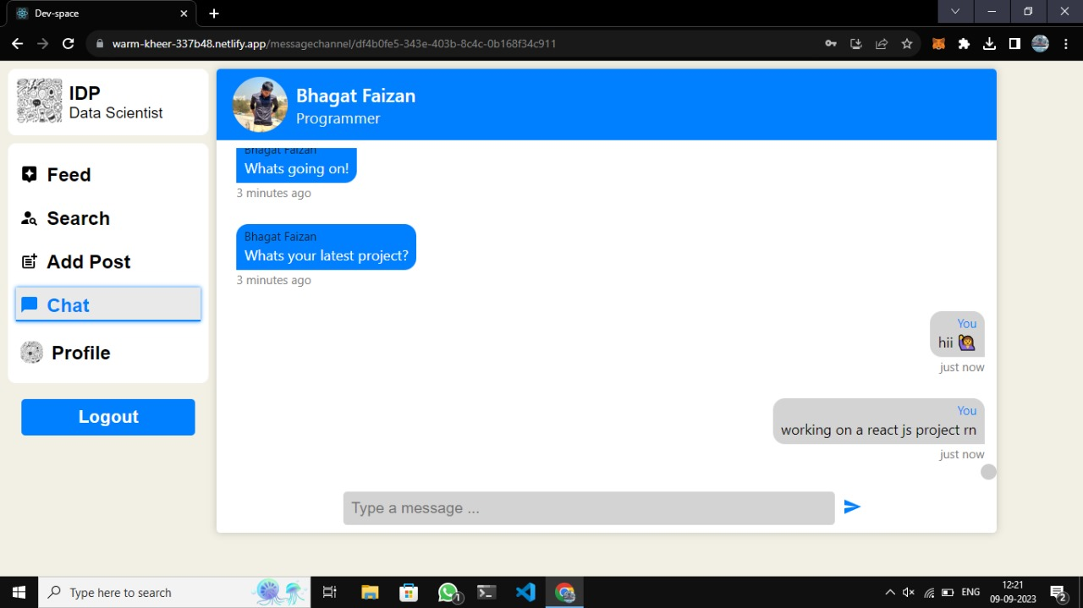

User can see the feed of the following developers and also chat with them in real-time

* 1. **Resume and test module:**

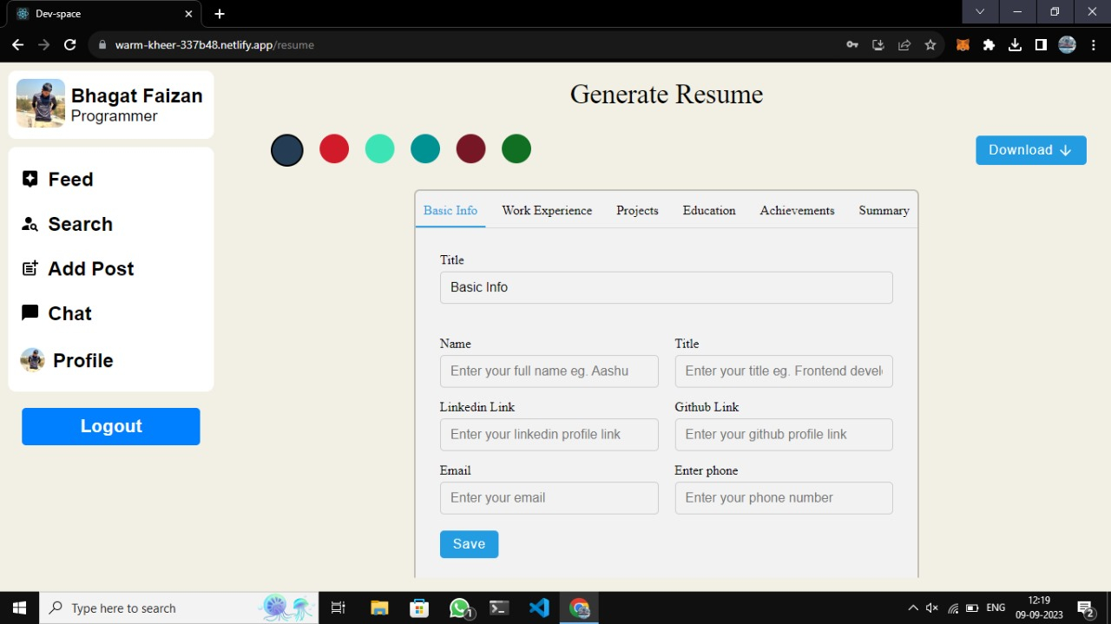

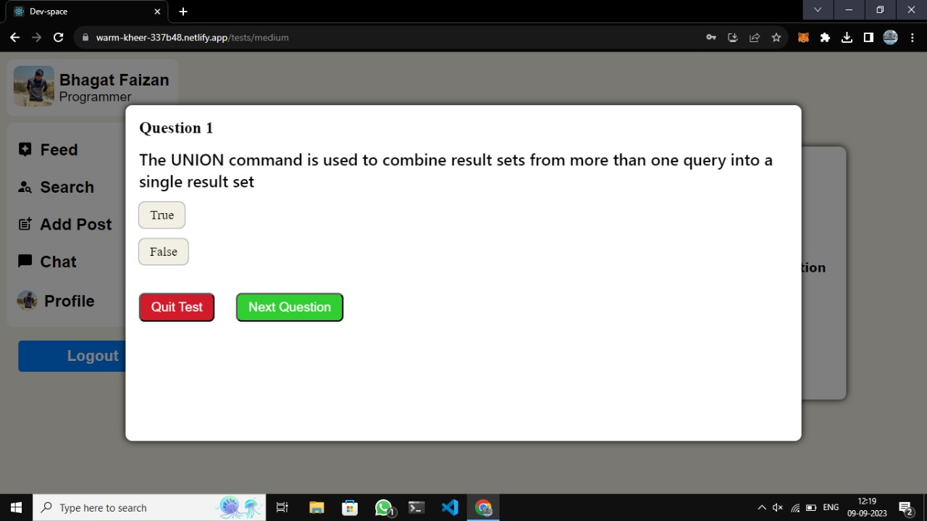

User can also generate a resume and also check the technical skills by giving a 10 point test.

1. **What is testing?**

Testing is a crucial part of software development and plays a vital role in ensuring the quality, reliability, and functionality of a product. It helps identify defects, errors, or deviations from expected behaviour, allowing for necessary corrections and improvements. Here are some key reasons why testing is important.

* 1. **Importance and types of testing**

1. Quality Assurance: Testing ensures that the software meets the specified requirements and functions as intended. It helps identify defects, bugs, and errors, allowing developers to address them before the software is released.
2. Reliability and Stability: Testing improves the reliability and stability of the software by verifying its functionality under different conditions and scenarios. It helps ensure that the software performs consistently and without unexpected failures.
3. User Satisfaction: Effective testing ensures that the software meets the needs and expectations of its users. By detecting and fixing issues, testing enhances user satisfaction and builds trust in the software.
4. **Future Enhancements**

* A platform where users can collaborate on into a project working together on a single codebase.
* A platform where user can copy the entire post of code and paste it on another platform.
* Users can share code files.
* Users can collaborate on a real-time project.
* Integrated compiler and interpreter.

**15. References & Bibliography**

**Website Links:**

* <https://chat.openai.com>
* <https://youtu.be/zM93yZ_8SvE?si=xdOyOlrCj589DKUp>
* <https://stackoverflow.com/>
* <https://react.dev/>
* https://www.w3schools.com /

**Bibliography books:**

* React 101 by Sonny Sangha ( E-book )
* Learn react hooks by Daniel Bugl
* The road to react by Robin Wieruch.
* Road to Frontend by Rafeh Qazi