Name: Gaurang Vaghela
Rollno: BEAD-22561
CI Practical 2
Problem Statement: Design a distributed application using RMI for remote computation where client submits two strings to the server and server returns the concatenation of the given strings.

Server.py
import Pyro4

@Pyro4.expose
class StringConcatenationServer:
def concatenate_strings(self, str1, str2):
result = str1 + str2
return result

def main():
daemon = Pyro4.Daemon()
ns = Pyro4.locateNS()

server = StringConcatenationServer()

uri = daemon.register(server)
ns.register("string.concatenation", uri)
print("Server URI:", uri)
with open("server_uri.txt", "w") as f:
f.write(str(uri))
daemon.requestLoop()

if __name__ == "__main__":
main()

Client.py
import Pyro4

def main():
with open("server_uri.txt", "r") as f:
uri = f.read()
server = Pyro4.Proxy(uri) # Connect to the remote server
str1 = input("Enter the first string: ")
str2 = input("Enter the second string: ")
result = server.concatenate_strings(str1, str2)
print("Concatenated Result:", result)

if __name__ == "__main__":
main()
OUTPUT:
Server:
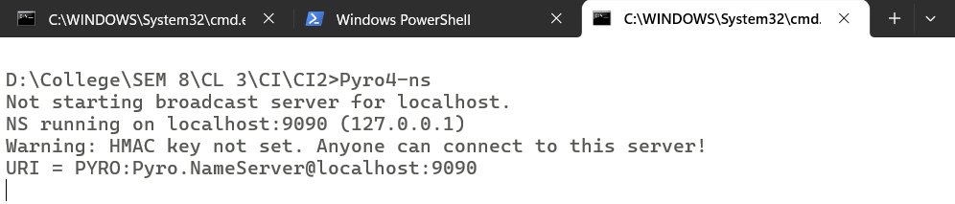

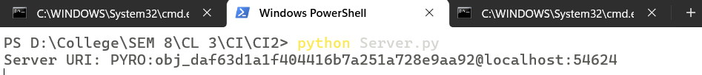

Client:
