Name: Gaurang Vaghela
Rollno: BEAD-22561
BDA Practical 1
Problem Statement: Set up and Configuration Hadoop Using CloudEra/ Google Cloud BigQuery. Databricks Lakehouse Platform. Snowflake. Amazon Redshift

Step 1: Install Java
sudo apt install openjdk-8-jdk -y
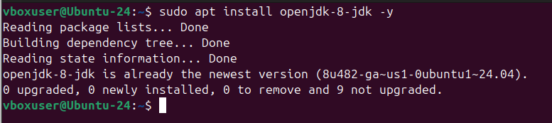

Step 2: Set JAVA_HOME
nano ~/.bashrc
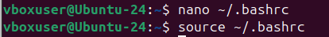

Add:
export JAVA_HOME=/usr/lib/jvm/java-8-openjdk-amd64
export HADOOP_HOME=~/hadoop
export PATH=$HADOOP_HOME/bin:$HADOOP_HOME/sbin:$PATH
source ~/.bashrc
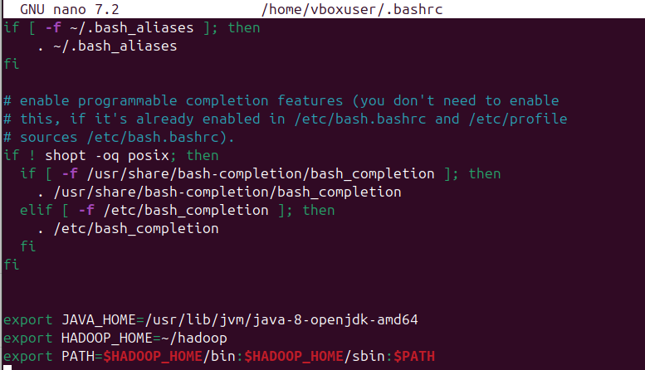

Step 3: Download and Extract Hadoop
wget https://downloads.apache.org/hadoop/common/hadoop-3.4.3/hadoop-3.4.3.tar.gz
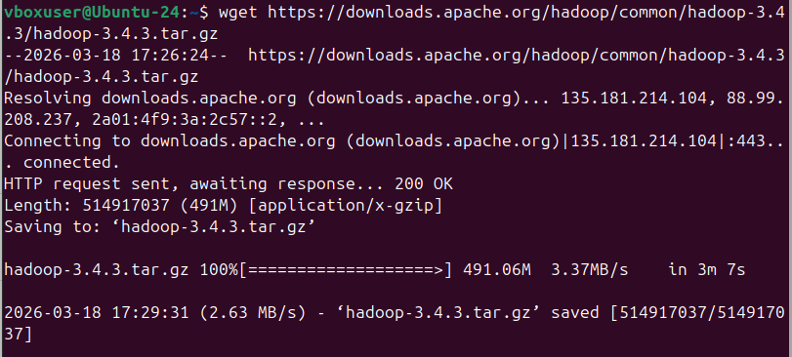
tar -xvzf hadoop-3.4.3.tar.gz
mv hadoop-3.4.3 hadoop
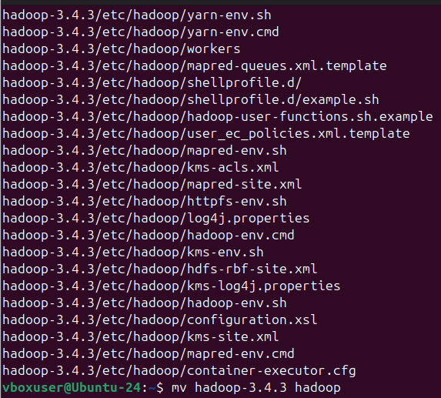

Step 4: Configure Hadoop Environment
nano ~/hadoop/etc/hadoop/hadoop-env.sh
Add:
export JAVA_HOME=/usr/lib/jvm/java-8-openjdk-amd64
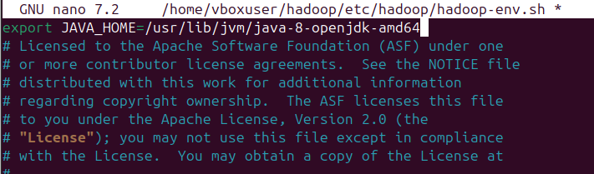

Step 5: Configure core-site.xml
nano ~/hadoop/etc/hadoop/core-site.xml
<configuration>
<property>
<name>fs.defaultFS</name>
<value>hdfs://localhost:9000</value>
</property>
</configuration>
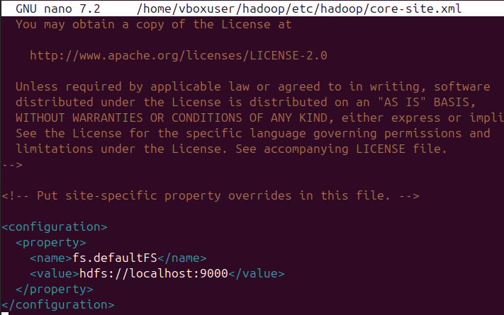

Step 6: Configure hdfs-site.xml
nano ~/hadoop/etc/hadoop/hdfs-site.xml
<configuration>
<property>
<name>dfs.replication</name>
<value>1</value>
</property>
<property>
<name>dfs.namenode.name.dir</name>
<value>file:///home/vboxuser/hadoopdata/namenode</value>
</property>
<property>
<name>dfs.datanode.data.dir</name>
<value>file:///home/vboxuser/hadoopdata/datanode</value>
</property>
</configuration>
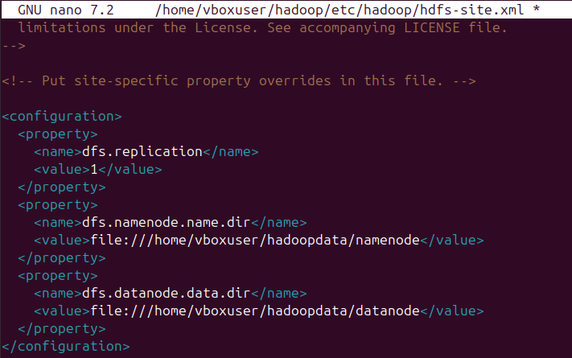

Step 7: Setup SSH
ssh-keygen -t rsa -P ""
cat ~/.ssh/id_rsa.pub >> ~/.ssh/authorized_keys
chmod 0600 ~/.ssh/authorized_keys
ssh localhost
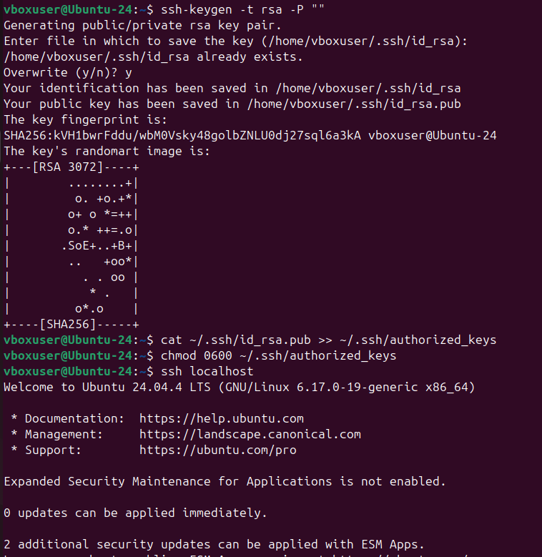


Step 8: Create Hadoop Directories
mkdir -p ~/hadoopdata/namenode
mkdir -p ~/hadoopdata/datanode
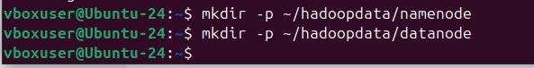

Step 9: Format NameNode
hdfs namenode -format
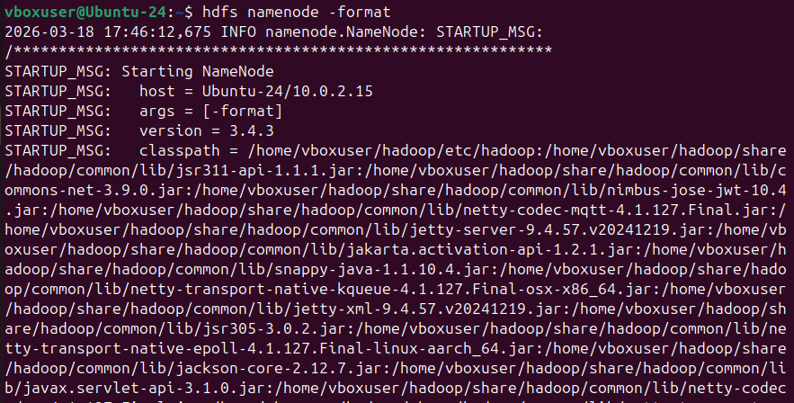

Step 10: Start Hadoop
start-dfs.sh
jps
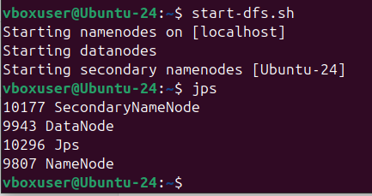

Step 11: Create Input File
echo "hello hadoop hello world" > file1.txt

Step 12: Create HDFS Directory and Upload File to HDFS
hdfs dfs -mkdir /input
hdfs dfs -put file1.txt /input
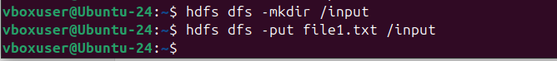

Step 13: Run WordCount Program
hadoop jar ~/hadoop/share/hadoop/mapreduce/hadoop-mapreduce-examples-3.4.3.jar wordcount /input /output
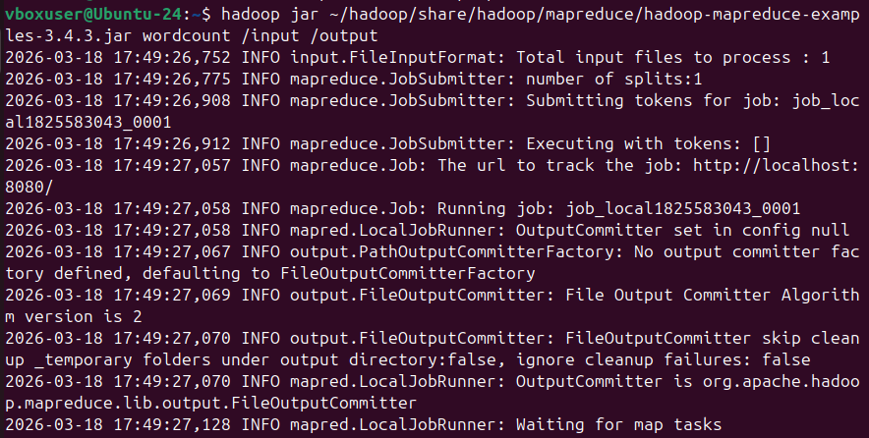

Step 15: View Output
hdfs dfs -cat /output/part-r-00000
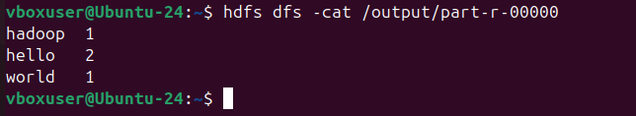

Result:
Hadoop was successfully installed and configured in pseudo-distributed mode. The WordCount MapReduce program was executed successfully and output was obtained.

