Name: Gaurang Vaghela
Rollno: BEAD-22561
BDA Practical 2
Problem Statement: To Develop a MapReduce program to calculate the frequency of a given word in a given file.

STEP 1: Create Java File and Write Code
nano WordCount.java

import java.io.IOException;
import org.apache.hadoop.conf.Configuration;
import org.apache.hadoop.fs.Path;
import org.apache.hadoop.io.IntWritable;
import org.apache.hadoop.io.LongWritable;
import org.apache.hadoop.io.Text;
import org.apache.hadoop.mapreduce.Job;
import org.apache.hadoop.mapreduce.Mapper;
import org.apache.hadoop.mapreduce.Reducer;
import org.apache.hadoop.mapreduce.lib.input.FileInputFormat;
import org.apache.hadoop.mapreduce.lib.output.FileOutputFormat;

public class WordCount {
// Mapper
public static class MyMapper extends Mapper<LongWritable, Text, Text, IntWritable> {
public void map(LongWritable key, Text value, Context context)
throws IOException, InterruptedException {
String[] words = value.toString().split(",");
for (String word : words) {
context.write(new Text(word.toUpperCase().trim()), new IntWritable(1));
}
}
}

// Reducer
public static class MyReducer extends Reducer<Text, IntWritable, Text, IntWritable> {
public void reduce(Text key, Iterable<IntWritable> values, Context context)
throws IOException, InterruptedException {
int sum = 0;
for (IntWritable val : values) {
sum += val.get();
}
context.write(key, new IntWritable(sum));
}
}

// Main
public static void main(String[] args) throws Exception {

Job job = Job.getInstance(new Configuration(), "WordCount");

job.setJarByClass(WordCount.class);
job.setMapperClass(MyMapper.class);
job.setReducerClass(MyReducer.class);

job.setOutputKeyClass(Text.class);
job.setOutputValueClass(IntWritable.class);

FileInputFormat.addInputPath(job, new Path(args[0]));
FileOutputFormat.setOutputPath(job, new Path(args[1]));

System.exit(job.waitForCompletion(true) ? 0 : 1);
}
}

STEP 2: Compile (Java 8 compatibility)
javac -source 1.8 -target 1.8 -classpath `hadoop classpath` -d . WordCount.java
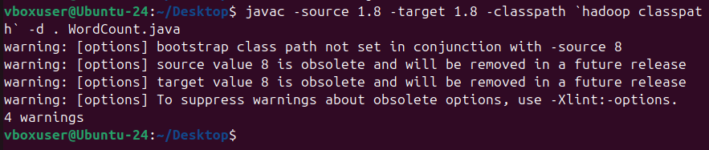

STEP 3: Create JAR file
jar -cvf wordcount.jar *.class
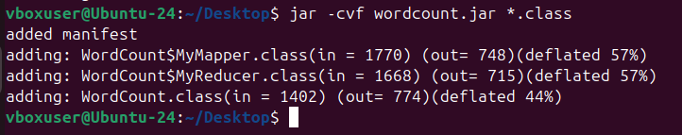

STEP 4: Start Hadoop
start-dfs.sh
start-yarn.sh
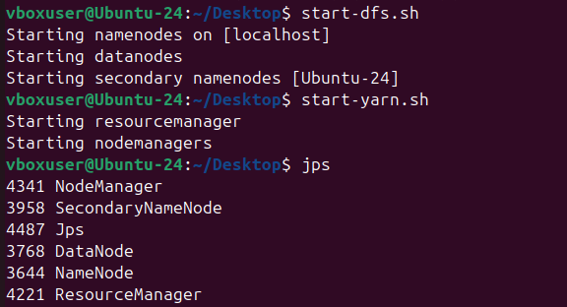

STEP 5: Create Input File
nano wordcount.txt
Bus, Car, bus, car, train, car, bus, BUS
STEP 6: Create HDFS Input Folder and Upload File to HDFS
hadoop fs -mkdir /input
hadoop fs -put wordcount.txt /input
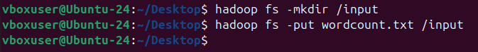

STEP 7: Run MapReduce Job
hadoop jar wordcount.jar WordCount /input /output
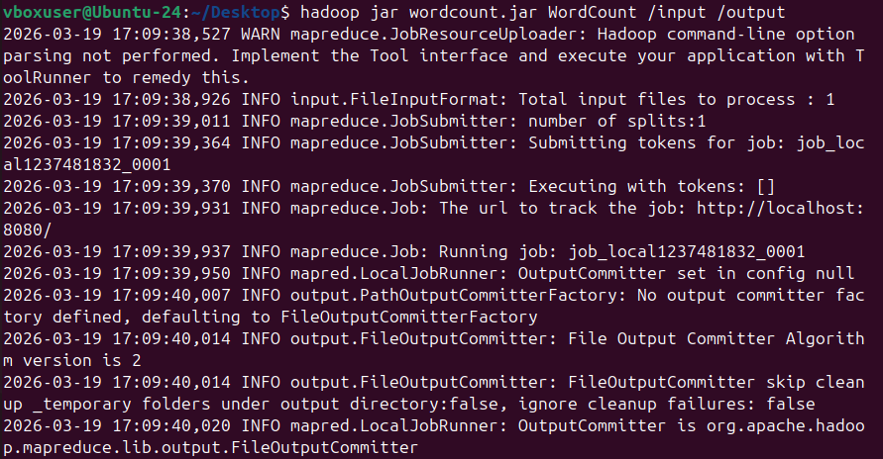

STEP 8: Check Output
hadoop fs -cat /output/part-r-00000
