Dr. D. Y. Patil Institute of Engineering, Management and Research
Akurdi, Pune-411044
Department-Artificial Intelligence and Data Science
Laboratory Journal | Subject: Computer Laboratory – IV AY:2025-26
Name: Atharva Velhankar Class: B.E. (A) Roll No: 22508

Lab Practical 3

To Develop a Map Reduce program to implement Matrix Multiplication.

Step 1: Create Working Directory
Commands:
mkdir ~/matrixmultiply
cd ~/matrixmultiply

Step 2: Create Matrix M Input File
Command:
nano M.txt
Enter the following content (row, column, value):
0,0,1
0,1,2
0,2,3
1,0,4
1,1,5
1,2,6

Step 3: Create Matrix N Input File
Command:
nano N.txt
Enter the following content (row, column, value):
0,0,7
0,1,8
1,0,9
1,1,10
2,0,11
2,1,12

Step 4: Create Combined Input File
Command:
nano input.txt
Enter the following content (matrix name, row, column, value):
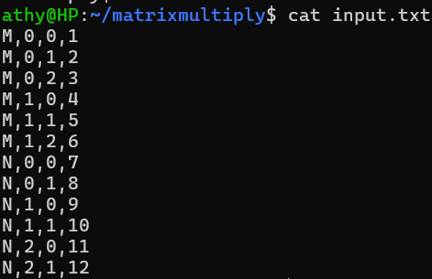

Step 5: Create the Java Program
Command:
nano Multiply.java

import java.io.IOException;
import org.apache.hadoop.conf.Configuration;
import org.apache.hadoop.fs.Path;
import org.apache.hadoop.io.LongWritable;
import org.apache.hadoop.io.Text;
import org.apache.hadoop.mapreduce.Job;
import org.apache.hadoop.mapreduce.Mapper;
import org.apache.hadoop.mapreduce.Reducer;
import org.apache.hadoop.mapreduce.lib.input.FileInputFormat;
import org.apache.hadoop.mapreduce.lib.output.FileOutputFormat;

public class Multiply {
public static class MatrixMapper extends
Mapper<LongWritable, Text, Text, Text> {
public void map(LongWritable key, Text value, Context context)
throws IOException, InterruptedException {
String line = value.toString();
String[] tokens = line.split(",");
if (tokens.length == 4) {
String matrix = tokens[0];
int i = Integer.parseInt(tokens[1]);
int j = Integer.parseInt(tokens[2]);
double val = Double.parseDouble(tokens[3]);
if (matrix.equals("M")) {
for (int k = 0; k < 2; k++) {
context.write(new Text(i+","+k),
new Text("M,"+j+","+val));
}
} else {
for (int r = 0; r < 2; r++) {
context.write(new Text(r+","+j),
new Text("N,"+i+","+val));
}
}
}
}
}

public static class MatrixReducer extends
Reducer<Text, Text, Text, Text> {
public void reduce(Text key, Iterable<Text> values,
Context context)
throws IOException, InterruptedException {
double[] M = new double[100];
double[] N = new double[100];
for (Text val : values) {
String[] parts = val.toString().split(",");
int j = Integer.parseInt(parts[1]);
double v = Double.parseDouble(parts[2]);
if (parts[0].equals("M")) { M[j] = v; }
else { N[j] = v; }
}
double sum = 0;
for (int j = 0; j < 100; j++) {
sum += M[j] * N[j];
}
context.write(key, new Text(String.valueOf(sum)));
}
}

public static void main(String[] args) throws Exception {
Configuration conf = new Configuration();
Job job = Job.getInstance(conf, "MatrixMultiply");
job.setJarByClass(Multiply.class);
job.setMapperClass(MatrixMapper.class);
job.setReducerClass(MatrixReducer.class);
job.setOutputKeyClass(Text.class);
job.setOutputValueClass(Text.class);
FileInputFormat.addInputPath(job, new Path(args[0]));
FileOutputFormat.setOutputPath(job, new Path(args[1]));
System.exit(job.waitForCompletion(true) ? 0 : 1);
}
}

Step 6: Compile the Java Program
Command:
javac -classpath $(hadoop classpath) Multiply.java

Step 7: Create JAR File
Command:
jar cf multiply.jar Multiply*.class

Step 8: Verify All Files
Command:
ls ~/matrixmultiply/

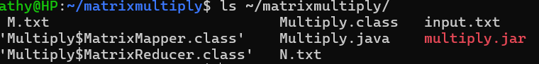

Step 9: Run the MapReduce Job
Command:
hadoop jar multiply.jar Multiply ~/matrixmultiply/input.txt ~/matrixmultiply/output

Step 10: View the Output
Command:
hadoop fs -cat ~/matrixmultiply/output/part-r-00000

