Name: Gaurang Vaghela
Rollno: BEAD-22561
BDA Practical 4
Problem Statement: Develop a MapReduce program to find the grades of students using user input.
Create Program Files:
CreateInputFile.java
import java.io.FileWriter;
import java.util.Scanner;

public class CreateInputFile {
public static void main(String[] args) throws Exception {

Scanner sc = new Scanner(System.in);
FileWriter fw = new FileWriter("student.txt");

System.out.println("Enter number of students:");
int n = sc.nextInt();

for (int i = 0; i < n; i++) {
System.out.println("Enter name and marks:");
String name = sc.next();
int marks = sc.nextInt();

fw.write(name + " " + marks + "\n");
}
fw.close();
System.out.println("Input file created successfully!");
}
}

GradeMapper.java
import java.io.IOException;
import org.apache.hadoop.io.*;
import org.apache.hadoop.mapreduce.Mapper;

public class GradeMapper extends Mapper<LongWritable, Text, Text, Text> {
public void map(LongWritable key, Text value, Context context) throws IOException, InterruptedException {

String[] data = value.toString().split(" ");

String name = data[0];
int marks = Integer.parseInt(data[1]);
String grade;

if (marks >= 90)
grade = "A";
else if (marks >= 75)
grade = "B";
else if (marks >= 50)
grade = "C";
else
grade = "D";

context.write(new Text(name), new Text(grade));
}
}

GradeReducer.java
import java.io.IOException;
import org.apache.hadoop.io.*;
import org.apache.hadoop.mapreduce.Reducer;

public class GradeReducer extends Reducer<Text, Text, Text, Text> {
public void reduce(Text key, Iterable<Text> values, Context context) throws IOException, InterruptedException {
for (Text val : values) {
context.write(key, val);
}
}
}

GradeDriver.java
import org.apache.hadoop.conf.Configuration;
import org.apache.hadoop.fs.Path;
import org.apache.hadoop.io.*;
import org.apache.hadoop.mapreduce.Job;
import org.apache.hadoop.mapreduce.lib.input.FileInputFormat;
import org.apache.hadoop.mapreduce.lib.output.FileOutputFormat;

public class GradeDriver {

public static void main(String[] args) throws Exception {

if (args.length != 2) {
System.out.println("Usage: GradeDriver <input path> <output path>");
System.exit(-1);
}

Configuration conf = new Configuration();
Job job = Job.getInstance(conf, "Student Grades");

job.setJarByClass(GradeDriver.class);
job.setMapperClass(GradeMapper.class);
job.setReducerClass(GradeReducer.class);

job.setOutputKeyClass(Text.class);
job.setOutputValueClass(Text.class);

FileInputFormat.addInputPath(job, new Path(args[0]));
FileOutputFormat.setOutputPath(job, new Path(args[1]));

System.exit(job.waitForCompletion(true) ? 0 : 1);
}
}

Step 1: Compile and Run Input Program
Commands:
javac CreateInputFile.java
java CreateInputFile
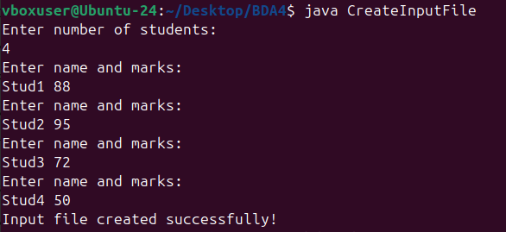

Step 2: Start Hadoop Services
Command:
start-dfs.sh
start-yarn.sh
jps
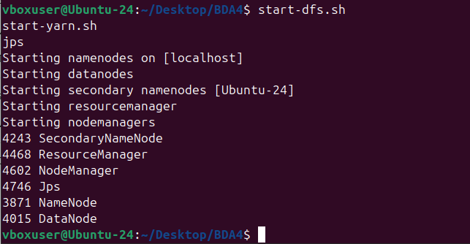

Step 3: Compile MapReduce Program
Command:
javac -source 1.8 -target 1.8 -classpath `hadoop classpath` -d . *.java
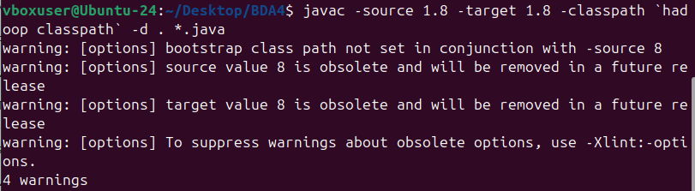

Step 4: Create JAR File
Command:
jar -cvf grades.jar *.class
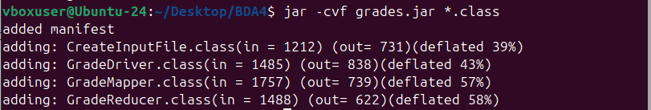

Step 5: Upload Input File to HDFS
Command:
hdfs dfs -rm -r input
hdfs dfs -mkdir input
hdfs dfs -put student.txt input/
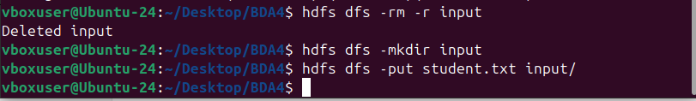

Step 6: Execute MapReduce Program
Command:
hdfs dfs -rm -r output
hadoop jar grades.jar GradeDriver input output
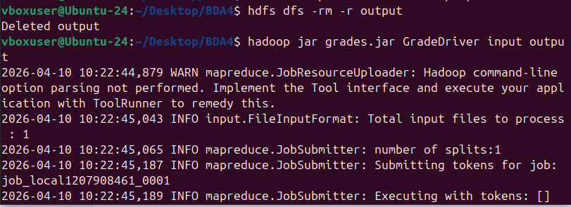

Step 7: Display Output
Command:
hdfs dfs -cat output/part-r-00000
