Name: Gaurang Vaghela
Rollno: BEAD-22561
BDA Practical 5
Problem Statement: Develop a MapReduce program to analyze Titanic ship data and to find the average age of the people (both male and female) who died in the tragedy. How many persons are survived in each class.

Create Program Files:
1. Average age of people who died (by gender)
AvgAgeMapper.java
import java.io.IOException;
import org.apache.hadoop.io.*;
import org.apache.hadoop.mapreduce.Mapper;

public class AvgAgeMapper extends Mapper<LongWritable, Text, Text, IntWritable> {

private Text gender = new Text();
private IntWritable age = new IntWritable();

public void map(LongWritable key, Text value, Context context)
throws IOException, InterruptedException {

String line = value.toString();

if (line.startsWith("PassengerId")) return;

String[] str = line.split(",(?=(?:[^\"]*\"[^\"]*\")*[^\"]*$)");

if (str.length > 5 && str[1].equals("1")) {

if (!str[5].isEmpty()) {
try {
int ageVal = (int) Float.parseFloat(str[5]);

gender.set(str[4]);
age.set(ageVal);

context.write(gender, age);
} catch (Exception e) {}
}
}
}
}

AvgAgeReducer.java
import java.io.IOException;
import org.apache.hadoop.io.*;
import org.apache.hadoop.mapreduce.Reducer;

public class AvgAgeReducer extends Reducer<Text, IntWritable, Text, IntWritable> {

public void reduce(Text key, Iterable<IntWritable> values, Context context)
throws IOException, InterruptedException {

int sum = 0;
int count = 0;

for (IntWritable val : values) {
sum += val.get();
count++;
}

context.write(key, new IntWritable(sum / count));
}
}

AvgAgeDriver.java
import org.apache.hadoop.conf.Configuration;
import org.apache.hadoop.fs.Path;
import org.apache.hadoop.io.*;
import org.apache.hadoop.mapreduce.Job;
import org.apache.hadoop.mapreduce.lib.input.FileInputFormat;
import org.apache.hadoop.mapreduce.lib.output.FileOutputFormat;

public class AvgAgeDriver {

public static void main(String[] args) throws Exception {

Configuration conf = new Configuration();

Job job = Job.getInstance(conf, "Average Age");

job.setJarByClass(AvgAgeDriver.class);

job.setMapperClass(AvgAgeMapper.class);
job.setReducerClass(AvgAgeReducer.class);

job.setOutputKeyClass(Text.class);
job.setOutputValueClass(IntWritable.class);

FileInputFormat.addInputPath(job, new Path(args[0]));
FileOutputFormat.setOutputPath(job, new Path(args[1]));

System.exit(job.waitForCompletion(true) ? 0 : 1);
}
}
2. Count of survivors per class
SurvivorMapper.java
import java.io.IOException;
import org.apache.hadoop.io.*;
import org.apache.hadoop.mapreduce.Mapper;

public class SurvivorMapper extends Mapper<LongWritable, Text, Text, IntWritable> {

private Text pclass = new Text();
private final static IntWritable one = new IntWritable(1);

public void map(LongWritable key, Text value, Context context)
throws IOException, InterruptedException {

String line = value.toString();

if (line.startsWith("PassengerId")) return;

String[] str = line.split(",(?=(?:[^\"]*\"[^\"]*\")*[^\"]*$)");

if (str.length > 2 && str[1].equals("0")) {

pclass.set("Class_" + str[2]);
context.write(pclass, one);
}
}
}

SurvivorReducer.java
import java.io.IOException;

import org.apache.hadoop.io.*;
import org.apache.hadoop.mapreduce.Reducer;

public class SurvivorReducer extends Reducer<Text, IntWritable, Text, IntWritable> {

public void reduce(Text key, Iterable<IntWritable> values, Context context)
throws IOException, InterruptedException {

int sum = 0;

for (IntWritable val : values) {
sum += val.get();
}

context.write(key, new IntWritable(sum));
}
}

SurvivorDriver.java
import org.apache.hadoop.conf.Configuration;
import org.apache.hadoop.fs.Path;
import org.apache.hadoop.io.*;
import org.apache.hadoop.mapreduce.Job;
import org.apache.hadoop.mapreduce.lib.input.FileInputFormat;
import org.apache.hadoop.mapreduce.lib.output.FileOutputFormat;

public class SurvivorDriver {

public static void main(String[] args) throws Exception {

Configuration conf = new Configuration();

Job job = Job.getInstance(conf, "Survivors Per Class");

job.setJarByClass(SurvivorDriver.class);

job.setMapperClass(SurvivorMapper.class);
job.setReducerClass(SurvivorReducer.class);

job.setOutputKeyClass(Text.class);
job.setOutputValueClass(IntWritable.class);

FileInputFormat.addInputPath(job, new Path(args[0]));
FileOutputFormat.setOutputPath(job, new Path(args[1]));

System.exit(job.waitForCompletion(true) ? 0 : 1);
}
}

Step 1: Start Hadoop
Commands:
start-dfs.sh
start-yarn.sh
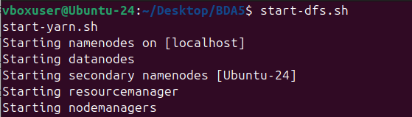

Step 2: Exit Safe Mode
Command:
hdfs dfsadmin -safemode leave

Step 3: Upload Dataset
Command:
hadoop fs -put Titanic.csv /

Step 4: Compile Code
Command:
javac -classpath `hadoop classpath` -d . *.java

Step 5: Create JAR
Command:
jar -cvf titanic.jar *
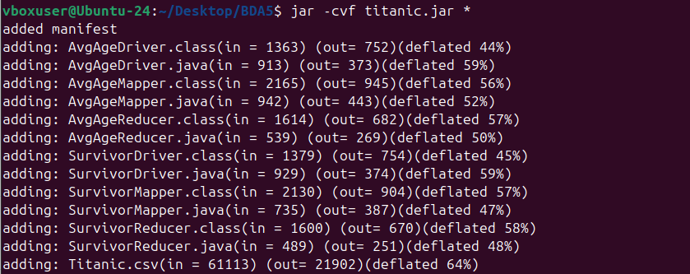

Delete Old Outputs
hadoop fs -rm -r /output1
hadoop fs -rm -r /output2

Step 6: Run Job 1
Command:
hadoop jar titanic.jar AvgAgeDriver /Titanic.csv /output1
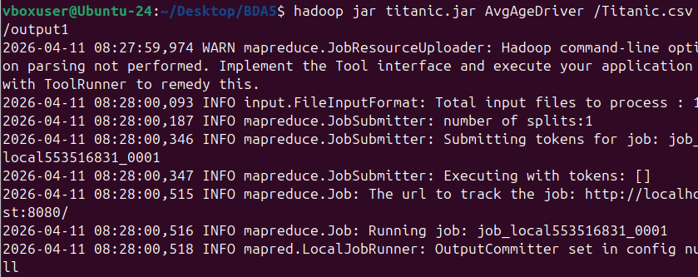

View Output 1
hadoop fs -cat /output1/part-r-00000

Step 7: Run Job 2
Command:
hadoop jar titanic.jar SurvivorDriver /Titanic.csv /output2
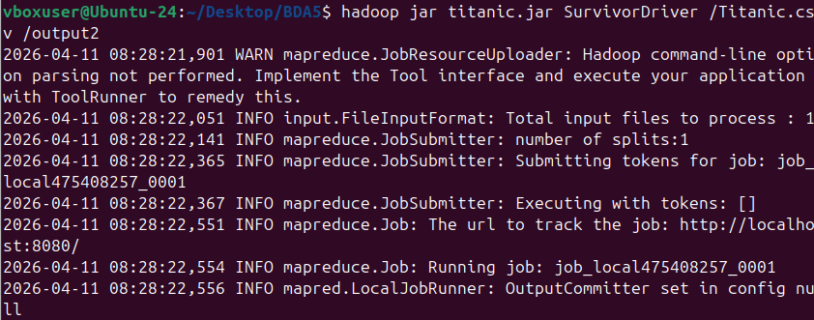

View Output 2
hadoop fs -cat /output2/part-r-00000


