Name: Gaurang Vaghela
Rollno: BEAD-22561
BI Practical 10
Problem Statement: Perform the data classification algorithm using any Classification algorithm

STEP 1: Import Libraries
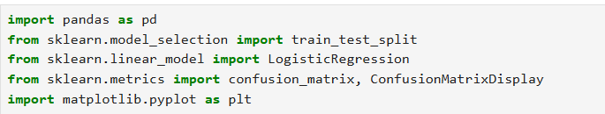

STEP 2: Load Dataset
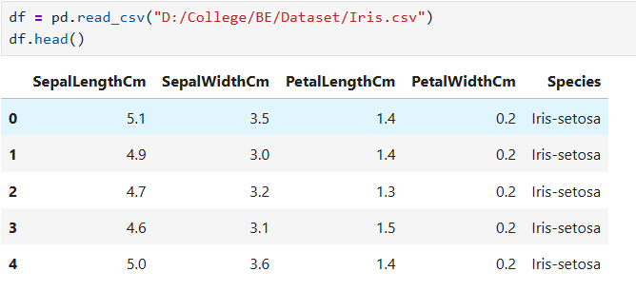

STEP 3: Prepare Data
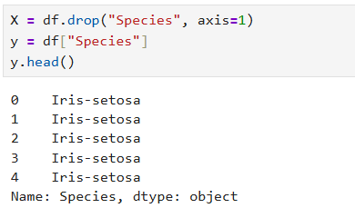

STEP 4: Convert Labels
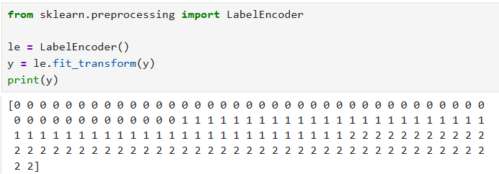

STEP 5: Split Data and Apply Classification Algorithm
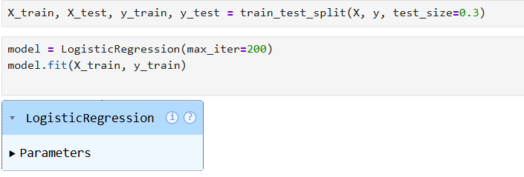

STEP 6: Prediction
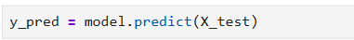

STEP 7: Evaluation
