Name: Gaurang Vaghela
Rollno: BEAD-22561
BI Practical 6
Problem Statement: Import Data from different Sources such as (Excel, Sql Server, Oracle etc.) and load in targeted system.

1) Launch Power BI Desktop.
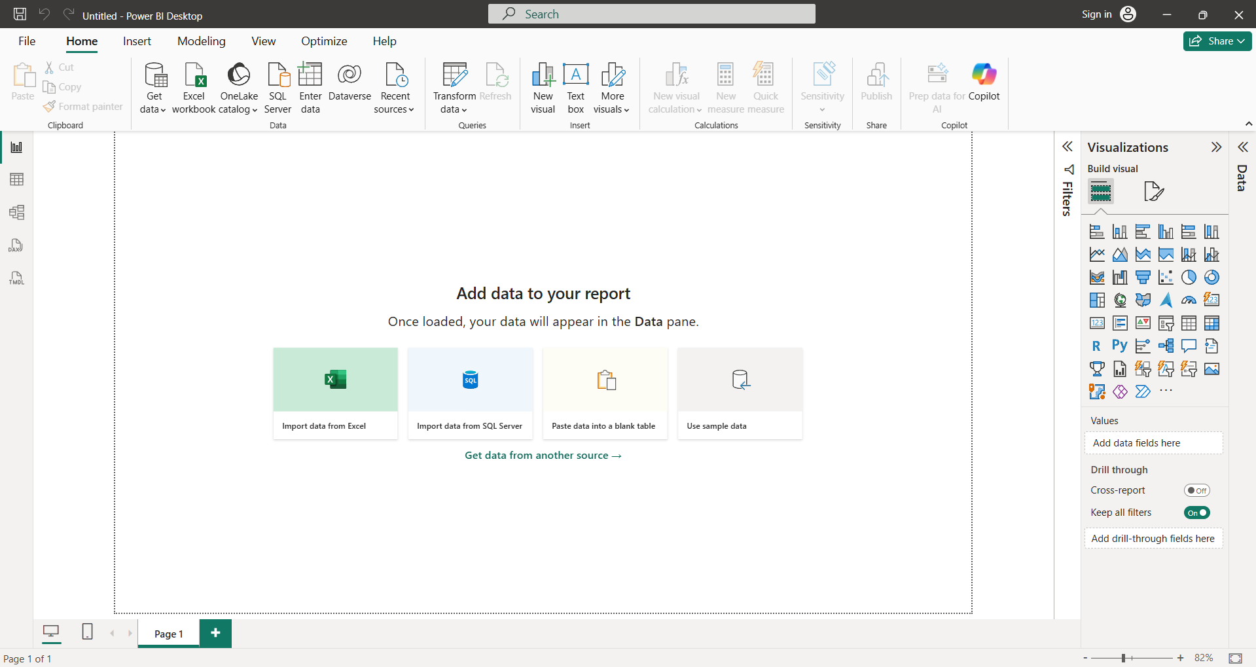

2) From the Home ribbon, select Get Data.
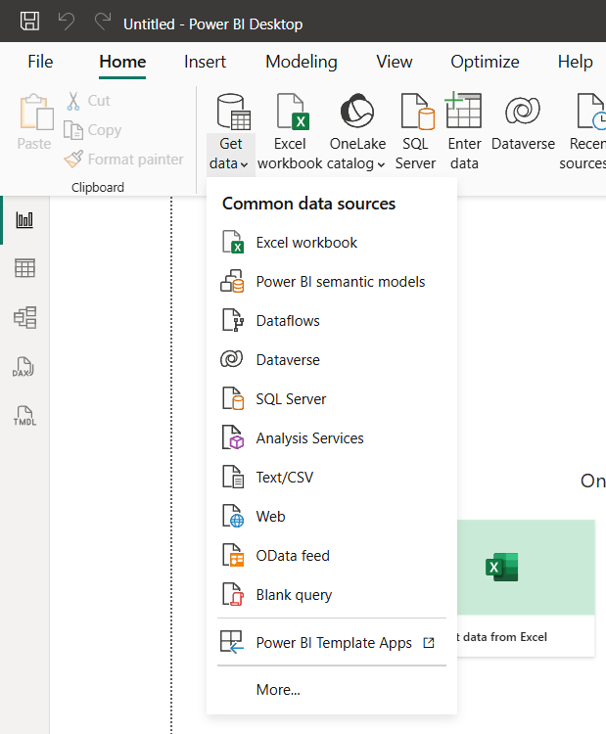

3) In the Open File dialog box, select the .xlsx file.
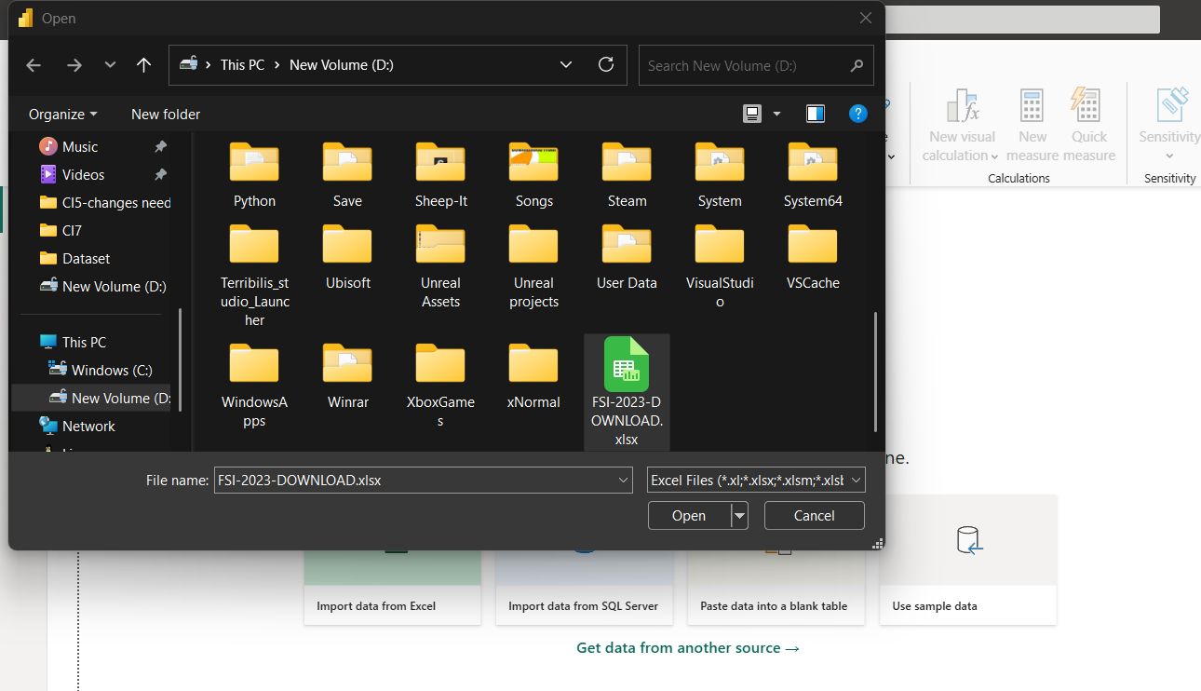

4) In the Navigator pane, select the Products table and then select Transform Data to make changes if any or select Load to load file in your report.
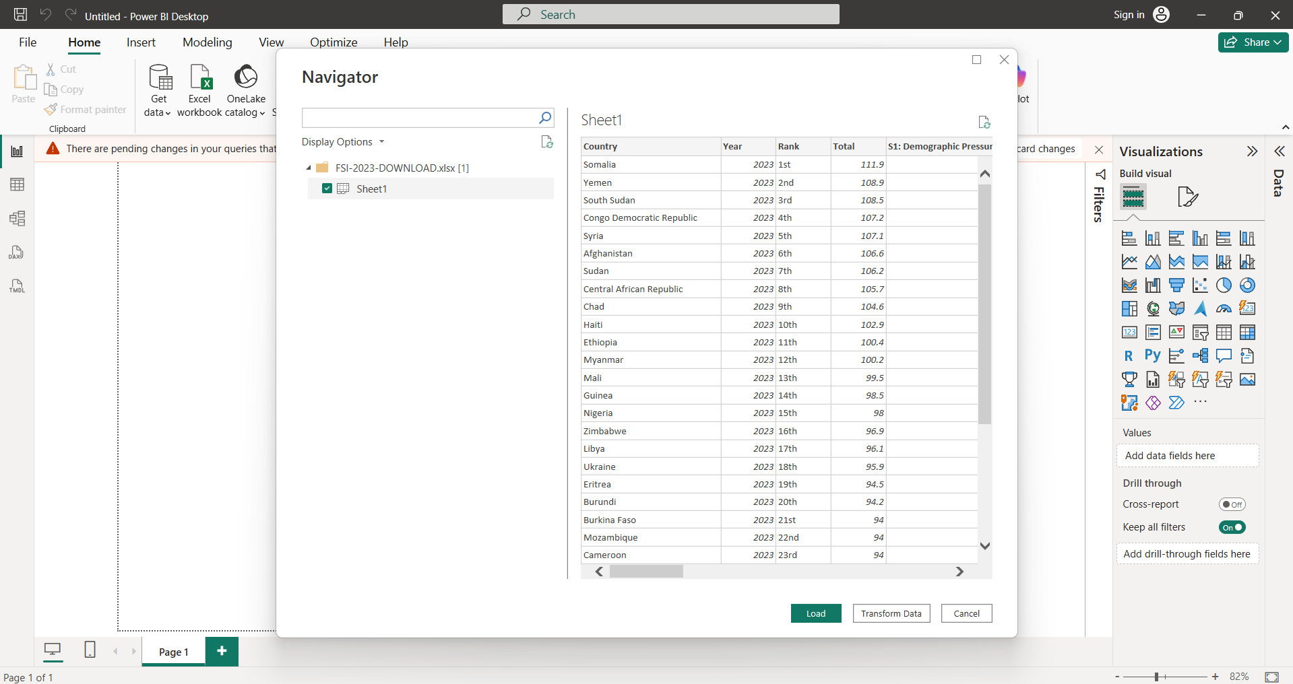
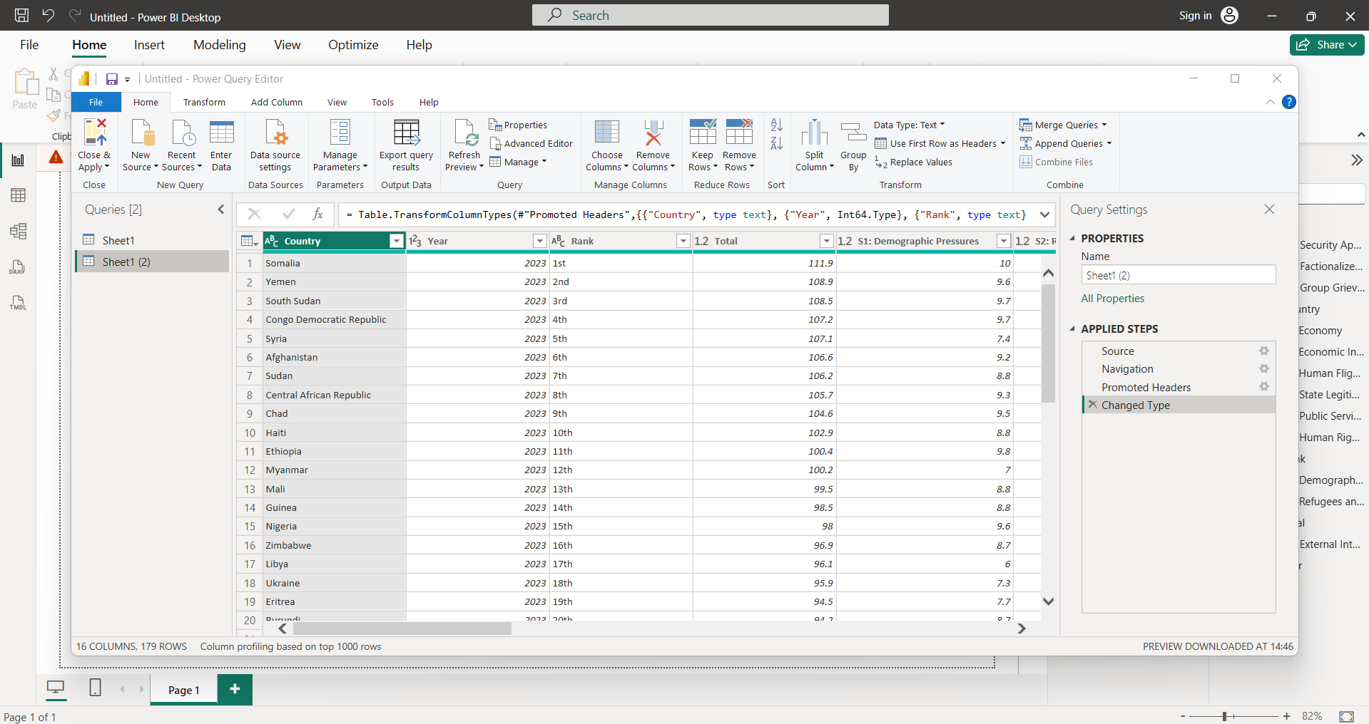

Importing Data from OData Feed: (http://services.odata.org/V3/Northwind/Northwind.svc/)
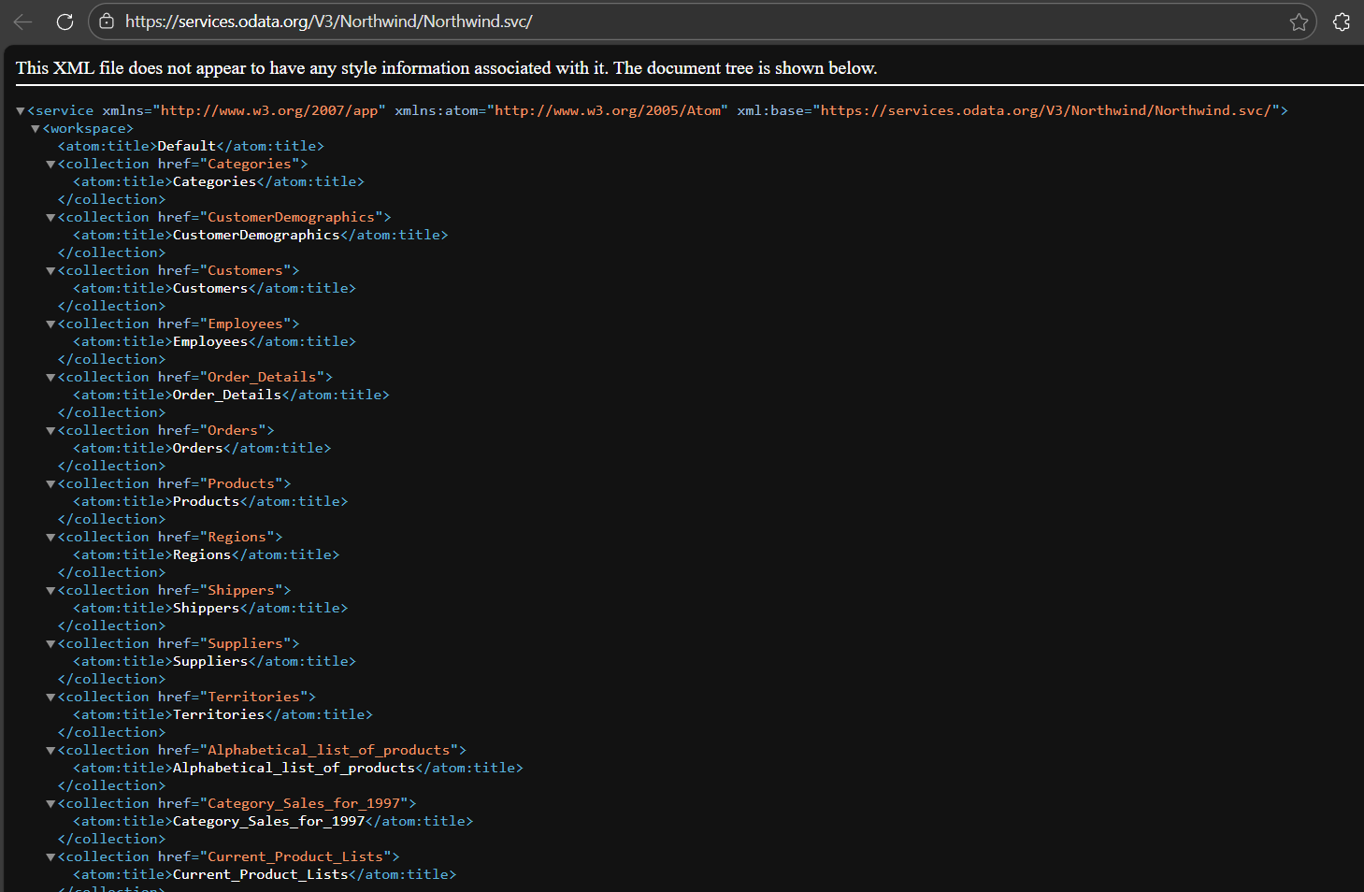
1) From the Home ribbon tab in the Query Editor, select Get Data. Browse to the OData Feed data source.
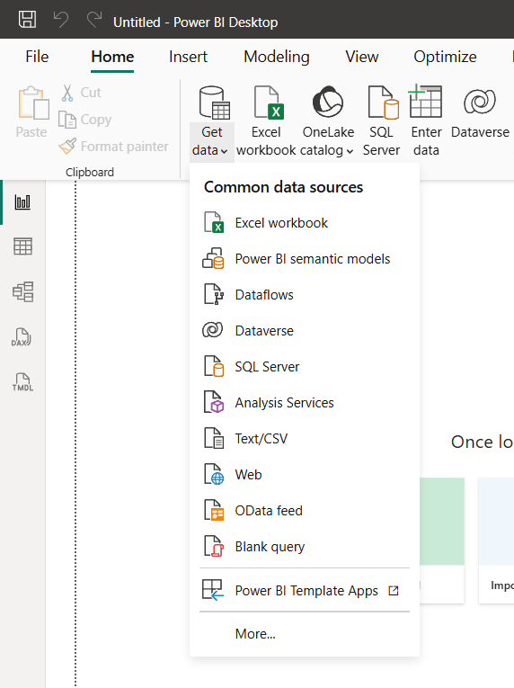

2) In the OData Feed dialog box, paste the URL for the Northwind OData feed.
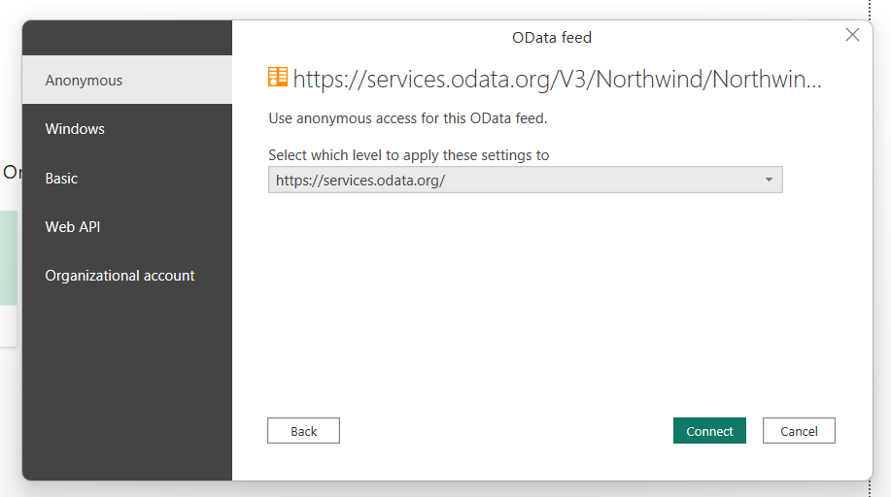

3) In the Navigator pane, select the Orders table, and then select Edit.
