Name: Gaurang Vaghela
Rollno: BEAD-22561
BI Practical 7
Problem Statement: Data Visualization from Extraction Transformation and Loading (ETL) Process.

Step 1: Check Data (Extraction)
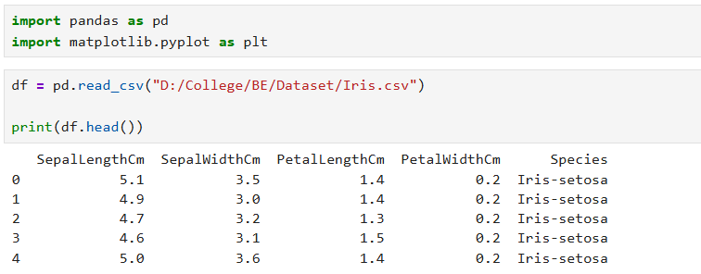

Step 2: Transform
Check missing values
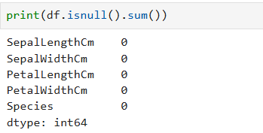

Create new column

Convert species names
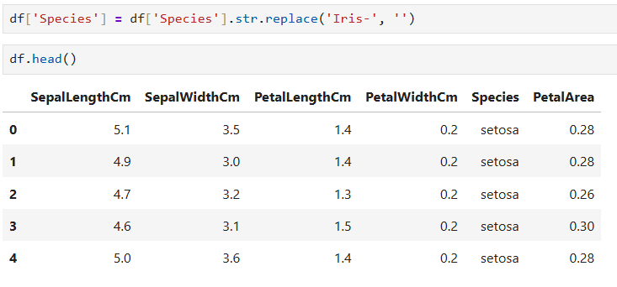

Step 3: Load

Step 4: Visualization
Sepal Length Distribution
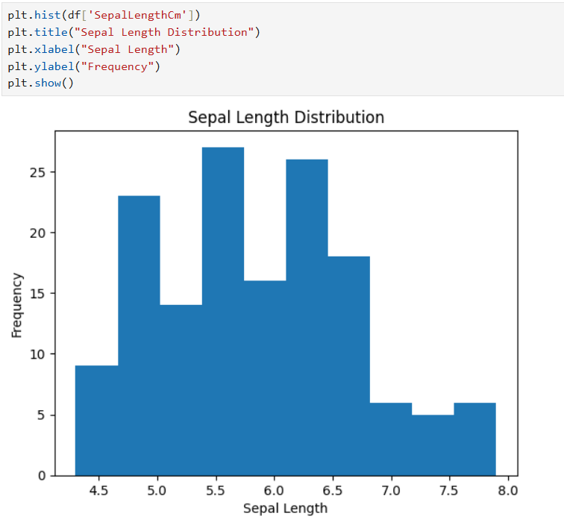

Scatter Plot
