Name: Gaurang Vaghela
Rollno: BEAD-22561
BI Practical 8
Problem Statement: Perform the Extraction Transformation and Loading (ETL) process to construct the database in the Sql server / Power BI.

STEP 1: Extraction (Load Data)
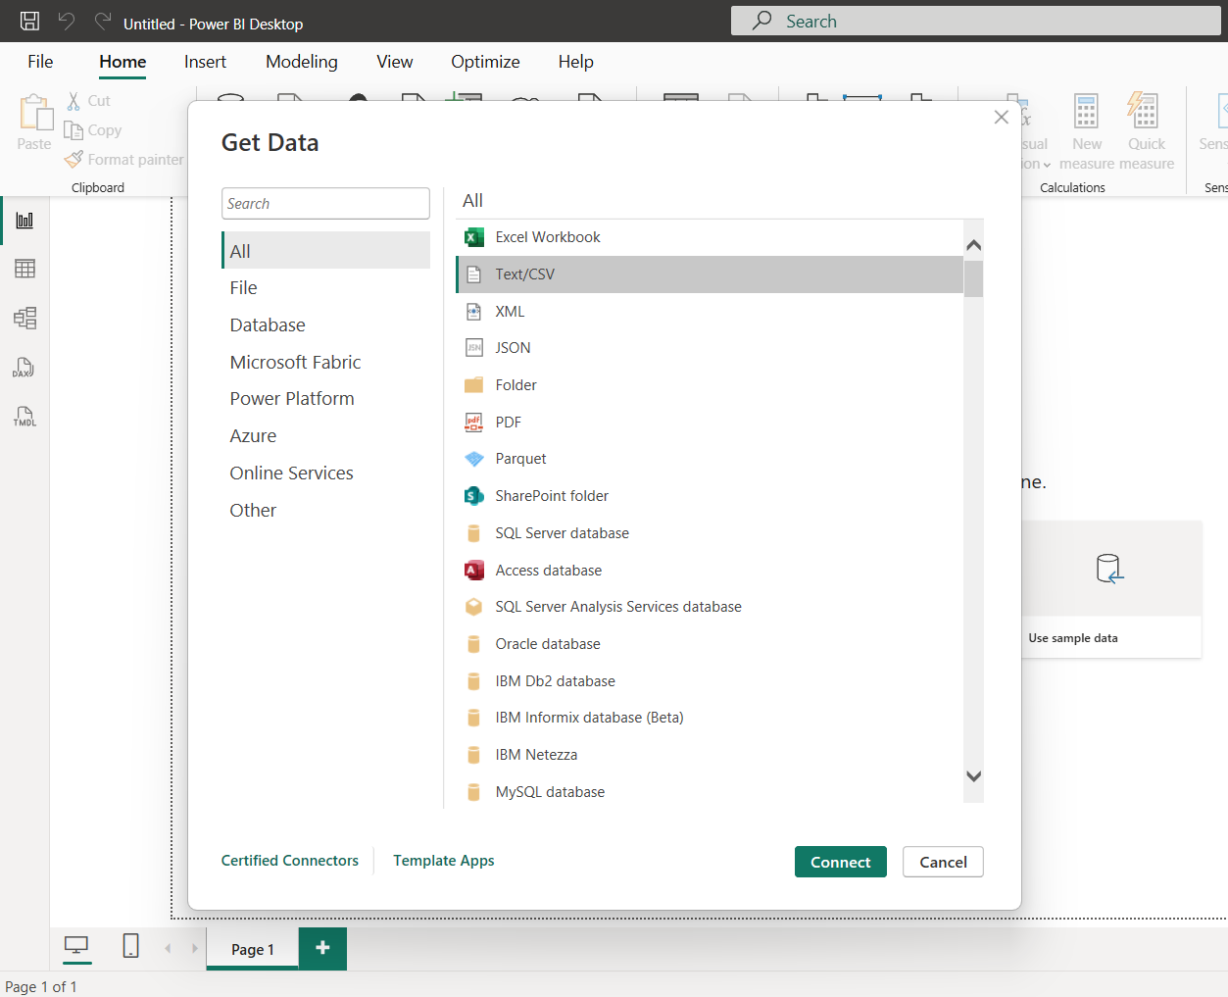

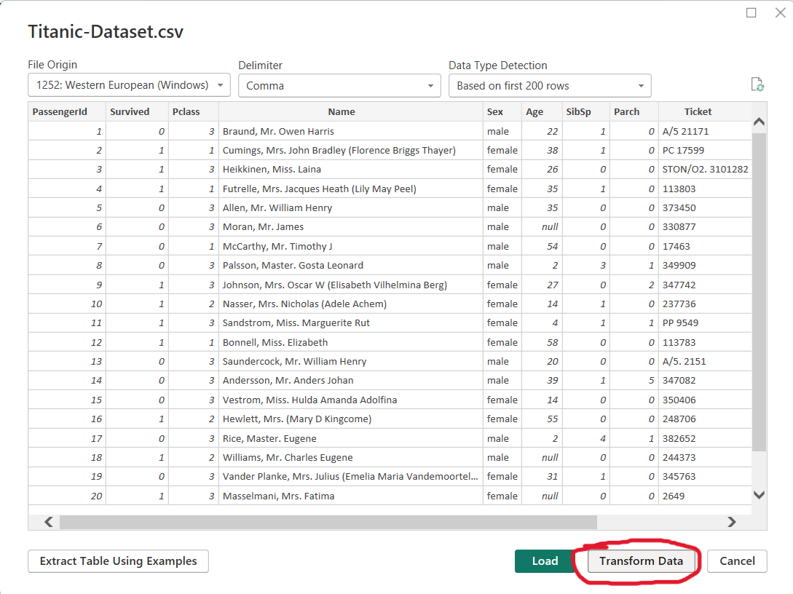

STEP 2: Transformation
(A) Remove Unnecessary Columns (Select the ones you want to keep)
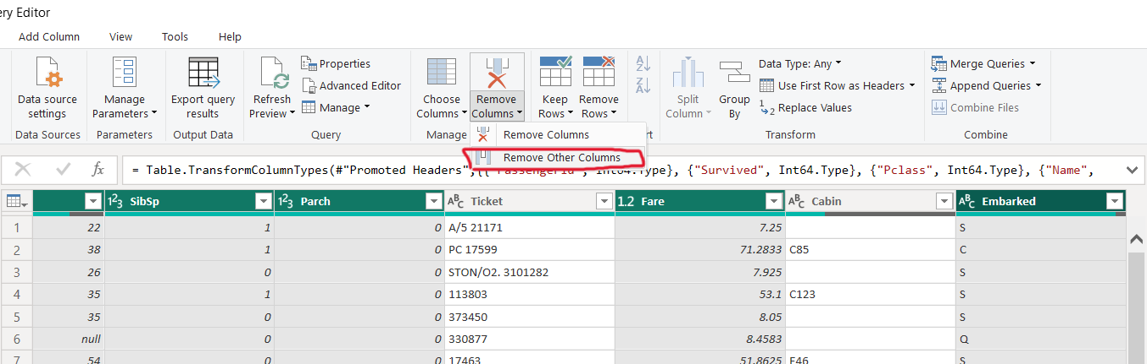

(B) Handle Missing Values (Replace with Average)
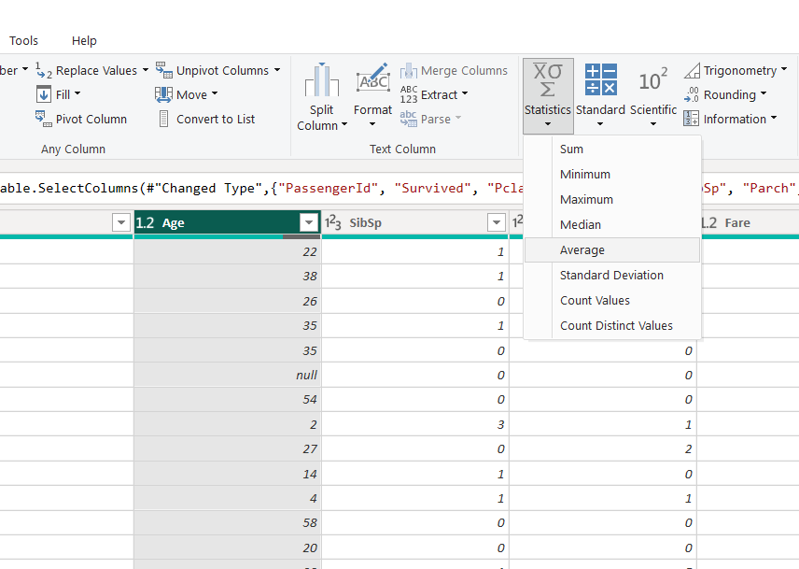

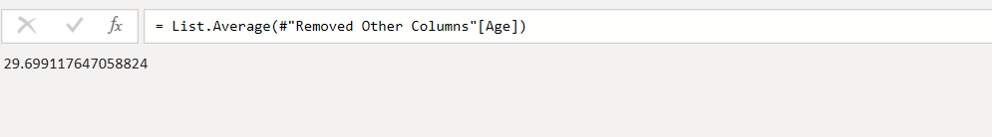

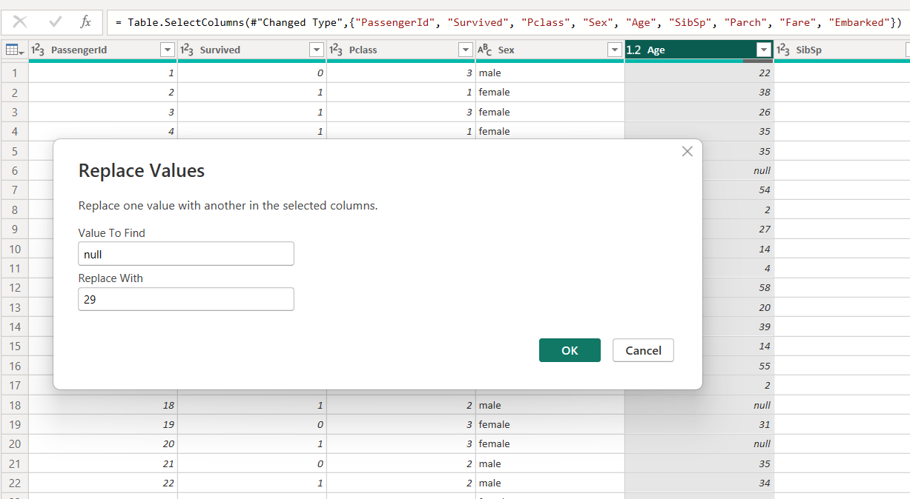

(C) Create NEW Column
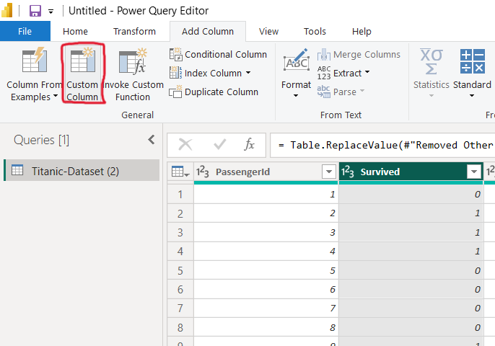
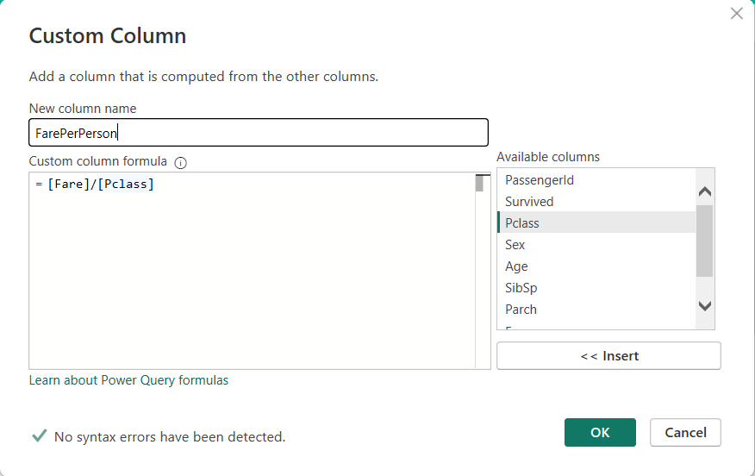

STEP 3: Loading
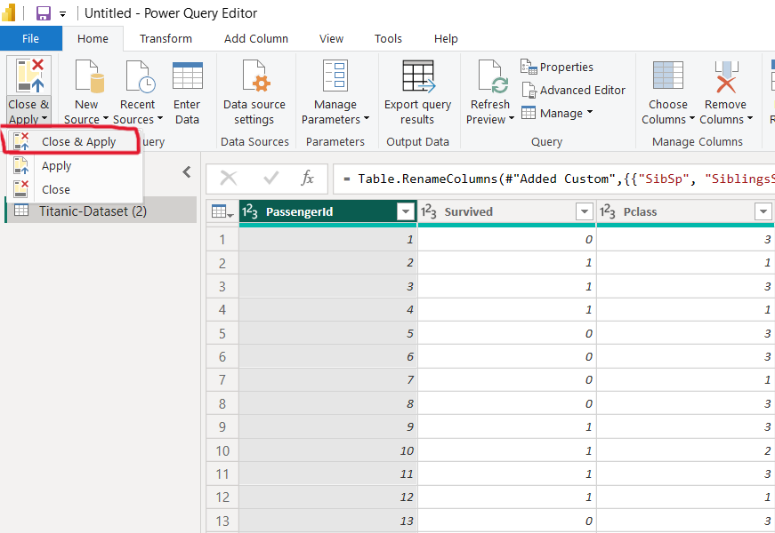

STEP 4: Database Construction
