Name: Gaurang Vaghela
Rollno: BEAD-22561
BI Practical 9
Problem Statement: Data Analysis and Visualization using Advanced Excel.

STEP 1: Open Excel & Enter Data
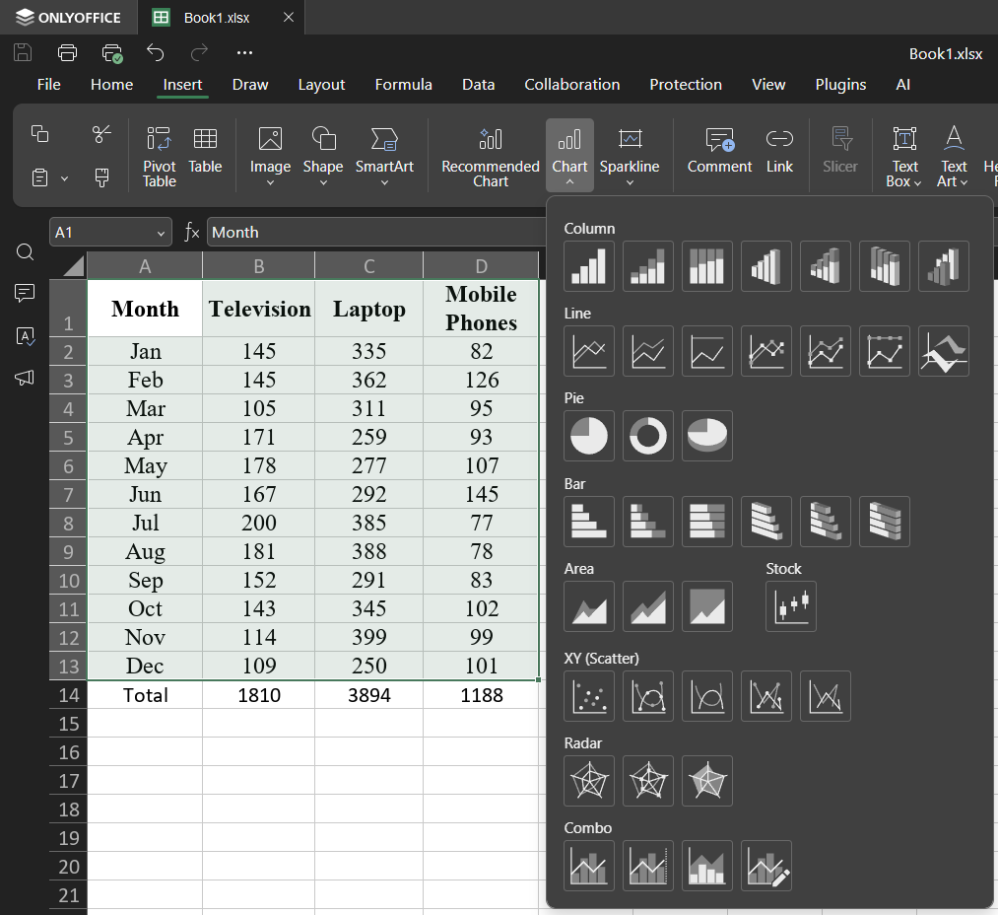

STEP 2: Create COLUMN CHART
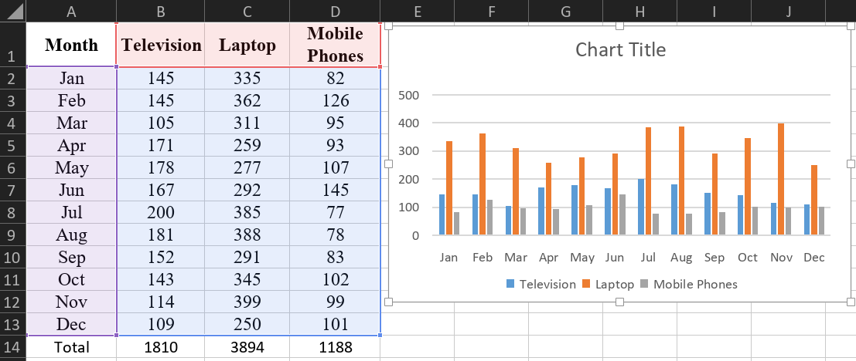

STEP 3: Create BAR CHART
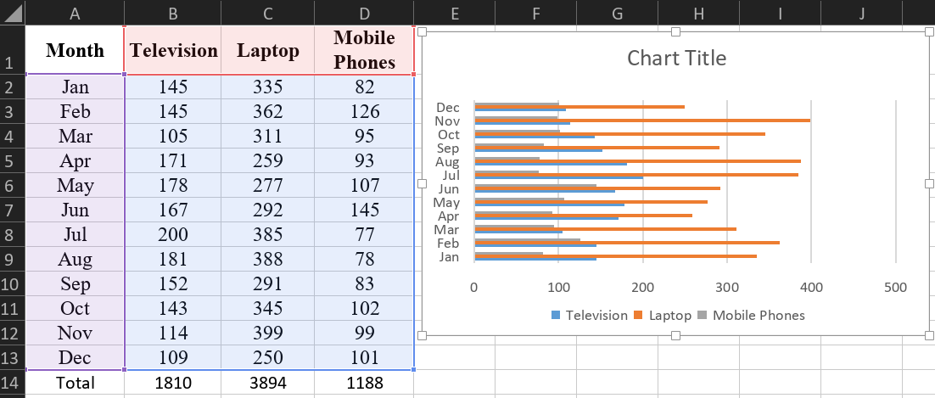

STEP 4: Create LINE CHART
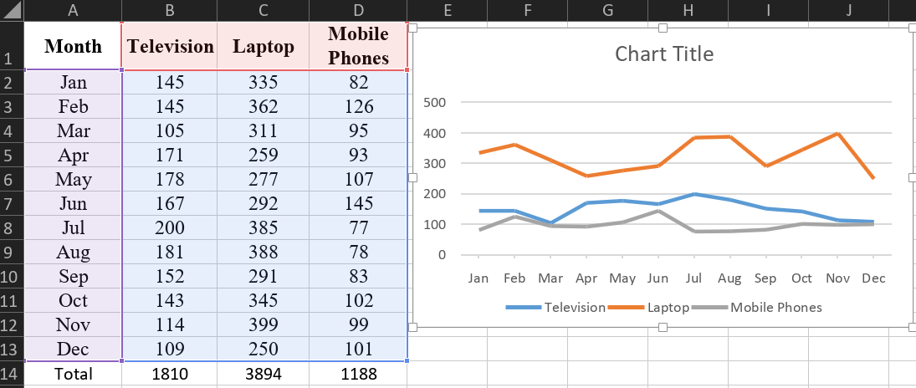

STEP 5: Create PIE CHART
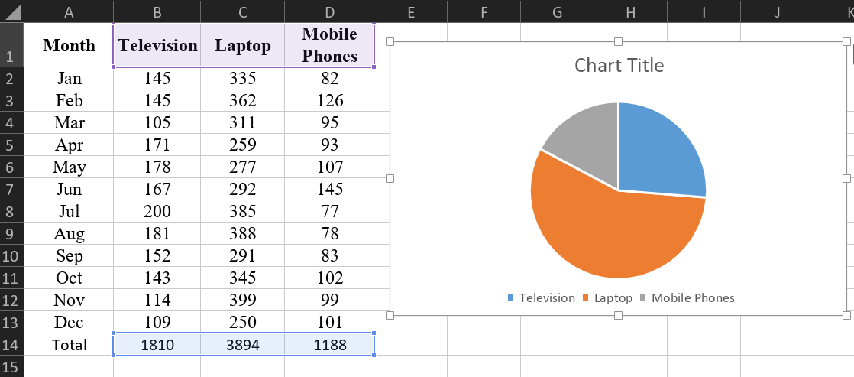

STEP 6: Create SCATTER PLOT
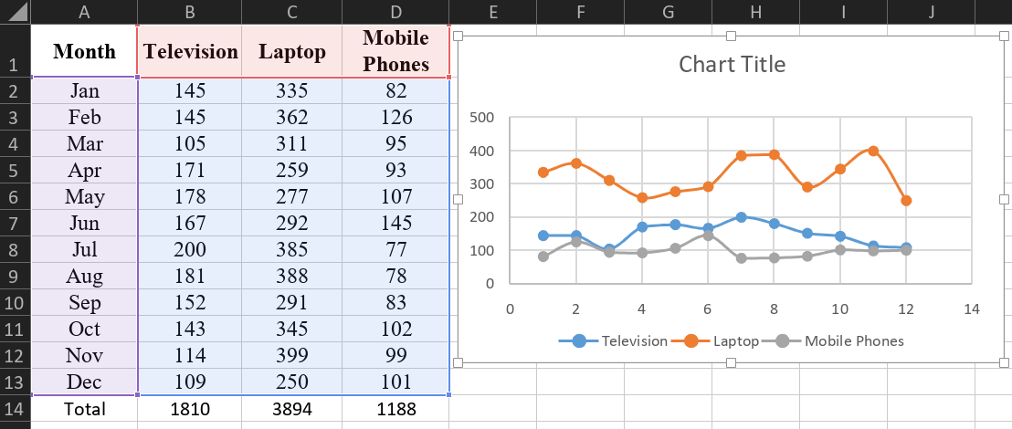

STEP 7: Create WATERFALL CHART
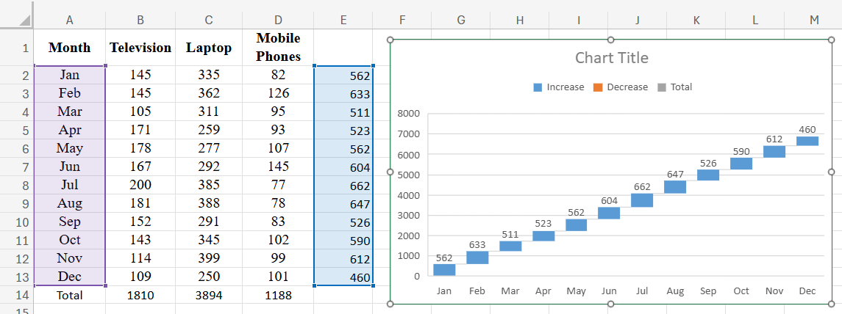

STEP 8: Customize Chart
Edit Chart Title
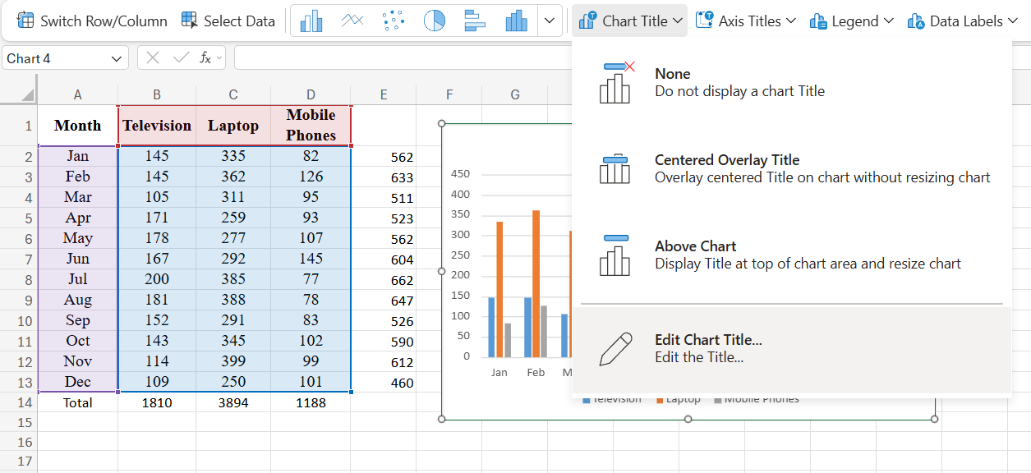

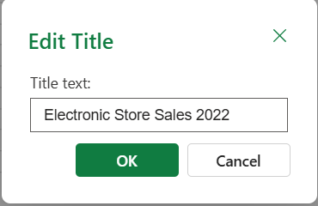

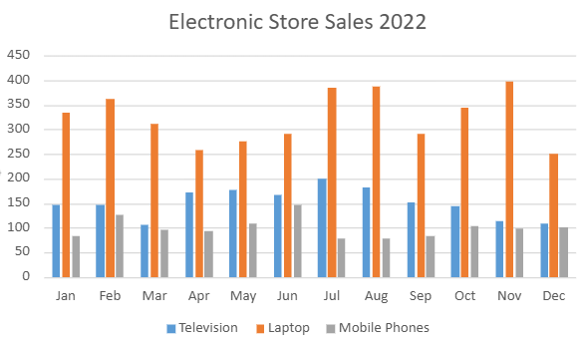

Display Data Labels
