**Name: Gaurang Vaghela**

**Rollno: TEAD-22561**

**DS (SL-III)**

**Practical 2**

**Code:**

**1. Import libraries and load ‘StudentsPerformance.csv’ dataset**

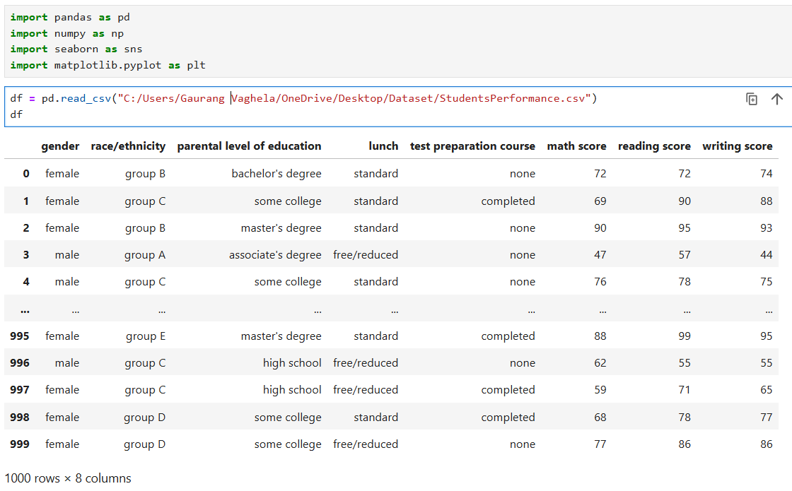

**2. Scan all variables for missing values and inconsistencies. If there are missing values and/or inconsistencies, use any of the suitable techniques to deal with them.**

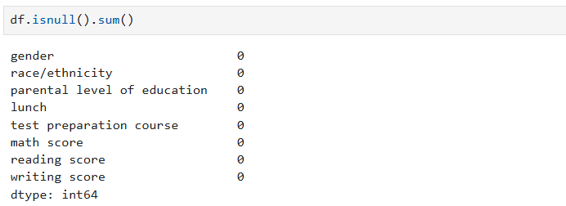

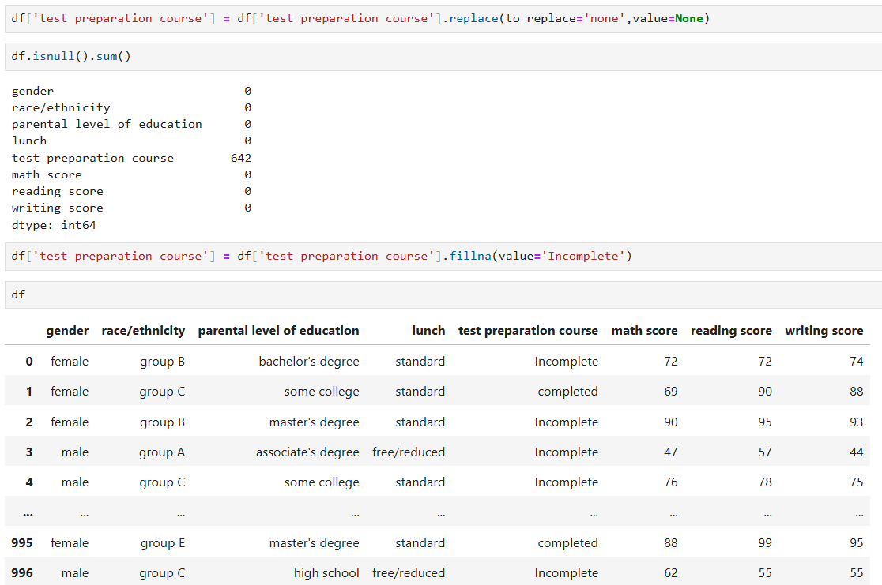

**3. Scan all numeric variables for outliers. If there are outliers, use any of the suitable techniques to deal with them.**

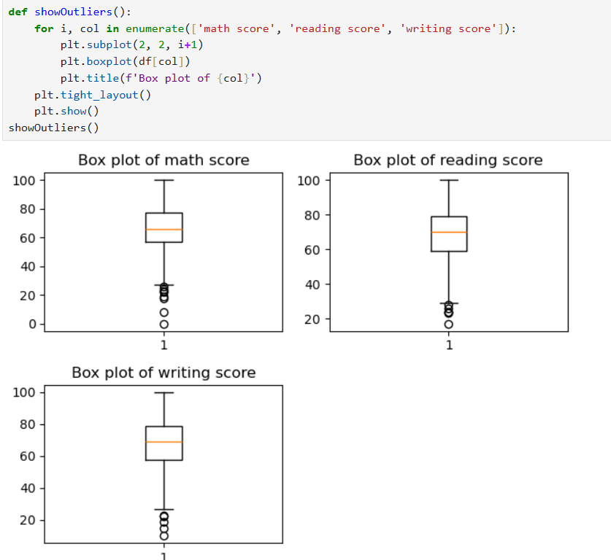



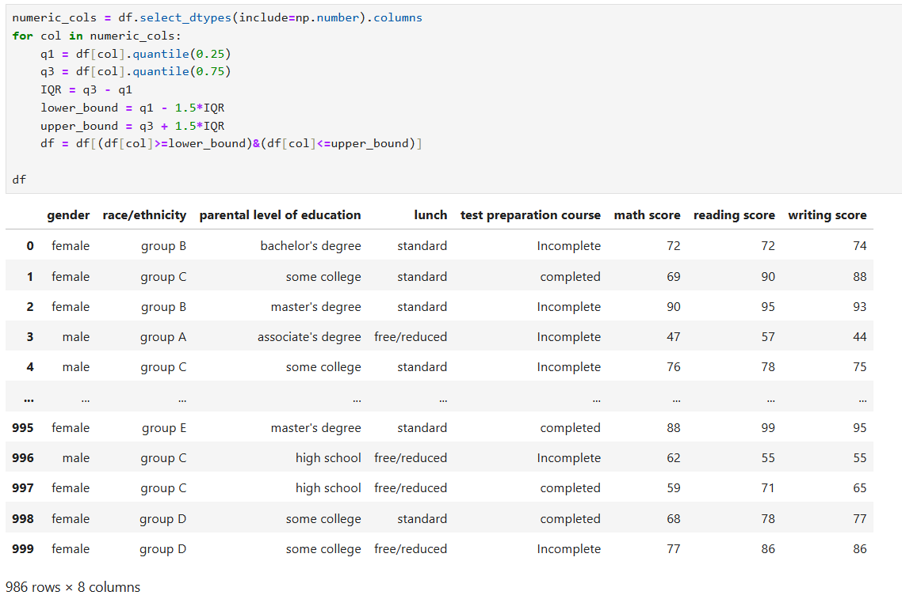

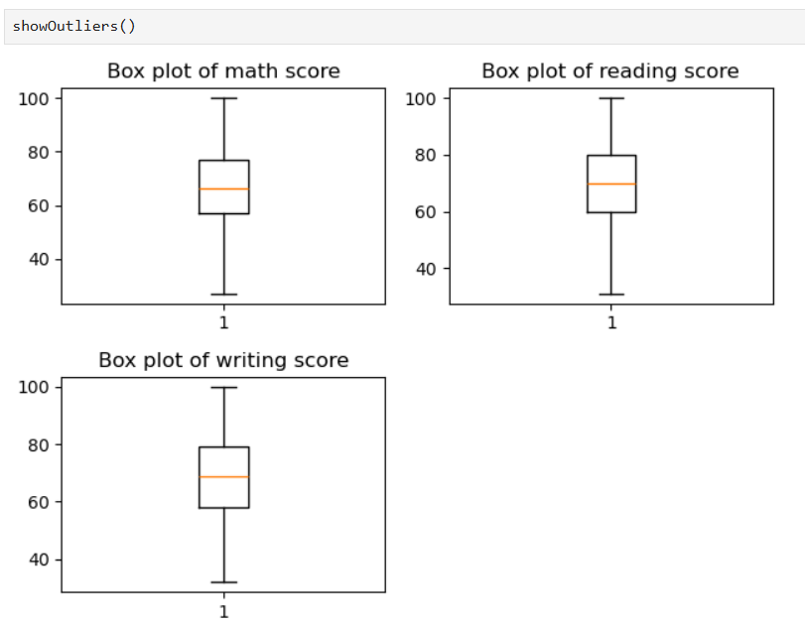

**4. Apply data transformations on at least one of the variables. The purpose of this transformation should be one of the following reasons: to change the scale for better understanding of the variable, to convert a non-linear relation into a linear one, or to decrease the skewness and convert the distribution into a normal distribution.**

