**Name: Gaurang Vaghela**

**Rollno: TEAD-22561**

**DS (SL-III)**

**Practical 3**

**Code:**

**1. Import libraries and load ‘Iris.csv’ dataset**

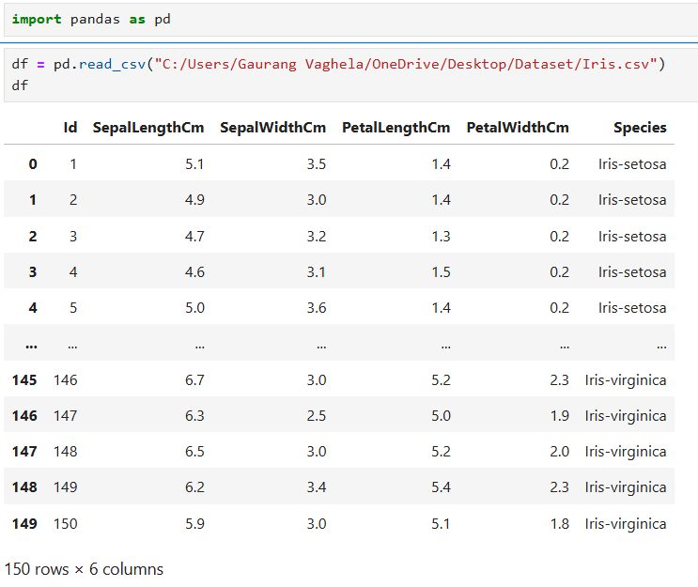

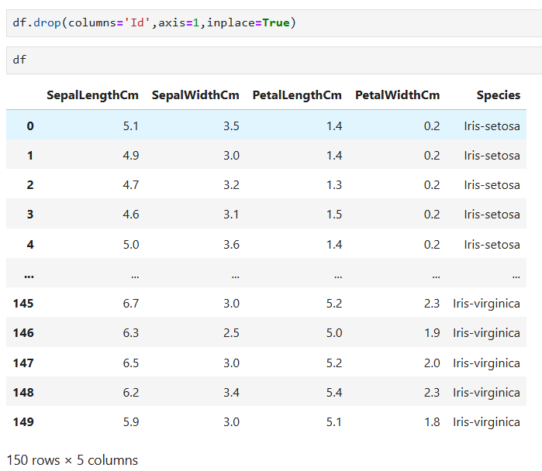

**2. Provide summary statistics (mean, median, minimum, maximum, standard deviation) for a dataset (age, income etc.) with numeric variables grouped by one of the qualitative (categorical) variables.**

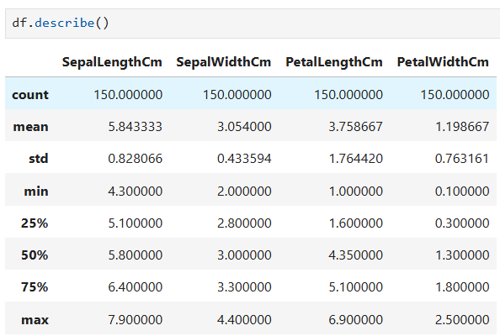

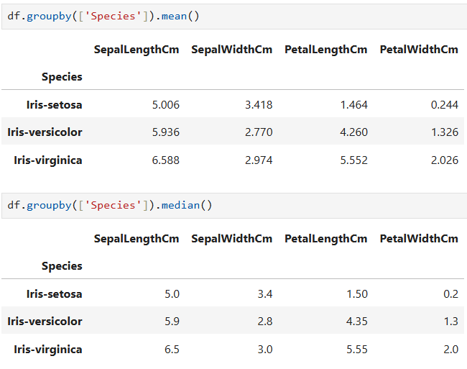

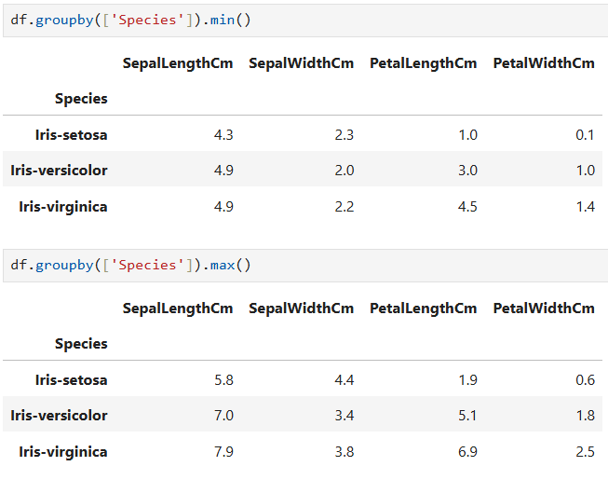

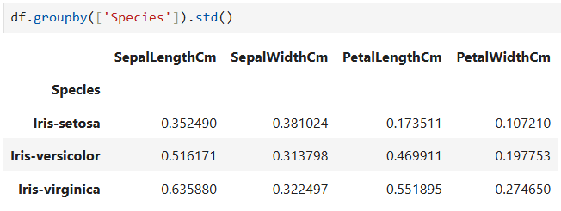

**3. Write a Python program to display some basic statistical details like percentile, mean, standard deviation etc. of the species of ‘Iris-setosa’, ‘Iris-versicolor’ and ‘Iris-versicolor’ of iris.csv dataset.**

