**Name: Gaurang Vaghela**

**Rollno: TEAD-22561**

**DS (SL-III)**

**Practical 4**

**Code:**

**1. Import libraries and load ‘HousingData.csv’ dataset.**

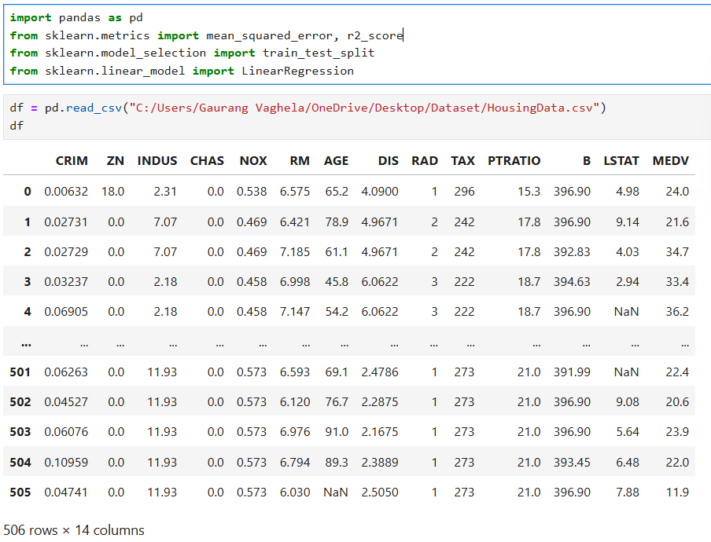

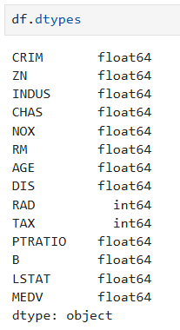

**2. Remove or fill null values.**

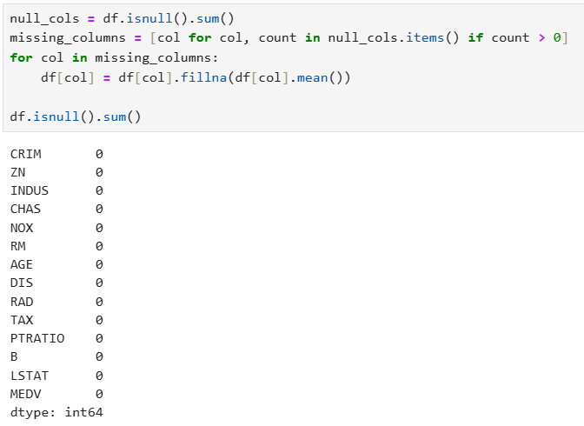

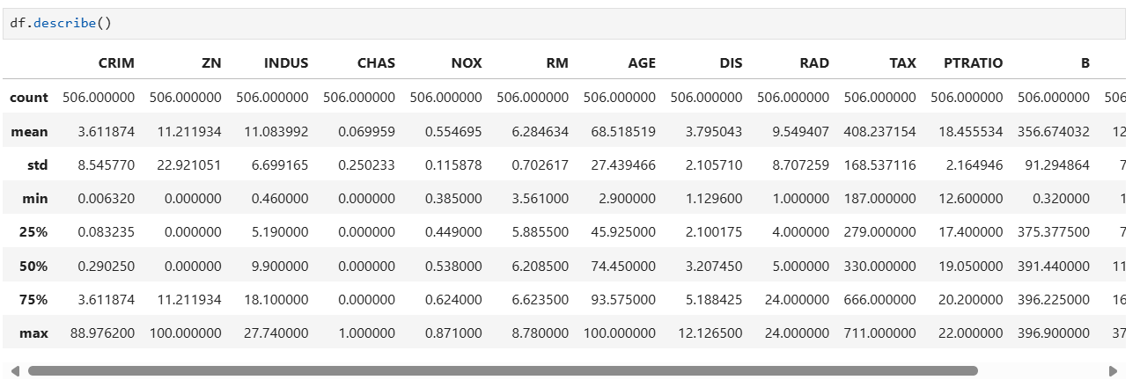

**3. Create a Linear Regression Model using Python/R to predict home prices using Boston Housing Dataset.**

