CE/CS 4390 — Computer Networks
Math Server — Project Report
Spring 2026 | Due: April 16, 2026

a. Group Members
Name | NetID | Role
Gaurang Dhanani | gxd210010 | Server, Protocol
Vedant Deshmukh | vxd220035 | Client, Testing, Docs

b. Project Contributions
Member | Tickets | What They Did
Gaurang | MS-01, 02, 03, 06 | MathServer, ClientHandler, RequestProcessor, MathEvaluator, ServerLogger, protocol_spec.md
Vedant | MS-04, 05, 07, 08 | MathClient, Makefile, integration testing, project report

c. Protocol Design
All messages are newline-terminated UTF-8 strings. Fields are separated by the pipe character |. Default port is 6789.

Direction | Type | Format | Example
Client → Server | JOIN | JOIN|<name> | JOIN|Alice
Server → Client | ACK | ACK|<message> | ACK|Welcome Alice
Client → Server | CALC | CALC|<op1>|<op>|<op2> | CALC|12|+|8
Server → Client | RESULT | RESULT|<expr>|<answer> | RESULT|12+8|20
Server → Client | ERROR | ERROR|<message> | ERROR|Division by zero
Client → Server | QUIT | QUIT | QUIT
Server → Client | BYE | BYE|<message> | BYE|Session ended. Goodbye Alice!

Session flow: client sends JOIN, server replies ACK, client sends CALC requests and receives RESULT or ERROR responses, client sends QUIT and server replies BYE.

d. Programming Environment
- OS: Windows 11
- JDK: OpenJDK 21
- IDE: VS Code with Java Extension Pack
- Build: GNU Make (javac used directly on Windows)
- Version control: Git / GitHub

e. How to Compile and Run

Compile
make all
Or on Windows directly:
javac *.java

Run the Server
java MathServer 6789

Run a Client (separate terminal)
java MathClient 127.0.0.1 6789

f. Execution Parameters
Parameter | Required | Default | Description
Server port | No | 6789 | Port the server listens on
Server IP | Yes (client) | 127.0.0.1 | IP address of the server
Client name | Yes (client) | — | Prompted at startup — display name for logging

g. Code Comments
All Java files have Javadoc-style class and method comments. Each major logic block (handshake, request loop, error handling, logging) has inline comments explaining the intent. See source files for full detail.

h. Application Status
Everything is fully implemented and working:
- Server accepts multiple simultaneous TCP clients using a thread pool
- CALC requests processed in global FIFO order via a shared LinkedBlockingQueue
- All four math operations work correctly including edge cases
- Client-side input validation catches bad input before sending to server
- server.log written with correct timestamps and session durations
- Clean disconnection (QUIT/BYE) and forced disconnect (client crash) both handled

Nothing is incomplete.

i. Challenges Faced
- Thread-safe result routing: getting the CALC result from the RequestProcessor thread back to the correct ClientHandler required a callback pattern using Java's Consumer<String> functional interface.
- FIFO ordering across clients: ensuring requests from Client A and Client B are processed strictly in arrival order required a single shared LinkedBlockingQueue rather than per-client queues.
- Socket cleanup: handling abrupt client disconnects without crashing the server required careful try-catch and finally blocks around all socket I/O.

j. What We Learned
- Practical experience with Java ServerSocket and multithreading for a real client-server application.
- Designing a custom application-layer protocol from scratch — the importance of clear message formats before writing any code.
- Thread safety in shared state: ConcurrentHashMap, LinkedBlockingQueue, and synchronized writes in the logger.
- The difference between graceful and forced disconnection and how to handle both on the server side.

k. Output Screenshots

Screenshot 1 — Server startup with Alice and Bob connected
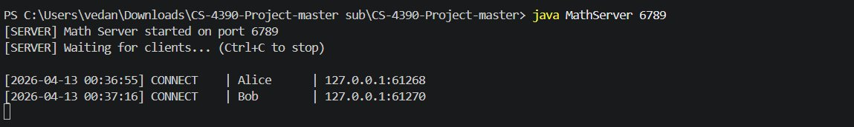
Server started on port 6789. Alice and Bob both connected simultaneously.

Screenshot 2 — Alice client handshake
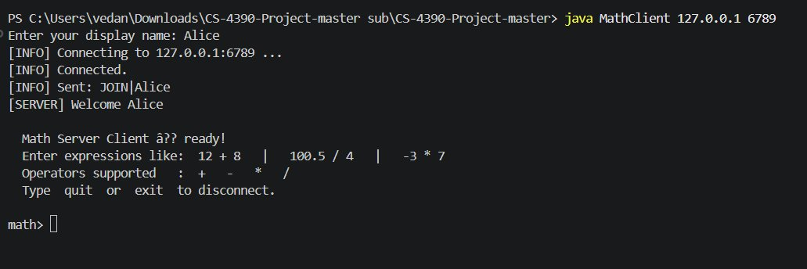
Alice connects, sends JOIN|Alice, receives ACK from server.

Screenshot 3 — Bob client handshake
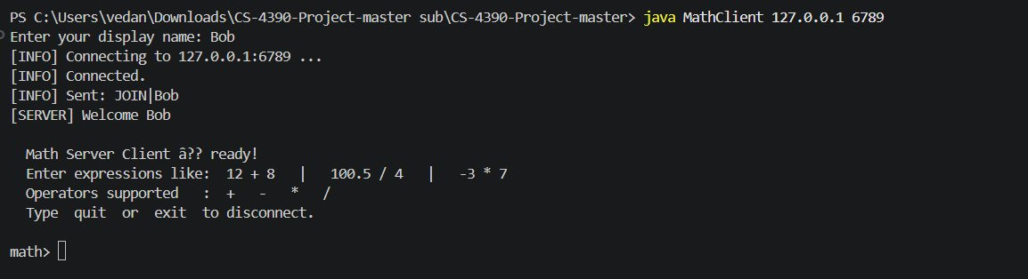
Bob connects while Alice is still active. Both clients run concurrently.

Screenshot 4 — Server log: interleaved requests from Alice and Bob
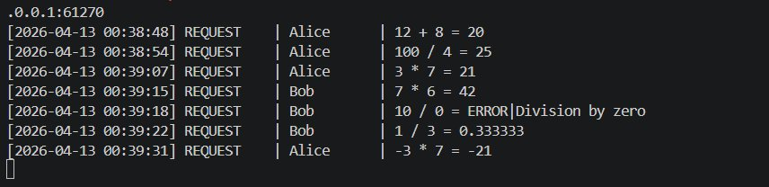
Server processes Alice and Bob requests in FIFO order. Bob's 10/0 returns error.

Screenshot 5 — Bob terminal: requests and error handling
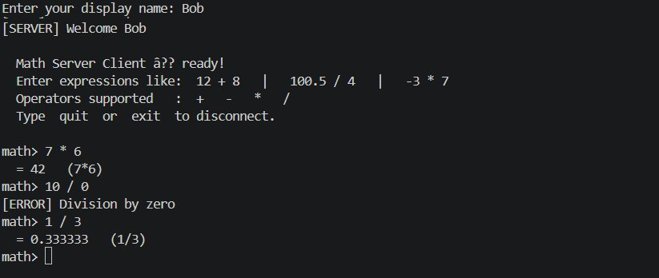
Bob sends 7*6=42, 10/0 returns ERROR|Division by zero, 1/3=0.333333.

Screenshot 6 — Alice terminal: all requests
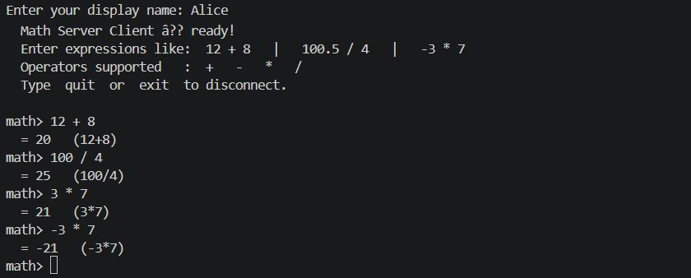
Alice sends 12+8, 100/4, 3*7, -3*7 — all return correct results.

Screenshot 7 — Alice clean disconnect
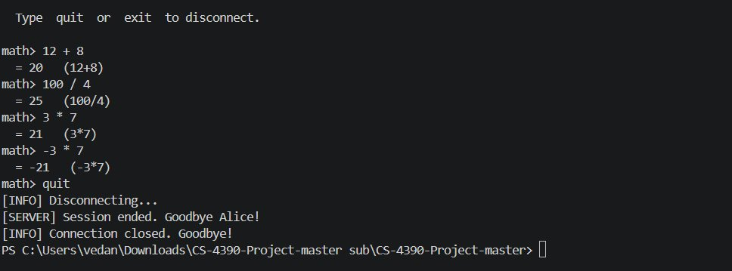
Alice types quit. Server sends BYE and client exits cleanly.

Screenshot 8 — Bob clean disconnect
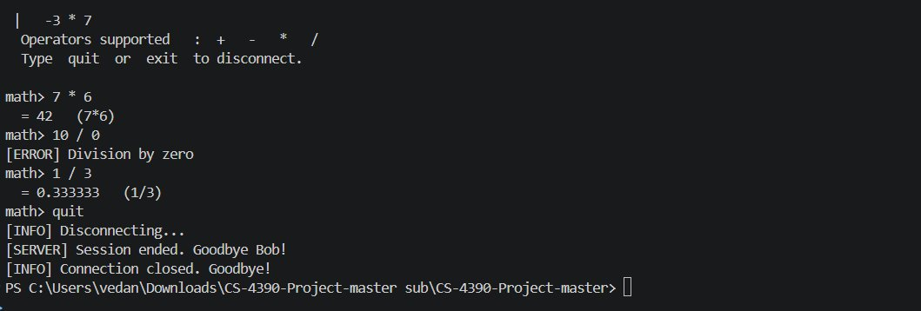
Bob types quit. Server sends BYE and client exits cleanly.

Screenshot 9 — Server log: both disconnects with session duration
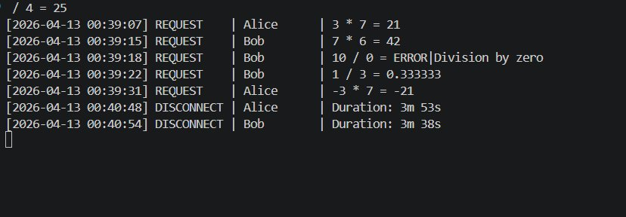
Server logs Alice disconnected (3m 53s) and Bob disconnected (3m 38s).

Screenshot 10 — Forced disconnect (Charlie)
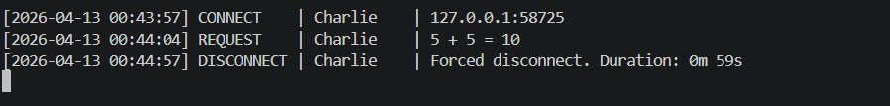
Charlie's terminal was closed without sending QUIT. Server logs forced disconnect.

Screenshot 11 — Full server.log output
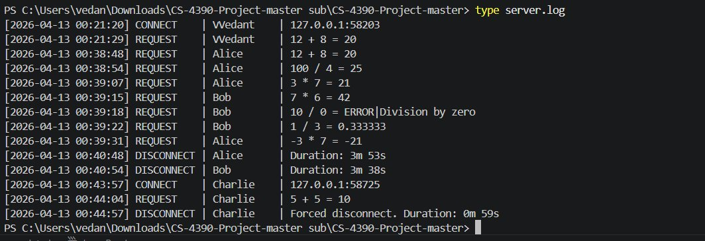
Complete server.log showing all sessions: Vedant (test), Alice, Bob, and Charlie (forced disconnect).

