

A Mini Project Report on

**Design and Implementation of Smoke Detector and Fire Prevention System using IOT Modules & Home Appliances**

for the subject

**Computer Communications (18CSS202J)**

by

Gaurang Ashava (RA2111027010007)

Harshit Kumar (RA2111027010003)

Safal Mehrotra (RA2111027010006)

Syed Adnan Hussainy (RA2111027010008)

Shwetha Anand (RA2111027010045)

To subject in-charge

Dr. R. Jayaraj

Assistant Professor, DSBS

SRMIST

**SRM INSTITUTE OF SCIENCE AND TECHNOLOGY**

**(Under Section 3 of UGC Act, 1956)**

**BONAFIDE CERTIFICATE**

Certified that this mini project report "**Design and Implementation of Smoke Detector and Fire Prevention System using IOT Modules & Home Appliances**" is the bona fide work of **Gaurang Ashava (RA2111027010007), Harshit Kumar (RA2111027010003), Safal Mehrotra (RA2111027010006), Syed Adnan Hussainy (RA2111027010008) and Shwetha Anand (RA2111027010045)** carried out the project work under my supervision.

SIGNATURE

Dr. R. Jayaraj

Assistant Professor

DSBS

SRM Institute of Science and Technology

**ACKNOWLEDGEMENT**

We express our heartfelt thanks to our honorable **Vice Chancellor Dr. C. MUTHAMIZHCHELVAN**, for being the beacon in all our endeavors.

We would like to express my warmth of gratitude to our **Registrar Dr. S. Ponnusamy**, for his encouragement

We express our profound gratitude to our **Dean (College of Engineering and Technology) Dr. T. V. Gopal**, for bringing out novelty in all executions.

We would like to express our heartfelt thanks to the Chairperson, School of Computing **Dr. Revathi Venkataraman**, for imparting confidence to complete my course project

We wish to express our sincere thanks to Course Audit Professor **Dr.Annapurani Panaiyappan,** Professor and Head, Department of Networking and Communications, and Course Coordinators for their constant encouragement and support.

We are highly thankful to our Course project Faculty **Dr. R Jayaraj,** Assistant Professor, Data Science and Business Systems for his assistance, timely suggestion, and guidance throughout the duration of this course project.

We extend my gratitude to our **Dr. M. Lakshmi,** Head of the Department of Data Science and Business Systems, and my Departmental colleagues for their Support.

Finally, we thank our parents and friends near and dear ones who directly and indirectly contributed to the successful completion of our project. Above all, I thank the almighty for showering his blessings on me to complete my Course project.

**INDEX**

|  |  |  |
| --- | --- | --- |
| S.No. | Particulars | Page No. |
| 1 | Abstract | 5 |
| 2 | Objective | 6 |
| 3 | Introduction | 7 |
| 4 | Findings | 9 |
| 5 | Existing System | 12 |
| 6 | Existing System Architecture | 13 |
| 7 | Disadvantages - Existing System | 14 |
| 8 | Proposed System | 15 |
| 9 | VESDA | 16 |
| 10 | Auto Aligning Smoke Detector | 17 |
| 11 | Heat Alarms | 18 |
| 12 | Installation | 19 |
| 13 | Configuration | 20 |
| 14 | Conditions | 25 |
| 15 | Use Case Diagram | 26 |
| 16 | Architectural Diagram | 28 |
| 17 | Precautions when Fire comes | 30 |
| 18 | Result | 32 |
| 19 | References | 32 |

**ABSTRACT**

In our modern world, the terms wireless networks, Internet of Things (IoT), Internet of Everything (IoE), and smart homes have taken on significant importance.

For engagement, communication, automation, and everything else involving humans, the majority of structures, businesses, institutions, and even homes rely on this technology.

Use Packet Tracer, one of the useful learning tools, to comprehend the complex concepts in wireless networks and IoT devices.

The Cisco Networking Academy offers this wireless network simulator without charge.

To make our homes safer and more comfortable, we'll use Packet Tracer to construct a smart smoke and fire detection alarm based on wireless and IoT devices.

We'll also use this project to demonstrate how to create various networking situations.

**OBJECTIVE**

There is still a significant human-caused problem with fire conflagration, and dwellings are particularly vulnerable to fire.

People have recently used smoke alarms with a single sensor to detect fire. In everyday life, smoke is released in many different ways.

The detection of fire with a single sensor is unreliable.

People may now remotely check on their homes to see how they are doing thanks to the rapid evolution of Internet technology.

At home automation stations, the fire alarm is crucial. The smoke detector of CO2 regulates this mechanism.

The system for the fire alarm is used in the living room, bedrooms, and kitchen.

The smoking alarm and sprinkler will activate if CO2 from smoke from the kitchen or other rooms is detected.

The fire alarm or sprinkler will be activated if CO2 or fire is detected.

Through the network, a fiber optic is used to connect this system to the fired station.

The fire alarm or sprinkler will be turned off if CO2 or flames are not found.

**INTRODUCTION**

**Q.)** What does a smoke detector mean?

**Answer: -**

A smoke detector is a device that detects the presence of smoke or other types of combustion gases in the air.

It is designed to alert occupants of a building, such as a home or an office, of a potential fire by emitting a loud alarm sound. Smoke detectors typically consist of a sensor that detects smoke and a loudspeaker that sounds an alarm.

They are an important safety feature in homes and buildings, as they can provide early warning of a fire and allow people to evacuate before the situation becomes more dangerous.

Installing smoke detectors on every level of a building and inside every bedroom is recommended for maximum protection.

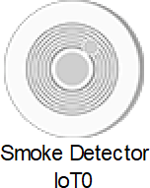

**Q.)** Why fire detection/smoke detection is necessary?

**Answer: -** Fire detection and smoke detection are necessary for several reasons:

**Early warning:** The primary reason for fire detection and smoke detection is to provide early warning of a fire. The earlier a fire is detected; the more time people have to evacuate the building and for emergency services to respond.

**Life safety:** Fires can spread rapidly, producing toxic smoke and gases that can be lethal in a matter of minutes. Smoke detectors are designed to detect the presence of smoke, which can alert occupants of a building to the potential danger and allow them to evacuate before the situation becomes more dangerous.

**Property protection:** Fire detection and smoke detection systems can also help protect property by alerting emergency services before the fire has a chance to spread and cause significant damage.

**Legal requirements:** In many countries, it is a legal requirement to have fire detection and smoke detection systems installed in buildings. This ensures occupants’ safety and minimizes the risk of fire-related incidents.

Overall, fire detection and smoke detection are essential safety features that can save lives, protect property, and ensure compliance with legal requirements.

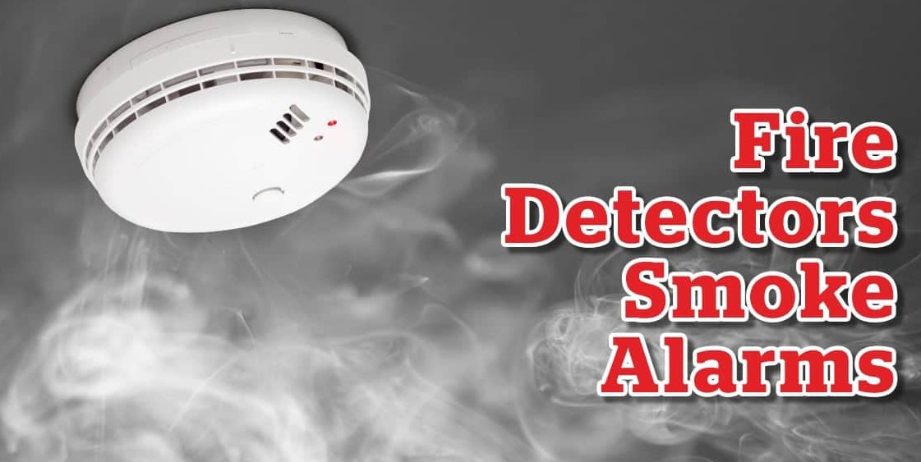

**FINDINGS**

Smoke alarms detect particles in the air. They most commonly do this using two types of detection technologies.

First, there are ionization detectors. These use a small bit of safely shielded radioactive material that electrically charges, or ionizes,

the air molecules between two metal plates. This produces a small electric current flowing from one plate to the other in the air.

When particles enter the chamber, they attract the ions and carry them away, reducing the current.

When the number of particles entering the chamber is enough to reduce that current below a certain amount, the device will register those particles as smoke and the alarm will sound. And about that radioactive material?

Most of its radiation is blocked inside the device, and even then, the radiation

levels in the device are much lower than the natural background radiation to which we are exposed every day.

The other type of commonly used detection technology is called photoelectric.

This technology works by detecting light that is reflected off particles from a light beam inside the sensing chamber. When no particles are present in the sensing chamber, the light from the beam does not strike the light detector, indicating all is clear.

When there are particles present and the amount of light registered by the light detector reaches a certain threshold level, the alarm sounds.

Both kinds of detectors can detect either slow-burning “soldering” fires or fast-burning “flaming” fires, but each technology has its particular strengths. Ionization-based alarms tend to detect small black soot particles from flaming fires more quickly because they are produced in greater numbers

and take away more current from between the plates. Photoelectric detectors tend to be more sensitive to a larger size and white, or light-colored particles, and thus more reflective, like those emitted by smoldering fires.

As important as smoke alarms are for protecting your family and your property, many times they can be a nuisance.

Smoke alarms near kitchens can detect the particles coming off your food as it cooks, even if you don’t burn it.

Sometimes something as simple as turning on a toaster can set them off.

So as with many safety measures, smoke detectors have a trade-off. They can be made sensitive enough to detect almost any smoke.

But if they did, they would detect the smoke you don’t want them to detect (such as from cooked food) and even other things such as dust.

Less sensitive detectors would have fewer nuisance alarms, but in an actual fire, they may not go off in time to save lives or property. Or they may not give off a signal at all.

Researchers are developing new tests and standards to make smoke alarms better at detecting the kinds of smoke we want them to detect and not the kinds we don’t, so we’re never tempted to disable the alarms and put ourselves in danger. As a result, the next generation of smoke detectors promises to cut down on the number of nuisance alarms while also signaling real fires more quickly. And with fire, time is everything when it comes to saving lives and property.

A smoke detector is an electronic fire-protection device that automatically senses the presence of smoke, as a key indicator of fire, and sounds a warning to building occupants. Commercial and industrial smoke detectors issue a signal to a fire alarm control panel as part of a building’s central fire alarm system.

By law, all workplaces must have a smoke detection system. Household smoke detectors, or smoke alarms, issue an audible and/or visual alarm locally from the detector itself.

They can be battery-powered single units or several interlinked hardwired (mains-powered) devices backed up by batteries.

The latter must be installed in all new buildings and after major refurbishments.

**EXISTING SYSTEM**

**Q.)** Why purpose does detection/smoke detection serves?

**Answer: -**

**Ionization smoke detectors:** These detectors use a small amount of radioactive material to ionize the air in the detection chamber. When smoke enters the chamber, it disrupts the ionization process, which triggers the alarm.

**Photoelectric smoke detectors:** These detectors use light sources and photosensors to detect smoke. When smoke enters the detection chamber, it scatters the light, which triggers the alarm.

**Combination smoke detectors:** These detectors combine both ionization and photoelectric detection methods for increased sensitivity to a wide range of fires.

**Air-sampling smoke detectors:** These detectors use a network of pipes and sampling holes to continuously draw in air and analyze it for the presence of smoke particles. They are often used in high-risk environments like data centers or museums.

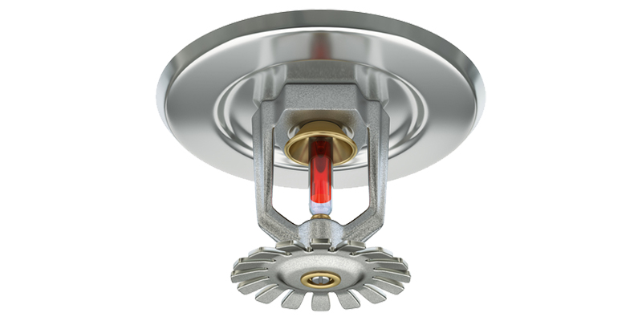

**EXISTING SYSTEM ARCHITECTURE**

The architecture of a smoke detection system typically includes the following components: -

**Smoke detectors:** These are the devices that detect the presence of smoke in the air. There are several types of smoke detectors, including ionization, photoelectric, combination, and air-sampling detectors.

**Control panel:** This is the main hub of the smoke detection system, where all the detectors are connected. The control panel receives signals from the detectors and triggers the alarm when smoke is detected.

**Notification devices:** These are the devices that alert occupants of the building to the presence of smoke or fire. They can include strobe lights, sirens, and voice alarms.

**Monitoring services:** Some smoke detection systems are connected to monitoring services that can alert emergency services in the event of a fire.

**Power supply:** Smoke detection systems require a reliable power supply, either through hardwired electrical connections or batteries.

**Remote access:** Some smoke detection systems allow remote access through a mobile app or web portal, enabling users to monitor the system and receive alerts from anywhere.

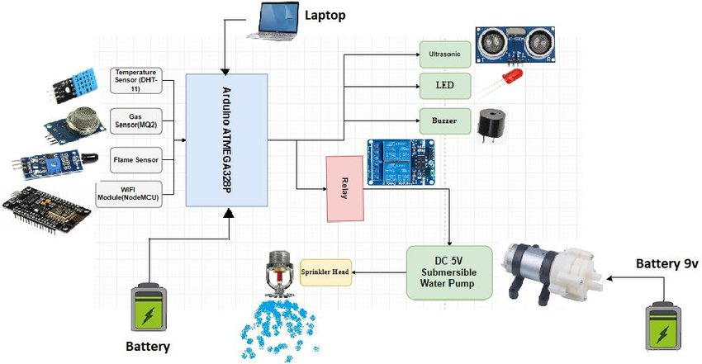

**DISADVANTAGES**

While smoke detection systems are an essential safety feature in buildings, there are a few disadvantages to these systems, including:

**False alarms:** Smoke detectors can be triggered by factors other than smoke, such as cooking fumes, steam, or dust. False alarms can be disruptive and can cause occupants to become complacent about real alarms.

**Limited detection range:** Smoke detectors typically have a limited detection range, making them less effective in larger buildings or with high ceilings.

**Response time:** Smoke detectors can take several seconds or even minutes to detect smoke, especially if the fire is in a remote area of the building. This delay can be critical in providing early warning of a fire.

**Maintenance:** Smoke detectors require regular maintenance, including battery replacement, testing, and cleaning. Failure to properly maintain the system can result in false alarms or a failure to detect smoke.

**Cost:** Smoke detection systems can be expensive to install and maintain, especially in larger buildings or in areas with complex layouts.

**PROPOSED SYSTEM**

There is also an increasing number of aspirating smoke detectors (ASD) on the market – more advanced, highly-sensitive, technologies that provide earlier warning detection and are used as part of active fire protection.

ASD systems work by drawing in air from each room through small, flexible tubing.

The air is then analyzed to identify the presence of minute smoke particles in a continuous process. They are not reliant on room airflow, so they can detect smoke before it is visible.

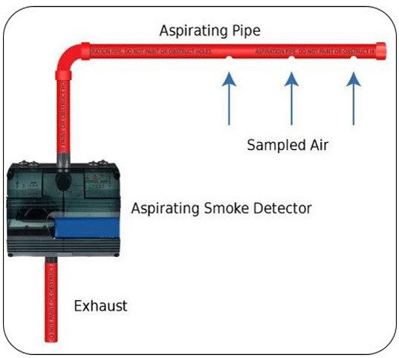Aspiration systems are widely used and preferred in challenging situations such as areas of high airflow, where condensation is present, or where very early detection is required in locations such as communications and computer rooms.

**VESDA (Very Early Smoke Detection Apparatus)**

Systems, a brand name of Honeywell, are laser-based advanced ASDs that give a pre-fire warning.

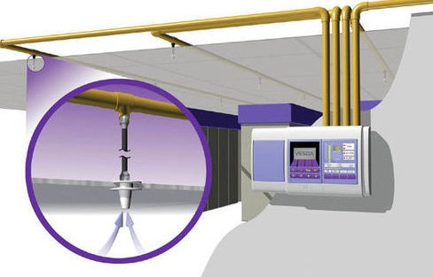They are beneficial in areas where high smoke sensitivity and easy access is required, such as computer rooms, cold rooms, and high-ceilinged buildings like warehouses and churches, because the detectors can be located at accessible levels for maintenance purposes.

**AUTO-ALIGNING SMOKE DETECTOR**

The latest type of intelligent smoke detector is a laser-assisted infrared optical beam smoke detector that self-aligns in less than a minute.

They are used to protect large commercial and public spaces such as theatres, shopping malls, and sports centers with large skylights, lofty ceilings, or condensation issues.

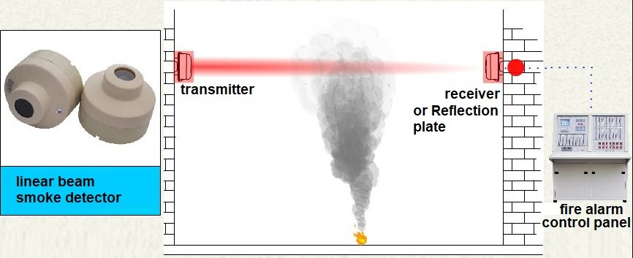

Some models can be installed with up to four detector heads per system.

Incidentally, some smoke detectors are not smoke detectors at all, but security devices incorporate hidden cameras.

**HEAT ALARMS**

Heat alarms detect an increase in temperature caused by a fire, although they are insensitive to smoke.

They are suitable for use in a kitchen, garage, or dusty room but should not be the sole means of fire detection.

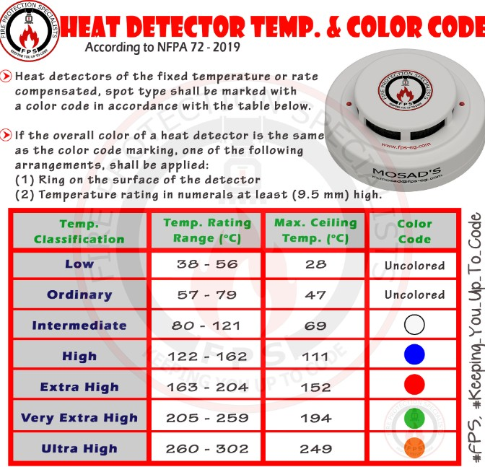

**INSTALLATION**

Mains-powered alarms must be installed by a qualified electrician or installation professional.

Domestic smoke alarms are much easier to install as no wiring is required, but they must be installed, maintained correctly, and regularly checked.

Smoke detectors have an average life of about eight to 10 years. Detectors need to be checked periodically, ideally once a week, and the batteries changed when required, at least once a year. A hard-wired smoke detector can last 10 years.

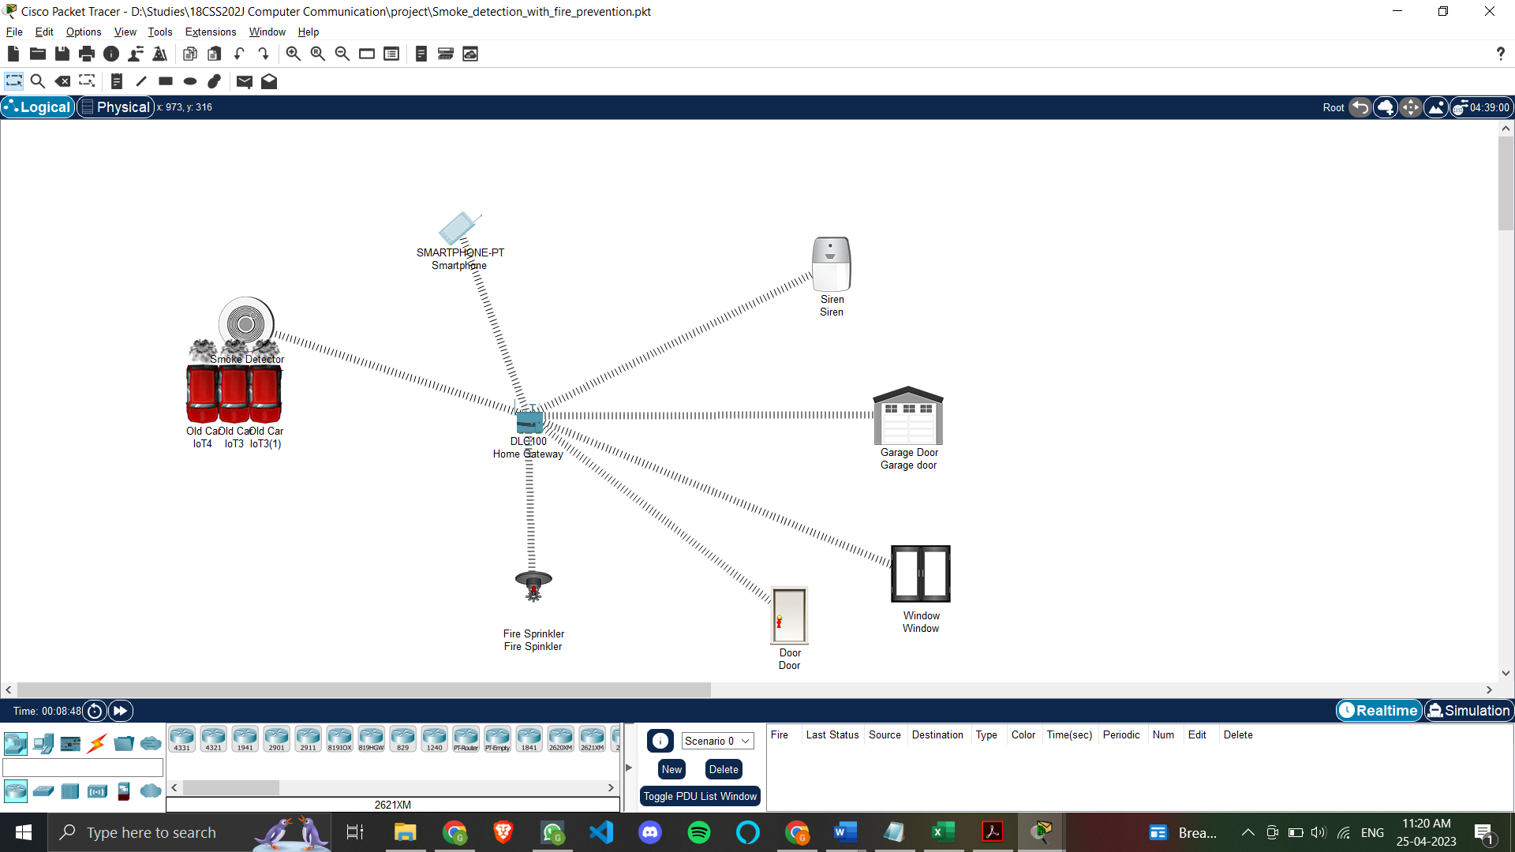

**CONFIGURATION**

Navigation



Smoke Detector Rules



Devices in the system



Implementation

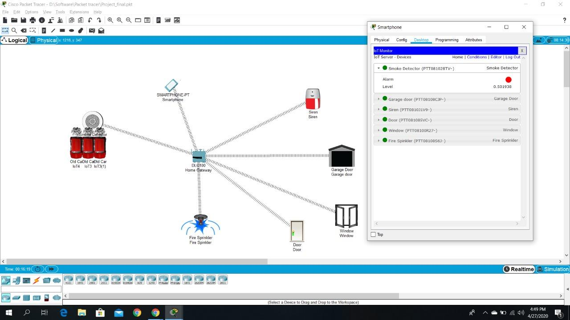

1. **DLC Home Gateway**

• Created a web page with a username and password to connect and gain

control of the system.

• Registration can be done on this router.

• Range of the router is set to a maximum (of 1000 meters or 1km).

• Ip address is assigned as 192.168.25.1 dynamically.

1. **Smartphone**

• Connect to the system by going to the web browser and entering the IP of

the registration server and logging in using your ID and Password.

• Ip address is assigned as 192.168.25.100 dynamically.

1. **Smoke Detector**

• Smoke Detector is used to detect any smoke.

E.g., When a fire breaks out the smoke detector will detect it. And in our project, when the smoke level goes beyond 0.5, certain conditions are triggered such as doors, and windows being opened, fire sprinklers, and sirens being turned on.

• It is connected to Home Gateway using an advanced setting in the I/O config i.e.

(PT-IOT-NM-1W) network adapter setting.

• Dynamic IP address is assigned using DHCP.

1. **Window**

• A window is an opening in a wall that allows the passage of light, sound, and sometimes air.

• It is connected to Home Gateway using the advanced setting in the I/O config i.e

(PT-IOT-NM-1W) network adapter setting

• Dynamic IP address is assigned using DHCP

1. **Door**

• A door is an opening from where people can enter or leave in normal

routine life as well as in an emergency.

• It is connected to Home Gateway using an advanced setting in the I/O config i.e

(PT-IOT-NM-1W) network adapter setting

• Dynamic IP address is assigned using DHCP

1. **Garage door**

• A Garage door is an opening from where vehicles can enter or leave. In

our case this is very crucial as garage doors are huge and can help the air

escape when there is a fire outbreak, releasing carbon dioxide and other gases into the air and helping people to take clean air if they are stuck

in the house.

• It is connected to Home Gateway using advanced settings in the I/O config i.e.

(PT-IOT-NM-1W) network adapter setting

• Dynamic IP address is assigned using DHC

1. **Fire sprinkler**

• The fire sprinkler sprays streams of water to suppress or extinguish the fire

when ordered by the home gateway. This happens when a smoke detector

detects a smoke level of more than 0.5.

• It is connected to Home Gateway using advanced settings in the I/O config i.e

(PT-IOT-NM-1W) network adapter setting

• Dynamic IP address is assigned using DHCP

1. **Siren**

• A siren is a device that makes a loud emergency sound when the smoke

The detector detects smoke levels greater than 0.5.

• It is connected to Home Gateway using advanced settings in the I/O config i.e

(PT-IOT-NM-1W) network adapter setting

• Dynamic IP address is assigned using DHCP

1. **Car**

• In the Cisco packet tracer, no object or entity can simulate the generation of smoke other than a car.

• So, we have used 3 cars to represent a smoke generation which is similar to smoke generated during a fire.

**CONDITIONS**

To implement the project, we need to specify certain conditions for all the devices to be activated and deactivated. Based on how and when these conditions change, there will be changes in the state of the devices.

To simulate smoke, we have used 3 cars. The conditions which are mentioned above are crucial for this simulation as follows:

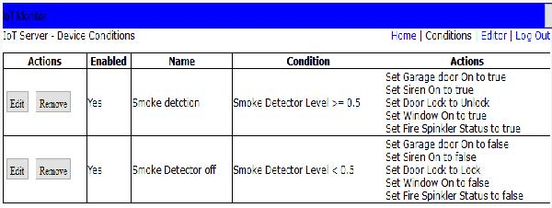

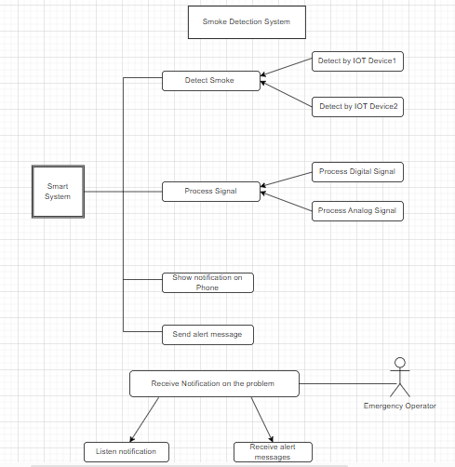**USE CASE DIAGRAM**

A use case diagram for an IoT-based smoke detection system would illustrate the different interactions and activities of the various actors involved in the system. Here is an explanation of the different elements that could be included in the use case diagram:

**Actors:** Actors are the different entities that interact with the system. In the case of an IoT-based smoke detection system, actors could include building occupants, building management personnel, and emergency responders.

**Use cases:** Use cases represent the different actions that an actor can perform within the system. For example, building occupants may trigger an alarm in the event of a fire, while building management personnel may access real-time data on the status of the smoke detection system.

**System boundaries:** System boundaries define the limits of the system and the interactions between actors and use cases. For example, the IoT-based smoke detection system may be integrated with other smart building systems, such as HVAC or security systems, which would be represented within the system boundaries.

**Relationships:** Relationships between actors and use cases illustrate the different ways in which they interact with each other. For example, building occupants may trigger an alarm, which would alert emergency responders.

Overall, a use case diagram for an IoT-based smoke detection system would provide a visual representation of the different actors, use cases, and interactions within the system. This diagram can be useful in designing and implementing the system, as well as in communicating its functionality to stakeholders.

**ARCHITECTURAL DIAGRAM**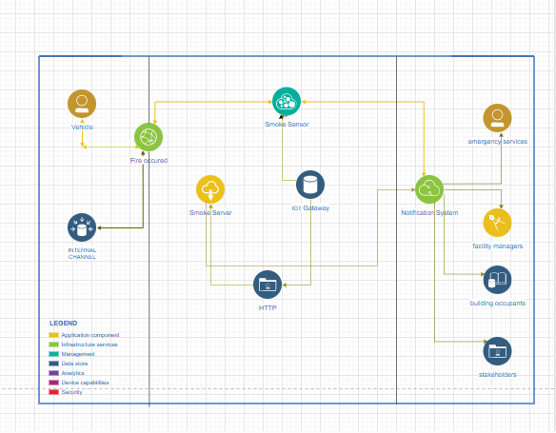

**IoT sensors:** These are the devices that detect smoke and send signals to the cloud-based platform. They may include smoke detectors, air quality sensors, and temperature sensors.

**A cloud-based platform:** This is the central hub of the system, where data from the IoT sensors is collected and analysed. The cloud-based platform may use machine learning algorithms to identify patterns in the data and detect potential fires.

**Communication protocols:** These are the protocols that enable the IoT sensors to communicate with the cloud-based platform. They may include wireless protocols such as Wi-Fi, Bluetooth, or Zigbee.

**Mobile app:** This is the interface through which building occupants and management personnel can access real-time data on the status of the smoke detection system. The mobile app may also include features such as push notifications and alerts in the event of a fire.

**Integration with other systems:** The IoT-based smoke detection system may be integrated with other smart building systems, such as HVAC, lighting, or security systems. This integration can provide a more comprehensive approach to building safety and enable automated responses to potential fires.

**Data storage and analysis:** The cloud-based platform may store data on historical smoke detection events and use this data to improve the accuracy and effectiveness of the system over time.

**PRECAUTIONS**

Burn injury and incidence rates

The following statistics are the latest available from the National SAFE KIDS Campaign and the United States Fire Administration (part of the Federal Emergency Management Agency):

**Injury and death rates:**

• The majority of fire-related deaths are caused by smoke inhalation of the toxic gases produced by fires. Actual flames and burns only account for about 30 percent of fire-related deaths and injuries.

• The majority of fires that kill or injure children are residential fires.

• The majority of children ages 4 and younger, who are hospitalized for burn-related injuries, suffer from scald burns (65 percent) or contact burns (20 percent).

• Fires kill about 500 children ages 14 and under each year.

• Hot tap water scald burns cause more deaths and hospitalizations than any other hot liquid burns.

**Causes:**

• The leading cause of home fires and related injuries is home-cooking equipment. However, most fire-related deaths are from residential fires ignited by smoking materials such as cigarettes.

• The leading cause of residential fire-related death and injury among children ages 9 and under is carelessness.

• The most common causes of product-related thermal burn injuries among children ages 14 and under are hair curlers, curling irons, room heaters, ovens, ranges, irons, gasoline, and fireworks.

• Most scald burns to children, especially small children between the ages of 6 months and 2 years, are caused by hot foods or liquids spilled in the kitchen, or other areas where food is prepared and served.

**Where and when:**

• Over half of the children ages 5 and under who die from home fires are asleep at the time of the fire. Another one-third of these children are too young to react appropriately.

• Deadly residential fires are most likely to start in a living or sleeping area.

• Residential fires and related deaths occur more often during cold-weather months, December through February, due to portable or area heating equipment.

• Most children’s play-related home fires begin in a bedroom or living room where children are left unattended. The majority of these fires are started by children playing with matches or lighters.

**Who:**

• Children in homes without working smoke alarms are at greater risk of fire-related death and injury in the event of a fire.

• Children ages 5 and under are more than twice as likely to die in a fire than any other age group.

**Smoke alarm and sprinkler system statistics:**

• By 2004, the majority of homes (96 percent) in the United States had at least one smoke alarm. However, only three-quarters of all homes had at least one working smoke alarm.

• Automatic sprinkler systems reduce the chance of dying in a residential fire by approximately 73 percent.

• Smoke alarms and sprinkler systems combined can reduce fire-related deaths by 82 percent and injuries by 46 percent.

**RESULT**

In conclusion, an IoT-based smoke detection system offers several advantages over traditional smoke detection systems. By leveraging the power of the Internet of Things, these systems can provide real-time monitoring, early warning of potential fires, and more precise detection capabilities. They can also integrate with other smart building systems to provide a more comprehensive approach to building safety.

However, it is important to note that an IoT-based smoke detection system also has some limitations and challenges, such as data security and privacy concerns, reliability issues with wireless connectivity, and the need for regular maintenance and updates.

Despite these challenges, the benefits of an IoT-based smoke detection system are significant, and it represents a promising avenue for enhancing building safety and improving emergency response times. As the technology continues to evolve and improve, we will likely see even more advanced and sophisticated IoT-based smoke detection systems in the future.

**REFERENCES**

* [www.researchgate.net](http://www.researchgate.net)
* [www.packettracernetwork.com](http://www.packettracernetwork.com)
* <https://www.youtube.com/watch?v=EmqOhV0vt4c>
* <https://www.packettracernetwork.com/internet-of-things/pt7-iot-devices-configuration.html>
* <https://www.packettracernetwork.com/internet-of-things/iot-advanced-programming.html>