Worksheet 2

Student Name:Gaurang Garg UID:25MCI1079
Branch: MCA(AI/ML) | Section/Group:1/A
Semester: II | Date of Performance:13/01/2026
Subject Name:- Technical Training | Subject Code: 25CAP-652

- Aim of the Session
To implement and analyze SQL SELECT queries using filtering, sorting, grouping, and aggregation concepts in PostgreSQL for efficient data retrieval and analytical reporting.
- Objective of the Session
After completing this practical, the student will be able to:
  - Retrieve specific data using filtering conditions
  - Sort query results using single and multiple attributes
  - Perform aggregation using grouping techniques
  - Apply conditions on aggregated data using HAVING clause
  - Understand real-world analytical queries commonly asked in placement interviews
- Practical / Experiment Steps
  - Create a sample table representing customer orders
  - Insert realistic records into the table
  - Retrieve filtered data using WHERE clause
  - Sort query results using ORDER BY
  - Group records and apply aggregate functions
  - Apply conditions on grouped data using HAVING
  - Analyze execution order of WHERE and HAVING clauses

- Procedure of the Practical
- Start the system and log in to the computer.
- Open PostgreSQL software. iii) Create and select the database.
create database CompanyDB;
- Create table using DDL command.
create table customer_orders( order_id serial primary key, customer_name varchar(20), product varchar(20), quantity int, price numeric(10,2), order_date date
);

- Insert records into the table.
insert into customer_orders(customer_name,product,quantity,price,order_date) values
('Aman', 'Laptop', 1, 55000.00, '2025-01-10'),
('Rohit', 'Mobile', 2, 20000.00, '2025-01-11'),
('Neha', 'Tablet',1, 30000.00, '2025-01-12'),
('Priya', 'Laptop',1, 56000.00, '2025-01-13'),
('Rahul', 'Mobile', 3, 18000.00, '2025-01-14'),
('Kiran', 'Headphone',2, 3000.00, '2025-01-15'),
('Suman', 'Keyboard', 1,1500.00, '2025-01-16'),
('Ankit', 'Mouse', 2,800.00, '2025-01-17');
- Display all records. select * from customer_orders;
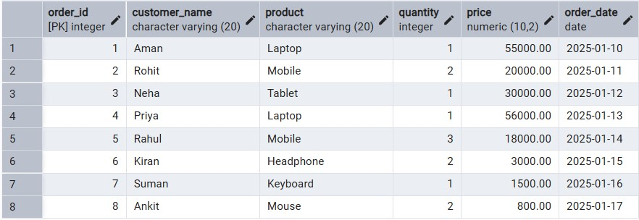
- Filtering Data Using WHERE clause.
select order_id, customer_name, product, quantity, price from customer_orders where price > 20000;
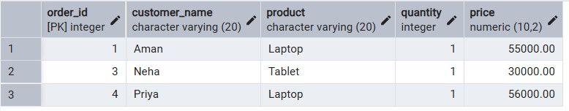

- Sorting Query Results. Ascending Order
select order_id, customer_name, product, quantity, price from customer_orders where price > 20000 order by price;
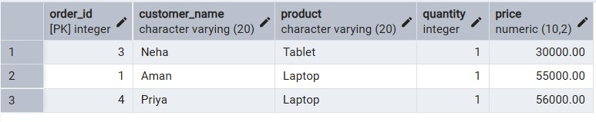
Descending Order
select order_id, customer_name, product, quantity, price from customer_orders where price > 20000 order by price desc;
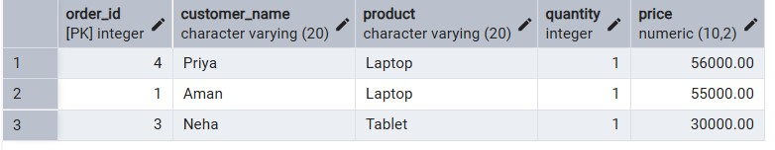

- Grouping Data for Aggregation.
select product, count(*) as total_product_sale from customer_orders group by product;
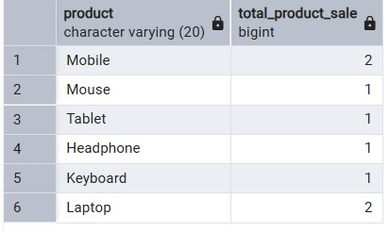
- Applying conditions on aggregated data (HAVING).
select product,
sum(quantity*price) as total_revenue from customer_orders group by product having sum(quantity*price) > 50000;
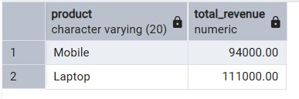

- Using WHERE and HAVING together.
select product, sum(quantity*price) as total_revenue from customer_orders where order_date >= '2025-01-01' group by product having sum(quantity*price) > 50000;
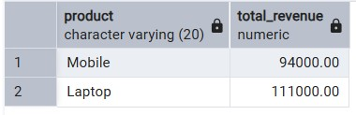

- I/O Analysis (Input / Output) Input:
  - Customer order details
  - Filtering, sorting, grouping, and aggregation queries Output:
  - Filtered customer records
  - Sorted result sets
  - Group-wise sales summary
  - Aggregated revenue reports
(Screenshots of execution and output attached)

- Learning Outcomes
  - Students understand how data can be filtered to retrieve only relevant records.
  - Students learn how sorting improves readability and usefulness of reports.
  - Students gain the ability to group data for analytical purposes.
  - Students clearly differentiate between WHERE and HAVING clauses.
  - Students develop confidence in writing analytical SQL queries.
  - Students are better prepared for SQL-based placement and interview questions.

