

Certificate

This is to certify that Gaurang Rehdu of class XII-B of St. Anne’s Sr. Sec School has successfully completed the Informatics Practices Project on the topic Online Exam Management under my guidance during the academic session 2019-2020.

This project is submitted for the partial fulfillment of CBSE-AISSCE practical examination (Informatics Practices) 2019-2020

External Examiner Internal Examiner

Input-Output Design

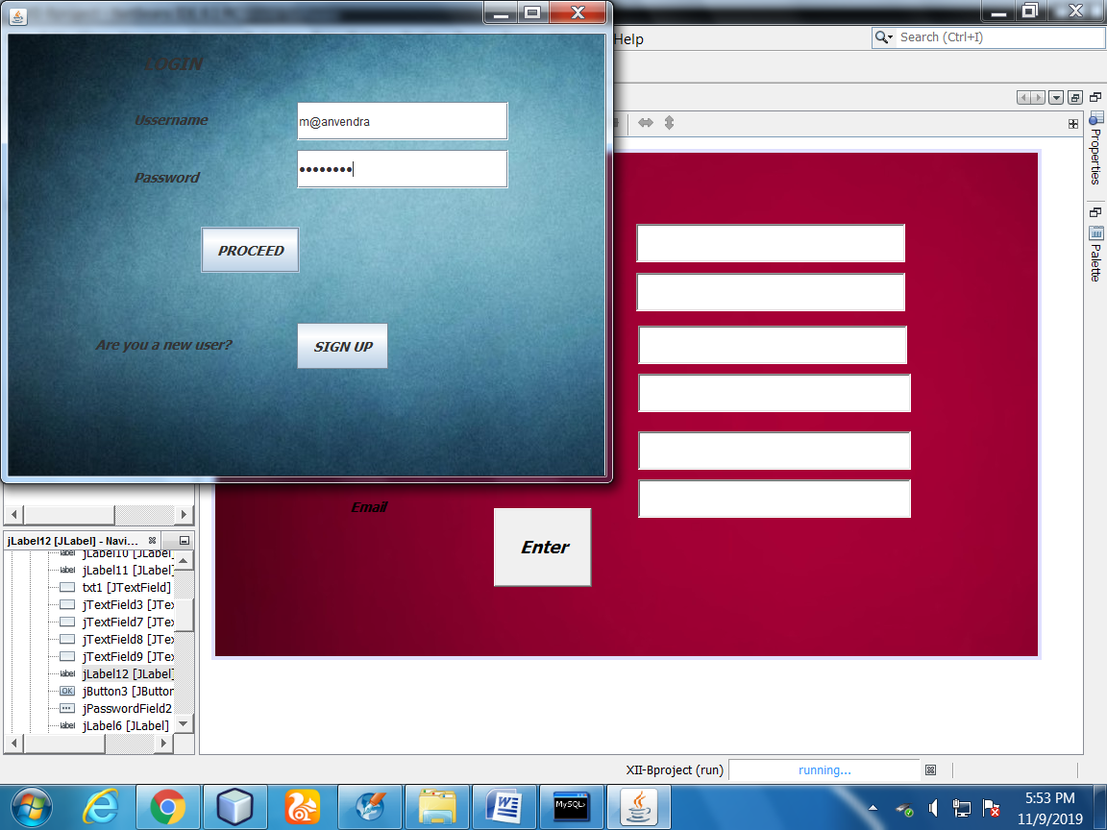

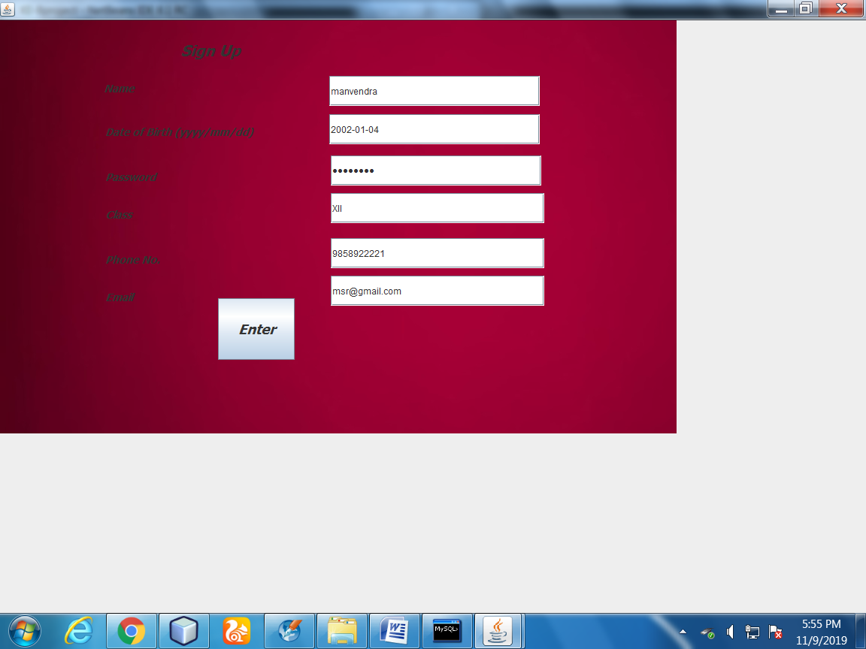 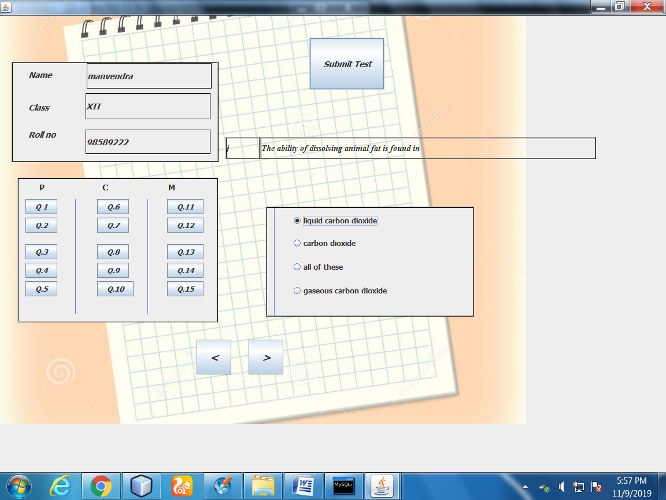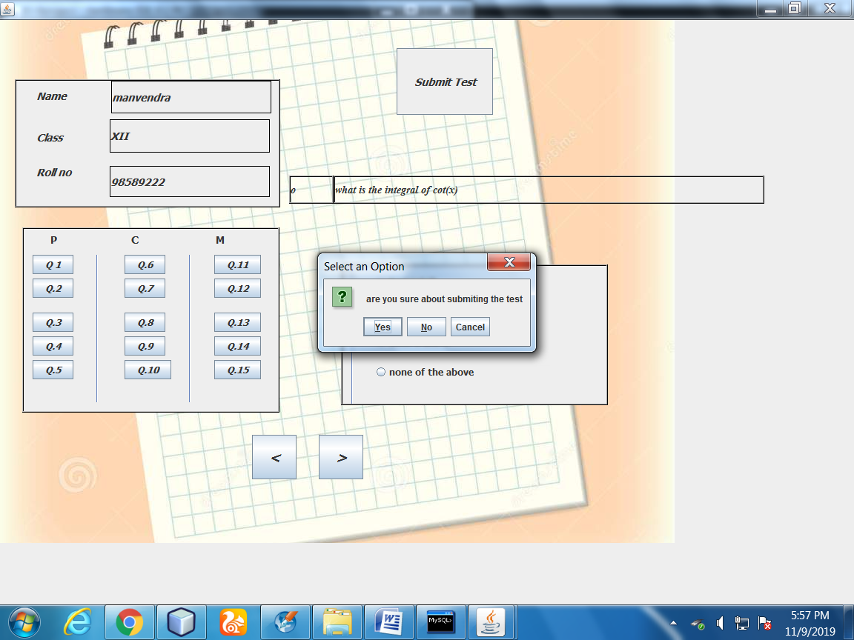 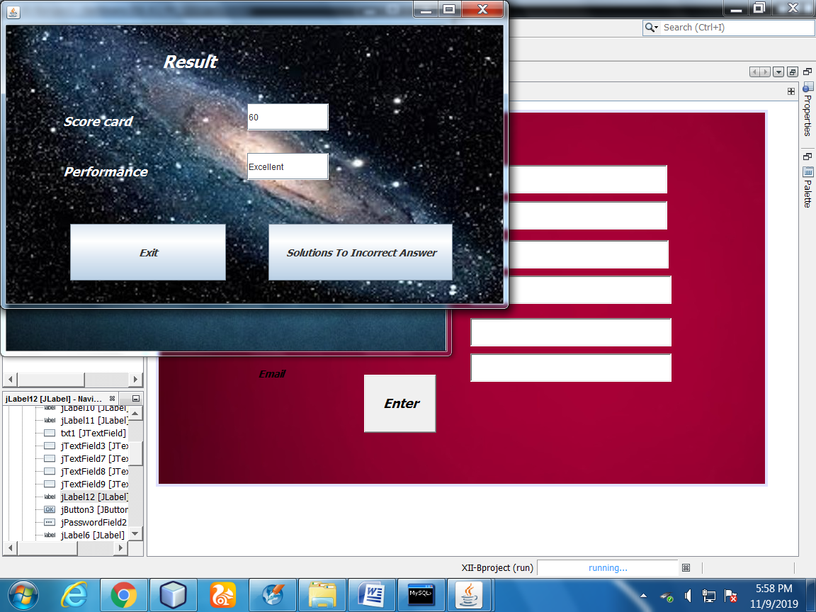

Data Dictionary

mysql> use project;

Database changed

mysql> show create table stuinfo;

| stuinfo | CREATE TABLE stuinfo (

name char(35) DEFAULT NULL,

dob date NOT NULL,

pwd char(25) NOT NULL,

class char(3) NOT NULL,

phno int(11) NOT NULL,

email char(20) NOT NULL,

usnm char(30) DEFAULT NULL

) ENGINE=InnoDB DEFAULT CHARSET=utf8 |

mysql> show create table marks;

---------------------------------------------------

CREATE TABLE marks(

marks int(11) DEFAULT NULL,

qno int(11) DEFAULT NULL

) ENGINE=InnoDB DEFAULT CHARSET=utf8 |

mysql> select \* from marks;

+-------+------+

| marks | qno |

+-------+------+

| NULL | 1 |

| NULL | 2 |

| NULL | 3 |

| NULL | 5 |

| NULL | 6 |

| NULL | 7 |

| NULL | 8 |

| NULL | 9 |

| NULL | 10 |

| NULL | 11 |

| NULL | 12 |

| NULL | 13 |

| NULL | 14 |

| NULL | 15 |

| NULL | 4 |

+-------+------+

15 rows in set (0.00 sec)

mysql> describe stuinfo;

+-------+----------+------+-----+---------+-------+

| Field | Type | Null | Key | Default | Extra |

+-------+----------+------+-----+---------+-------+

| name | char(35) | YES | | NULL | |

| dob | date | NO | | NULL | |

| pwd | char(25) | NO | | NULL | |

| class | char(3) | NO | | NULL | |

| phno | int(11) | NO | | NULL | |

| email | char(20) | NO | | NULL | |

| usnm | char(30) | YES | | NULL | |

mysql> stuinfo | CREATE TABLE stuinfo (

-> name char(35) DEFAULT NULL,

-> dob date NOT NULL,

-> pwd char(25) NOT NULL,

-> class char(3) NOT NULL,

-> phno int(11) NOT NULL,

-> email char(20) NOT NULL,

-> usnm char(30) DEFAULT NULL );

mysql> insert into marks(qno)

-> values(1);

Query OK, 1 row affected (0.03 sec)

mysql> insert into marks(qno)

-> values(2);

Query OK, 1 row affected (0.03 sec)

mysql> insert into marks(qno)

-> values(3);

Query OK, 1 row affected (0.05 sec)

mysql> insert into marks(qno)

-> values(4);

Query OK, 1 row affected (0.05 sec)

mysql> insert into marks(qno)

-> values(5);

Query OK, 1 row affected (0.03 sec)

mysql> insert into marks(qno)

-> values(6);

Query OK, 1 row affected (0.03 sec)

mysql> insert into marks(qno)

-> values(7);

Query OK, 1 row affected (0.01 sec)

mysql> insert into marks(qno)

-> values(8);

Query OK, 1 row affected (0.02 sec)

mysql> insert into marks(qno)

-> values(9);

Query OK, 1 row affected (0.03 sec)

mysql> insert into marks(qno)

-> values(10);

Query OK, 1 row affected (0.03 sec)

mysql> insert into marks(qno)

-> values(11);

Query OK, 1 row affected (0.03 sec)

mysql> insert into marks(qno)

-> values(12);

Query OK, 1 row affected (0.05 sec)

mysql> insert into marks(qno)

-> values(13);

Query OK, 1 row affected (0.03 sec)

mysql> insert into marks(qno)

-> values(14);

Query OK, 1 row affected (0.03 sec)

mysql> insert into marks(qno)

-> values(15);

Query OK, 1 row affected (0.03 sec)

mysql> select \* from marks;

+-------+------+

| marks | qno |

+-------+------+

| NULL | 1 |

| NULL | 2 |

| NULL | 3 |

| NULL | 4 |

| NULL | 5 |

| NULL | 6 |

| NULL | 7 |

| NULL | 8 |

| NULL | 9 |

| NULL | 10 |

| NULL | 11 |

| NULL | 12 |

| NULL | 13 |

| NULL | 14 |

| NULL | 15 |

+-------+------+

15 rows in set (0.00 sec)

Enhancement And Limitations