COUNT-API Implementation

**Environment and Configuration Information:**

Source code is present in counter-api folder.

Configuration File: Data file is present in **resources** folder

Username: vipin and Password: vipin

Log file path: ${java.io.tmpdir}/logs

Log files Name: counter-api.log

Testing Client: Postman and Spring Rest Template

Implementation Details:

Maven based build.

Rest Services is implemented using Spring MVC Rest.

Log4j has been implemented.

Sample test case has been written for CountService using junit and mockito

Java 1.8, Spring 4 and Tomcat 8

**Test Results:-**

Tested with Postman to test (<http://localhost:8080/counter-api/search/>) with username:”vipin” and password “vipin”.

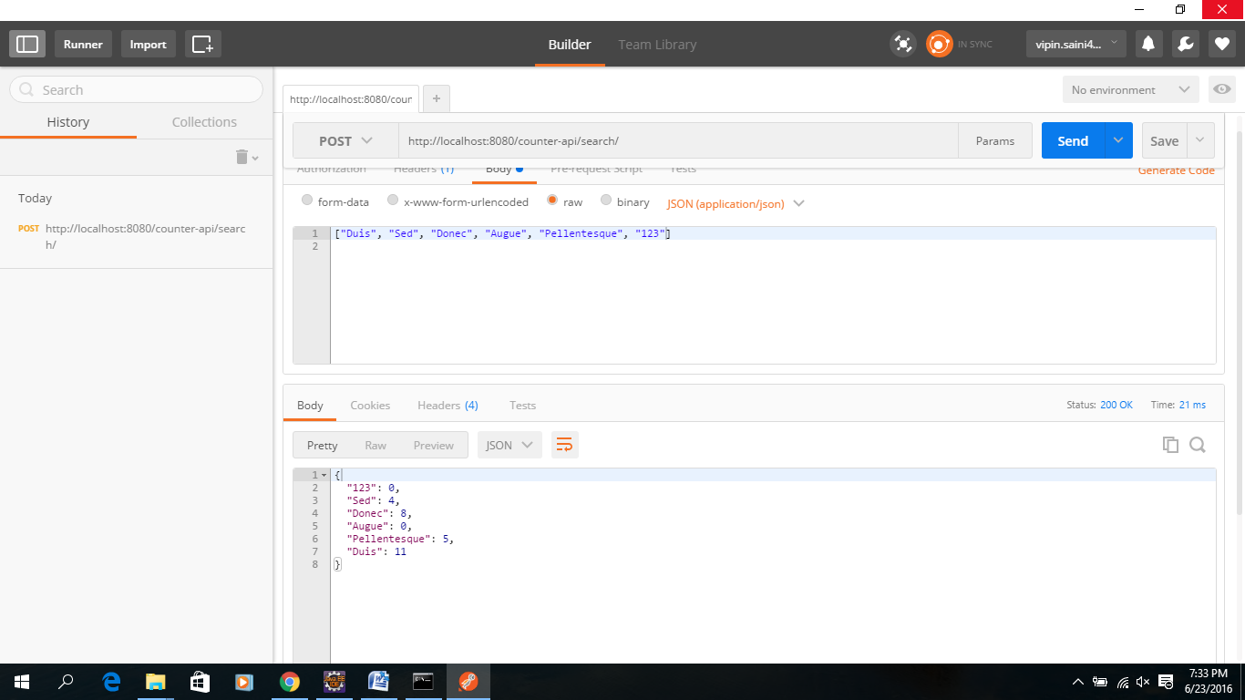

Tested with Postman to test (<http://localhost:8080/counter-api/top/5>) with username:”vipin” and password “vipin”.

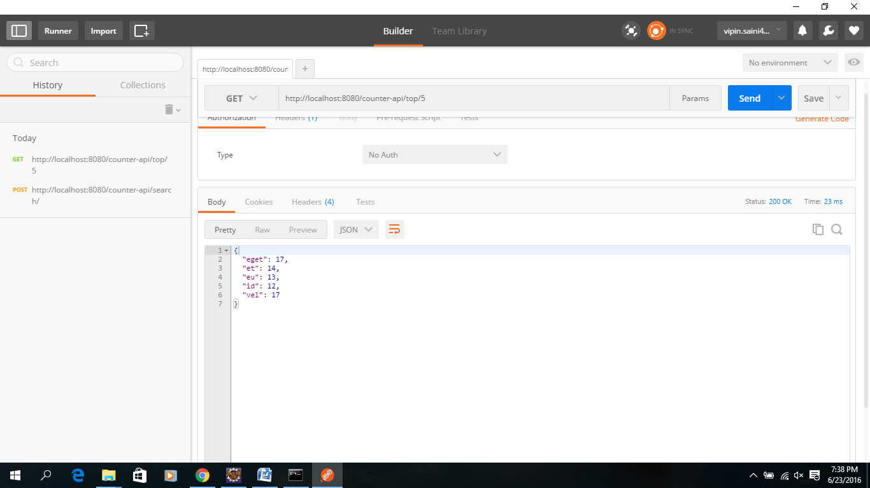

Tested with Postman to test (<http://localhost:8080/counter-api/top/20>) with username:”vipin” and password “vipin”.

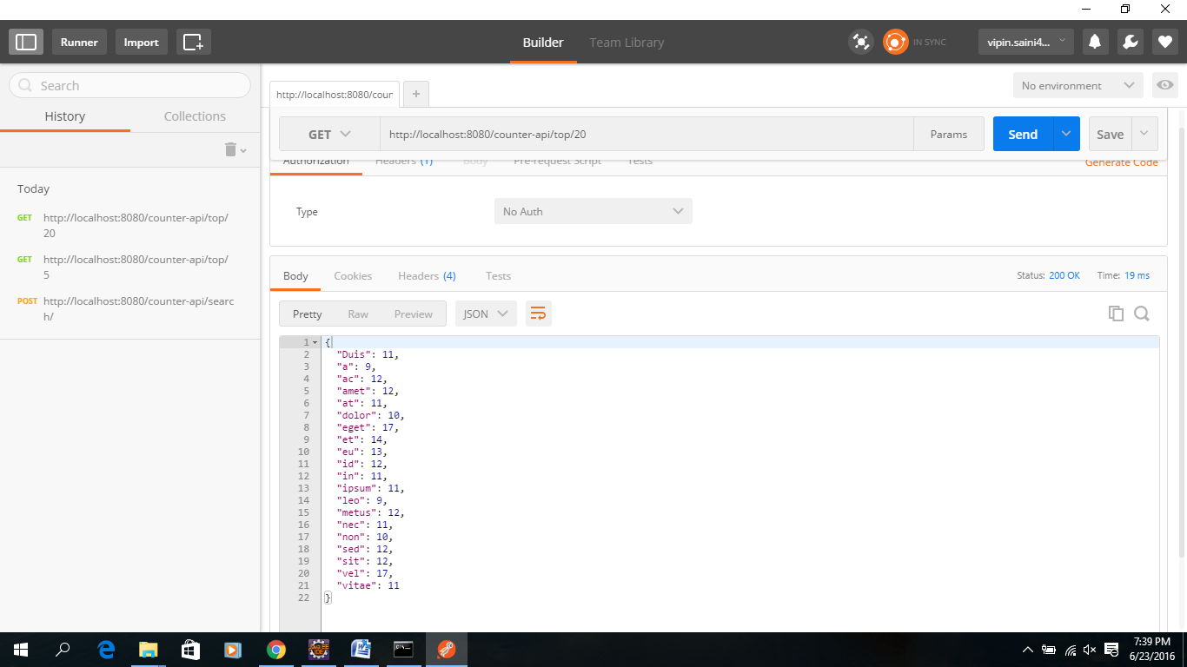

Currently the response is printed as json in case of /top/5 request. I need to change this into CSV format.

Limitation: - Output of /search/ request is Json, Not CSV.