**Componentization Documentation**

**Site Name/Code Name: amazon.in (for reference)**

1. **Page Name:** Home Page
   * + 1. **Authorization:** Anyone
       2. **Accessibility:** anywhere
       3. **Action:** will jump to performed event on the items

**Home Page Component List**

* + 1. **Header**



* + - 1. **Logo Component**



* + - * 1. **Authorization:** Anyone
        2. **Accessibility:** Whole Site
        3. **Action:** Redirect to Home
      1. **Navigation Component**



* + - * 1. **Authorization:** Anyone/User Dependent (*1)
        2. **Accessibility:** Whole Site (*2)
        3. **Action:** Jump to that page Item

**\*1** Anyone (Home/Category/Today Deal) /User Dependent (Track Order/Return Item/Order)

**\*2** Except Landing Page, because generally on landing page navigation items hidden

* + - 1. **Search Component**



* + - * 1. **Authorization:** Anyone
        2. **Accessibility:** Whole Site
        3. **Action:** Will return results as per searched
    1. **Body**

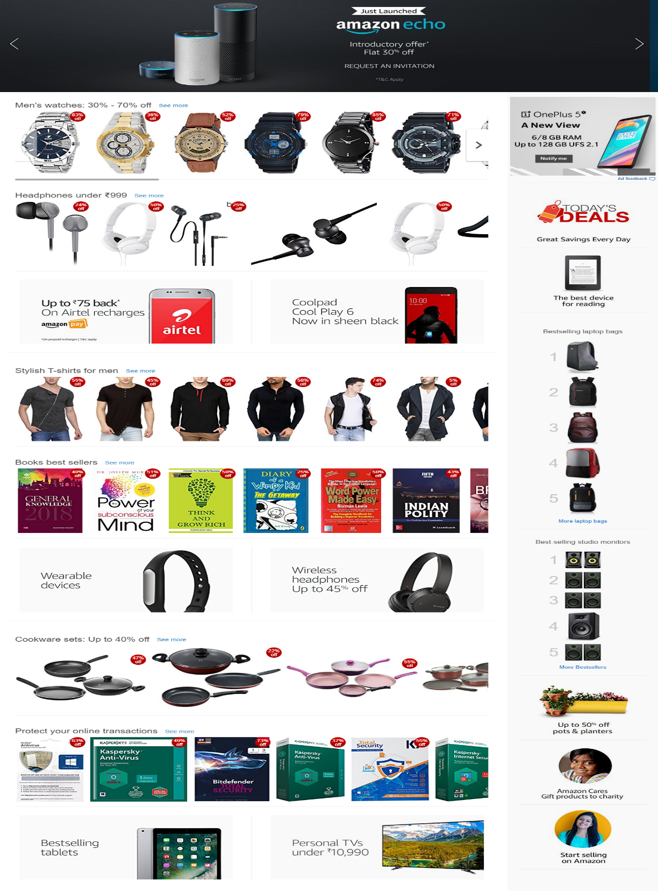

* + - 1. **Carousel Component**

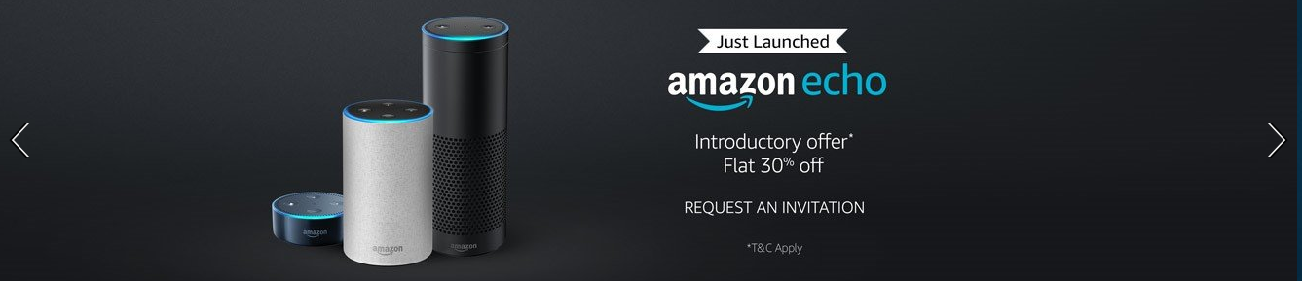

* + - * 1. **Authorization:** Anyone
        2. **Accessibility:** Whole Site
        3. **Action:** Carousel behavior (*1)

**\*1** previous, next, dot click event, on image click jump to that item.

* + - 1. **Image Slider Component**

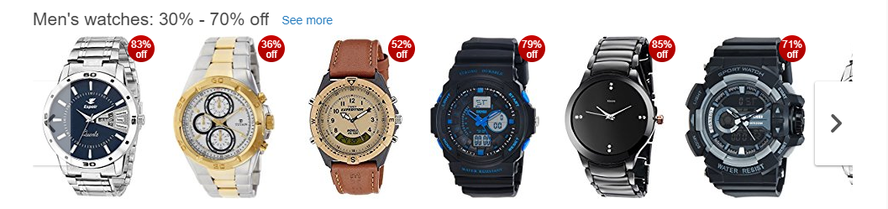

* + - * 1. **Authorization:** Anyone
        2. **Accessibility:** Whole Site
        3. **Action:** slider behavior (*1)

**\*1** previous, next, will redirect to clicked item

* + - 1. **Image Title Description Widget Component**

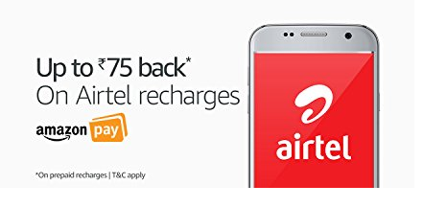

* + - * 1. **Authorization:** Anyone
        2. **Accessibility:** Whole Site
        3. **Action:** Will show the component and on click of title/image will redirect to the item details
      1. **Image Title Widget Component**

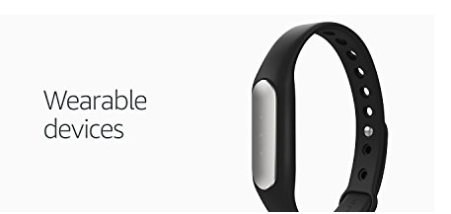

* + - * 1. **Authorization:** Anyone
        2. **Accessibility:** Whole Site
        3. **Action:** Will show the component and on click of title and image will redirect to the item details
      1. **Title Description Widget Component**



* + - * 1. **Authorization:** Anyone
        2. **Accessibility:** Whole Site
        3. **Action:** Will show the component and on click of title will redirect the item details
      1. **Back To Top Widget Component**



* + - * 1. **Authorization:** Anyone
        2. **Accessibility:** Whole Site
        3. **Action:** On click will jump to top of the page
      1. **Image Links Widget Component**

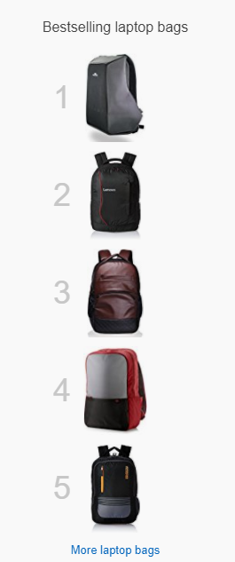

* + - * 1. **Authorization:** Anyone
        2. **Accessibility:** Whole Site
        3. **Action:** Will show the component and on click of image and title will redirect to item details page
      1. **Teaser(Offer) Widget Component**

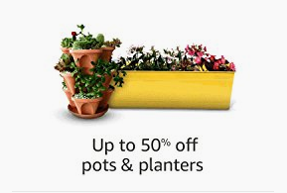

* + - * 1. **Authorization:** Anyone
        2. **Accessibility:** Whole Site
        3. **Action:** Will show component and on click of link will redirect to the item details page
    1. **Footer**

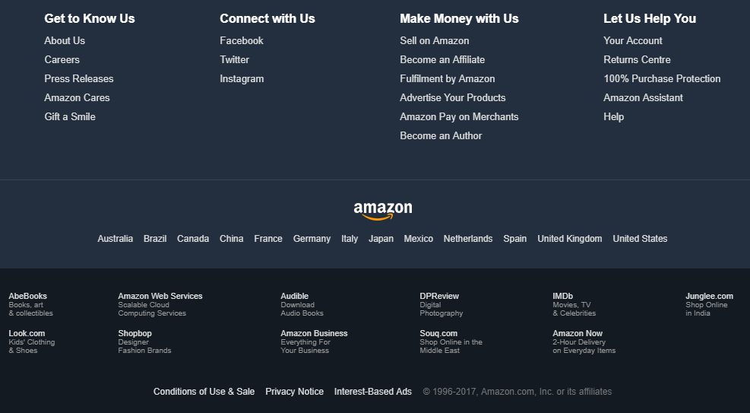

* + - 1. **Footer Links Component**

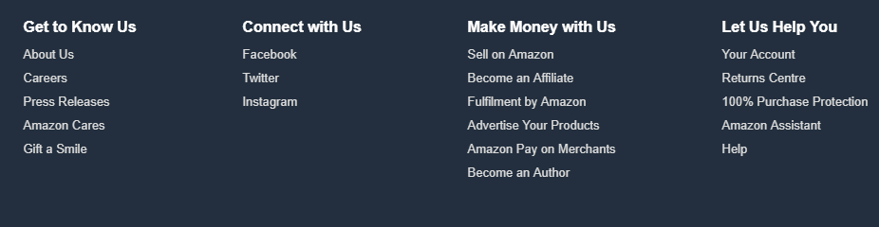

* + - * 1. **Authorization:** Anyone
        2. **Accessibility:** Whole Site
        3. **Action:** Will show the list of footer link and on the click of links will redirect to the page item.
      1. **Copyright Component**



* + - * 1. **Authorization:** Anyone
        2. **Accessibility:** Whole Site
        3. **Action:** Will show copyright access component

**@Note: Same for the other pages, if there are any repeated components on another page then leave it only unique components will be listed here.**

Please share your experience/feedback/Suggestions.

Thanks