**Network design for Apartment**

Factors considered:

Maximum number of users is fixed (18)

All users are in closed vicinity. Maximum distance is height of apartment (4 floors x 12 ft = ~50ft)

Decent budget

Tree topology is implemented. The core layer consists of main router, distribution layer consists of the intermediate switch and routers and the access layer has all the devices communicating over internet.

**Implementation Details:**

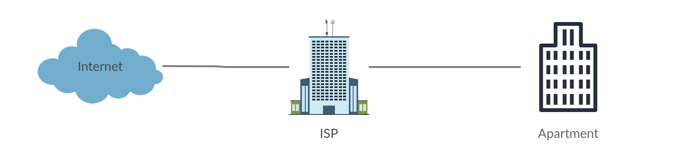

The ISP is connected to the outer internet. The ISP provides a connection to the apartment through wire (RG-6/U coaxial underground cable).

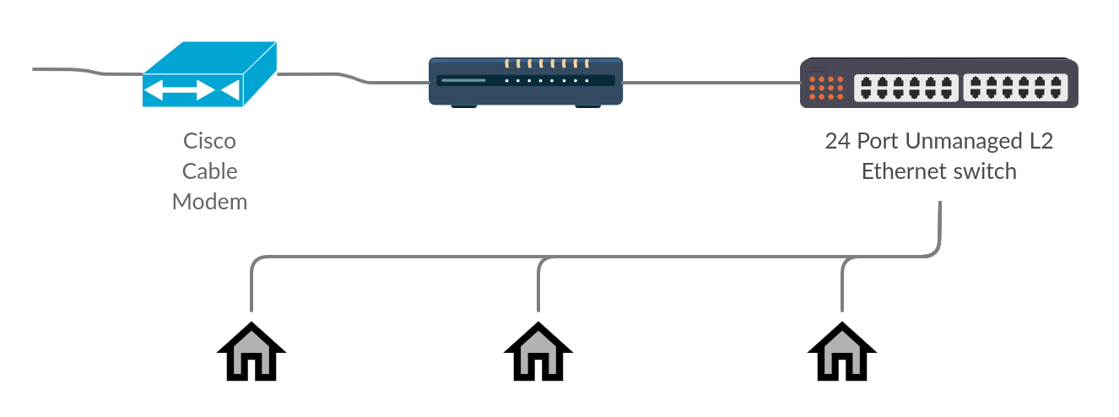

The cable has analog signals which needs to be converted into digital signals. A cable modem is used to do that. In the above picture, is a cable modem what accepts RG-6/U (coaxial cable) input signals and outputs digital signals through Ethernet LAN port.

Now, using a RJ45 Cat-6 Ethernet LAN cable (LAN cable (male to male)) we connect the modem to a router (1Gbps Wireless Smart Dual-Band Gigabit Wi-Fi Router). Since people in a residential apartment use internet for general purposes like web browsing, email, video streaming, etc. 1 IP address from ISP is enough (additional IPs will add more cost). But with 1 IP address, we can connect only one device. Hence, we form a private network and use router as gateway to public internet.

Now, using a LAN cable, we connect the router to a switch (24-Port Gigabit Ethernet Unmanaged L2 Switch speed up to 1Gbps). Since we have 18 flats and it cannot increase, we need around 18 connections (from router to each flat). 24 port switches should do the work. The switch is unmanaged as there is no need for services like bandwidth management, quality of service management, etc. Unmanaged switches are cheaper than managed switches. There is no requirement of VLAN, hence L2 switch will work. Using a LAN cable (male to female), the switch is connected to each flat.

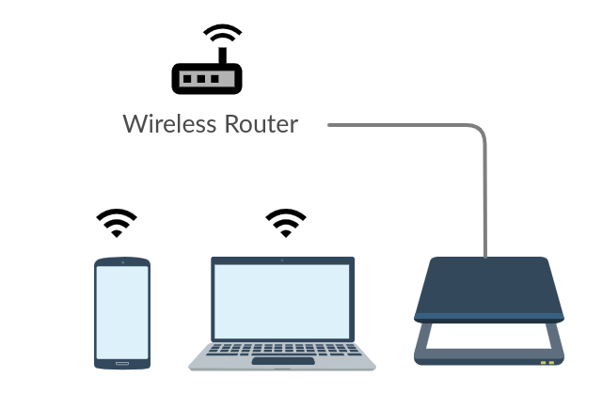

At each flat, a router is used so that using one IP, multiple devices can be connected. Also, a private network at each flat is necessary due to security concerns. A router (cheaper compared to main router, like Wi-Fi Dual Band Wireless Router speed up to 300Mbps) can create a private network and devices can be connected using Wi-Fi or LAN cable.

In any of the private networks, no as such static IP addressing scheme is required. The default ones used by router will work. It can be from pool of private IP addresses pool like 192.168.x.x or 10.x.x.x