# Chapter – 2

**The Invisible Living World: Beyond Our Naked Eye**

## Q1. Various parts of a cell are given below. Write them in the appropriate places in the following diagram.

**Parts of the cell:** Nucleus, Cytoplasm, Chloroplast, Cell wall, Cell membrane, Nucleoid

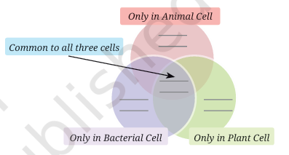

**Answer:**

## Common to all three cells: Cell membrane, Cytoplasm

## Only in Animal Cell: None (from the given options)

## Only in Plant Cell: Chloroplast

## Only in Bacterial Cell: Nucleoid

## Q2. Aanandi took two test tubes and marked them A and B...

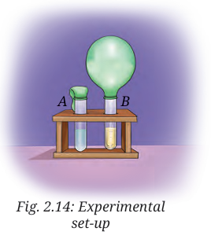

### (i) What do you predict will happen after 3–4 days?

**Answer:** After 3–4 days, the balloon attached to test tube B will be inflated. This is because the yeast in test tube B produces carbon dioxide gas during the fermentation of sugar. The released carbon dioxide inflates the balloon.

Correct option: (c) Yeast produced a gas inside the test tube B which inflated the balloon.

### (ii) She took another test tube with lime water...

**Answer:** Aanandi wants to find out which gas is present inside the balloon. By passing the gas into lime water, she can test it. If the lime water turns milky, it confirms the presence of carbon dioxide gas.

**Q3. A farmer was planting wheat crops in his field. He added nitrogen-rich fertiliser to the soil to get a good yield of crops. In the neighbouring field, another farmer was growing bean crops, but she preferred not to add nitrogen fertiliser to get healthy crops. Can you think of the reasons?**

**Answer:** Bean crops are leguminous plants. They have root nodules containing Rhizobium bacteria which fix atmospheric nitrogen into the soil naturally. Hence, additional nitrogen fertiliser is not required for bean crops, but it is required for wheat crops.

## Q4. Snehal dug two pits, A and B, in her garden. In pit A, she put fruit and vegetable peels and mixed it with dried leaves. In pit B, she dumped the same kind of waste without mixing it with dried leaves. She covered both the pits with soil and observed after 3 weeks. What is she trying to test?

**Answer:** Snehal is trying to test the process of composting and the role of mixing biodegradable waste with dried leaves in preparing compost. Mixing improves aeration and speeds up decomposition.

## Q5. Identify the following microorganisms:

**(i) I live in every kind of environment, and inside your gut**.  
**Answer:** Bacteria  
  
**(ii) I make bread and cakes soft and fluffy.**  
**Answer:** Yeast  
  
(iii) I live in the roots of pulse crops and provide nutrients for their growth.  
**Answer:** Rhizobium bacteria

## Q6. Devise an experiment to test that microorganisms need optimal temperature, air, and moisture for their growth.

**Answer:** Take four slices of bread. Keep one slice in a dry place, one in a sealed container without air, one in a refrigerator (low temperature), and one in a warm moist place. After 2–3 days, observe the slices. The slice kept in the warm and moist place shows maximum growth of microorganisms. This proves that microorganisms require suitable temperature, air, and moisture to grow.

## Q7. Take 2 slices of bread. Place one slice in a plate near the sink. Place the other slice in the refrigerator. Compare after three days. Note your observations. Give reasons for your observations.

Answer: The bread slice near the sink will have fungus growth, while the slice in the refrigerator will remain fresh. This is because warm and moist conditions near the sink promote microbial growth, while low temperature in the refrigerator slows down the growth of microorganisms.

## Q8. A student observes that when curd is left out for a day, it becomes more sour. What can be two possible explanations for this observation?

**Answer:**  
1. Bacteria such as Lactobacillus continue to grow in curd when kept outside, producing more lactic acid.  
2. The warm temperature outside enhances bacterial activity, leading to increased sourness.

## Q9. Observe the set-up given in Fig. 2.15 and answer the following questions:

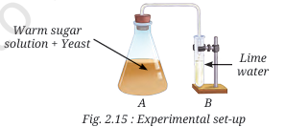

(i) What happens to the sugar solution in flask A?  
**Answer:** The yeast ferments the sugar solution and converts it into alcohol and carbon dioxide.  
  
(ii) What do you observe in test tube B after four hours? Why do you think this happened?  
**Answer:** The lime water in test tube B turns milky because carbon dioxide gas produced during fermentation passes through it.  
  
(iii) What would happen if yeast was not added in flask A?  
**Answer:** No fermentation would take place, no carbon dioxide would be produced, and the lime water in test tube B would remain clear.