# Chapter – 5

### Exploring Forces

## Q1. Match items in Column A with the items in Column B.

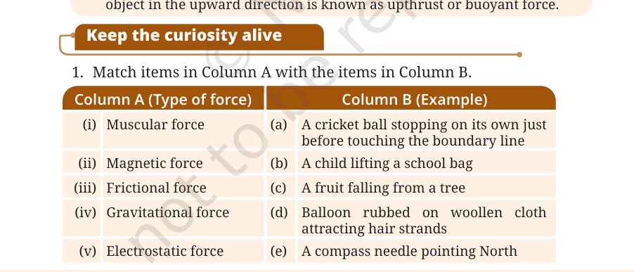

**Answer:**  
(i) Muscular force → (b) A child lifting a school bag  
(ii) Magnetic force → (e) A compass needle pointing North  
(iii) Frictional force → (a) A cricket ball stopping on its own just before touching the boundary line  
(iv) Gravitational force → (c) A fruit falling from a tree  
(v) Electrostatic force → (d) Balloon rubbed on woolen cloth attracting hair strands

## Q2. State whether the following statements are True or False.

(i) A force is always required to change the speed of motion of an object. – **True**  
(ii) Due to friction, the speed of the ball rolling on a flat ground increases. – **False** (It decreases due to friction)  
(iii) There is no force between two charged objects placed at a small distance apart. – **False** (Electrostatic force acts between charged objects)

## Q3. Two balloons rubbed with a woolen cloth are brought near each other. What would happen and why?

**Answer:** The balloons will repel each other. When we rub balloons with wool, they get charged with static electricity. Since both balloons get the same type of charge (either both positive or both negative), they repel each other due to electrostatic force.

## Q4. When you drop a coin in a glass of water, it sinks, but when you place a bigger wooden block in water, it floats. Explain.

**Answer:** This happens because of **density**.

* The coin is denser than water, so it sinks.
* The wooden block is less dense than water, so it floats, even if it's bigger in size.

It’s not the size, but the material and density that decide if an object will float or sink.

## Q5. If a ball is thrown upwards, it slows down, stops momentarily, and then falls back to the ground. Name the forces acting on the ball and specify their directions.

**Answer :** If a ball is thrown upwards, it slows down, stops momentarily, and then falls back.  
(i) During its upward motion – Gravitational force acts downward, opposite to the direction of motion.  
(ii) During its downward motion – Gravitational force acts downward, in the direction of motion.  
(iii) At its topmost position – The velocity becomes zero but gravitational force still acts downward.

## Q6. A ball is released from the point P and moves along an inclined plane and then along a horizontal surface as shown in the Fig. 5.16. It comes to stop at the point A on the horizontal surface. Think of a way so that when the ball is released from the same point P, it stops (i) before the point A (ii) after crossing the point A.

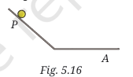

**Answer :** A ball released from point P moves down an inclined plane and stops at point A due to friction.  
(i) To stop before A: Increase roughness of the surface (increase friction).  
(ii) To stop after A: Decrease roughness of the surface (reduce friction).

## Q7. Why do we sometimes slip on smooth surfaces like ice or polished floors? Explain

**Answer :** We sometimes slip on smooth surfaces like ice or polished floors because friction is very less. Friction provides grip for walking. Reduced friction makes it difficult to balance, causing slipping.

## Q8. Is any force being applied to an object in a non-uniform motion?

**Answer :** Yes. Non-uniform motion means the speed or direction of the object is changing. A change in motion is only possible when a force is acting on it.

## Q9. The weight of an object on the Moon becomes one-sixth of its weight on the Earth. What causes this change? Does the mass of the object also become one-sixth of its mass on the Earth?

**Answer :** The weight of an object on the Moon becomes one-sixth of its weight on Earth because the Moon’s gravitational force is one-sixth that of the Earth’s. The mass of the object remains the same everywhere; only weight changes with gravity.

## Q10. Three objects 1, 2, and 3 of the same size and shape but made of different materials are placed in the water. They dip to different depths as shown in Fig. 5.17. If the weights of the three objects 1, 2, and 3 are w1 , w2 , and w3 , respectively, then

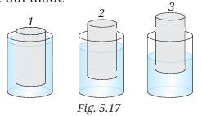

**Answer :** Three objects of same size but different materials dip to different depths.  
The deeper an object dips, the lighter it is (lower weight).  
From Fig. 5.17: Object 1 dips the least (heaviest), object 3 dips the most (lightest).  
Correct relation: (ii) W1 > W2 > W3