**Credit Rating Classifier**

Python

1. Code

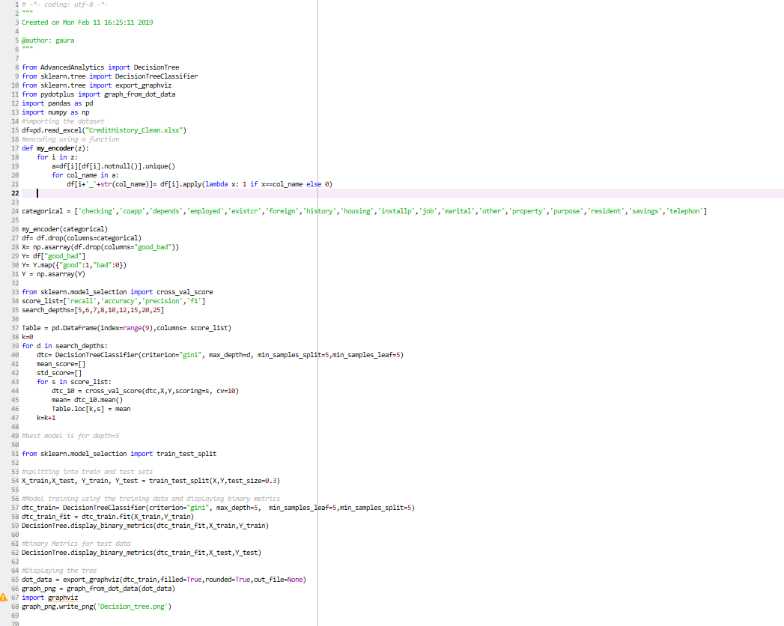

1. Table of metrics

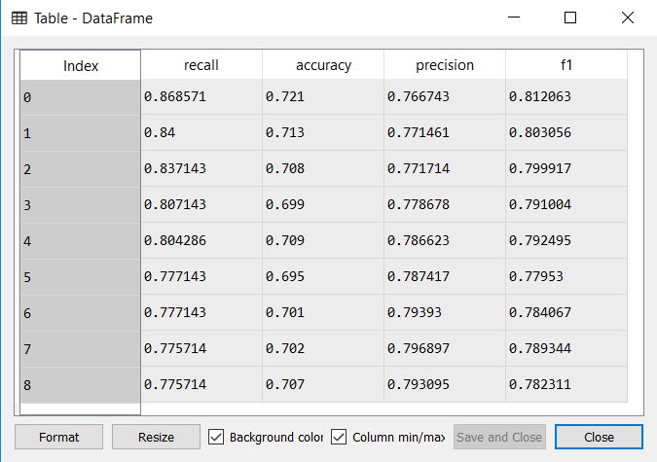

1. Model Depth Selection

Depth = 5 is selected as it has the highest recall, accuracy also its precision and F1 score are among the highest.

1. Table of metrics for decision tree with depth = 5

4.a On Training data

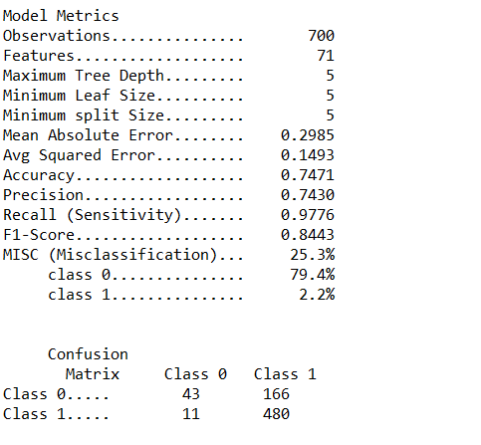

4.b On test set

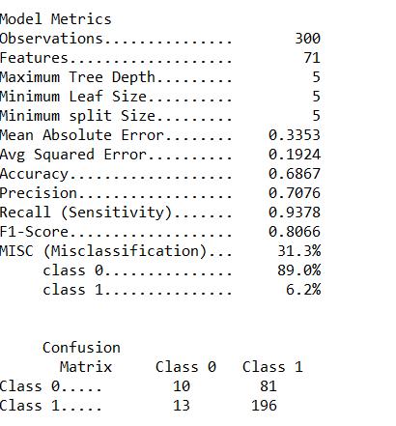

1. Decision Tree diagram

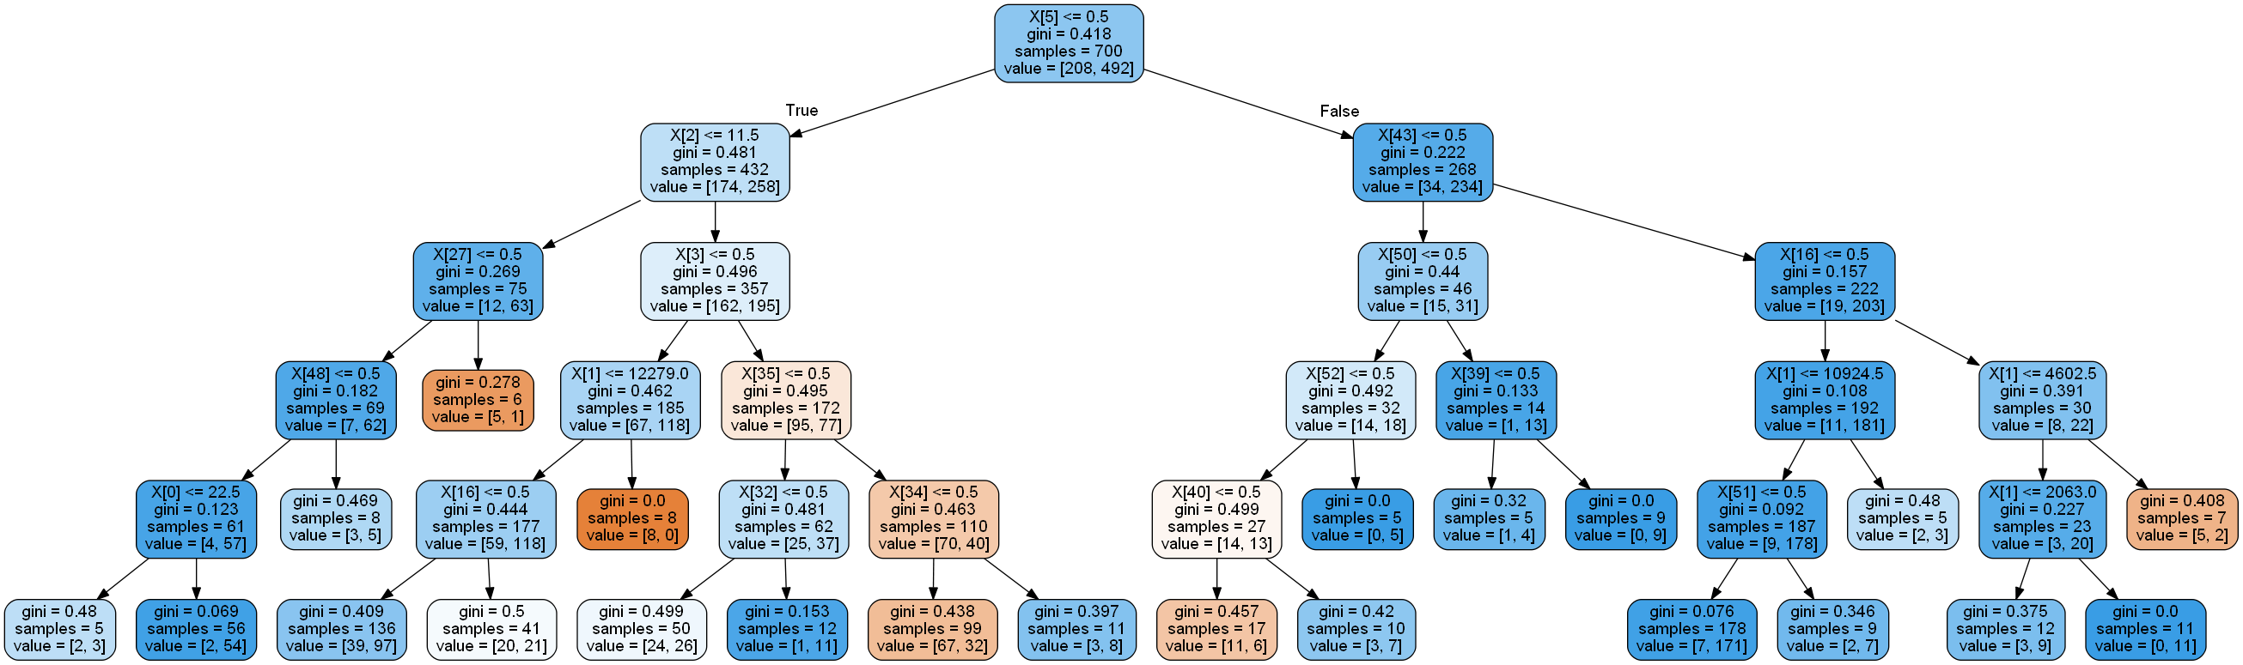

**SAS**

**Diagram for the project.**

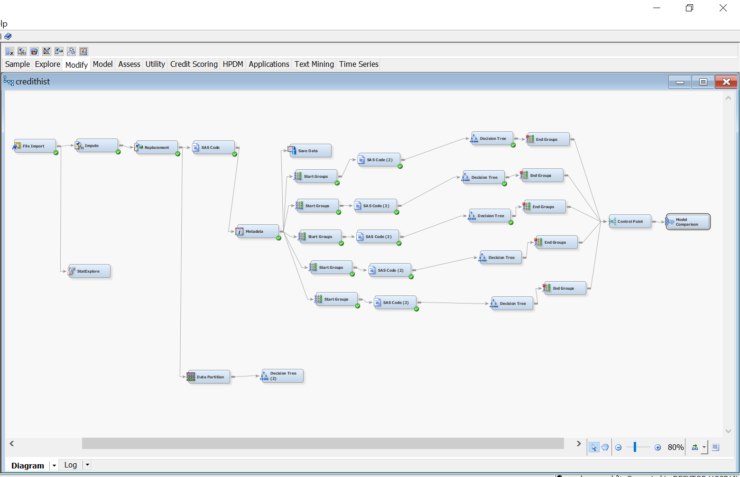

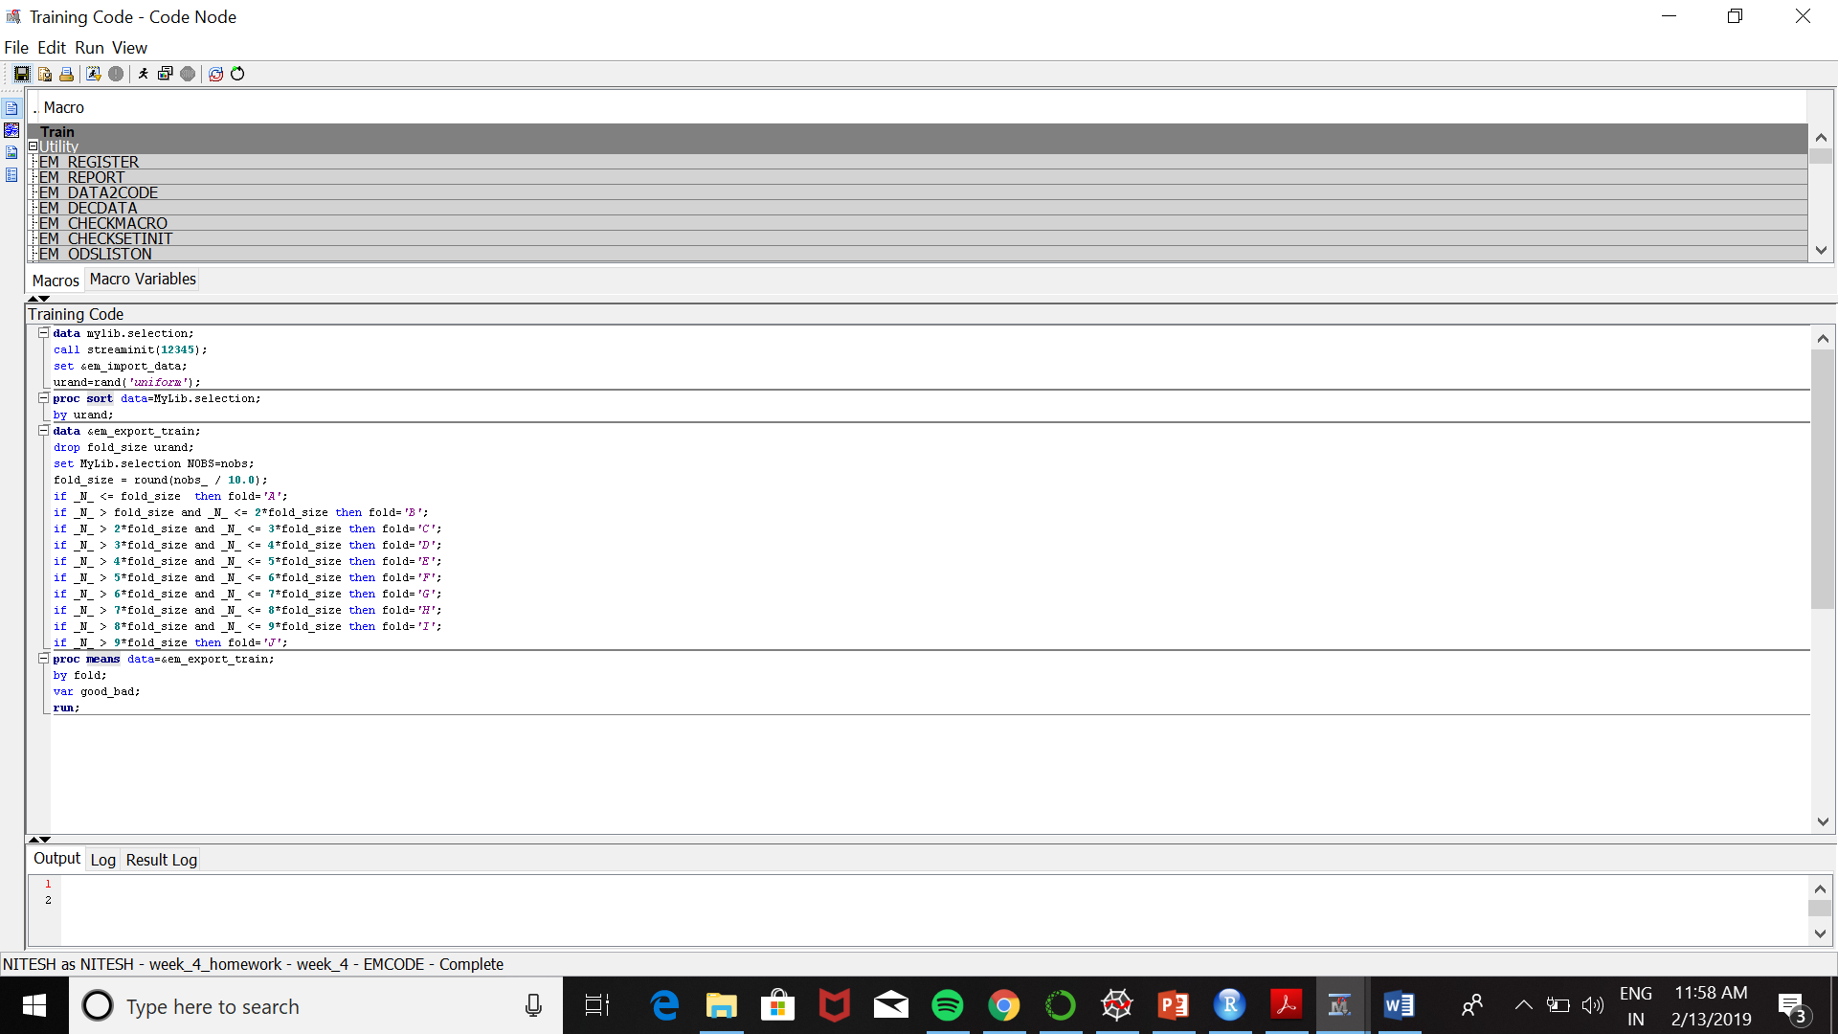 **Creating the Folds using SAS Code**

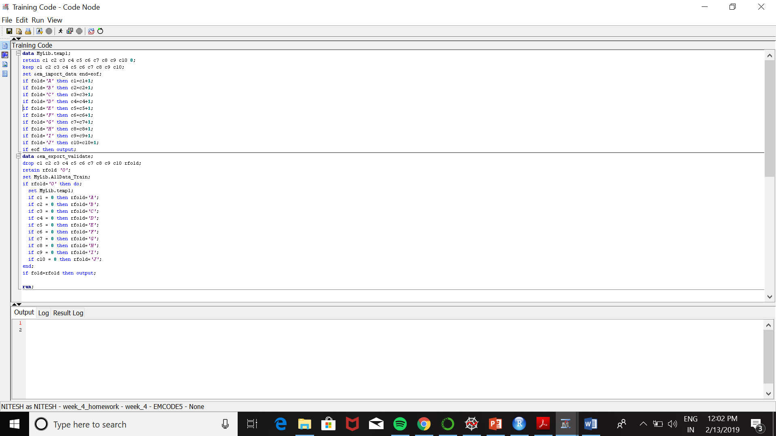 **Folds for cross-validation**

depth = 5

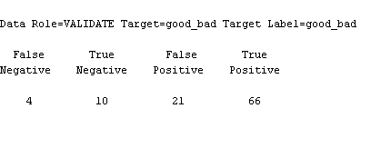

|  |  |  |  |
| --- | --- | --- | --- |
| Accuracy | precision | Recall | F1 |
| 0.75 | 0.75 | 0.94 | 0.67 |

depth =6



|  |  |  |  |
| --- | --- | --- | --- |
| Accuracy | precision | Recall | F1 |
| 0.75 | 0.75 | 0.94 | 0.67 |

depth =8

|  |  |  |  |
| --- | --- | --- | --- |
| Accuracy | precision | Recall | F1 |
| 0.77 | 0.80 | 0.93 | 0.85 |

depth = 10

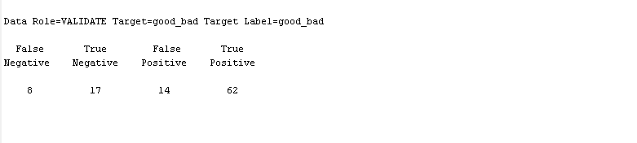

|  |  |  |  |
| --- | --- | --- | --- |
| Accuracy | precision | Recall | F1 |
| 0.78 | 0.82 | 0.89 | 0.85 |

depth = 12

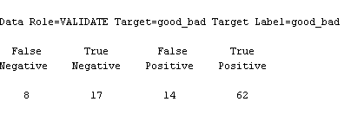

|  |  |  |  |
| --- | --- | --- | --- |
| Accuracy | precision | Recall | F1 |
| 0.78 | 0.82 | 0.86 | 0.85 |

**4)**

Best depth out of the depths 5 , 6, 8, 10, 12 using cross-validation resulted in depth 8

Best Depth – 12, since the recall, precision and F1 and accuracy all seems high as this value

**5)**

**Train Metrics**

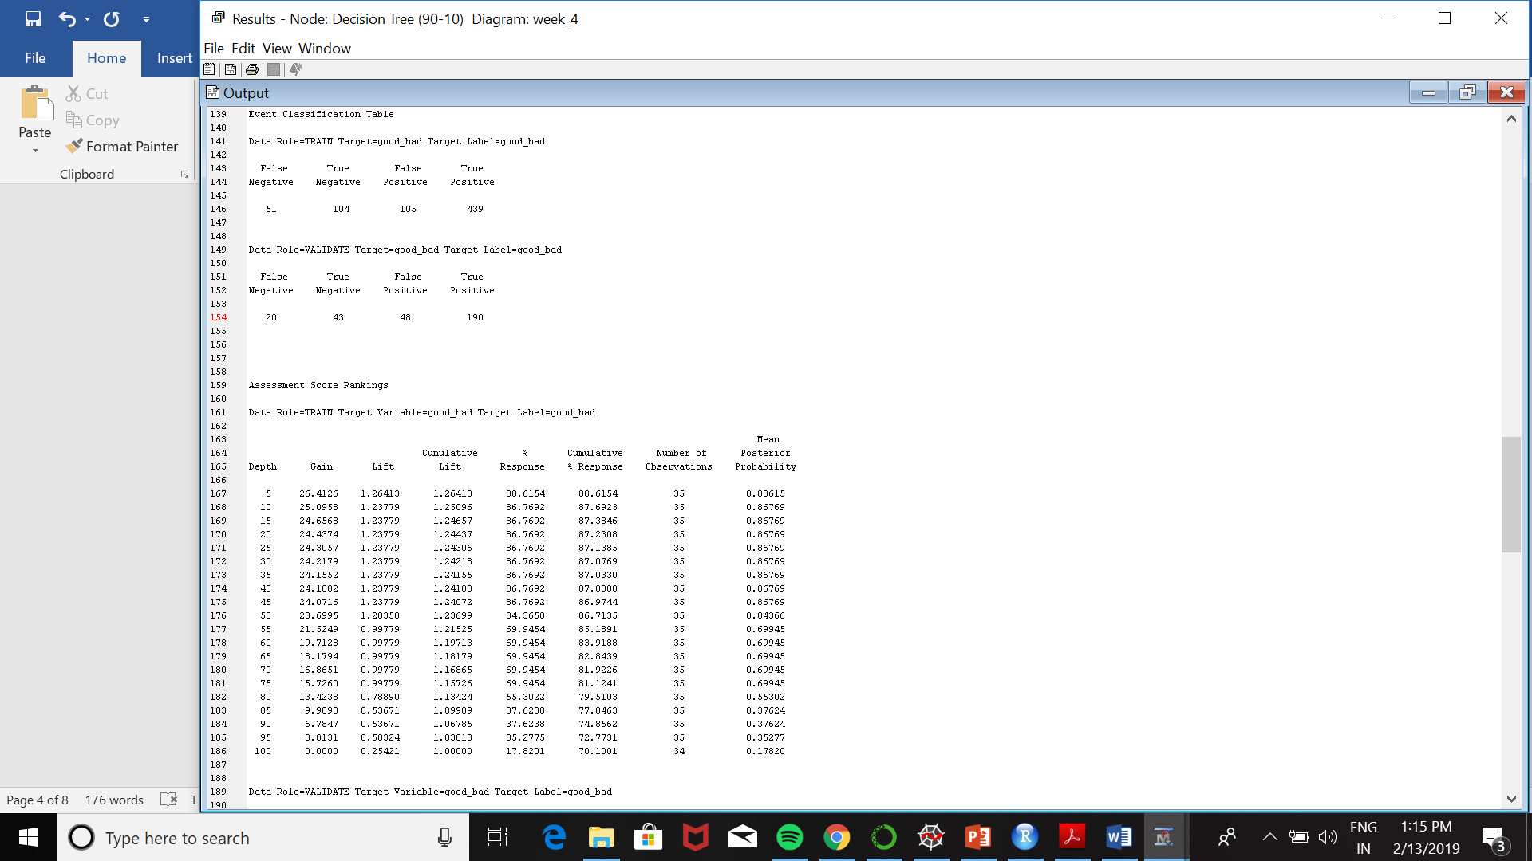

|  |  |  |  |
| --- | --- | --- | --- |
| Accuracy | precision | Recall | F1 |
| 0.78 | 0.81 | 0.90 | 0.85 |

**Test Metrics**

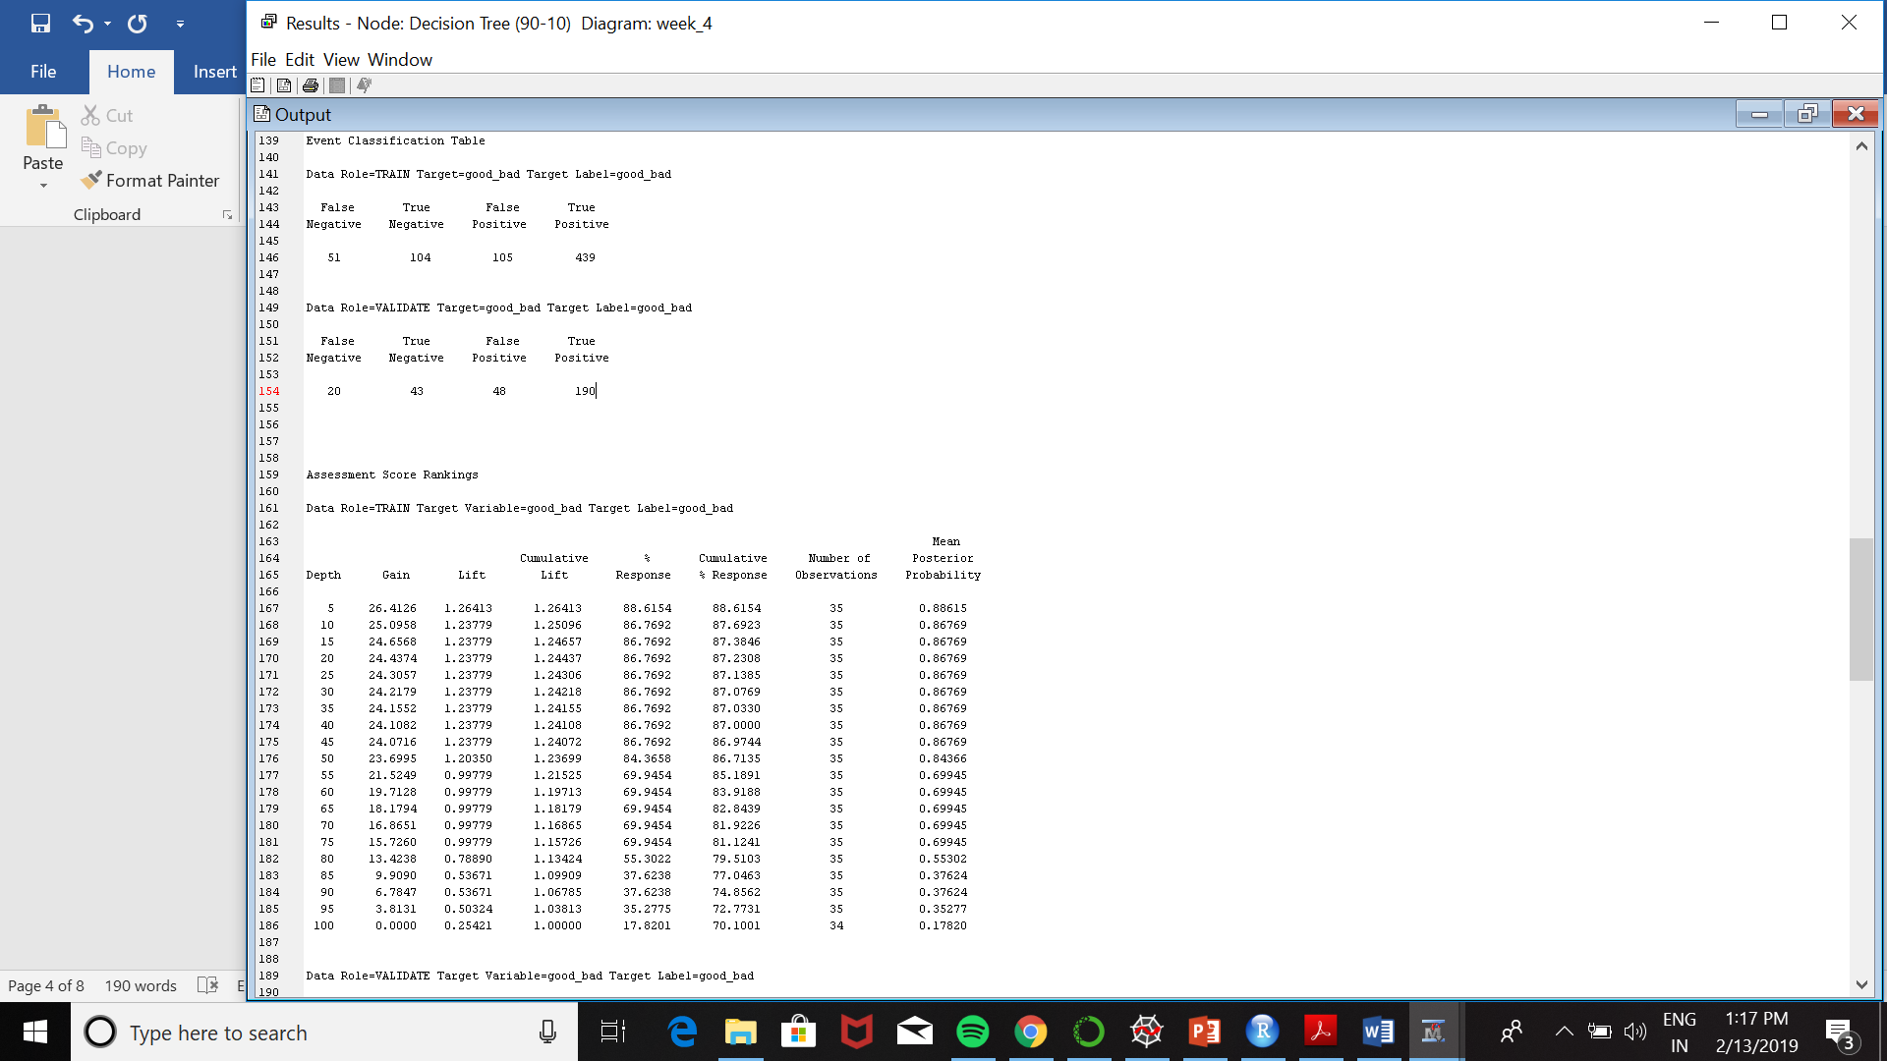

|  |  |  |  |
| --- | --- | --- | --- |
| Accuracy | precision | Recall | F1 |
| 0.78 | 0.80 | 0.90 | 0.85 |

**6)**

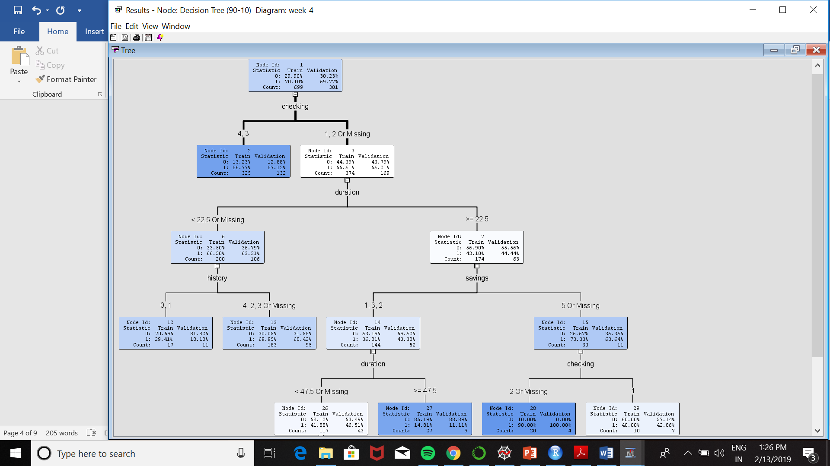Decision tree

