**EECS116/CS112A Assignmnet #3**

Gaurav Venkatesh

Ryan Yuen

Jake Williams

**1. [5pts] Find all female customers who live in Irvine.**

pi cid, gender, address_city

(

sigmagender = 'F' ( sigma address_city = 'Irvine'

(Customer) )

)

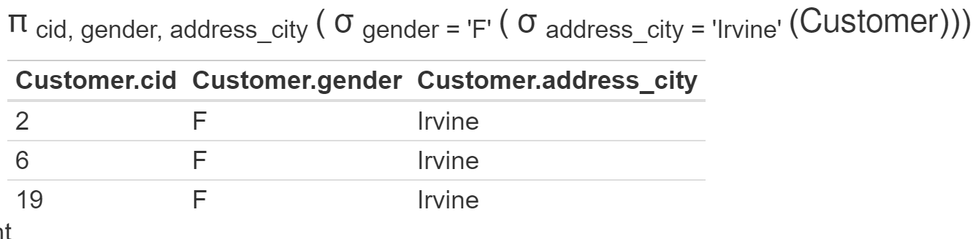

**2. [5pts] Find the names of dishes served by the lounge with an “lid” value 113.**

pi name (

sigma lid = 113 (Dish)

)

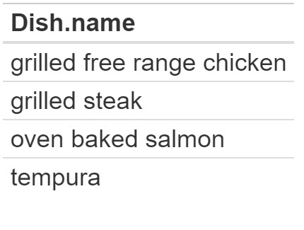

**3. [10pts] Find the credit card number and its expiration date of a customer (cid:16).**

pi card_number, expr_date (

sigma cid = 16 (Customer) ⨝ Credit_Card

)

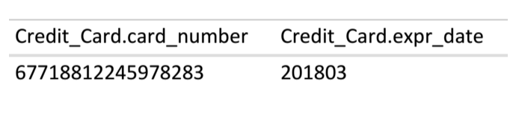

**(Test again answer doesnt match the format given )**

**4. [10pts] Find the gender, address_street, and address_city of a customer who ordered**

**“wafu steak”. Note that many lounges can serve “wafu steak”.**

pi gender , address_street, address_city (

sigma name = 'wafu steak'

(Customer ⨝ ( DishOrder ⨝ DishOrder_Contains_Dish ) )

)

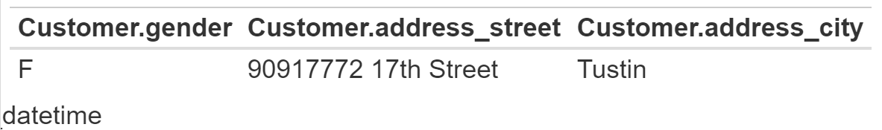

**5. [10pts] Find the name and quantity of each dish ordered by a customer who reserved**

**only one ticket for the flight N124 on 08:21:00 Sep. 07, 2015(We use ‘yyyyMMDD**

**hh:mm:ss’ for the string datetime format).**

pi DishOrder_Contains_Dish.name, quantity1, Customer_Reserves_Flight.quantity, cid (

σ flight_number = 'N124' (

sigma projected_departure_datetime = '2015-09-07 08:21:00' (

sigma Customer_Reserves_Flight.quantity = 1 (

(pi oid, lid, name, quantity->quantity1 (DishOrder_Contains_Dish) ⨝ DishOrder) ⨝ Customer_Reserves_Flight

)

)

)

)

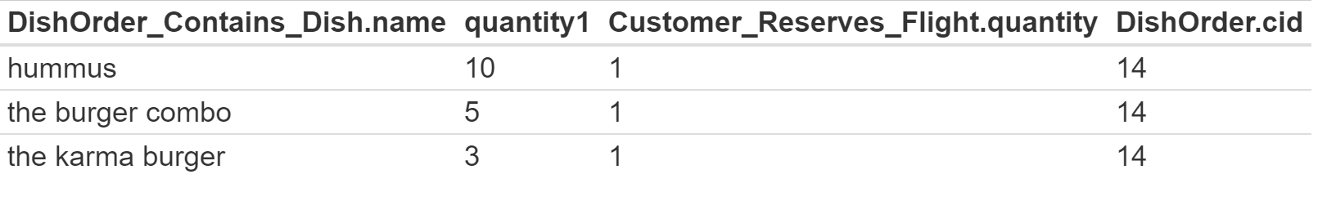

**6. [10pts] Find the cids and emails of customers who haven’t ordered any dishes at all.**

pi cid, email (Customer) - pi cid,email ( Customer ⨝ DishOrder )

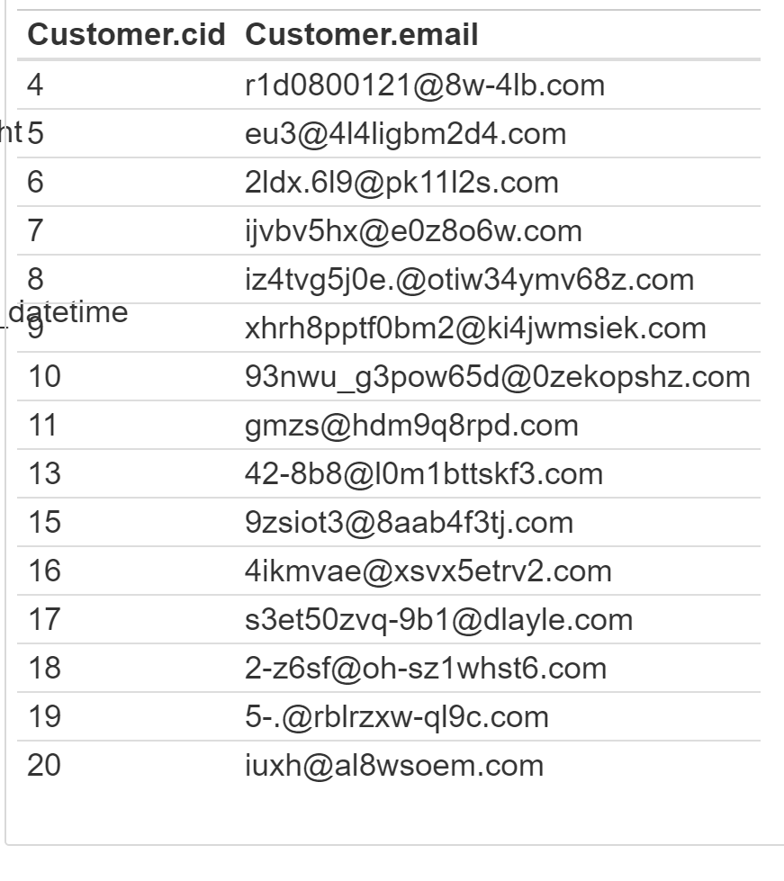

**7. [10pts] List the ids and ssns of customers who placed an order with every lounge**

**(using Division operator).**

(pi cid, ssn ((Customer) ⨝ pi cid, lid (DishOrder) / pi lid Lounge))

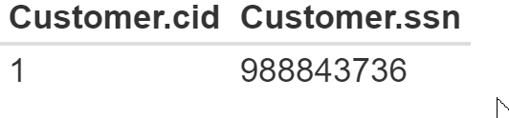

**8. [10pts] Find the ssns of employees from New Jersey.**

pi ssn sigma address_state = 'NJ' ( pi ssn, address_state FlightAttendant ∪ pi ssn, address_state

MaintenanceEngineer ∪ pi ssn, address_state OperationStaff ∪ pi ssn, address_state Pilot)

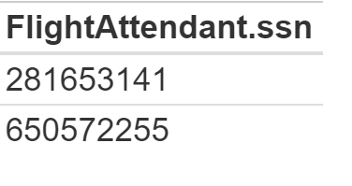

**Part B. SQL Queries [30 pts]**

**In this part, use SQL queries to do analysis on the dataset above.**

**1. Find cids of customers who reserved fights.**

select distinct cid

from Customer_Reserves_Flight

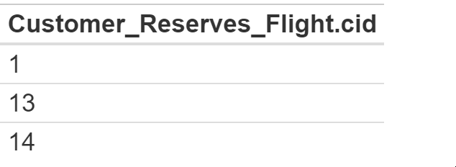

**2. Find customers whose street address ends with “Warner Avenue”.**

select distinct *

from Customer as C where C.address_street

LIKE '%Warner Avenue'

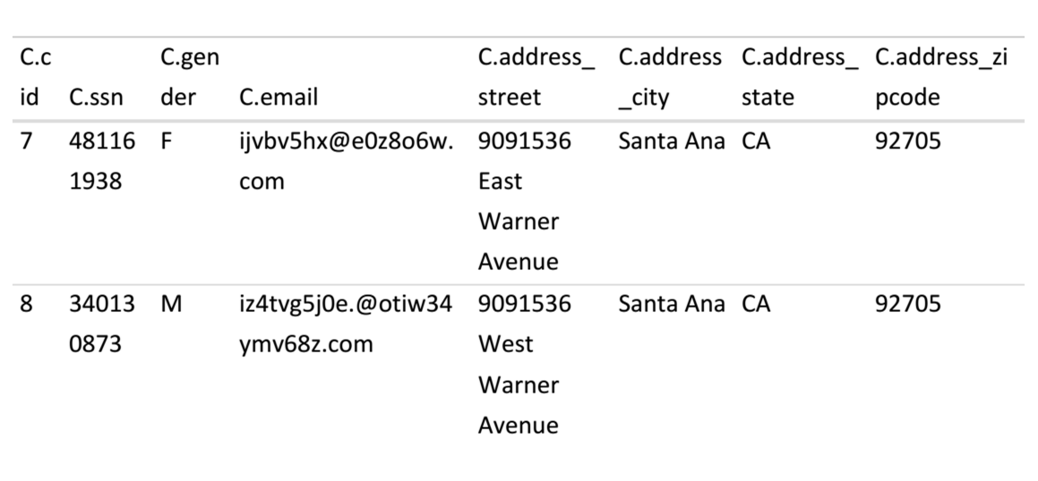

**3. Find customers who reserved flights and ordered dishes.**

select distinct C.*

from Customer as C, Customer_Reserves_Flight as CRF, DishOrder as D

where C.cid = CRF.cid and CRF.cid = D.cid

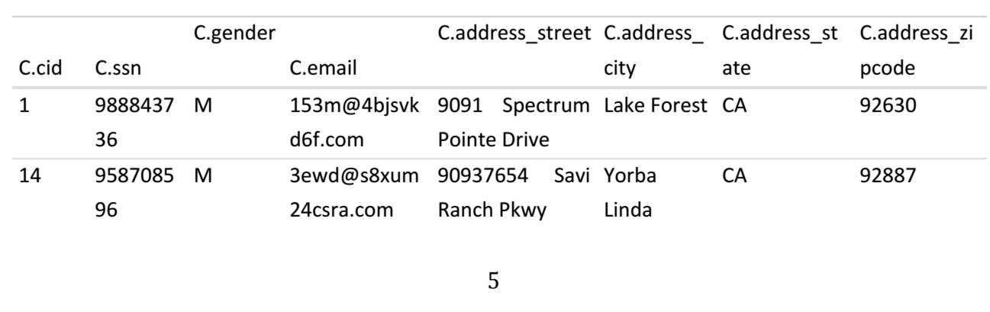

**4. Find the locations of lounges which serve “tacos” or “hummus”.**

select location

from Lounge natural join Dish

where name = 'tacos' OR name = 'hummus'

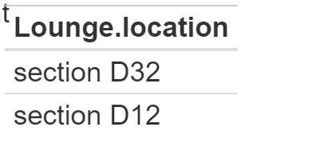

**5. Find cids of customers who didn’t order any dishes nor reserve any flights.**

**From friends:** SELECT Customer.cid

From Customer

Left join Customer_Reserves_Flight

on Customer.cid = Customer_Reserves_Flight.cid

WHERE Customer_Reserves_Flight.cid = null

