University of California, Irvine Fall 2016

## **EECS 119 Introduction to VLSI Design**

**Design Project #2**

Design a static CMOS logic gate that implements the following logic function.

F = ((A.B) + C + (D.E))’



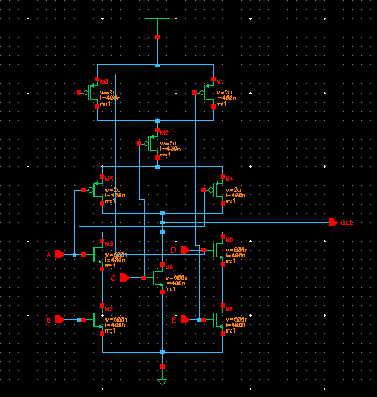***Circuit Diagram***

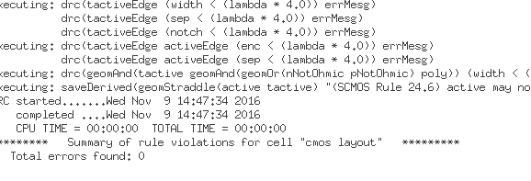  
Verifying the layout to find no errors

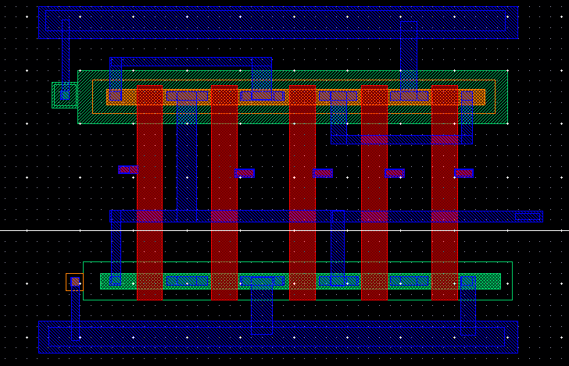

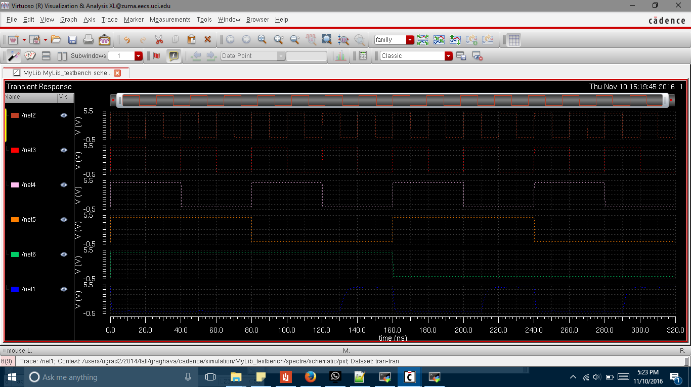

Output realization:

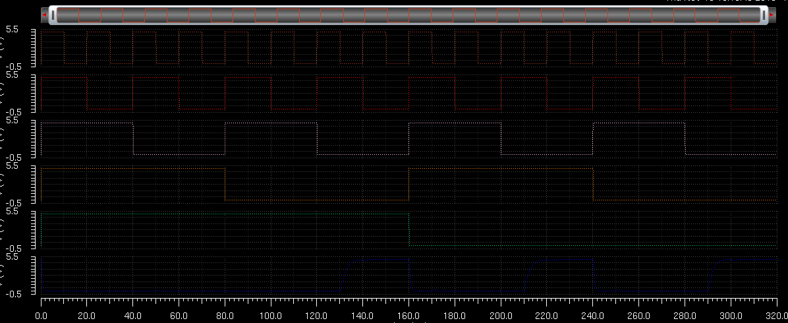

Verified result.