James Ortiz-Luis, 32386064

Mario Ruiz, 46301389

EECS 148 Homework 2

**1. Socket Programming Assignments**

Web Server

HelloWorld.html

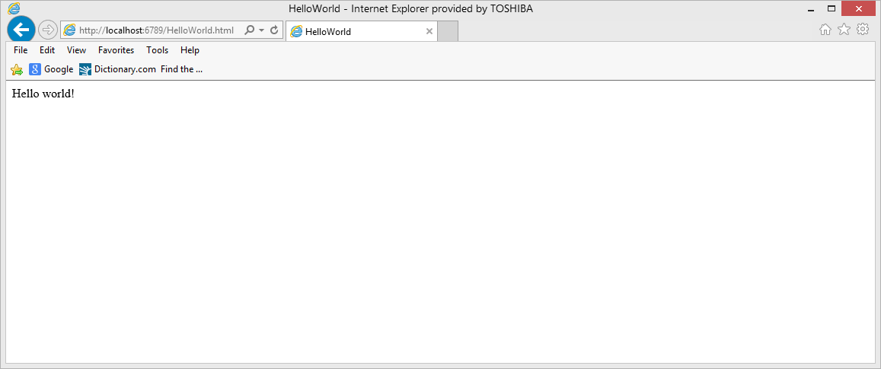

lab1.html

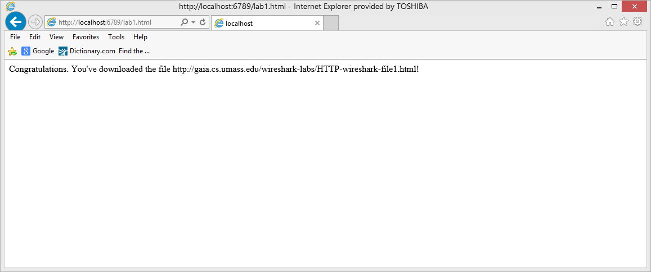

lab2.html

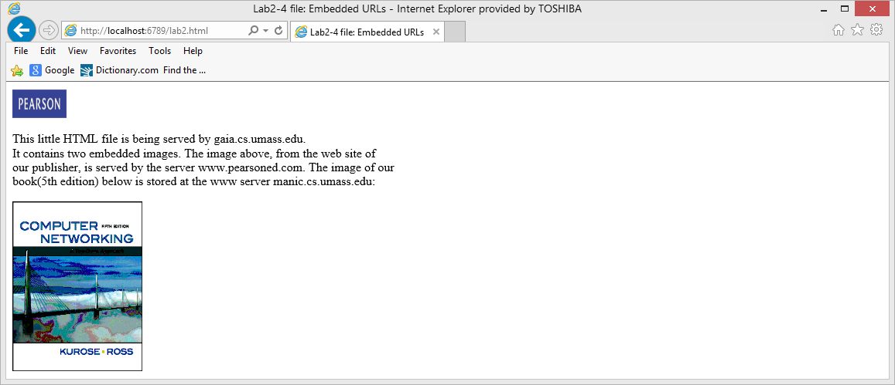

404 Not Found

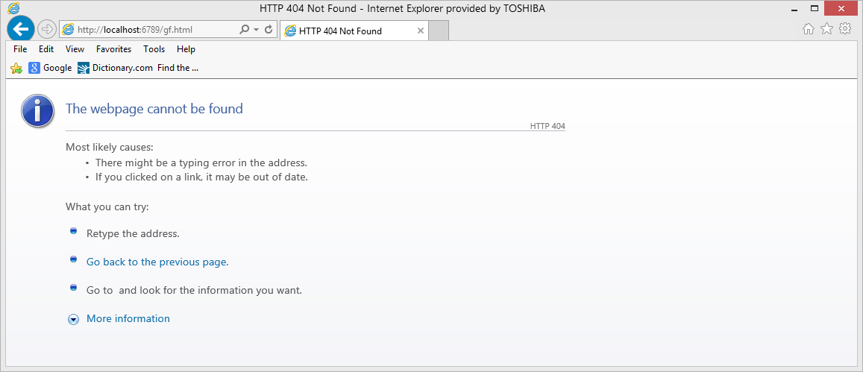

Mail Client

MAIL FROM: <athina@uci.edu>

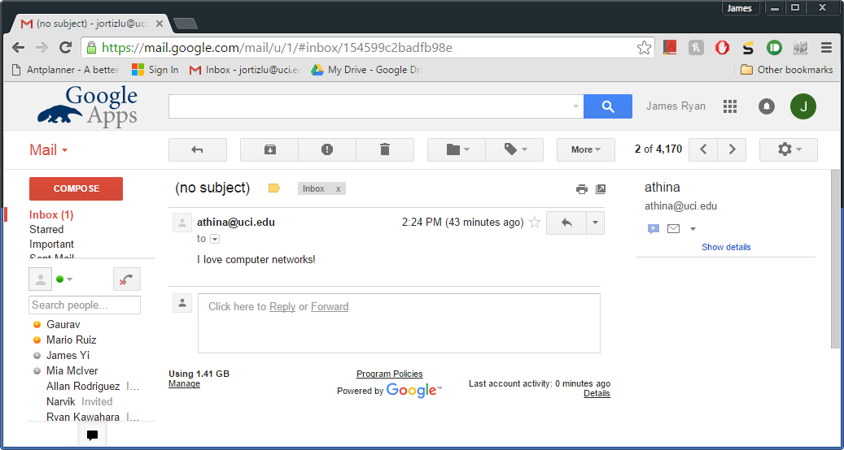

**2. Wireshark Lab: HTTP**

Part 1:

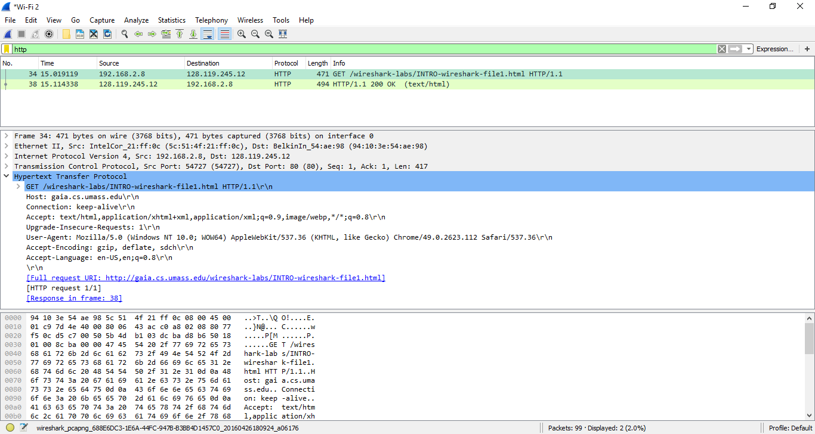

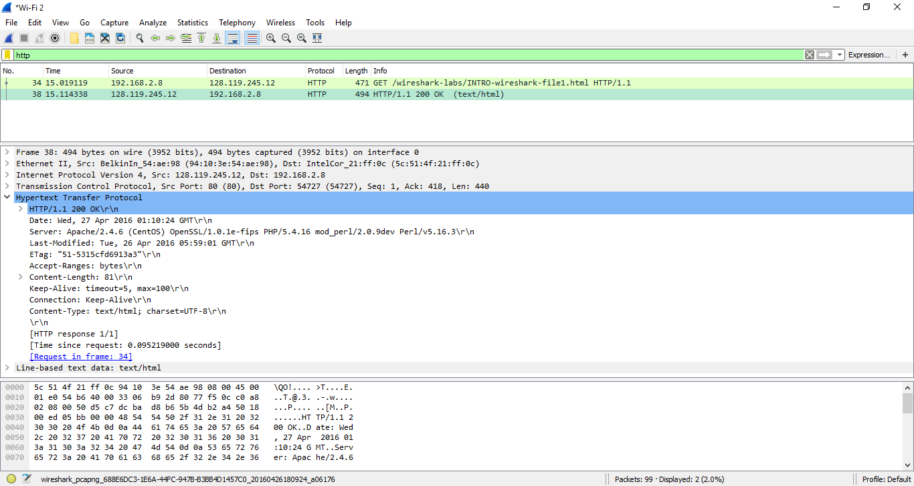

1. My browser is running HTTP 1.1. The server is also running version 1.1 of HTTP.
2. The browser accepts both US-English and English.
3. My computer’s ip address is 192.168.2.8. The ip address of the server is 128.119.245.12.
4. The status code returned from the server to my browser is “200 OK”.
5. The HTML file that I am retrieving was last modified at the server on Tue, 26 Apr 2016 05:59:01 GMT.
6. There are 81 bytes of content being returned to my browser.
7. I do not see any headers within the data that are not displayed in the packet-listing window.

Part 4:

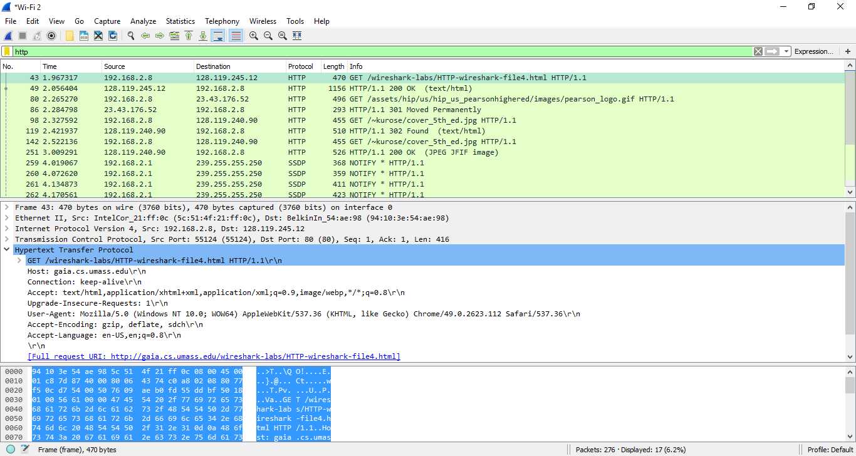

1. My browser sent 4 HTTP GET request messages.The messages were sent to ip addresses 128.119.245.12 , 23.43.176.52 , and 128.119.240.90.
2. My browser downloaded the two images serially because the second image was not requested by the browser until the first image was requested and sent.

**3. HTTP**

1. Persistent HTTP without pipelining:

= retrieving IP address from local DNS server + initiating TCP connection + HTTP request

base + time to transmit base + HTTP request Image 1 + time to transmit image 1 + HTTP

request image 2 + time to transmit image 2

= 4 RTTcs + RTTDNS + 3 file transmission time

1. Non-persistent HTTP with 2 parallel connections:

= retrieving IP address from local DNS server + initiating TCP connection + HTTP

requests base + time to transmit base + parallel HTTP requests for images 1 and 2 +

time to transmit both images in parallel.

= 4 RTTcs + RTTDNS + 2 file transmission time

**4. More DNS**

1. The whois database is a searchable list of all the currently registered domains names and their information such as creation and expiration dates, IP address block, and various other details.
2. The whois databases we used godaddy.com and whois.icann.org. UCI’s name servers: ns1.service.uci.edu, ns2.service.uci.edu Google’s name servers: ns1.google.com, ns2.google.com, ns3.google.com, ns4.google.com

1. Type A queries search for the IP address. Type NS queries search for the name servers. Type MX queries search for the mail exchange servers for the domain. Running NS and MX queries on ‘localhost’ did not work while on campus.

nslookup on local host:

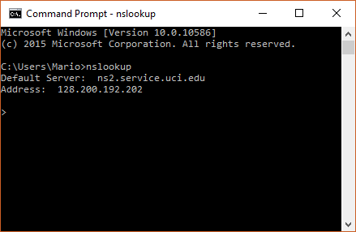

nslookup type A on local host:

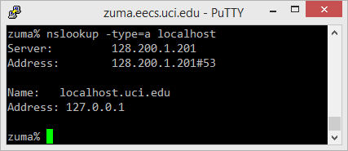

nslookup type NS on local host:

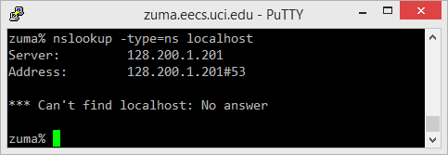

nslookup type MX on local host:

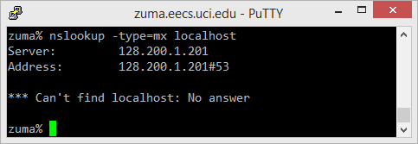

nslookup on google.com:

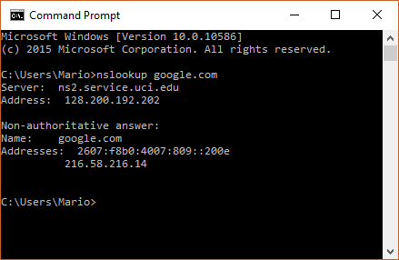

nslookup type A on google.com

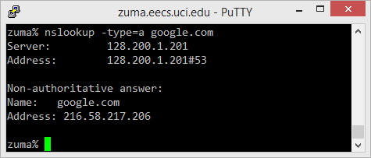

nslookup type NS on google.com

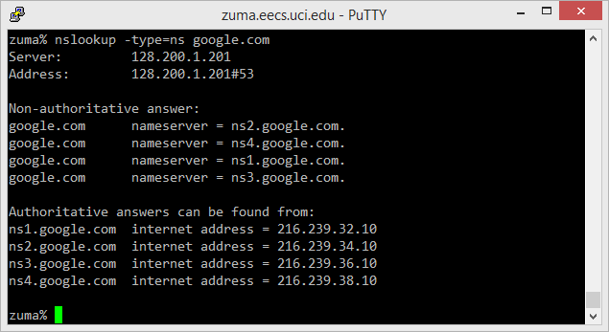

nslookup type MX on google.com

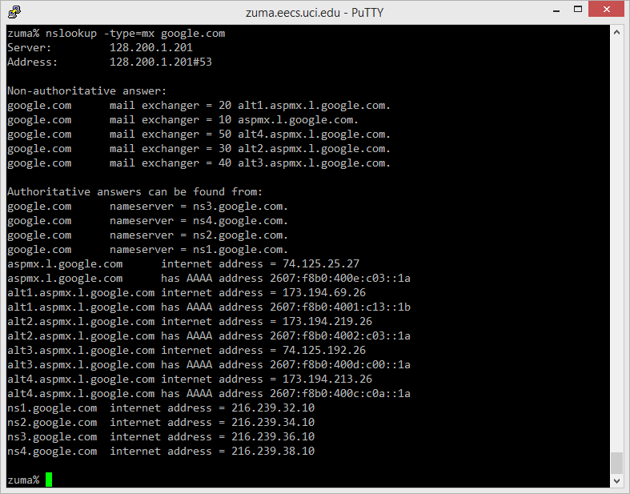

nslookup on uci.edu:

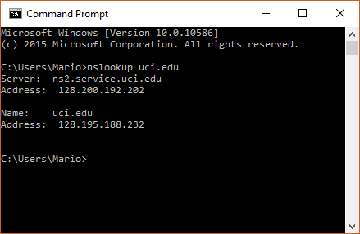

nslookup type A on uci.edu

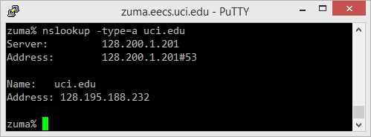

nslookup type NS on uci.edu

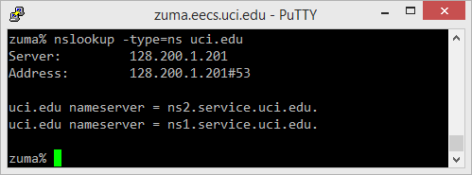

nslookup type MX on uci.edu

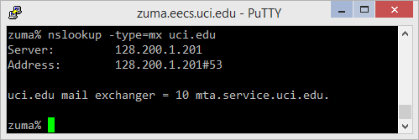

1. UCI has only one IP address. stackoverflow.com has multiple IP addresses

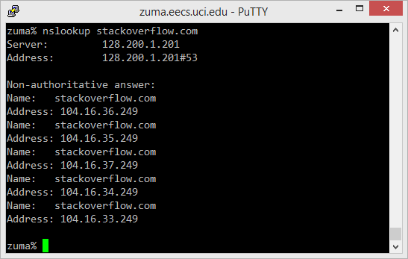

1. IP address range: 128.195.0.0 - 128.195.255.255  
   