James Ortiz-Luis, 32386064

Mario Ruiz, 46301389

EECS 148 Homework 3

**1. TCP Reliability**

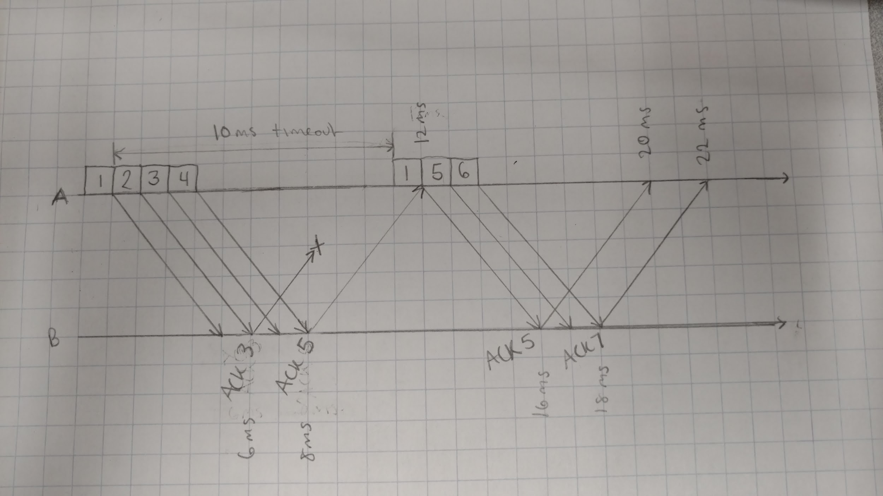

Total time = 22 ms

**2. (a) Chapter 3 P.40**

1. [1, 6], [23, 26]
2. [6, 16], [17, 22]
3. Triple duplicate ACK because cwnd would have been set to 1 if it was a timeout
4. Timeout because cwnd was set to 1
5. ssthresh = 32 initially because that is when congestion avoidance starts
6. ssthresh = 21 because when loss is detected at transmission round 16, cwnd is 42 and ssthresh is set to half of that
7. Ssthresh = 13 because when loss is detected at transmission round 22, cwnd is 26 and ssthresh is set to half of that
8. 7th round

|  |  |
| --- | --- |
| Transmission round | Packets sent |
| 1 | 1 |
| 2 | 2-3 |
| 3 | 4-7 |
| 4 | 8-15 |
| 5 | 16-31 |
| 6 | 32-63 |
| 7 | 64-95 |

1. cwnd = 7 and ssthresh = 4 because ssthresh is set to half of cwnd = 8 when loss occurs, and the new cwnd is set to the new ssthresh + 3 MSS
2. ssthresh = 21 and cwnd = 4 because ssthresh is set to half of cwnd = 42 when loss occurs at transmission round 16, and the new cwnd is 4 because TCP Tahoe sets cwnd to 1 after the loss occurs and cwnd becomes 4 at the 19th round because of slow start
3. 52 packets

|  |  |
| --- | --- |
| Transmission round | Number of Packets sent |
| 17 | 1 |
| 18 | 2 |
| 19 | 4 |
| 20 | 8 |
| 21 | 16 |
| 22 | 21 |

**2. (b) Chapter 3 P.45**

$L=1/(\frac{W}{2}+(\frac{W}{2}+1)+...+W)$ $=1/(\sum_{k=0}^{W/2}{}\frac{W}{2}+k)$ $=1/(\frac{W}{2}(\frac{W}{2}+1)+\sum_{k=0}^{W/2}{}k)$ $=1/(\frac{W^{2}}{4}+\frac{W}{2}+\frac{(W/2)(W/2+1)}{2})$ $=1/(\frac{W^{2}}{4}+\frac{W}{2}+\frac{W^{2}}{8}+\frac{W^{}}{4})$ $=1/(\frac{3}{8}W^{2}+\frac{3}{4}W)$

2. If W is very large, $\frac{3}{8}W^{2}≫\frac{3}{4}W$ so $L≈1/(\frac{3}{8}W^{2})⇒W≈\sqrt{\frac{8}{3L}}$  
   Thus, average throughput $≈\frac{3}{4}\sqrt{\frac{8}{3L}}\frac{MSS}{RTT}≈\frac{1.22 MSS}{RTT\sqrt{L}}$

**3. Chapter 3, Wireshark Lab #2: Exploring TCP**

1. IP address is 192.168.1.102, and TCP port number is 1161 for the source.
2. IP address is 128.119.245.12, and TCP port number is 80 for gaia.cs.umass.edu
3. IP address is 169.234.100.162, and TCP port number is 55794 for my computer.
4. The sequence number of the TCP SYN segment is 0dd601f4, but Wireshark gives a relative sequence number of 0. The SYN flag set to 1 identifies the segment as a SYN segment.
5. The sequence number is 34a27419 (relative sequence number is 0), and the acknowledgment number is 0dd601f5 (relative ack number is 1). The acknowledgment value is the sequence number used to initiate the TCP connection plus 1. The SYN and ACK flags set to 1 identify the segment as SYNACK.
6. The sequence number is 0dd601f5 (relative sequence number is 1).

|  |  |  |  |  |  |
| --- | --- | --- | --- | --- | --- |
| Segment # | Sequence # | Time sent | Time ACK received | RTT | EstimatedRTT |
| 1 | 0dd601f5 | 0.026477 | 0.053937 | 0.02746 | 0.02746 |
| 2 | 0dd6042a | 0.041737 | 0.077294 | 0.035557 | 0.028472 |
| 3 | 0dd609de | 0.054026 | 0.124085 | 0.070059 | 0.033670 |
| 4 | 0dd60f92 | 0.054690 | 0.169118 | 0.114428 | 0.043765 |
| 5 | 0dd61546 | 0.077405 | 0.217299 | 0.139894 | 0.055781 |
| 6 | 0dd61afa | 0.078157 | 0.267802 | 0.189645 | 0.072514 |

|  |  |  |  |  |  |  |
| --- | --- | --- | --- | --- | --- | --- |
| Segment # | 1 | 2 | 3 | 4 | 5 | 6 |
| TCP Segment Length | 565 | 1460 | 1460 | 1460 | 1460 | 1460 |

1. The minimum amount of available buffer space advertised is 5840. The lack of receiver buffer space does not throttle the sender.
2. There are no retransmitted segments. You check for segments sent with a repeated sequence number.
3. The receiver typically acknowledges each segment individually which is 1460 bytes of data. The receiver acknowledges 2352 bytes at frame 52 which is an acknowledgement for two segments.
4. Throughput is 164091 bytes/5.455830 s = 30.076 KBps which is the total amount of bytes transferred divided by the total time of the TCP connection.
5. TCP’s slowstart phase is from 0 to 0.01242 seconds, and congestion avoidance takes over afterwards.
6. For my own trace, TCP’s slowstart phase seems to occurs at a few time intervals such as [3.049, 3.068], [3.143, 3.168], and [3.257, 3.288], and seems to be in congestion avoidance elsewhere.  
   