Title  **Functional Specification for Batch View Phase (I) module of CVC IPC App**

**Approvals**

|  |  |  |  |
| --- | --- | --- | --- |
|  | **Prepared by** | **Reviewed by** | **Approved by** |
| **Signature** |  |  |  |
| **Date** | 2020/07/06 |  |  |
| **Name** | **Mr. Naresh Ghadi** |  |  |
| **Designation** |  |  |  |

# Table of Contents

Title 1

1 Table of Contents 2

2 Revision History: 3

3 Objective: 4

4 Scope: 5

5 Project Name: 6

6 Reference Documents 7

7 Abbreviations: 8

8 Responsibilities: 8

9 Functional Specifications 9

9.1 Menu Item 9

9.1.1 Description 9

9.2 Primary Entity, Secondary entity 9

9.2.1 Description 9

9.3 Batch View Log 9

9.3.1 Description 9

9.4 Batch View Exception 9

9.4.1 Description 11

9.5 Batch View Main Grid 10

9.5.1 Description 10

9.6 Batch View Bottom Tab Strip 12

9.6.1 Description 12

9.7 Primary Entity Type 13

9.7.1 Description 14

9.8 Batch View Detail Tab 13

9.8.1 Description 14

9.9 Batch View Audit Tab 13

9.9.1 Description 14

9.10 Batch View Alarm Tab 13

9.10.1 Description 14

9.11 Batch View Recipe Tab 13

9.11.1 Description 14

9.12 Batch View User Tab 13

9.12.1 Description 14

10 FS Tags 21

# Revision History:

|  |  |  |  |  |
| --- | --- | --- | --- | --- |
| **Date** | **Revision No.** | **Description** | **Concerned Person** | **Signature** |
|  |  |  |  |  |
|  |  |  |  |  |
|  |  |  |  |  |
|  |  |  |  |  |
|  |  |  |  |  |
|  |  |  |  |  |
|  |  |  |  |  |

# Objective:

The Functional Specification Document is a document that provides detailed information on how the system solution will function and the requested behavior for the requirements mentioned in the SRS document. This document is created based on the high-level requirements identified in the Software Requirement (SRS-CVC_IPC_APP_Batch View Phase (I)) and provides traceability on the functional specifications back to the software requirements. It is our desire that a completed specification document meet the following criteria:

* It should be able to adequately serve as training material for new project members, imparting to them enough information and understanding about the project implementation.
* It should serve as “objective evidence” that the designers and/or implementers are following through on their commitment to implement the functionality described in the requirements specification.
* It needs to be as detailed as possible, while at the same time not imposing too much of a burden on the designers and/or implementers that it becomes overly difficult to create or maintain.

# Scope:

Functional Specification document will be describing all the specifications required for developing the said functionality and implementing it in existing CVC IPC App project. This document must include

* Systems input and output
* Process flows or Context Diagrams
* Data flow diagrams
* Interface Requirements
* Error Handling
* Validations List

# Project Name:

CVC IPC App Batch View Module

# Reference Documents

|  |  |
| --- | --- |
| [1] | wikipedia.org, "HTML," wikipedia.org, [Online]. Available: https://en.wikipedia.org/wiki/HTML. [Accessed 20 05 2020]. |
| [2] | wikipedia.org, "XPath," [Online]. Available: https://en.wikipedia.org/wiki/XPath. [Accessed 16 05 2020]. |
| [3] | CVC, *CVC_IPC_App-Btch View Phase (I)-SRS.docx,* 2020. |
| [4] | github.com, "rjamesnw/v8dotnet," github.com, [Online]. Available: https://github.com/rjamesnw/v8dotnet. [Accessed 16 05 2020]. |

# Abbreviations:

|  |  |
| --- | --- |
| SRS | Software Requirement Specification |

# Responsibilities:

* Developer
* Project Manager
* Managing Director

# Functional Specifications

## Menu Item

### Description

Application top bar will display a Screen named “Batch View” in the Menu Item “Machine Customization”. When a user selects this option, it will redirect to the Batch View main screen. Permission for the Batch View system will be handled according to the existing system permission structure.

## Primary Entity, Secondary entity

### Description

The application has many entities and its relationships. A screen in this application is always mapped to one entity that is batch entity and shows it relationships through many views grouped inside these screens. Batch system will keep the data of those entity tables and all the rows in those tables will be treated as primary or secondary entities.

### Description

Batch View Main Screen contains two parts as top and bottom views. Top view has to show all the available or created batch in a grid. Bottom view is a tab stripe with first tab named ‘Details’ and it contains all the properties of the selected batch in the top list view.

## Batch View Log

### Description

Download report of batch log will be logged in the existing audit logs with necessary data to reproduce or troubleshoot the error. This will follow the existing architecture of the application

## Batch View Exceptions

### Description

Batch View execution should be capable of handling the exceptions safely and create a log with exception, Stack trace and any other available data to reproduce the issue. The exceptions should explain clearly the issue so that users can do the resolution.

When an exception is occurred in the process of the Batch View, user will be notified with details of the exception and up to the current action all the global parameters and input parameters for the current action are stored in the database. the batch view will be tagged as ‘exception occurred’ and can be executed from the action, which had the exception.

## Batch View Main Grid

### Description

The grid should have:

|  |  |
| --- | --- |
| **Field Names** | **Description** |
| Batch ID | Unique, Auto generated Id of the Batch |
| Batch Number | Unique Name of the Batch |
| Batch Size | It shows the size of the batch |
| Batch Start Date | It shows the When batch started |
| Batch End Date | It shows the When batch ended |
| Batch Status | It shows the status of the batch |

Columns with all the regular functionalities with the CVC IPC App grid. First record of batch will be selected on data binding to grid. Bottom view should refresh according to the selected batch in the grid.

.

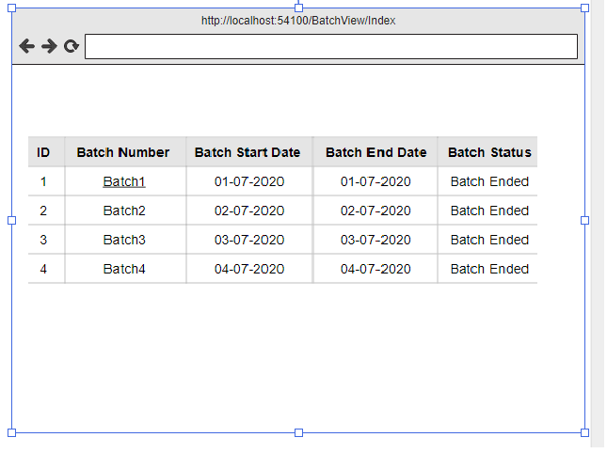

Figure 1Workflow Add New Window

## Batch View Bottom Tab strip

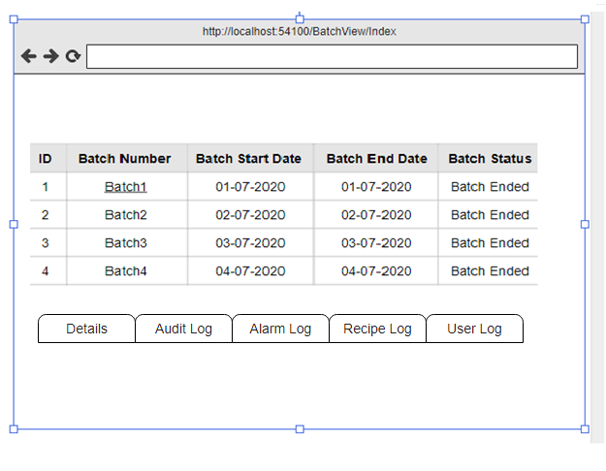

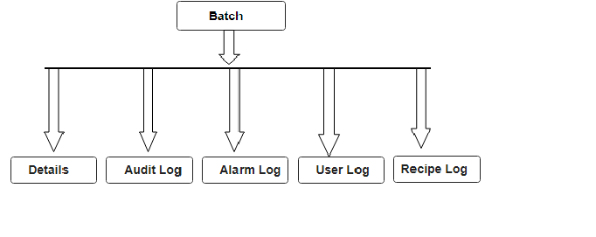

### Description

Tab strip will contain following Tabs. Detail tab will be selected by default.

|  |  |
| --- | --- |
| **Tabs** | **Description** |
| Detail | It shows the details of selected batch from top grid of batch. (9.20, Figure 2 Batch Detail tab) |
| Audit | It shows the audit log records of selected batch |
| Alarm | It shows the alarm log records of selected batch |
| User | It shows the user log records of selected batch |
| Recipe | It shows the recipe log records of selected batch |

## Primary Entity Type

### Description

There are tables in the systems which contains the data about primary entities of the application as “Machine”, “User” etc. Primary entity type table will contain the data about those tables with table’s SQL meta data and matching data model meta data in the application.

In the batch view module, all the data rows in the tables that mentioned in the Primary entity type table will be treated as a primary entity. Or can be selected as a secondary entity.

Ex: If Primary entity types table have a record of Machine table then, all the Machine table rows will be treated as primary entities.

## Batch View Detail Tab

### Description

This will contain the details for the selected batch of the grid. All the fields of batch should display here as read only fields.

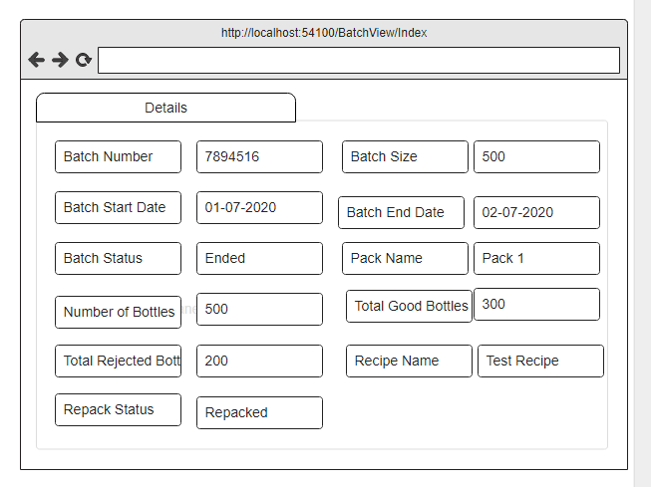

Figure 2 Workflow Detail tab

## Batch View Audit Tab

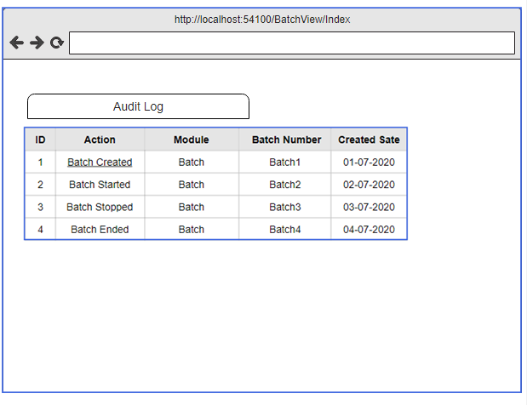

### Description

Audit tab show all the records which saved in auditlog table of selected batch. First record of batch will automatically select in the top grid and audit log record related to that batch displayed in the audit log bottom view by default when the Screen is selected for display (RS6).

Table/List of Audit Log have pagination which shows default 10 record per page and you can select page size from record per page dropdown.

Pagination bar placed in bottom of Audit Log table which contain page number and previous and next button

Bottom Table/List of Audit Log have search box placed in top right side of table which search record from list of Alarm log by any properties which available in table

Bottom Table/List of Audit Log have sorting properties that is up and down arrow for each column which sort record in ascending and descending order

Bottom Table/List of Audit Log have one pdf download button from which user can download whole Audit Log for selected batch report in pdf format

Top Table/List of Audit Log have date filter which will filter record as per selection.

## Batch View Alarm Tab

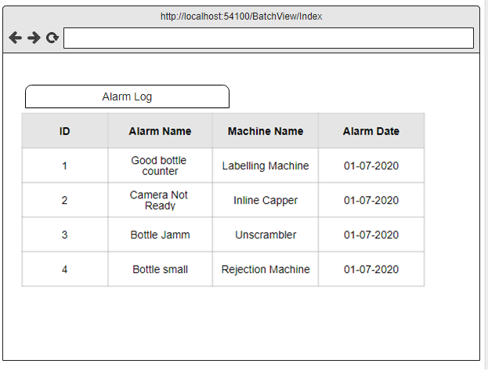

Alarm tab show all the records which saved in alarm table of selected batch. First record of batch will automatically select in the top grid and alarm log record related to that batch displayed in the alarm log bottom view by default when the Screen is selected for display (RS6).

Table/List of Alarm Log have pagination which shows default 10 record per page and you can select page size from record per page dropdown.

Pagination bar placed in bottom of Alarm Log table which contain page number and previous and next button

Bottom Table/List of Alarm Log have search box placed in top right side of table which search record from list of Alarm log by any properties which available in table

Bottom Table/List of Alarm Log have sorting properties that is up and down arrow for each column which sort record in ascending and descending order

Bottom Table/List of Alarm Log have one pdf download button from which user can download whole Alarm Log for selected batch report in pdf format

Top Table/List of Alarm Log have date filter which will filter record as per selection

## Batch View Recipe Tab

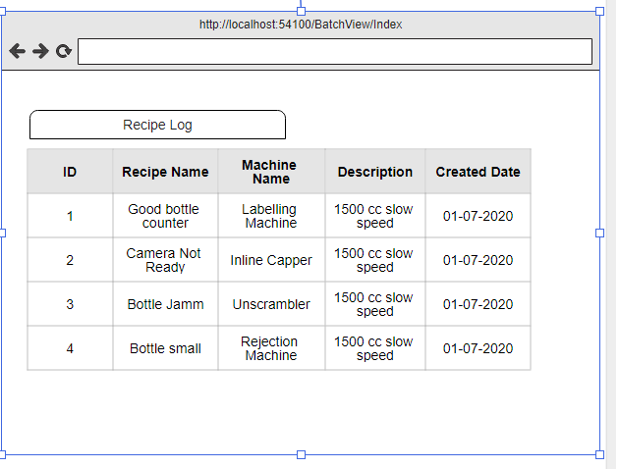

Recipe tab show all the records which saved in recipe table of selected batch. First record of batch will automatically select in the top grid and recipe log record related to that batch displayed in the Recipe log bottom view by default when the Screen is selected for display (RS6).

Recipe Log tab contain table/List of Recipe Log records of selected batch

Table/List of Recipe Log have pagination which shows default 10 record per page and you can select page size from record per page dropdown.

Pagination bar placed in bottom of Recipe Log table which contain page number and previous and next button

Bottom Table/List of Recipe Log have search box placed in top right side of table which search record from list of recipe log by any properties which available in table

Bottom Table/List of Recipe Log have sorting properties that is up and down arrow for each column which sort record in ascending and descending order

Bottom Table/List of Recipe Log have one pdf download button from which user can download whole Recipe Log for selected batch report in pdf format

Top Table/List of Recipe Log have date filter which will filter record as per selection

## 9.12 Batch View User Tab

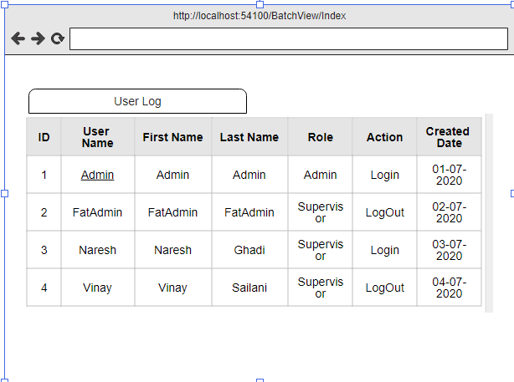

User tab show all the records which saved in user table of selected batch. First record of batch will automatically select in the top grid and user log record related to that batch displayed in the User log bottom view by default when the Screen is selected for display (RS6).

User Log tab contain table/List of User Log records of selected batch

Table/List of User Log have pagination which shows default 10 record per page and you can select page size from record per page dropdown.

Pagination bar placed in bottom of User Log table which contain page number and previous and next button

Bottom Table/List of User Log have search box placed in top right side of table which search record from list of User Log by any properties which available in table

Bottom Table/List of User Log have sorting properties that is up and down arrow for each column which sort record in ascending and descending order

Bottom Table/List of User Log have one pdf download button from which user can download whole User Log for selected batch report in pdf format

Top Table/List of User Log have date filter which will filter record as per selection

# FS Tags

|  |  |  |
| --- | --- | --- |
| RS Tag |  | Description |
|  |  | There need to be a Batch View engine which can be administered from the existing application |
|  |  | Application should have Screen named Batch View in the Menu Item – Machine Customization |
|  |  | Batch View Main Screen should be divided into two views, Top and Bottom View |
|  |  | Top view will show all the available or created batches in Table/List format |
|  |  | Top Table/List of batch contain Batch number,Batch startdate,batch enddate,batch size and batch status |
|  |  | Top Table/List of batch have pagination which shows default 10 record per page and you can select page size from record per page dropdown. |
|  |  | Pagination bar placed in bottom of table which contain page number and previous and next button |
|  |  | Top Table/List of batch have search box placed in top right side of table which search record from list of batch by any properties which available in table |
|  |  | Top Table/List of batch have sorting properties that is up and down arrow for each column which sort record in ascending and descending order |
|  |  | Top Table/List Batch have one pdf download button from which user can download whole batch report in pdf format |
|  |  | Top Table/List Batch have Batch startdate and batchenddate date filter which will filter record as per selection |
|  |  | Bottom view will be a details form and list view such as audit log, alarm log, recipe log and user log |
|  |  | Details tab will show the all the properties of the selected batch in the top list view |
|  |  | First record of Batch should be automatically selected in the Top list view and details displayed in the bottom view by default when the Screen is selected for display |
|  |  | Details tab contain pdf button which download details of selected batch in pdf format |
|  |  | Audi Log tab contain table/List of Audit Log records of selected batch |
|  |  | Table/List of audit Log have pagination which shows default 10 record per page and you can select page size from record per page dropdown. |
|  |  | Pagination bar placed in bottom of Audit Log table which contain page number and previous and next button |
|  |  | Bottom Table/List of Audit Log have search box placed in top right side of table which search record from list of audit log by any properties which available in table |
|  |  | Bottom Table/List of Audit Log have sorting properties that is up and down arrow for each column which sort record in ascending and descending order |
|  |  | Bottom Table/List of Audit Log have one pdf download button from which user can download whole Audit Log for selected batch report in pdf format |
|  |  | Top Table/List of Audit Log have  date filter which will filter record as per selection |
|  |  | Alarm Log tab contain table/List of Alarm  Log records of selected batch |
|  |  | Table/List of Alarm Log have pagination which shows default 10 record per page and you can select page size from record per page dropdown. |
|  |  | Pagination bar placed in bottom of Alarm Log table which contain page number and previous and next button |
|  |  | Bottom Table/List of Alarm Log have search box placed in top right side of table which search record from list of Alarm log by any properties which available in table |
|  |  | Bottom Table/List of Alarm Log have sorting properties that is up and down arrow for each column which sort record in ascending and descending order |
|  |  | Bottom Table/List of Alarm Log have one pdf download button from which user can download whole Alarm Log for selected batch report in pdf format |
|  |  | Top Table/List of Alarm Log have  date filter which will filter record as per selection |
|  |  | Recipe Log tab contain table/List of Recipe Log records of selected batch |
|  |  | Table/List of Recipe Log have pagination which shows default 10 record per page and you can select page size from record per page dropdown. |
|  |  | Pagination bar placed in bottom of Recipe Log table which contain page number and previous and next button |
|  |  | Bottom Table/List of Recipe Log have search box placed in top right side of table which search record from list of recipe log by any properties which available in table |
|  |  | Bottom Table/List of Recipe Log have sorting properties that is up and down arrow for each column which sort record in ascending and descending order |
|  |  | Bottom Table/List of Recipe Log have one pdf download button from which user can download whole Recipe Log for selected batch report in pdf format |
|  |  | Top Table/List of Recipe Log have  date filter which will filter record as per selection |
|  |  | User Log tab contain table/List of User Log records of selected batch |
|  |  | Table/List of User Log have pagination which shows default 10 record per page and you can select page size from record per page dropdown. |
|  |  | Pagination bar placed in bottom of User Log table which contain page number and previous and next button |
|  |  | Bottom Table/List of User Log have search box placed in top right side of table which search record from list of User Log by any properties which available in table |
|  |  | Bottom Table/List of User Log have sorting properties that is up and down arrow for each column which sort record in ascending and descending order |
|  |  | Bottom Table/List of User Log have one pdf download button from which user can download whole User Log for selected batch report in pdf format |
|  |  | Top Table/List of User Log have  date filter which will filter record as per selection |
|  |  | Settings panel of dashboard screen contain Audit Log and Alarm Log tab |
|  |  | Audit Log tab and Alarm tab will visible after batch creation |
|  |  | Audit Log tab and Alarm tab will hide after batch end |
|  |  | Audit Log tab and Alarm tab will show live record related to running batch |
|  |  | Audi Log tab of settings panel contain table/List of Audit Log records of running batch |
|  |  | Table/List of audit Log in settings panel have pagination which shows default 10 record per page and you can select page size from record per page dropdown. |
|  |  | Pagination bar placed in bottom of Audit Log (in setting panel )table which contain page number and previous and next button |
|  |  | Bottom Table/List of Audit Log(in setting panel) have search box placed in top right side of table which search record from list of audit log by any properties which available in table |
|  |  | Bottom Table/List of Audit Log (in setting panel) have sorting properties that is up and down arrow for each column which sort record in ascending and descending order |
|  |  | Bottom Table/List of Audit Log (in setting panel) have one pdf download button from which user can download whole Audit Log (in setting panel) for running batch report in pdf format |
|  |  | Bottom Table/List of Audit Log (in setting panel) have  date filter which will filter record as per selection |
|  |  | Alarm Log tab of settings panel contain table/List of Alarm Log records of running batch |
|  |  | Table/List of Alarm Log in settings panel have pagination which shows default 10 record per page and you can select page size from record per page dropdown. |
|  |  | Pagination bar placed in bottom of Alarm Log (in setting panel )table which contain page number and previous and next button |
|  |  | Bottom Table/List of Alarm Log(in setting panel) have search box placed in top right side of table which search record from list of Alarm log by any properties which available in table |
|  |  | Bottom Table/List of Alarm Log (in setting panel) have sorting properties that is up and down arrow for each column which sort record in ascending and descending order |
|  |  | Bottom Table/List of Alarm Log (in setting panel) have one pdf download button from which user can download whole Alarm Log (in setting panel) for running batch report in pdf format |
|  |  | Bottom Table/List of Alarm Log (in setting panel) have  date filter which will filter record as per selection |

|  |
| --- |
| **END OF DOCUMENT** |