Privacy Policy
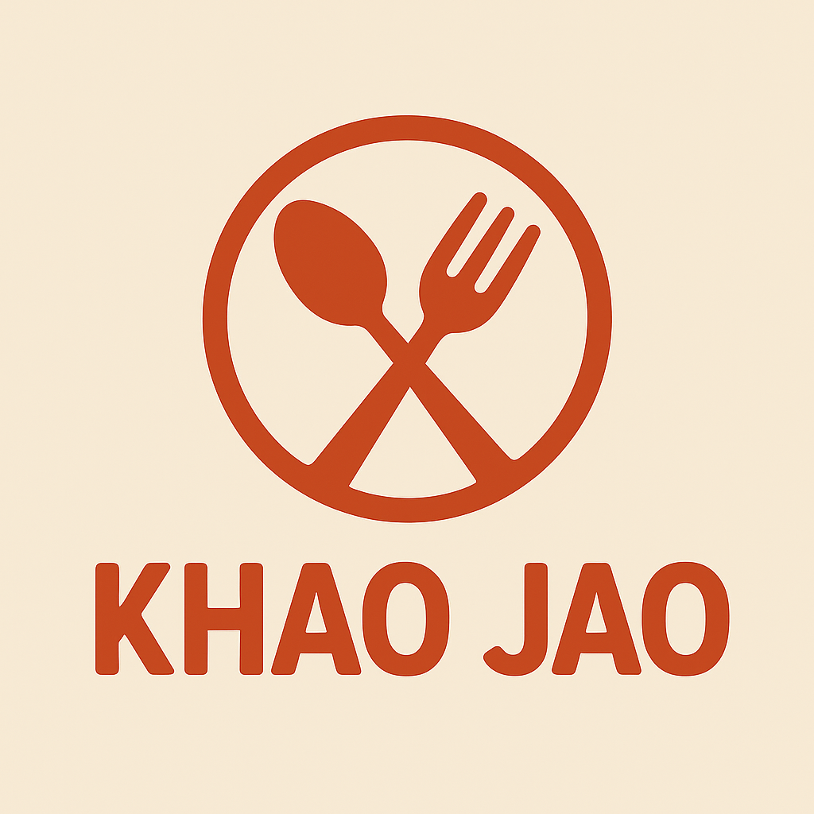
App Name: KHAO JAO
Prepared By: Gaurav Singh
Date: 27-11-2025
At , KHAO JAO your privacy is important to us. This policy explains what personal data we collect, why we collect it, how it’s used, and your rights under the GDPR.

1. Personal Data We Collect
- Full Name & Email Address
- Location Data
- Payment Information
- Order History
- IP Address & Device Information

2. Purpose of Data Collection
- To create and manage user accounts
- To suggest nearby restaurants based on your location
- To process secure payments
- To personalize offers and improve experience
- To detect fraud and enhance security

3. Legal Basis for Processing
- Consent – when you create your account
- Contract – to process your orders
- Legitimate Interest – for analytics and fraud prevention
- Legal Obligation – for tax and financial records

4. Data Sharing
We only share necessary data with:
- Delivery partners (location data)
- Payment gateway providers (secure & compliant)
- Internal technical and support teams

5. Data Retention
- Account Info: 2 years after inactivity
- Order History: 2 years
- Payment Data: As required by law
- Device Logs: 6 months

6. Your GDPR Rights
- Right to Access
- Right to Rectification
- Right to Erasure
- Right to Withdraw Consent
- Right to Lodge a Complaint
To exercise your rights, email us at: privacy@KHAOJAO.com

7. Security Measures
All data is encrypted in transit and at rest. Access is role-based and logged.

8. Contact Us
If you have questions, contact our Data Protection Officer at privacy@KHAOJAO.com

