MINOR PROJECT — PROGRESS REPORT
Project Title | Machine-Learning Surrogate for Airfoil Aerodynamics
Student Name | Gaurav Shukla
Student ID (SID) | 24101014
Programme / Branch | Aerospace Engineering
Semester / Year | 5th Semester
Supervisor | Dr. Konark Arora, Dr. Rakesh Kumar
Department | Aerospace Engineering
Date of Submission | 19/10/2026
1. Project overview
Predict lift (Cl), drag (Cd) and pitching moment (Cm) from airfoil shape and flow conditions as a surrogate for repeated XFOIL/CFD evaluations. The NASA Airfoil Learning Dataset contains 818 airfoils and 768,542 operating points. The goal is generalization to unseen shapes, not reproduction of previously observed airfoils.
2-3. Geometry correction and version 2 method
v1's separately centered surfaces lost thickness/camber offsets; 43% of stations had negative thickness. Raw data were rebuilt with shared normalization, cosine sampling, thickness/camber and eight descriptors. All 818 geometries are non-negative; 462 tiny crossings across 371 airfoils are clipped and logged. Two linked tables replace the 1.7 GB CSV. v2 models log(Cd), Cl and Cm, reporting relative, regime, Reynolds and L/D errors. Geometry validity is not a causal MLP-gain claim.
The frozen airfoil-disjoint train/validation/test split is 572/123/123 airfoils and 538,380/113,678/116,484 rows. RAdam/SiLU MLPs use validation stopping and train-only scaling. The completed study has 12 fits: six paired MSE/Huber runs (seeds 42, 43, 44), four additional one-factor sweep fits, and two train-only exposure-audit fits.
4. Results on held-out airfoils | 19 October 2026 update
Test Median (%) | MSE | Huber
Cl | 4.7819% +/- 0.1246 pp | 3.8338% +/- 0.0169 pp
Cd | 6.6331% +/- 0.0610 pp | 5.6116% +/- 0.0650 pp
Cm | 11.3164% +/- 0.5075 pp | 10.1244% +/- 0.4508 pp

Mean +/- sample SD of per-seed test medians; n = 3, ddof = 1. SD is in percentage points (pp), not a 95% confidence interval or ensemble uncertainty. Source: [S] three_seed_summary.csv, checked against three_seed_metrics.csv.
Primary finding: Huber beats paired MSE medians for every target in all three seeds, but Cd tail accuracy is unstable (seed-44 R-squared = -0.602146). Validation selects WD 0, yet its Cd RMSE is 67.68% worse than the CPU baseline. The default configuration and pinned accuracy baseline remain unchanged; WD 0 is an experimental candidate, not an overall improvement.
Historical context: scikit-learn v2 test medians Cl/Cd/Cm = 5.96/8.11/12.28%; retained CPU Huber = 3.81/5.57/9.65%. Their L/D medians were 12.64% and 8.60%. The defective v1 geometry/R-squared comparison is historical, not a causal benchmark. Full prior text, tables and plots remain in the original backup [H].
4.1 Paired-seed medians and drag tail accuracy
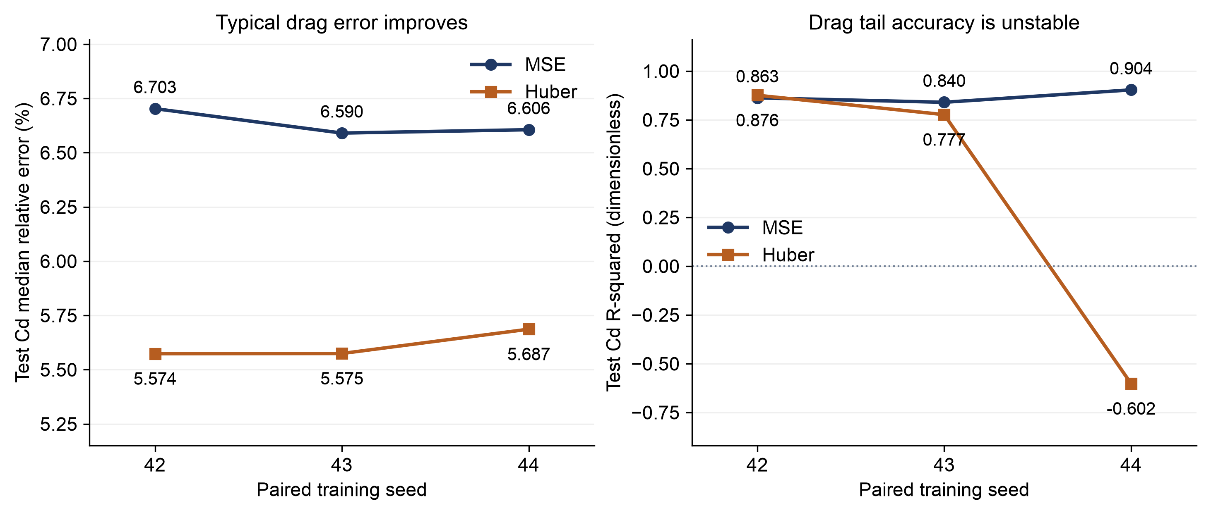
Figure 1. Same unseen-airfoil test set, paired seeds 42/43/44. Huber Cd R-squared is 0.875953/0.776601/-0.602146 despite median errors 5.5736/5.5745/5.6866%. Individual runs, not confidence intervals. Source: [S] three_seed_metrics.csv.
4.2 Validation selection and the median-only guard
Frozen selection: sweep_decay_0, seed 42, Huber delta 0.05 (standardized fitting-target units), WD 0. Validation Cd median error is 5.6603% versus 5.8984% for default WD 1e-5. The central condition is reused; no best test seed is selected.
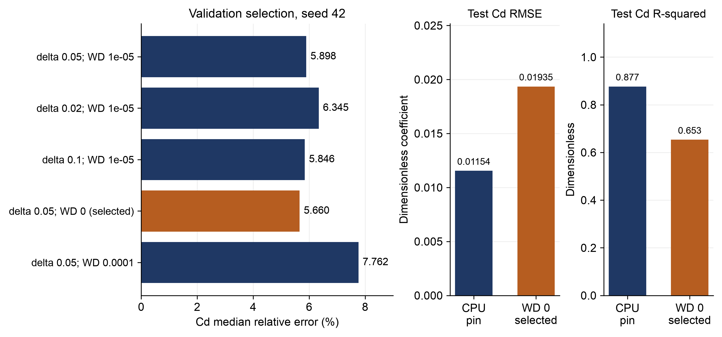
Figure 2. Five validation conditions and the selected candidate's test tail metrics versus the retained CPU pin. Separate RMSE/R-squared axes; lower RMSE and higher R-squared are better. Sources: [S] study_selection.json, selected_analysis.json; [B].
Selected test medians Cl/Cd/Cm = 3.9154/5.5420/9.5685%. Cd RMSE = 0.0193512 versus CPU 0.0115403; R-squared = 0.653138 versus 0.876639. Thus a slightly better median does not imply better overall drag accuracy.
Median-only guard: PASS at maximum degradation 0.5 pp. Cl +0.101676 pp; Cd -0.030899 pp; Cm -0.081213 pp (candidate minus CPU). Cd RMSE nevertheless rises 67.68%. This guard does not protect tails. Do not adopt WD 0 or tune further on this test set.
4.3 Controlled exposure audit and remaining limits
Both arms use 347,877 training rows, the same 54,917 audit rows and 80,612 common stopping rows, all from canonical TRAIN only. Exposed training replaces part of its equal row budget with 54,974 other operating points from 114 audit airfoils; the honest arm sees none of those airfoils. Neither trains on audit rows or stopping geometries.
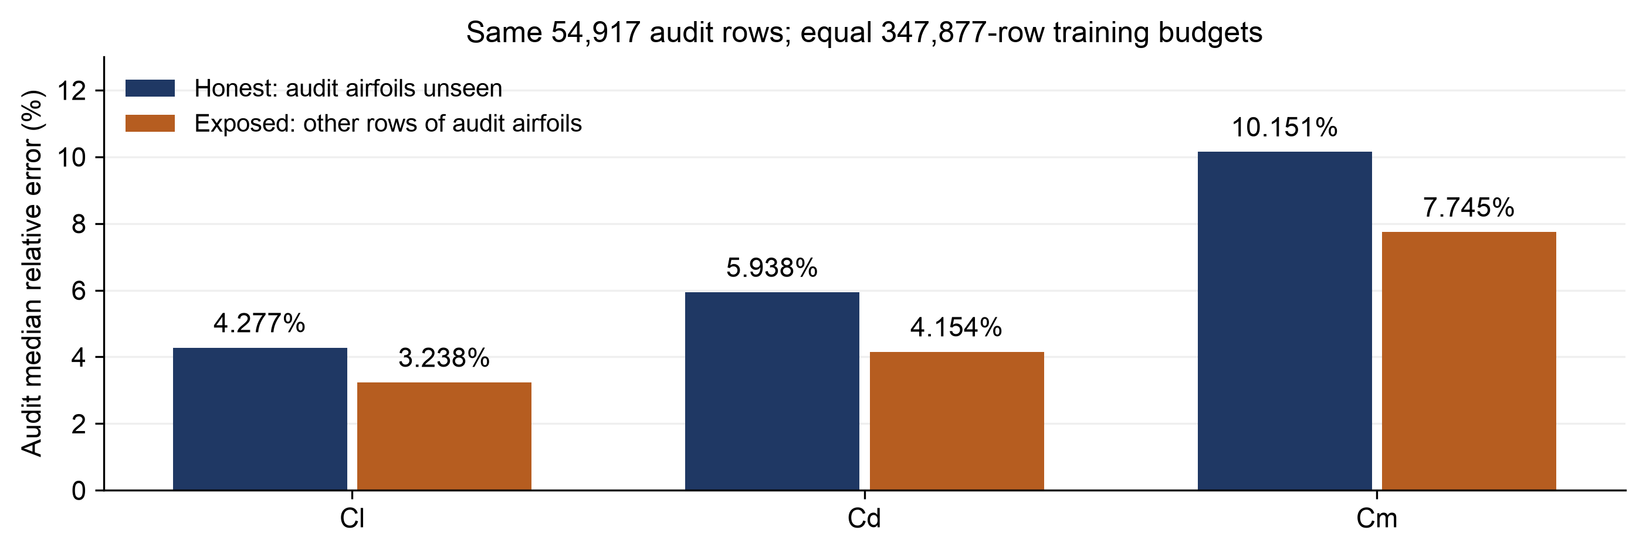
Figure 3. Same audit sample; one fit per arm, seed 42 (no uncertainty bars). Exposure improves this audit, not unseen-airfoil generalization, and is not universal proof of memorization. Sources: [S] leakage_metrics.csv, leakage_split.json.
Cd median falls 5.93781% to 4.15372% (1.78409 pp; 30.05% relative). Cd R-squared rises 0.934978 to 0.956848 at identical audit SST 44.67275. Canonical validation/test were excluded from this diagnostic.
5-6. Conclusions, limitations and next steps
Do not promote WD 0: fixed |alpha| > 12-degree Cd R-squared improves 0.713768 to 0.769079, but |alpha| <= 12 degrees regresses 0.897004 to 0.502316. These are angle proxies, not measured stall. FX 79-W-660A supplies 81.87% of selected Cd SSE; Re = 50,000 R-squared is 0.07179. No hard geometries were removed.
Matched |alpha| <= 12 degrees, Ncrit 9, Re 1e6 (9,360 rows, 123 airfoils): selected Cd median/mean 6.3253/11.5124% versus CPU 6.4442/11.1710%. NeuralFoil's 0.37% mean is not directly comparable: dataset, split and averaging differ.
Completed: seed replication, sweep, exposure audit, diagnostics and CI guard. Next: predeclare tail-aware validation criteria and investigate geometry/low-Re failures; retain defaults/pin. No further test tuning or best-test-seed selection. New generalization claims require independent holdout evidence and matched speed benchmarks.
Sources and verification
[S] results/kaggle/controlled-study-v2/experiments/v2/20261019T115249707139Z
[B] results/kaggle/cpu-v2/experiments/v2/20261018T115938507650Z/test_metrics.csv
[H] results/kaggle/controlled-study-v2/report-backup.docx; separate docs/ report unchanged.
Source 96bf0bc0d4af2bfb515a835a252c84cfd863a811; exact bundle SHA-256:
e2512826802de6e7dfbfaa61221cb53a1cb471819225ebe10b01b18e44eb5fc5
Relative error = |prediction-actual|/|actual|, excluding actual=0; saved fractions x100 give %. SD/deltas are pp. Coefficients, RMSE and R-squared are dimensionless. Regime/matched metrics: [S] selected_analysis.json and CPU diagnostics.json; pin: configs/accuracy_baseline. Legacy/external comparison: README.md.
All 12 fits succeeded on one Tesla T4 (two available), Torch 2.11.0+cu128 / CUDA 12.8; validation patience stopped all within 300 epochs. Logged study completion: 2001.6 s (~33.36 min, setup included). Cloud tests: 469 passed/4 skipped/1 deselected; warning from a 20-epoch fixture only. Local handoff: 290 fit-free tests. GitHub CI added, remote execution unverified (gh unavailable). This report uses saved JSON/CSV only: no new fits/inference.

