Contents

Summary 2

Shelters – Master Data 2

Add/ Edit Shelter Brand 2

List Shelter Brands 2

Add/ Edit Maintenance Type 2

List Maintenance Type 2

Shelters - Maintenance 2

Static Inventory Prototype 2

Add Static Inventory Prototype 2

Edit Static Inventory Prototype 3

Manage Static Inventories 4

Add Static Real 4

Edit Static Inventories 4

# Summary

This project is a part of GUS, which is a vast ERP system to manage all activities of Advertising Vehicles. The purpose is to keep track of all Shelters purchased and their maintenance.

1. Shelters - Master Data
2. Shelters – Maintenance
3. Labour Tracking and Scheduling

Shelters Inventory management is already a part of GUS, however this feature needs to be enhanced throughout the system to take care of owning and maintaining the shelters by AV.

# Shelters – Master Data

Following features need to be added to GUS as a part of master data:

1. Brands
2. Maintenance Types

## Add/ Edit Shelter Brand

## List Shelter Brands

## Add/ Edit Maintenance Type

## List Maintenance Type

# Shelters - Maintenance

## Static Inventory Prototype

### Add Static Inventory Prototype

This is an existing feature in GUS which would be changed to accommodate additional information that system needs to capture related to Shelters for the purpose of maintenance, warranty and servicing.

The current state of screen is depicted below:

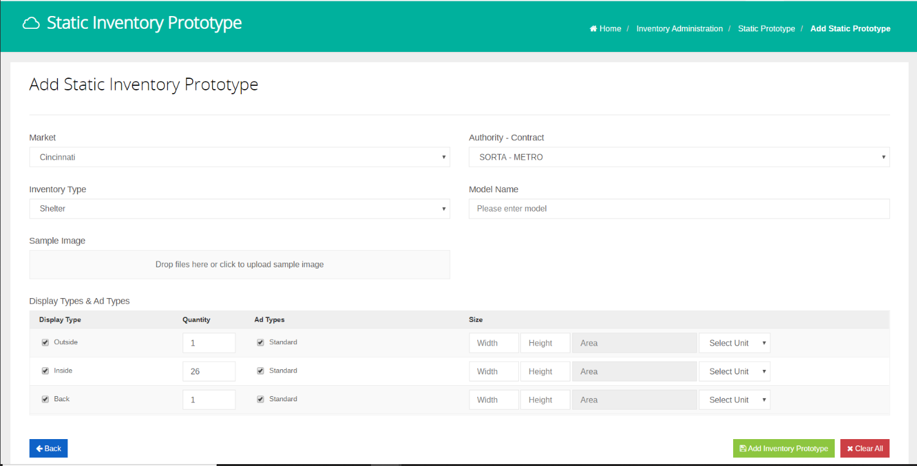

Following screen depicts the to-be state:

### Edit Static Inventory Prototype

This is an existing feature in GUS which would be changed to accommodate additional information that system needs to capture related to Shelters for the purpose of maintenance, warranty and servicing.

The current state of screen is depicted below:

Following screen depicts the to-be state:

## Manage Static Inventories

### Add Static Real

This feature is already implemented in GUS. For **Cincinnati** market and Inventory Type **Shelters**, the system would be changed to accommodate the following:

1. Upon Inventory creation using this screen, the shelters Status would be marked as **Out of Service**.
2. Aa

### Edit Static Inventories

This is an existing feature in GUS which would be changed to accommodate additional information that system needs to capture related to Shelters for the purpose of maintenance, warranty and servicing.

The current state of screen is depicted below:

Following screen depicts the to-be state: