Corporate IT – Services and Support.

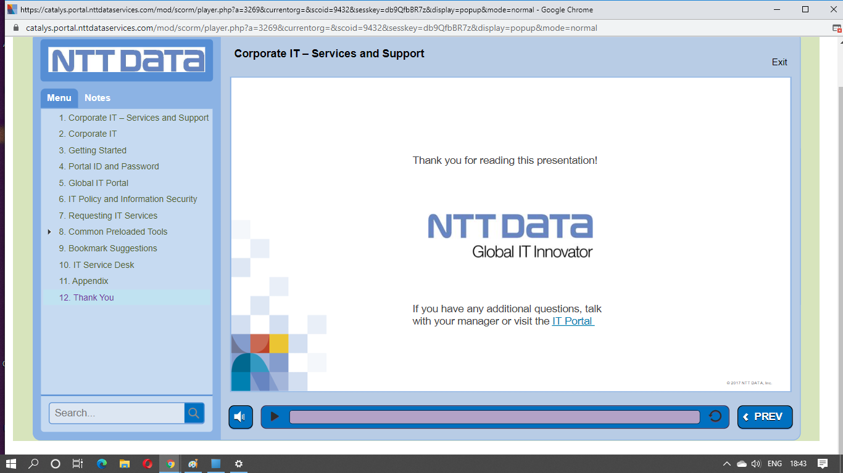

Performance Management

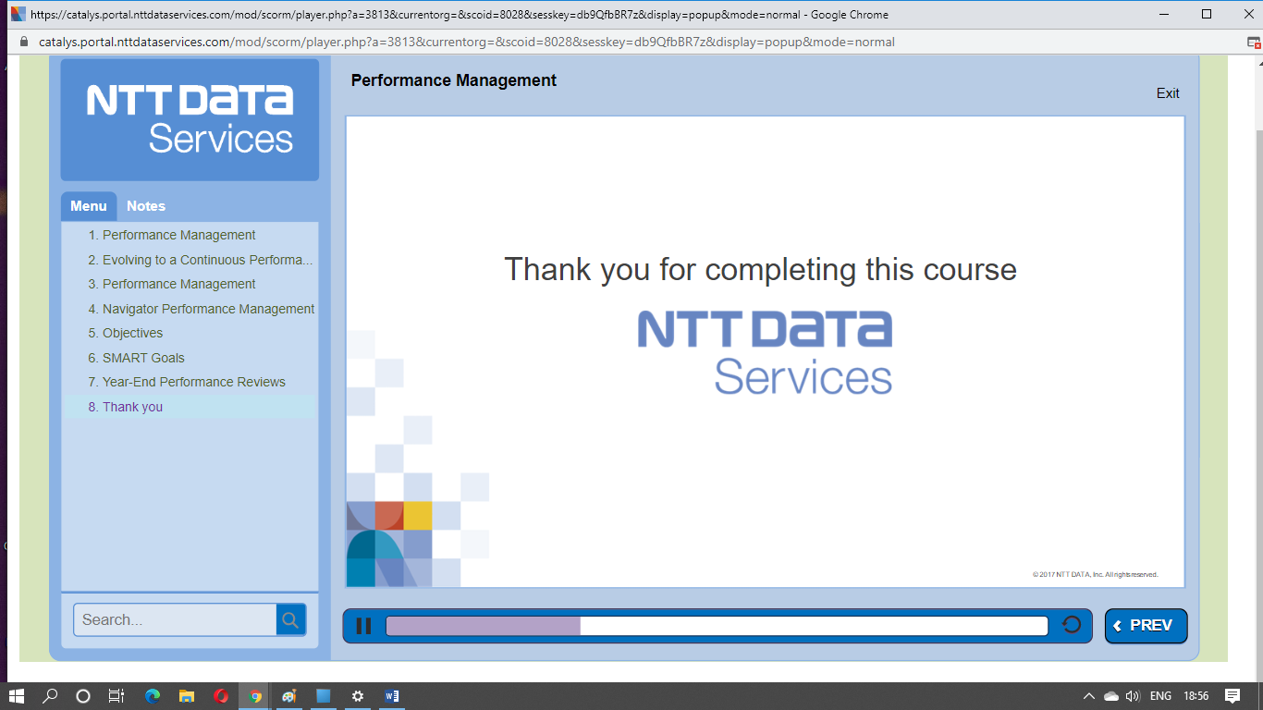

Privilege Leave,Casual and Sick leave, and Holiday Time.

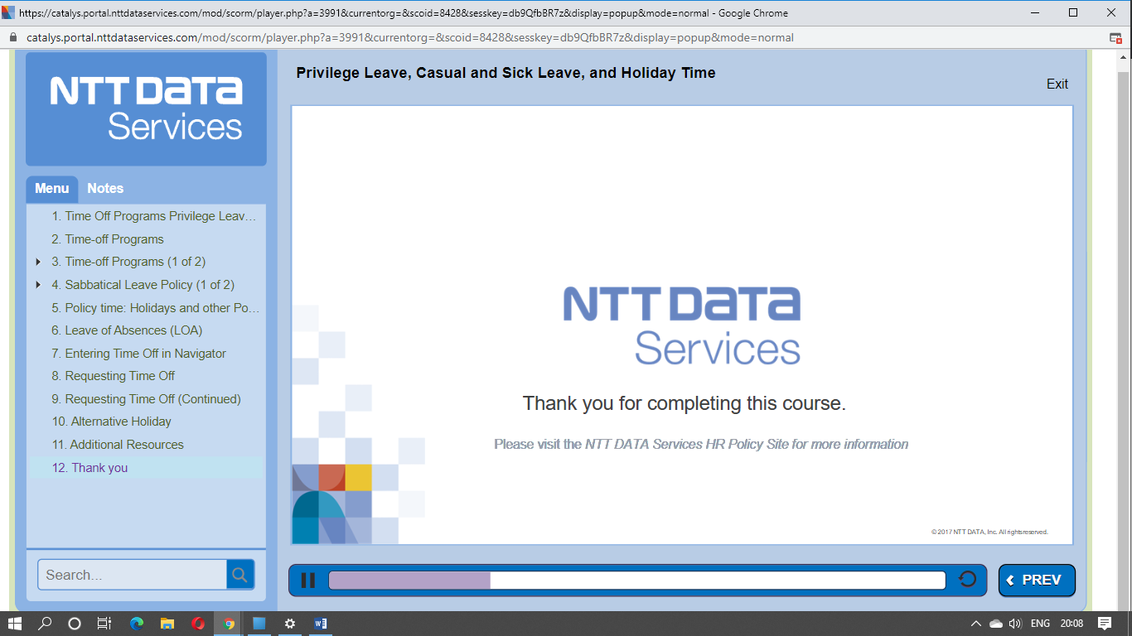

GBBS Finance Induction

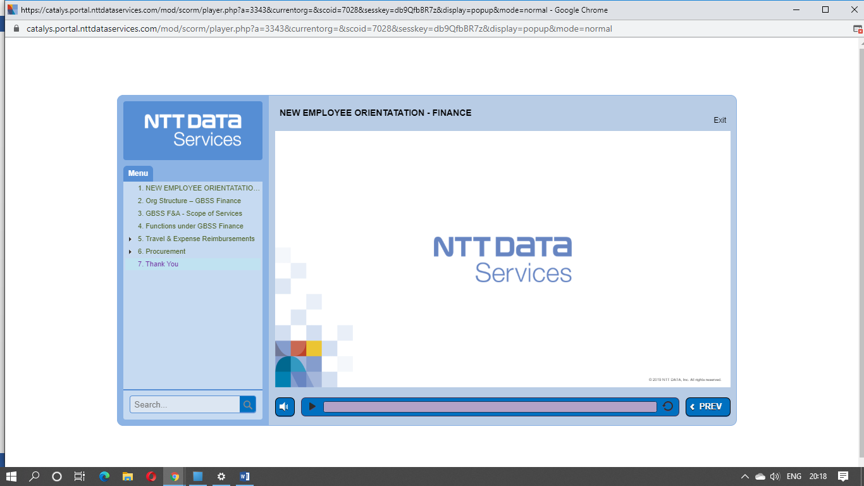

## NEO - PMG Quality Management System Induction

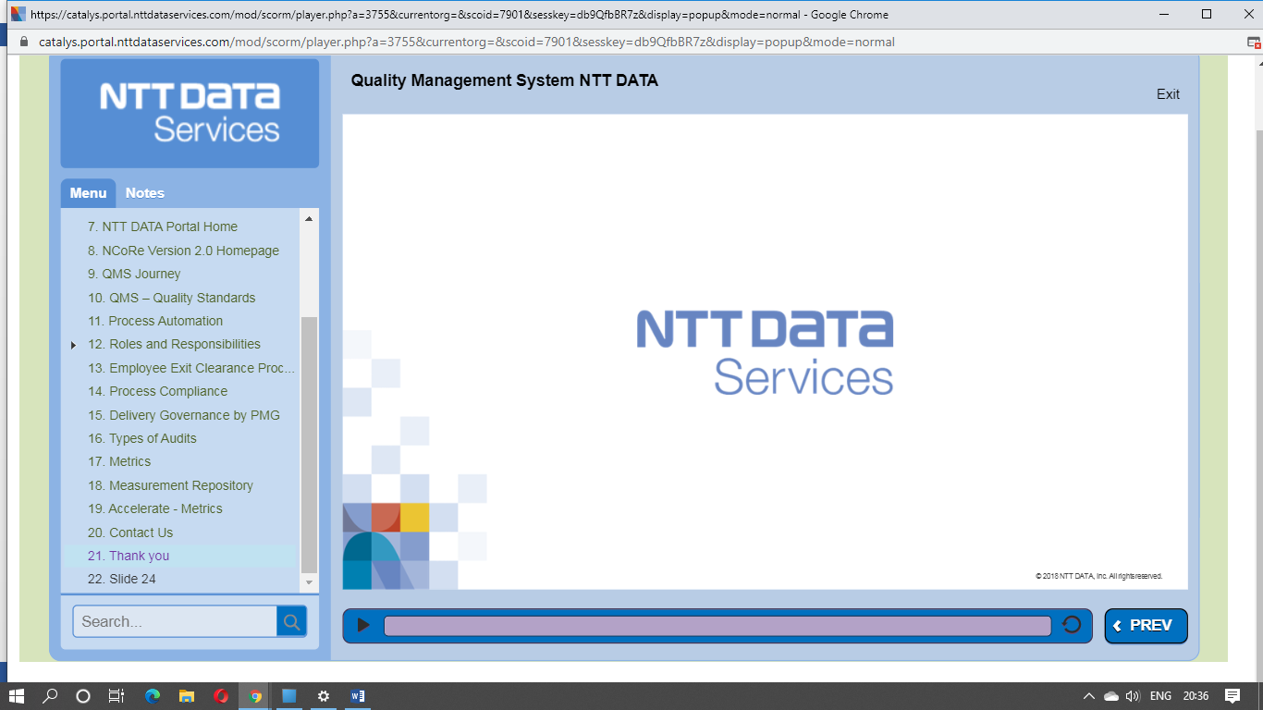

Software Quality Assurance (SQA)@NTT DATA

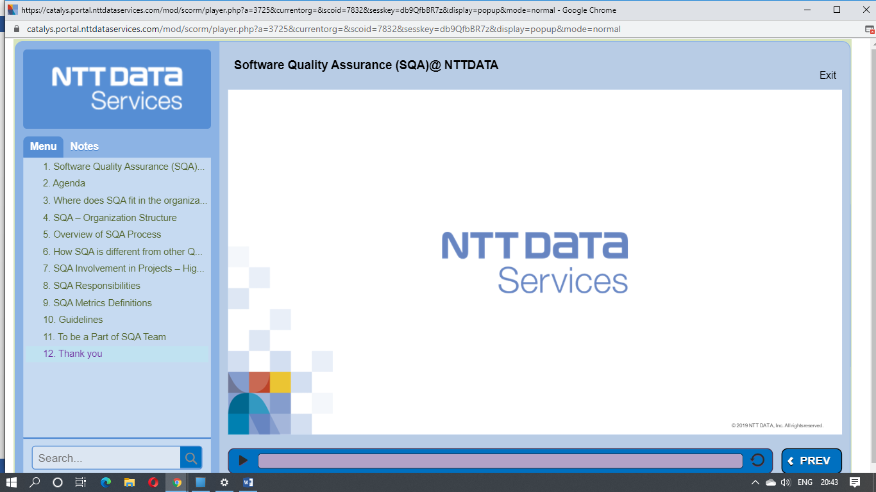

New Employee Orientation Human capital.

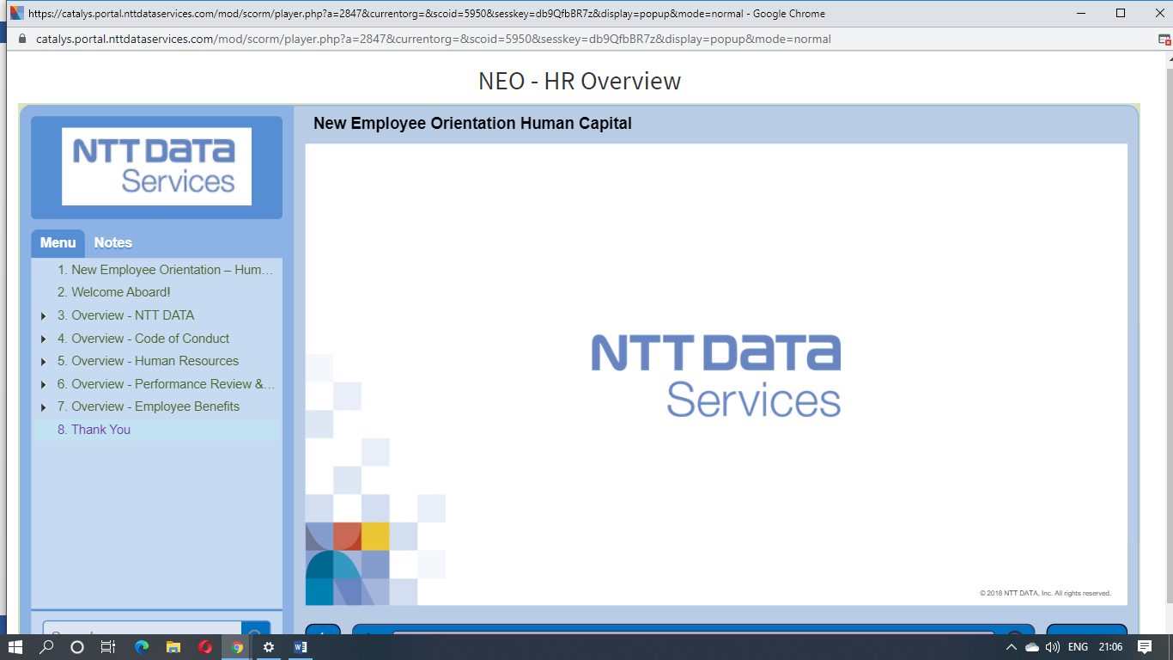

Global Resource Management (GRM)

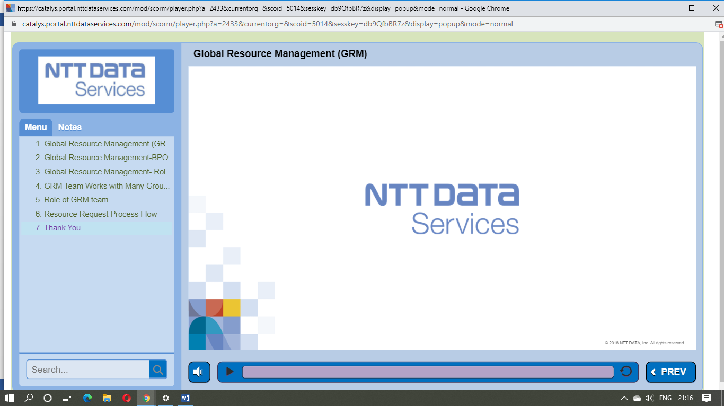

New Employee Orientation Survey.

