**TASK 1 REPORT**

**Title:** Analysing a 10x20 DataFrame with Machine Learning.

**Description:** Create one DataFrame which is having 10 columns and 20 rows (And it should be meaningful) and apply one machine learning model also.

1. **Task Description:**

The task involves analysing a meaningful dataset with 10 columns and 20 rows and applying Logistic Regression for predicting the target variable which is Diabetes. The workflow includes:

* Creating a synthetic dataset with realistic health-related features such as Age, BMI, etc.
* Creating Train and Test Set from Dataset.
* Training a Logistic Regression model.
* Model Performance evaluation on accuracy and classification report.

1. **Task output screenshot:**

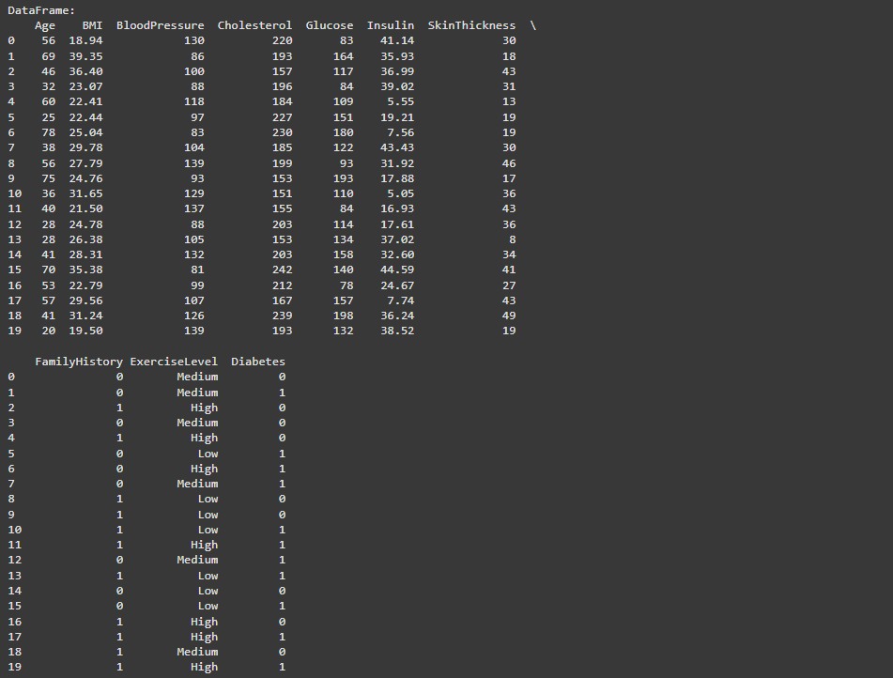

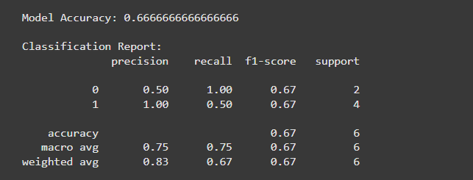

1. **Widgets/Algorithms used in task:**

* pandas to create and manipulate the dataset.
* numpy to generate random numerical data.
* In scikit-learn used LogisticRegression for classification, train_test_split to split the dataset, accuracy_score and classification_report for model evaluation.

**Algorithm used:**

* **Logistic Regression**: A statistical method used to model the relationship between a dependent variable (binary classification: 0 or 1) and one or more independent variables.